

JOB PROFILE
Job Title: | Administrative Assistant | School/Department: | Rossett Acre Primary School
Salary Grade: | Band 4 | Working Hours: | Monday to Friday  24.25 hours a week
Contract Type: | Permanent, part time, term time only | Location: | Harrogate
Responsible to: Headteacher
Role summary:
To deliver exceptional receptionist and administrative support for both internal and external customers and actively promote the school’s vision and ethos.
Red Kite Learning Trust is committed to safeguarding and promoting the welfare of students and expects all colleagues and volunteers to share this commitment.
Special conditions of service:
No smoking policy, including e-cigarettes.
Role specific responsibilities:
- To work as part of a team
- Friendly, professional and approachable attitude to all stakeholders including parents and visitors to our main Reception desk, telephone, email etc.
- To liaise with colleagues to prioritise work to meet conflicting deadlines
- To maintain accurate records
- To be the main first aider in school and incorporate various first aid duties including,
  - Weekly checking of expiry of medication held in school, administering medication and ensuring medication file is up to date
  - Routine checking of first aid kits and deliberators
  - Ordering first aid supplies
  - Booking staff on first-aid courses and keeping list up to date throughout school
  - Administering first aid and updating the accident spreadsheet daily and recording any reportable accidents on the Trust portal
  - Sending medical allergy forms to caterers and updating the allergy board in kitchen and staff room. Produce the medical/dietary sheet for each class in September and update throughout the year
  - Completion of Care plans
- Liaising with school milk and fruit providers
- Keeping supply folders up to date
- Organising Trips, including swimming, under the direction of teachers - booking coaches, costings, letters etc
- Completing Fire checklist sheet and ensuring fire meeting points are displayed throughout school
- Update lunch registers and figures and calculate monthly totals. Checking of meal balances and communicating with those parents in arrears
- Update room timetables
- Recording and banking of occasional cash coming into school
- Ordering of Y6 leavers hoodies
- Creating book labels for all classes
- Organising school photographs
- Annual office archiving and shredding
- Organising annual Rossett Show
- Photocopier – logging faults and sending back used toners
- Occasional covering of the hall for school dinners
- To provide an excellent customer service to parents, pupils, colleagues and visitors to the school.
- To liaise with parents and staff as required.
- To collate and prepare information from a variety of sources including basic reports such as those relating to student data etc.
- To operate relevant equipment/ICT packages e.g. Word, Excel, databases, spreadsheets, Internet
- Maintain stock and supplies, cataloguing and distributing as required
- To communicate effectively with internal and external customers in relation to work undertaken
- To be aware of, and comply with, policies and procedures relating to child protection, health, safety and security, confidentiality, equal opportunities and data protection, reporting all concerns to the appropriate person.
- To contribute to the overall ethos/work/aims of the school
- To undertake any other duties that are reasonably required by Senior Leadership Team

RK People responsibilities:
- Contribute to the overall aims and values of our Trust, appreciate and support the roles of other members of the wider team and attend and participate in relevant meetings as required
- Comply with all Trust policies and procedures including child protection, health, safety, welfare, security, confidentiality and data protection, reporting any concerns to the appropriate person
- Contribute to ensuring safeguarding procedures are in place and used effectively at all times
The role holder must demonstrate a flexible approach to the delivery of the role. Consequently, the role holder may be required to perform work not specifically identified in the job profile but which is in line with the general scope, grade and responsibilities of the role.
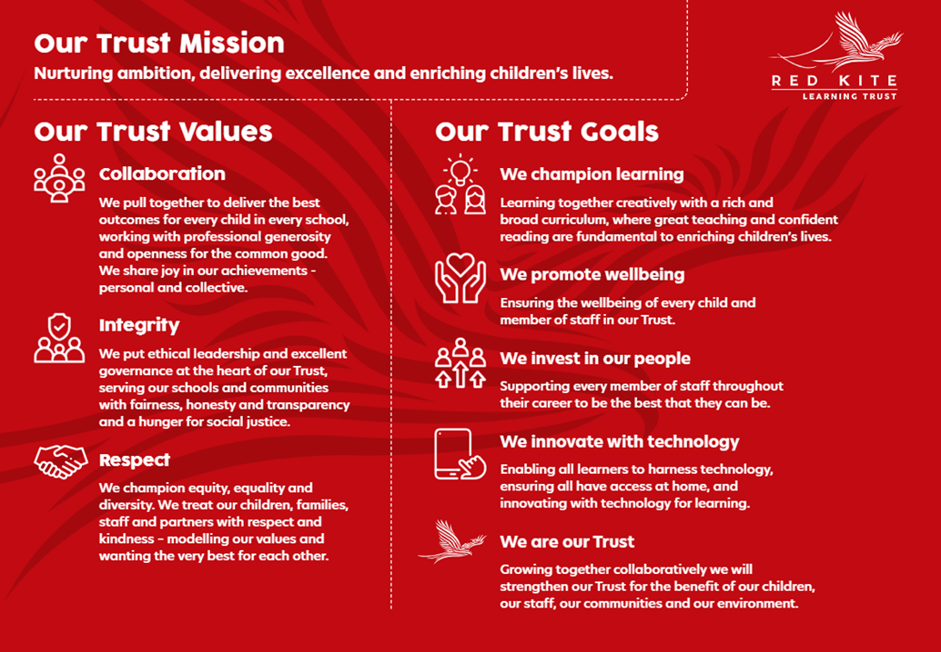
PEOPLE PROFILE
Aptitudes and Characteristics |  |  |  | Essential | Desirable
Ability to work flexibly and collaboratively as part of a team as well as on own and show initiative |  |  |  | *
Experience of working in a school administration setting |  |  |  |  | *
Ability to communicate effectively with a wide range of people |  |  |  | *
Ability to remain calm in difficult situations |  |  |  | *
Ability to administer first aid |  |  |  | *
Ability to input/retrieve information from databases and information systems |  |  |  | *
Ability to process documentation using Word |  |  |  | *
Able to prioritise work to meet conflicting deadlines |  |  |  | *
Able to demonstrate good numeracy and literacy skills |  |  |  | *
Knowledge of general office procedures and practice |  |  |  | *
Experience of dealing with queries from a wide range of people |  |  |  | *
Experience of working in partnership with others to deliver work to set deadlines |  |  |  | *
Experience of providing customer focussed services |  |  |  | *
Experience in the use of the Microsoft package |  |  |  | *
Willing to abide by all the Academy’s policies and procedures such as Equal Opportunities, Health and Safety, Child Protection, Confidentiality and Data Protection Policies |  |  |  | *
To display a responsible and co-operative attitude to working towards the achievement of the school’s aims and objectives |  |  |  | *
An ability to respect sensitive and confidential work |  |  |  | *
Commitment to own personal development and learning |  |  |  | *
Qualifications, Knowledge and Experience |  |  |  | Essential | Desirable
Participate in development and training opportunities |  |  |  | *
First aid qualification or willing to undertake the relevant training |  |  |  | *
Knowledge/qualifications demonstrating ability in numeracy and literacy |  |  |  | *
Have experience of working with children |  |  |  |  | *
Safeguarding and Promoting the Welfare of Students |  |  |  | Essential | Desirable
An appropriate motivation to work with children and young people |  |  |  | *
Ability to maintain appropriate relationships and personal boundaries with children and young people |  |  |  | *
Committed to the safeguarding and promoting the welfare of children and young people |  |  |  | *

