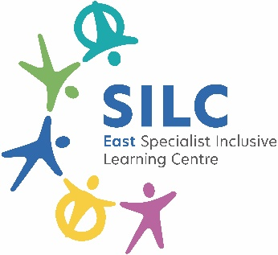 | External Job Advertisement  East SILC  Hollin Hill Drive,  Leeds,  LS8 2PW  Tel: 0113 2930236  www.eastsilc.org
Post: | Travel Trainer & Teaching Assistant
Salary Details: | Travel Trainer (B3 FTE £26,403/ Actual £10,740)  Level 1 Teaching Assistant (B1 FTE £25,185/ Actual £13,691)
Hours: | Travel Trainer- 17.5 hours  Level 1 Teaching Assistant- 24 hours  Temporary- due to Travel Training funding  Term Time only + 5 days (pro rata)
The East Specialist Inclusive Learning Centre (SILC) is a 2-19 generic special school with 470 learners on roll. All our learners have special learning needs and some have physical/ medical difficulties. The East SILC is a complex organisation which operates on a variety of sites to provide a range of outreach services across the city, including partnerships with primary and secondary providers, the city-wide Physical Difficulties and Medical Service including a moving and handling service, as well as the Medical Needs Teaching Service for Leeds.
Do you want to join a team making a difference to learner’s lives?
An exciting opportunity has arisen to join our expanding school community.

We are seeking to recruit to a temporary Travel Trainer and Level 1 Teaching Assistant, based at the BCC (Bridge) site. As with all appointments to the East SILC, staff may be asked to work at any site within the organisation and it will be an expected part of this role to support students at other SILC sites. The successful candidates will train individual learners to travel independently from their home to their school setting using public transport or walking. They will work closely with the staff at the learner’s setting, the parents/carers and the local authority to ensure an effective and productive process.

If you have the requirements identified below we would like to receive an application from you:
- A commitment to fostering independence in learners.
- Aspire to be an outstanding practitioner.
- Good interpersonal skills to be able to liaise with parents/carers, professionals and the wider community.
- To be a reliable timekeeper and self-motivated.
- To be able to work with learners with complex needs and challenging behaviours.
- Must have an interest in and experience of working with learners with a wide range of additional needs.
- A willingness to train and develop skills to improve our school offer to learners.
- Willing to make a positive contribution to the broader life of the school.
What we offer:
- A strong team ethos and a commitment to staff wellbeing.
- Excellent CPD opportunities to grow and develop through mentoring and coaching.
- A thorough induction process is in place

To apply please visit eastsilc.org/News/Vacancies.
Closing date for applications: |  | Friday 13th March at midday
Interviews to take place: |  | W/C 16th March 2026
The East SILC is committed to safeguarding and promoting the welfare of children and young people and expects all staff and volunteers to share this commitment. Appointments are made subject to a satisfactory enhanced Disclosure and Barring Service check (DBS formally CRB) and medical clearance from Leeds City Council’s Occupational Health Service.
All shortlisted candidates must complete a self-disclosure form before interview.
It is illegal to apply if you are on the Children’s Barred List.
The East SILC promotes diversity and wants a workforce which reflects the population of Leeds.

