



WELCOME TO BUXTON COMMUNITY SCHOOL

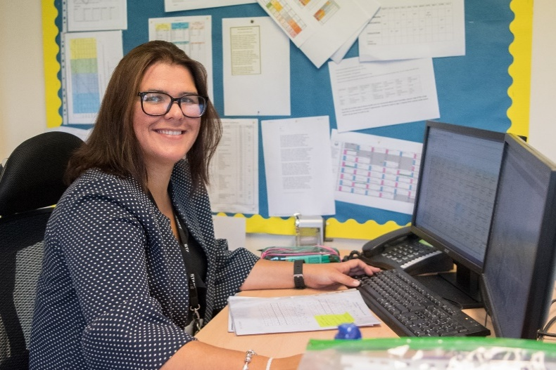

Welcome to our school, part of the Embark Federation.
We are proud to be part of a family of 29 schools across Derbyshire who believe that by working together we can create schools that stand out at the heart of their communities. Our Trust is guided by four core values – Family, Integrity, Teamwork and Success – which underpin everything we do and shape the experiences of both our students and staff.
At Buxton Community School, we are ambitious for every young person and every member of staff. We believe education should be academically rigorous, personally enriching and genuinely transformative. Our shared purpose across Embark is simple but powerful: Love Learning, Love Life.
Situated in the heart of the Peak District, Buxton Community School is a thriving and ambitious 11–18 secondary school serving over 900 students. As a key educational provider within our community, we are committed to delivering exceptional teaching, outstanding pastoral care and a broad curriculum that enables every young person to thrive from Key Stage 3 through to Sixth Form.
Our culture is built on high expectations, positive relationships and a commitment to ensuring that every student feels valued, supported and challenged. Through our core values of Ready, Respectful and Safe, we foster an environment where students develop confidence, character and the skills needed to succeed both in school and beyond.
In recent years, the school has undergone significant transformation. Strong leadership, a relentless focus on improvement and a commitment to educational excellence have resulted in sustained improvements in teaching, learning and student outcomes. We are proud of the progress we have made and excited about the next stage of our journey.
We are equally committed to creating a positive working environment for our staff. Staff wellbeing is a genuine priority, and we have deliberately structured our systems to support workload reduction, professional growth and a healthy work-life balance. This includes providing additional non-contact time above national expectations and investing in high-quality professional development at every stage of a colleague’s career.
As we continue to strengthen our school, we are seeking colleagues who are passionate about their subject, committed to educational excellence and motivated by making a difference to the lives of young people. We are looking for individuals who bring energy, positivity and ambition; professionals who want to be part of a supportive team that is determined to provide the very best educational experience for every student.
If you share our values, ambition and belief that every child deserves an exceptional education, we would be delighted to receive your application and welcome you to the Buxton Community School community.
We want the best for our staff and young people, and we will not let it get more complicated than that.
Mrs S Jones
Headteacher

The Role

An exciting opportunity has arisen for an enthusiastic, organised and hard-working School Business Assistant - Receptionist.
We are seeking to employ a highly motivated, cheerful and experienced Receptionist to join our friendly and committed Administration team. This role is very varied, so we are looking for someone who is flexible, resourceful and able to cope in a fast-paced environment, dealing with a high volume of calls and visitors.
We are looking for someone who:
- Has experience of working with people as part of a team,
- Has English and Mathematics at Grade C or above at GCSE,
- Has strong communication skills,
- Can demonstrate a rapport with visitors, parents and students and be welcoming and professional.

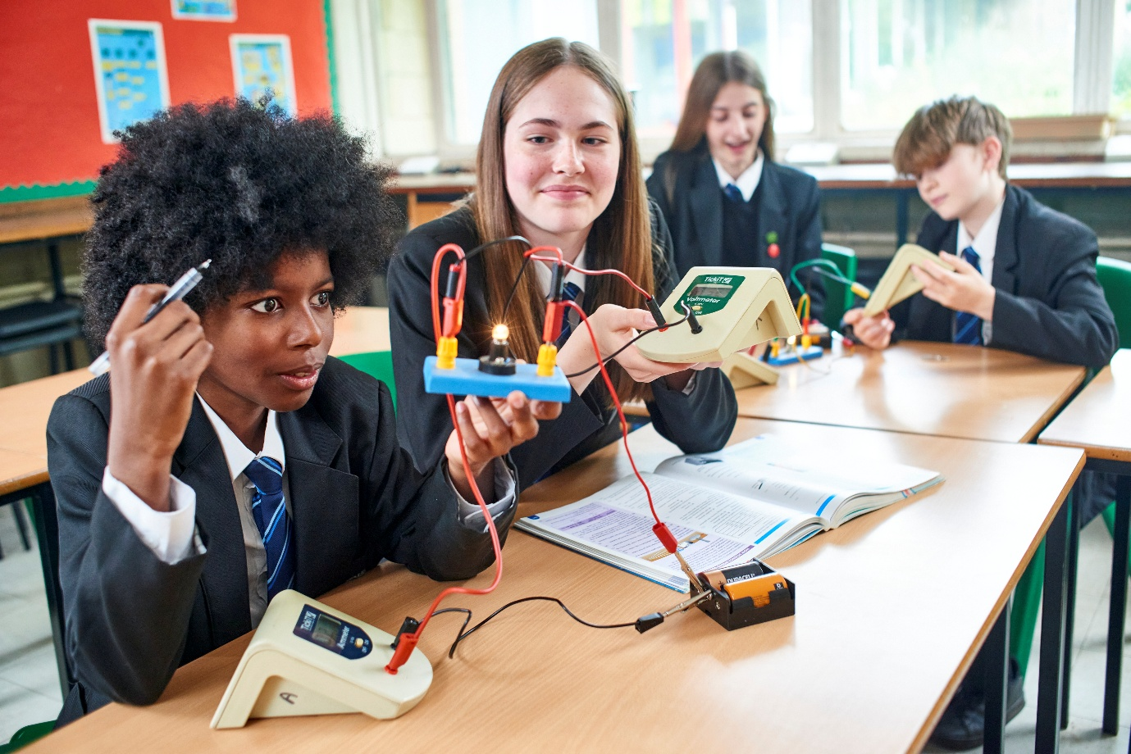

Job Description
Post Title: School Business Assistant - Receptionist

Grade: 6 (FTE £25,989 - £26,458)

Actual Salary: £9,022

Weeks per Annum: 39

Hours of Work: 15 Hours per week 2 days 8am – 4pm

Responsible to: Headteacher’s PA

Purpose of the Role:

To work as part of the Communications team to provide high quality administrative support for the efficient running of the school.

To provide the first point of contact for parents and visitors, ensuring communication and information are effective.

To make a significant contribution to promoting the vision, ethos and brand of Buxton Community School.

Accountabilities/Responsibilities:

Purpose of the Role:

To provide the first point of contact for parents and visitors, ensuring communication and information are effective.

To work as part of the Communications team to provide high quality administrative support for the efficient running of the school.

To make a significant contribution to promoting the vision, ethos and brand of Buxton Community School.

Accountabilities / Responsibilities:

Reception Duties

- Responsible for checking suitability and allowing admission of visitors, parents and students through the school gates.
- Deal with incoming and outgoing telephone calls.
- Deal with all school reception desk enquiries from visitors, parents, students and colleagues.
- Inward and outward post administration requirements.

Whole School
- Support with administration across all key stage areas of whole school letters and annual publications.
- Support the whole school marketing strategy and procedures, ensuring a consistent high-quality finish.
- Provide administrative support for other members of the administration staff as required.
- Undertake communications from the School Office. This includes email, messages to parents via Arbor (our management information system), letters, updating digital screens and ensuring necessary communications are sent out in a timely manner.
- Being part of the team who administer basic first aid to all students, staff and visitors, following school procedures. Including administration of medication where appropriate and necessary and making the necessary records.
- Ensuring a high standard of cleanliness is maintained in the school office and reception area.
- Co-ordinate the students on monitor duties each day.
- Dealing with routine issues involving visitors, telephone callers and incoming mail in a courteous and sensitive manner; resolving problems and re-directing queries within established guidelines.
- Bringing to the attention of the management more complex or contentious issues, including occasions when it is clear to the post holder that the issue is one of high priority.
- Ensuring that all correspondence produced meets the high professional presentation standards required.

Other
Post holder is required to be flexible in their approach to the work. Also required to undertake training and development activities.

Key Relationships – Internal and External:
Internal and External with all staff, students, visitors and parents.

Other:
- Carry out any other duties as directed by the Headteacher/Line Manager commensurate with the general level of responsibility of the post.
- Whilst every effort has been made to explain the main duties and responsibilities for the post, each individual task undertaken may not be identified, especially in the context of a busy and growing school which requires flexibility in all of its employees.
- To comply with the requirements of Health and Safety, other relevant legislation and school documentation and to understand and comply with the school’s Equal Opportunities Policy.
- All staff are expected to be courteous to colleagues and students and provide a welcoming environment to parents and other visitors.
- Responsibility for the safeguarding of all young people.

Note: The Headteacher has a responsibility to revise and amend all job descriptions, as necessary. This will normally be by consultation and agreement with the postholder and, to this end, all job descriptions will be kept under regular mutual review.

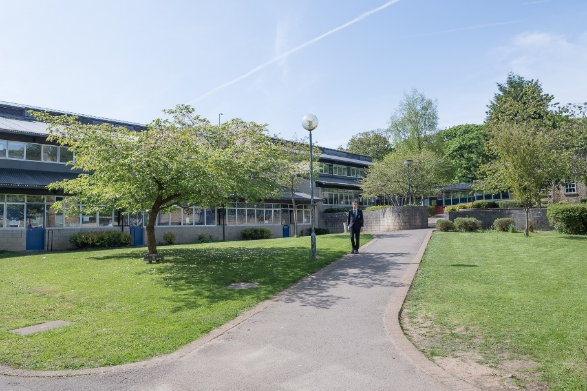

Person Specification

School Business Assistant – Receptionist

- Knowledge & Experience
- Experience of working in a busy office environment
- Ability to work flexibly across operational boundaries and as part of a team
- Ability to absorb and understand a wide range of information concerning the diverse functions across the school
- Knowledge and qualification for basic first aid – or willingness to undertake training

- Skills and Abilities
- The ability to work under pressure and meet deadlines
- Ability to work as a team member and on own initiative
- Excellent organisational, written and oral communication skills
- Willingness to assist and participate in the wider aspects of school life
- Excellent knowledge of Microsoft packages

- Education and Qualifications
- Good standard of education – Maths and English to GCSE Level C or equivalent
- IT Literate

- Attitude and Personal Qualities
- Discretion and confidentiality
- Ability to multi task, work under pressure and meet deadlines
- A proactive approach with a high level of initiative
- Outstanding interpersonal skills and the ability to establish and maintain excellent working relationships with others
- Patience and ability to remain calm
- Suitability to work with children
- Commitment to equality and anti-discriminatory practice
- Reliable and punctual
- Personable and well presented

In addition, the person appointed to this post will:

- Be totally committed to the safeguarding and welfare of children
- Be punctual to work and have an excellent attendance record
- Possess the necessary qualifications, experience and/or skills to discharge the duties associated with this position
- Work in accordance with the school’s policies including Health & Safety
- Be capable of maintaining high standards of work at all times
- Be committed to being part of a team but be able to show initiative and be capable of working unsupervised when appropriate
- Have excellent personal organisation and time management skills
- Be honest, reliable and trustworthy
- Be open and frank and not afraid to ask for guidance and help when it is needed
- Be capable of building excellent relationships with others
- Be prepared to work hard and to discuss issues which arise from work
- Have plenty of energy and enthusiasm and the ability to maintain a sense of humour and perspective when things get tough!
- Be calm, precise and patient when dealing with others, including students
- Be committed to professional self-improvement both by In Service Training and “learning on the job”
- Be an excellent role model for young people

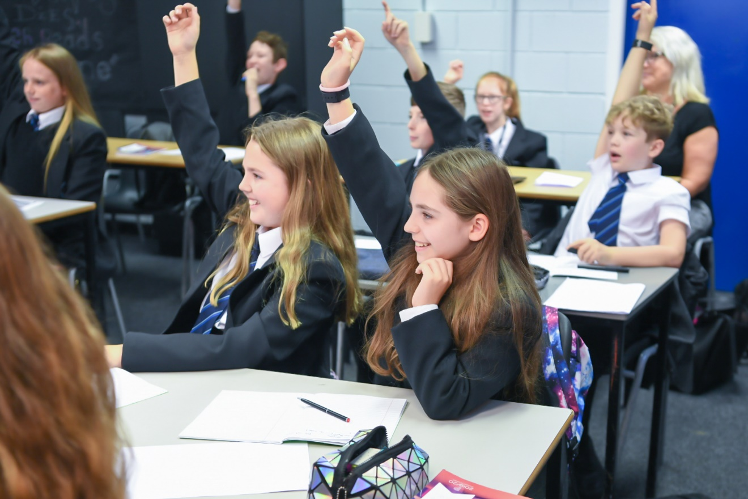

The Application Process

If you are interested in applying for the role, please apply via My New Term.

Closing date for applications is Wednesday 15th July 2026

If you are short-listed for interview, you will be contacted in advance to discuss arrangements for the interview. Unfortunately, if you have not been contacted prior to the interview day, your application has not been successful on this occasion.

Buxton Community School is committed to safeguarding and the process of safer recruitment. As a result, this post is subject to an enhanced Disclosure and Barring Service check, and all shortlisted candidates will be expected to prove their identity at interview. The successful candidate will be expected to show original copies of qualifications and further proof of their identity.

