Shipley C of E Primary
Nursery Teaching Assistant Recruitment Information Pack
Fixed term, Part time (25 hours per week)
Band 6 - Actual salary £14,715 to £15,934







Closing date: Midday Friday 9th January 2026

Interview: 16th January 2026

Contents

Welcome letter from CEO of BDAT Page 3
Shipley Academy Vision and Values Page 4
About BDAT Page 5
BDAT Mission, Vision and Values Page 6
Teacher Advert Page 7
TA Job Description & Person Specification Page 8 - 16
How to find us Page 17
Selection Process Guidance Page 18 - 19

Welcome to Bradford Diocesan Academies Trust
Dear Applicant

On behalf of BDAT and the Governors of Shipley Primary school, we would like to thank you for showing an interest in the Teaching Assistant post at our school.

Set in the heart of Bradford, Shipley Primary school is a community where we are incredibly proud of our unique children, supportive parents, great staff and forward thinking governors.

At the centre of Shipley CE School lies a learning community that embraces every opportunity to offer an exciting, social, multi-cultural and pioneering educational experience for each and every one of our learners.

We have a dedicated team who are fun, friendly and motivated to ensure that each learner is stretched and that they experience fulfilment in learning every single day.

Thank you again for your interest in our school. We very much look forward to receiving your application.

Yours sincerely

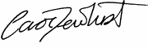
Carol Dewhurst
Chief Executive Officer, BDAT



About BDAT

Shipley Primary School is an academy within Bradford Diocesan Academies Trust. If you are successful in being appointed, the Trust will be your employer.

General Information and Background

Bradford Diocesan Academies Trust (BDAT) is a Multi-Academy Trust (MAT) supporting 19 primary and secondary schools in Bradford. We are a Trust which prides our self in delivering great education outcomes and life opportunities for all our children. We are an inclusive Trust working with children from a rich range of backgrounds who reflect our communities and the city we serve. We are proud to be all about Bradford and developing the future generation of lifelong learners who will go on to achieve incredible things.

BDAT is a Trust which recognises each of our schools is unique. We actively encourage and celebrate difference as we know each of our schools serves very different communities. However, we also know that a key strength of being part of a Trust means together our schools can support each other, learn from each other and share great practice. As importantly we know from working our way through the COVID pandemic, that a problem shared really can be a problem halved, and by working together we can save ourselves time, money and lots of duplication of work.

We are a Trust which is value-led and we know it is important that we consistently live these values. The Trust’s mission is “to provide education of the highest quality within the context of Christian belief and practice.” We strongly believe every child only has one chance at a good education.

Our core Trust values are aspiration, inclusion, compassion, resilience and excellence. We seek to model these values in all we do, including how we recruit and develop our staff, how we teach our students and how we liaise with our families, friends and partners. We are a proudly Christian organisation committed to providing high-quality education for all within our ethos. Whilst robust Christian principles underpin the work of the Trust, everyone is encouraged to explore their own spirituality and to recognise and understand that of others. We describe ourselves as having inclusive values believing these are as appropriate and important to staff and students of all faiths (and to those without faith) as they are to those who practice within the Church of England. It is for this reason we choose to support and sponsor Non-Church of England Academies, as well as those within the faith. Therefore, we welcome applications for this role from employees of all faiths as long as they understand and can promote the values which we share.

BDAT is a large Trust, however we pride ourselves in knowing and understanding our schools. We are all part of the BDAT family and we all have the same motivation – to see our children succeed. For more information about us follow us on twitter @wearebdat or visit www.bdat-academies.org

BDAT’s Mission, Vision and Values

BDAT’s mission is:

‘To provide high quality education within the context of Christian belief and practice so that every child can fulfil their academic potential and accomplish their individual goals’

Our vision is:

‘That every student in a BDAT academy gets a happy and high quality education enabling competence, confidence and character to thrive; and that our Academies become the schools of choice in Bradford.’

Our values are:

Aspiration. We set high expectation for ourselves, our children and our staff so that each of us is supported to achieve our own potential. We expect nothing but the best from ourselves and from others.

Inclusion. We understand everyone is equal, without exception. We value and encourage diversity and difference. We proactively seek to learn from others.

Excellence. We provide rigorous support and challenge to our schools and our students. We strive for excellence in all we do.

Compassion. We care for each other. We respect each other and treat our friends and colleagues how they would expect to be treated. We make sure we are safe, feel loved and are actively supported at all times.

Resilience. We are ambitious and reflective. We are determined and brave in making decisions and when facing challenges. We expect our schools to provide us with the skills and knowledge to guide us through our future as life-long learners.



Shipley CE Primary School

Outline Job Description

POST TITLE: PART TIME FIXED TERM NURSERY TEACHING ASSISTANT LEVEL 3
POST REF: EDV-2025-SCPS-60823
GRADE: BAND 6

GENERIC INTRODUCTION:

The following information is furnished to assist staff joining the school to understand and appreciate the work content of their post and the role they are to play in the organisation. The following points should be noted:

- Whilst every endeavour has been made to outline the main duties and responsibilities of the post, a document such as this does not permit every item to be specified in detail. Broad headings, therefore, may have been used below, in which case all the usual associated routines are naturally included in the job profile.

- Employees should not refuse to undertake work, which is not specified on this form, but they should record any additional duties they are required to perform and these will be taken into account when the post is reviewed.

- BDAT is an Equal Opportunities Employer and requires its employees to comply with all current equality policies both in terms of equal opportunity for employment and access to BDAT Services.

- BDAT is committed, where possible, to making any necessary reasonable adjustments to the job role and the working environment that would enable access to employment opportunities for disabled job applicants or continued employment for any employee who develops a disabling condition.

PRIME OBJECTIVES OF THE POST:

To complement, appreciate and support the role of teachers and other professionals by undertaking work/care/support programmes which enables access to learning in the community as part of a teacher planned approach.

To support the class teacher in the management of pupils in the classroom, and other senior staff on a range of teaching and learning experiences which deliver an appropriately differentiated and suitably challenging creative curriculum for all pupils whilst meeting statutory requirements.

To implement agreed work programmes with individuals/groups, in or out of the learning environment. This will include assisting the teacher in the whole planning cycle and the management/preparation of tasks/resources.

Work within school policies and procedures under the direction and guidance of senior staff and within an agreed system of supervision.

May from time to time be required to undertake other duties commensurate with the grade and level of responsibility defined in this job description.

Working in Nursery, you will be required to provide intimate care where necessary.
EFFORT DEMANDS:

- Will assist in maintaining the good discipline of pupils throughout school and be expected to use good common sense, as well as use initiative in all matters relating to the conduct and behaviour of individual pupils, groups of pupils and whole classes, the safety, mobility (if required), hygiene and well being of the pupils; making decisions within established working practices and procedures.

- Will recognise and challenge any incidents of racism, bullying, harassment, victimisation and any form of abuse of equal opportunities, ensuring compliance with the relevant school policy and procedures.

- Will deal with any issues, immediate problems or emergencies that arise in line with school policies and procedures liaising with colleagues where necessary e.g. dealing with a sick, injured or distressed child.

- Acting as a role model, will establish productive and constructive working relationships with pupils, setting high expectations, motivating and interacting with them, being aware of their individual needs, supporting difference and ensuring all pupils have equal access to opportunities to learn and develop whilst responding appropriately.

- Will have the ability to cope with the requirements of the post, which may include working with pupils who have emotional/behavioural/physical difficulties.

- Will use specialist learning skills/training/experience to support pupils.

- Make decisions using initiative where appropriate within established working practices.

- Will contribute to the overall ethos/work/aims of the school.

- Will support, uphold and contribute to the development of the schools Equality policy in respect of both employment issues and the delivery of services to the community.

- Will appreciate and support the role of other professionals.

- Be vigilant and sensitive to any child protection/safeguarding concerns that arise, reporting any concerns to the designated officer in line with school policy and procedure.

RESPONSIBILITIES:

- Assist in the management of pupils in the learning environment.

- Assist the teacher with lesson planning and planning of other learning activities, evaluating and adjusting lessons/work plans as appropriate and in accordance to pupil responses/needs whilst helping pupils to access learning activities through specialist support.

- Will transfer work and resources back to the teacher and feed back any issues.

- As agreed, and with limited supervision, deliver a range of teaching and learning experiences which should be appropriately differentiated and suitably challenging.

- Will undertake routine marking of pupils work and accurately record achievement/progress, administer and assess routine tests and invigilate exams/tests.

- Support the teacher in establishing, adapting and undertaking structured and agreed learning activities/teaching programmes appropriate to the pupil’s needs to ensure physical, social, emotional and intellectual development, taking into account diversity e.g. language, culture, ability, race and religion.

- Will recognise own strengths and areas of expertise and use these to advise and support colleagues in order to ensure the smooth running of the learning environment and contribute to relevant meetings.

- Will supervise and support pupils consistently at all times including those with special needs; recognising and responding to their individual needs whilst ensuring their safety and education in the learning environment.

- Assist and provide suggestions on the implementation of Individual Education Plans and Personal Care Programmes; attending to the pupils’ personal needs and maintaining related personal programmes with the correct use of care materials including the safety and well being of the pupils, therapy and medical intervention needs of the pupil and first aid, paying attention to social, health, physical and welfare matters as well as high standards of cleanliness and hygiene e.g. washing, dressing, toileting, and, if applicable, mobility.

- For posts working with pupils who are physically less able, it may be necessary to be able to physically assist the pupil in line with school policies and good practice.

- May be required to supervise whole classes in the short term absence of the teacher in accordance with short term plans. The primary focus will be to maintain the planned range of activities in the learning environment, maintain good order and to keep pupils on task.

- Promote and reinforce the inclusion, acceptance and integration of all pupils, including those with specific and special needs and those from different cultures and/or with a different first language as appropriate.

- Set challenging and demanding expectations, employ strategies to recognise and reward achievement of self-reliance whilst promoting self-esteem. Encourage pupils to act independently, working co-operatively and interacting with others.

- Will prepare, create and maintain a purposeful, orderly and supportive learning environment to meet the lesson plans. Take responsibility for the care, preparation, maintenance and use of relevant equipment, assisting pupils in its use and clearing/storage afterwards.

- Will be aware of pupil progress, monitor/record pupil responses against pre-determined learning objectives as well as provide accurate, constructive and detailed feedback/reports to the teacher and pupils.

- In liaison with the class teacher, will establish constructive relationships and communicate with other agencies and professionals to support achievement and progress of pupils.

- Promote positive values, attitudes and good pupil behaviour and encourage pupils to take responsibility for their own actions whilst supporting the teacher in managing this. Deal promptly with conflict and incidents (including those involving restraint) and reporting challenging behaviour where appropriate in line with established policy.

- Will gather/report information from/to parents/carers as directed, taking into account parental/carer concerns, dealing with them sensitively under the direction of the teacher.

- Will be responsible for maintaining manual and computerised records and contributing to the reviews of systems/records as required.

- Will provide clerical/administrative support as directed by the teacher.

- Will implement local and national learning strategies and will support pupils to achieve learning goals e.g. literacy, numeracy, early years as directed by the teacher whilst making effective use of opportunities provided by other learning activities to support the development of relevant skills.

- Will support pupils in the use of ICT in learning activities as directed by the teacher, develop skills to deliver ICT packages to pupils and develop pupils competence and independence in its use.

- Will participate in own performance development, identify and address any training needs/other learning activities.

- Will assist with the supervision of pupils out of lesson times, including before and after school and at lunchtimes, accompanying teaching staff and pupils on visits, trips and out of school activities; taking responsibility for a group under the supervision of the teacher.

- Will take delegated responsibility in the supervision of Teaching Assistants, students on work experience, trainees and voluntary helpers.

ENVIRONMENTAL DEMANDS/WORKING CONDITIONS:

- Will have long periods of sitting or standing.

- Available to work during school hours during term time and a willingness to be flexible as may be required to attend staff meetings/training sessions outside of usual hours.

- Will have contact with members of the public/other professionals e.g. teaching staff, governors, parents/carers, community groups, local education authority, external providers etc.

- This post may include a degree of manual lifting and handling. You are expected to be aware of health and safety policies and procedures and frequently assess your ability to carry out the lifting tasks required of you.

- Report all concerns to an appropriate person.

SPECIAL CONDITIONS OF SERVICE:

- An Enhanced DBS with Children’s Barred List check is required for this post, along with any other relevant safer recruitment checks as outlined in Part 3 of Keeping Children Safe in Education. This is to ensure that there are no contra-indications in personal background or criminal records indicating unsuitability to work with children/young people/vulnerable clients/finance.

Other Considerations

- To contribute to the whole school culture of safeguarding by attending safeguarding training at least annually to keep knowledge up to date; being aware of and complying with policies and procedures relating to safeguarding and child protection; being vigilant for signs that children may be being abused and to report any such concerns to the school’s Designated Safeguarding Lead or the Headteacher.
- To act in accordance with Data Protection Act principles and BDAT’s UK GDPR policy and maintain confidentiality at all times e.g. access to staff/student/parent and carers files.
- Accept and commit to the principles underlying the Schools Equal Rights policies and practices.
- Be able to perform all duties and tasks with reasonable adjustment, where appropriate, in accordance with the Equality Act.
- Must be legally entitled to work in the UK.

PERSONNEL SPECIFICATION:
 | ESSENTIAL
EXPERIENCE: | - Experience of working in a team situation.  - Experience of working with or caring for children of relevant age e.g. voluntary organisation or parental/caring responsibilities.  - Experience of working with pupils with additional educational needs, more able special educational needs, and varying special educational needs.  - Experience of working in a relevant discipline.  - Clerical/administrative/financial experience.
QUALIFICATIONS/  TRAINING: | - Minimum of GCSE English and Mathematics at grade C/4 or above (or equivalent)  - Level 3 Diploma in Supporting Teaching and Learning in Schools.  - Certificate in Paediatric First Aid.  - Other relevant qualifications relating to the post e.g. Level 3 BTEC/NVQ in Health/Childcare, first aid qualification.  - Evidence of further training/development and/or willingness to participate in further training and development opportunities e.g. relevant learning strategies, literacy and/or particular curriculum or learning area such as sign language, bi-lingual, dyslexia, ICT, math, English etc  - Your Level 3 qualification must be ‘full and relevant’ (as per the DfE Early Years Qualification List)
KNOWLEDGE/ SKILLS: | - Will possess a full working knowledge of the School’s relevant policies/procedures/codes of practices with an outline understanding of relevant legislation.  - Will have knowledge of the policies covering their service area.  - Knowledge of childcare with an understanding/awareness of the principles of child development and learning processes as appropriate.  - Working knowledge of national/foundation stage curriculum and other relevant learning programmes/strategies.  - Good organisational and problem-solving skills with the ability to work proactively and independently  - Good communication skills.  - Exercise advisory, guiding, negotiating and persuasive skills at a developed level.  - Excellent numeracy/literacy skills.  - Good ICT skills.  - Ability to use relevant equipment/resources.  - Ability to self-evaluate learning needs and actively seek new learning opportunities.  - Ability to understand classroom roles and responsibilities.  - An understanding of the needs of a multicultural society.  - An understanding of the issues relating to pupils who have additional learning needs, more able and special educational needs.  - Knowledge of Behaviour Management.  - Knowledge and commitment to schools' Equality policy.  - Knowledge of Health and Safety requirements.  - Ability to relate well to pupils and adults.  - Ability to work constructively as part of a team with a willingness to share knowledge, expertise and experience.  - Ability to remain calm under pressure; prioritising conflicting demands .  - Demonstrate a commitment to working with children of the relevant age.  - Demonstrate good co-operative, interpersonal and effective listening skills.  - Maintain confidentiality in matters relating to the school, its pupils, parents or carers.  - Ability to perform all duties and tasks with reasonable adjustments where necessary, working flexibly and willing to accept change.  - Ability to cope with the requirements of the post, which will include working with pupils who have emotional/ behavioural/physical difficulties.

BDAT LEADERSHIP COMPETENCY FRAMEWORK:

At BDAT we believe that it is important we have common expectations of what makes an effective Trust and School leader, supported by a consistent set of deﬁnitions and standards for leadership at different levels. The BDAT Leadership Competency Framework sets out our Trust-wide expectations of what makes a good leader. They inform how we expect our leaders to act and behave and explain what skills and attributes leaders are expected to demonstrate whilst they work in our schools.
They also support the Trust ICARE values on how we work together as colleagues within BDAT.

The framework is applicable to both teaching and support staff working across all roles within our Trust and Academies because at BDAT we believe everyone can be a leader in their role and can continue to develop leadership skills and expertise at each step of their career.

The Leadership Competency Framework is not designed to replace the professional standards to which we must adhere (such as the Headteacher Standards, ISBL Professional Standards and The Nolan Principles of Public Life) but is designed to complement them by setting out those skills and attributes which make a leader in BDAT unique and special.

This post sits within the following areas of the framework.

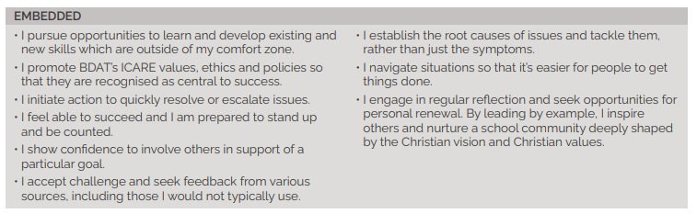

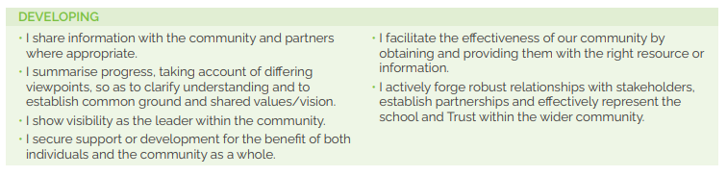
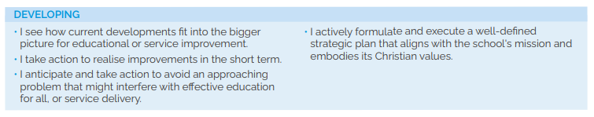

How to Find Us

MAP
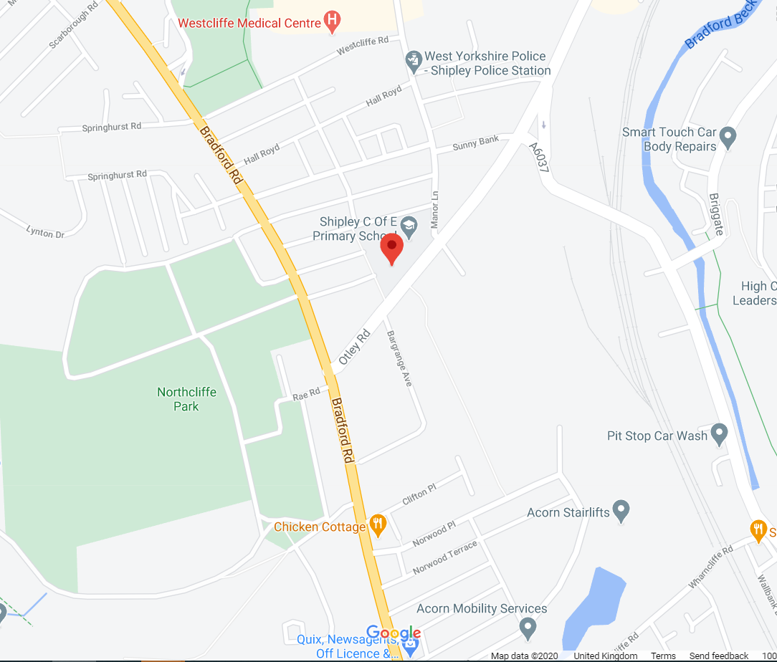


Otley Road, Shipley, BD18 2PT
T: 01274 583900
E: office@shipley.bdat-academies.org
W: shipleyceprimary.org.uk
X: @shipley_CE


2nd Floor, Jade Building, Albion Mill,
Albion Road, Bradford, BD10 9TQ
T: 01274 909120
E: info@bdat-academies.org
W: www.bdat-academies.org
Selection Process Guidance

Safeguarding

We are committed to safeguarding our pupils and will assess the candidate’s suitability for working with children as part of the selection process. We will check the accuracy of all information and investigate any perceived anomalies. We take up references prior to interview and use these to verify the information you have given us. Firm offers of employment are never made without satisfactory references. All potential employees are subject to an enhanced disclosure from the Disclosure and Barring Service.

Inclusion
As a Trust we are an inclusive employer. We welcome applications from candidates of all backgrounds, faith, ethnicities or with any protected characteristics. We are simply looking for the very best candidate for the job and will assess your application only on the information in your written application or your performance at interview should you be successfully shortlisted.

We will ensure that the selection process is fair and without discrimination for or against any candidate based on age, ethnicity, gender, religious beliefs, marital status, or sexual orientation. The person specification sets out the criteria used to assess candidates through the selection process.

Visits to the school
Visits to the school are warmly welcomed by prior arrangement, you will not be disadvantaged if you are unable to visit. Please contact school 01274 583900 to arrange a mutual appointment. The visit will give you an opportunity to ask questions about the role and the school to assess if this is somewhere you would like to work.

Applications
Applications can be made at, or via the school website https://mynewterm.com/jobs/146536/EDV-2025-SCPS-60823
We do not accept CVs as part of the selection process. Please ensure that you demonstrate how your experience and skills make you suitable for the position.

Shortlisting
We assess all applications against the person specification criteria using the evidence you provide in your application. This is done by a panel of senior staff and governors. We carefully check all applications for anomalies.
Candidates who best meet the person specification will be invited to an interview. We will notify you by telephone with e-mail confirmation to follow. If you have not heard from us within 2 days of the shortlisting date, you have not been successful at this stage.

References
We request references for all candidates who are invited to interview. Requests will be made at the same time that candidates are invited to interview. Your first referee should be your current or last, employer.

Interview Process
The interview process will take 1 day and will consist of an observation and formal interview. Candidates will be informed of the decision by telephone. Candidates must bring with them proof of their right to work in the UK.

Offer of Employment
We will make a verbal offer of employment by telephone on the day of the interview and this will be confirmed in writing. Any offer is made subject to:
- References satisfactory to us
- A satisfactory DBS check
- Provision of proof of identity and qualifications

