
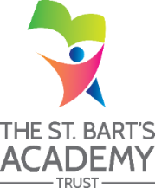
BART’S TRAINING AND SUPPORT ALLIANCE
Job Description

Job Title: | Midday Activitiy Assistant
Grade: | Level 2

JOB PURPOSE
To work as part of a team monitoring pupil behaviour during the midday break.
KEY DUTIES / RESPONSIBILITIES
- Supervise activities and maintain the health, safety, welfare, good conduct and safeguarding of pupils during the midday break, having regard to special or additional needs
- Report incidents in line with school policy
- Assist in the supervision of other activities during the midday break, including setting out and storing equipment
- Encourage pupils to select and eat healthy balanced meals
- Clean up spillages of food or liquid during meal service
- Wipe down tables and clean dining areas between meals
- Undertake similar work at other times, such as before and after school
- Be responsible for promoting and safeguarding the welfare of children and young people within the academy, raising any concerns following academy protocol/procedures
- Any other duties appropriate to the post.

BART’S TRAINING AND SUPPORT ALLIANCE
Person Specification

Job Title: | Midday Activity Assistant
Grade: | Level 2

PERSON SPECIFICATION
Minimum Essential Requirements - Evidenced by: a: application form b: test c: interview
 | a | b | c
Requires knowledge of school procedures for supervision of midday meals service and lunchtime activities.

