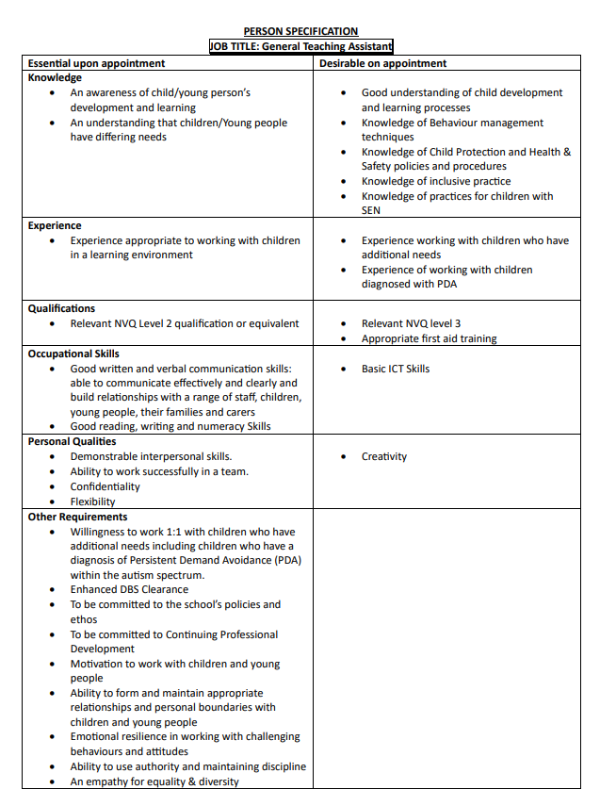



Recruitment Safeguarding Information

Richard Taylor CE Primary School and YCST takes safeguarding very seriously and are committed to safeguarding and the promotion of the welfare of all children and the prevention of extremism. We expect all staff and volunteers to share this commitment.

Online searches on shortlisted candidates will be undertaken prior to interview.

Successful applicants will be required to provide references, undertake an enhanced check through the Disclosure and Barring Service, and comply with the Safeguarding Policy and Child Protection Practices of St Peter’s YCST. Checks are also undertaken to verify identity, address, qualifications required for the post, right to work in the UK, previous employment history. For further information please contact the school office on admin@richardtaylor.ycway.uk

Yorkshire Causeway Schools Trust

Richard Taylor Church of England CE Primary School is part of Yorkshire Causeway Schools Trust, a growing multi academy trust which is currently comprised of nine schools in the Harrogate and Skipton areas. The Trust employs over 600 members of staff who together work to ensure the best possible outcomes for the 3,800 pupils within our schools. In addition to providing an education that is ambitious for all pupils, the Trust strives to be a good employer and prides itself on value and respect as the basis for all relationships. Yorkshire Causeway Schools Trust is committed to safeguarding and promoting the welfare of our pupils and young people. We have a robust Child Protection Policy, and all staff will receive training relevant to their role at induction and throughout employment with the Trust. We expect all staff and volunteers to share this commitment. This post is subject to a satisfactory enhanced Disclosure and Barring Service criminal records check for work with children.

Yorkshire Causeway has a strong commitment to achieving equality of opportunity in its academies and in the employment of staff. The post holder will ensure that Yorkshire Causeway Schools Trust meets it statutory obligations in relation to all aspects of equality legislation.

