
Woods Avenue, Hatfield, Hertfordshire, AL10 8NN
Telephone: 01707 276 504

Woods Avenue, Hatfield, Hertfordshire, AL10 8NN
Telephone: 01707 276 504


Southfield School
Candidate Information Pack
Midday Supervisor

Introduction
Due to expansion, we are looking to recruit a Midday Supervisor. Your role will be every day, two hours a day, to support the busiest, but most fun time of the school day. Children are at the heart of this role, so someone who is comfortable assisting with children doing physical tasks is going to be a great fit. The ideal candidate will have an enthusiasm for play, and who are willing to use their initiative to make the lunch break fun, enjoyable and safe for our children.

Contract Type
This is a permanent role, working term time only.

Start Date
We are looking to appoint as soon as possible.

Please note: If we receive a high volume of applications, we may close this advert early. Southfield School reserves the right to interview and appoint candidates on receipt of applications before the closing date. We encourage you to submit your application as soon as possible.

Salary
TBC

About the School
Southfield is a primary school for over 100 pupils with Learning Difficulties, which include, Autism, Speech Language and Communication Needs, Global Developmental Delay, and other conditions.


Admissions are via the Local Authority, and the present criteria is that children are accessing learning approximately 50% below their chronological age. We follow the EYFS and Key Stage 1 National Curriculum and adapt these to meet the individual interests and needs of our pupils. We do this through a 3 Phase curriculum that is presently being developed. Priority is given to communication, self-regulation, independence and functional Literacy and Maths. We use a wide range of approaches and strategies to support learning, including multi-sensory communication, social stories, TEACCH and Hertfordshire Steps. We also work with a range of professionals, from advisers in the Local Authority to Therapists and social care colleagues. Access to sporting and creative arts organisations, provide a range of enhanced learning opportunities, both in school and the local area.

Southfield is going through a period of rapid and exciting change, that you could be part of. It is a journey of challenge, in the pursuit of excellence, but one that provides huge rewards both personally, in your professional development and when you see the difference you make to the lives of our young people and their families.

About the Role
A Midday Supervisor is key to supporting our SEN children with area outside of their classroom. You will be working with teaching and catering staff to ensure that pupils enjoy a safe, happy and comfortable lunch and playtime.
The role will involve working as part of an established skilled team to support pupils with complex learning difficulties. It will involve supervising children in their outside play and in the dining room, promoting social and self-help skills. Some pupils will also require support with their personal care.
Experience of working with children with SEN would be an advantage as would a first aid qualification but is not essential as we will offer training. You will be required to attend training sessions / days when necessary to ensure pupils receive the highest quality care and support.

The school is committed to safeguarding children and young people.

More details of the job include supporting in the following areas:
Lunchtime
- Support for developing eating skills
- Support for developing table manners
- Support for developing social skills and communication
- Support for developing independence skills

Playtime
- Support for developing play skills
- Support for developing social skills
- Support for developing independence skills

Personal Care
Support pupils in all aspects of both independent personal care and support personal care to ensure the dignity and self-esteem of pupils is always respected.

Dining Room
- To assist where necessary with all aspects of ‘setting up’ the dining area
- To ensure the dining room is left clean and tidy at the end of lunchtime

About the Person
- Experience of working in an environment where there are children and young people would be desirable, but not essential.
- Experience of working with pupils with SEND would be an advantage.
- Knowledge of basic hygiene procedures.
- Ability to communicate effectively with children and adults.
- Ability to use your initiative.
- A good sense of humour.
- Excellent team working skills.
- A belief that all our pupils deserve the highest quality care and support.

A word from our Headteacher

Are you bored with life? Looking for a new challenge? Have a desire to work in an environment where you can make a ‘real’ difference to the lives of young people? If so, Southfield School is the right environment for you.
We are a family with over 100 pupils. No two students are alike, and no two members of staff are alike. Our pupils all have challenging ASD and associated conditions.
Our school vision is to support all children, so they thrive during their time at Southfield School and are prepared socially, emotionally, and academically for their next steps in education. Collaboration with parents and carers and the entire multi-disciplinary team who support our students is vital and key to our success.
Everyone plays a part in the future of our students with staff skills being used in order that we have a huge range of skill set and expertise. Everyone makes a difference to the lives of our students and families.
We are looking for like-minded, resilient staff who are passionate and who can work in a team.
If you have yet to find what it is that you were meant to do with your life – Southfield School may be what you have been searching for.

Come and join us and make a difference to the lives of children every day.

Angela O’Rourke
Headteacher

Our Vision and Values

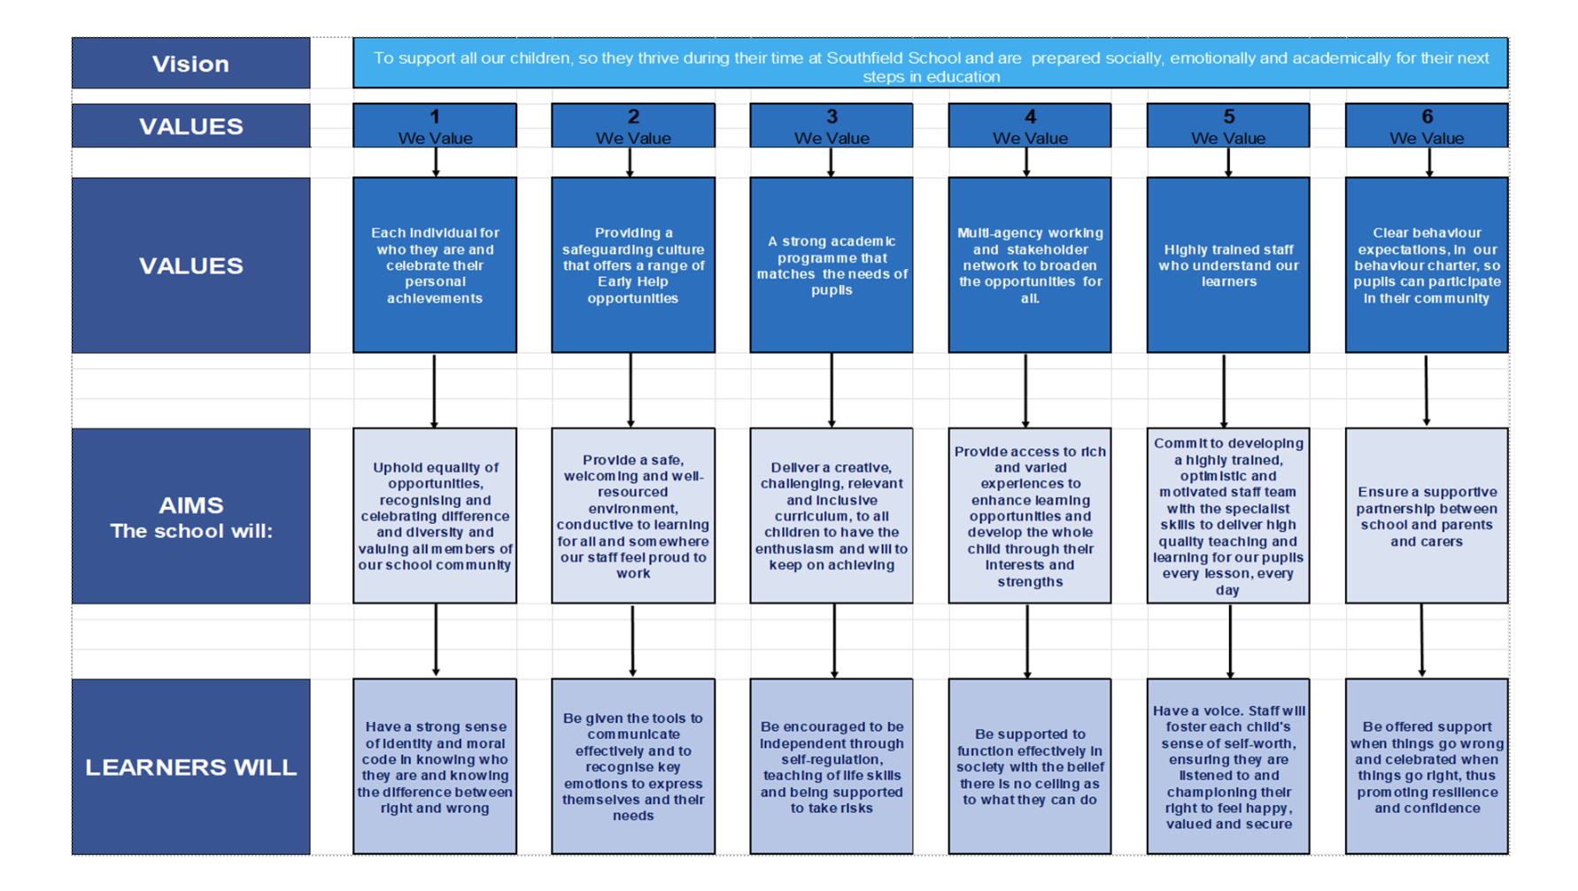
A Bright Future for ALL
Post Application Information
Equal Opportunities Monitoring Form
At Southfield School, we want our workforce to reflect the diversity of the community we
serve. It is our policy to ensure that job applicants and employees are treated justly, and are
recruited, selected, trained, and promoted on the basis of the job requirements, skills and
abilities. We will ensure that people are not disadvantaged by conditions or requirements, which cannot be shown to be justified as being necessary for the effective performance of
the job. You are under no obligation to complete this form, however if you do you are agreeing, under the Data Protection Act 2018 that Southfield School may hold and use personal information about you for monitoring purposes.

Safeguarding
Southfield School has a responsibility for and is committed to safeguarding and promoting
the welfare of children, young people, and vulnerable adults to ensure that they are
protected from harm. All conditional offers of employment are subject to the following pre-employment clearances:

Satisfactory Medical Clearance
All successful candidates complete a medical questionnaire and may be required to pass a
medical examination by the Southfield School.

Satisfactory References
It is the school’s practice to take up 2 references from your last two job references. Referees must not be a member of your family, or spouse/partner and the reference must be provided on letter headed paper or come from a work email address. If you are a recent school or further education leaver, one of your references must be from your school or college. Occasionally more than two references may be required, if this is the case, we will inform you before we contact former employers.
In line with our safer recruitment policy, we will take up references ahead of interview. Once we have received your references, we will call your referees to verify that the reference
is from them as part of the keeping children safe in education requirement. No employment
will be offered until 2 satisfactory references are received.

Rehabilitation of Offenders Act 1974
The Rehabilitation of Offenders Act 1974 makes it unlawful for prospective employers to
consider offences in relation to which the person concerned is deemed to be rehabilitated. This means that after a certain period (dependent on the seriousness of the offence
and length and severity of the punishment), the person concerned is to be assessed as if the conviction has been ‘spent’ (i.e. treated as if it had never occurred). Rehabilitation periods vary according to the type and length of conviction originally incurred. All posts within the school are covered by the Rehabilitation of Offenders Act (Exemptions)
Order 1975 and DBS clearance is required and therefore detail must be given about all
convictions, whether spent or not.

Disclosure and Barring Service (DBS) (Previously CRB) Clearance
As all posts require a DBS check, the successful candidate will be required to complete the
appropriate DBS documentation. The successful candidate will be unable to take up the
appointment until the clearance is received from the DBS. The timescale for these checks is
outside the Southfield School’s control.

Prohibition from Teaching
All teaching appointments are subject to a check with the Department for Education to
ensure that you are not subject to a prohibition order or an interim prohibition order.

Evidence of Qualifications
We will need evidence of the qualifications (original certificates) you specify in your
application form. Originals must be brought to the interview for candidates who have been
short-listed. Copies will not be accepted.

Eligibility to work in the UK
To comply with the Asylum and Immigration Act 1996 (As AMENDED) (Immigration, Asylum
and Nationality Act 2006), all employers in the United Kingdom are required to make basic
documentation checks on every person they intend to employ. We ask all short-listed applicants to provide proof that they can be legally employed. We must see satisfactory proof in the form of original documentation before we can confirm any
offer of employment. If we do not see satisfactory proof, an offer of employment can be
withdrawn.
The complete list of documents that may be accepted as proof of your identity, along with
information on the number and types required can be found below. There are three routes as outlined, however where possible, we encourage short listed applicants to produce
documents which adhere to Route 1 of the ID Checking process to avoid delays in the ID
checking process.

