


Welcome
Trent College is an independent co-educational boarding and day school, located in Long Eaton, Nottinghamshire. Founded in 1868, we have been providing a first-class education for over 150 years.
Set in a beautiful 45-acre campus we enjoy state-of-the-art facilities, including modern classrooms, sports facilities, and boarding houses. With traditional foundations and a modern outlook, Trent College is renowned for providing an excellent education for its 1,200 pupils.
The Elms is our Nursery and Junior School which provides a stimulating and nurturing environment to our youngest children, aged 6 weeks to 11 years. The two schools work closely together and share the same vision, aims and ethos. Together, we give the highest priority to the quality of our academic provision. Alongside a strong focus on sports, music, drama and a wide range of co-curricular activities to develop our pupils’ character and resilience, to prepare them for the modern world.
Rated ‘Excellent’ across the whole school by the Independent Schools Inspectorate in 2021, Trent College has a strong academic record, with a high percentage of students achieving top grades in their examinations and going on to study at some of the best universities in the UK and abroad.
We have highly qualified and experienced teaching staff who are committed to providing an excellent standard of education. We also have a large population of support staff, ensuring that our friendly school and beautiful campus operate to the very highest standards.

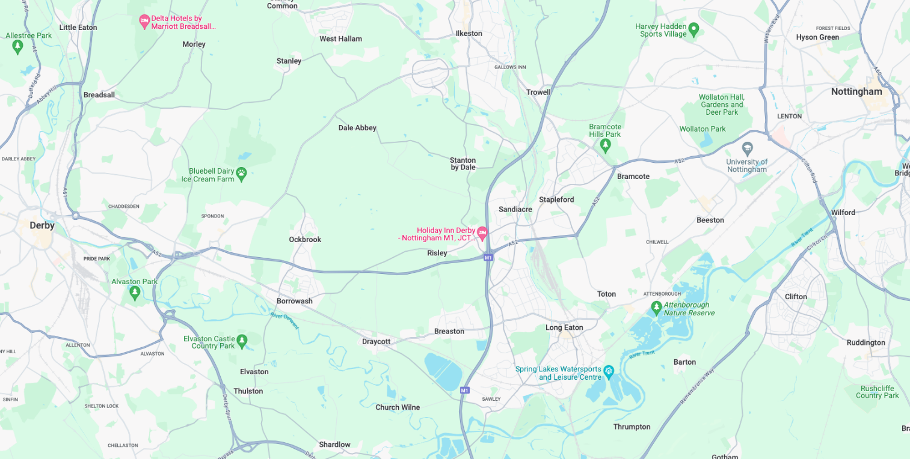
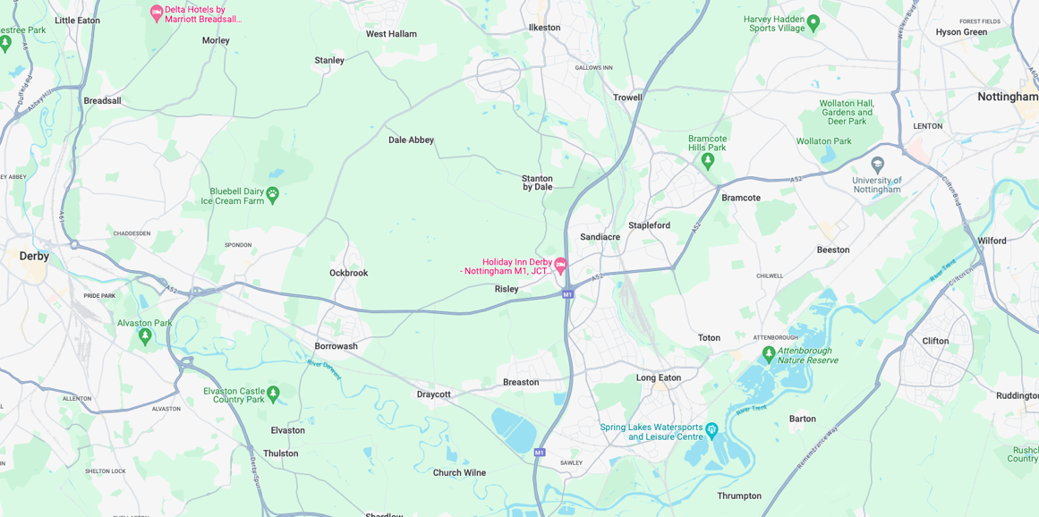


Our Location
Trent College and The Elms are conveniently situated on the border of Nottinghamshire and Derbyshire.
Ideally located at the heart of the UK’s motorway system, we are only 2 miles from junction 25 of the M1, which provides easy access to the M42 and A1.
Reaching Trent College by rail couldn’t be easier. Long Eaton boasts its own train station, located 1.5 miles from the schools. Rail routes through Long Eaton run along the Midlands Main
Line route, with direct routes to London, Loughborough, Leicester, Birmingham, Nottingham, Derby, Chesterfield and Sheffield.

Our Local Community
Working in partnership and serving the community are natural and very important values at Trent College and The Elms. We work with many local schools in Long Eaton and the wider Erewash borough to increase opportunities and aspirations, and to share the school’s excellent grounds, facilities and specialist staff.



Teacher of Physical Education and Games

Job Description
We are seeking a passionate and dedicated teacher of PE and Games to enhance the teaching of academic and practical Physical Education and the coaching of sport at Trent College and The Elms. The person appointed will join a team of experienced teachers led by the Director of Sport. Whilst the Director of Sport oversees the Department, some responsibilities are shared amongst members of the Department.

The ideal candidate will be able to deliver high-quality lessons in academic Physical Education, practical Physical Education and Games. The successful candidate will have a strong subject knowledge and the ability to engage and inspire students across all key stages at Trent College and The Elms.

Key Responsibilities

- Deliver high-quality teaching of academic Physical Education.
- Plan, prepare, and assess engaging lessons in line with curriculum standards.
- Coach school teams in our performance sports of netball, hockey, cricket, and tennis, contributing to regular training sessions and Saturday fixtures.
- Promote sporting excellence and participation across all ability levels.
- Support and mentor students in both academic and practical contexts.
- Work collaboratively with other members of the PE department to develop resources and share best practice.
- Assist in organising school sporting events, tournaments, and trips.



Pastoral Care

- In addition to the academic role, every teacher is encouraged to play a full role in the life of the school outside the classroom.
- Teachers are expected to attend and support regular school events, including but not limited to assemblies, drama productions, religious services, concerts and speech days.

Additional Duties

- This is not an exhaustive job description and may be subject to change according to the needs and development of the role. It is expected that the post holder may undertake such other duties as may be reasonably be requested.
- A Trent teacher is dedicated to educating the “whole child”, in accordance with the aims of the school.
- They are aware of the individual needs of each student and strive to help each student develop his or her full potential.
- They work with students both inside and outside the classroom and are committed to active involvement in the total school curriculum.
- They co-operate with colleagues to ensure a fully integrated curriculum and regularly participate in activities directed toward their own professional development.
- A Trent College teacher is always available to students, colleagues, and administration during the entire school day. In the time other than that scheduled for lunch, a teacher may be assigned activities such as supervision, tutorial, class coverage, etc. by the Head/ Deputy Head.

Person Specification
Education and Qualifications

- A degree in Sport Science, Physical Education, or a related field.
- A recognised teaching qualification (e.g. PGCE or equivalent).

Required Characteristics

- Experience in teaching academic Physical Education, including BTEC National in Sport, GCSE and A-Level PE qualification.
- Experience in the delivery of Girls’ PE and Games
- Excellent interpersonal and communication skills.
- A strong commitment to student development, wellbeing, and achievement.

Desirable Characteristics

- Experience in teaching and coaching netball, hockey, tennis & cricket.
- Experience working within an independent or high-performing school setting.
- Coaching qualifications in one or more of the listed sports.
- Experience organising inter-school competitions and sports tours.
- First Aid certification or willingness to train.
- A minibus driving licence or willingness to train.





Benefits
- Staff can enjoy complimentary lunches in the Obolensky Dining Hall during term time. Free car parking is available on site and staff have access to a cycle to work scheme.
- Staff are able to make free use of the school gym and leisure facilities at designated times.
- A defined contribution pension scheme is available to join, provided by AVIVA, with a generous employer contribution. Members also benefit from death in service and income protection.
- Enhanced sick pay and maternity pay is available to staff.
- Staff are entitled to a fee remission for children attending the school, In line with our policy.
- We provide a range of benefits to support staff, including counselling, an employee assistance programme and 24/7 online GP consultations.

Terms and Conditions
- Competitive salary.
- Permanent, full-time position.



Making an Application
Candidates who wish to apply for this post should complete the online application form.
If you have any questions about the role please email recruitment@trentcollege.net or telephone 0115 949 4949 (during term time).
The closing date for applications is included in the advert.
Interviews are scheduled to take place on the 20 May 2026.
We reserve the right to close this advertisement early if we receive a volume of strong and suitable applications.

The school is committed to safeguarding and promoting the welfare of children and young people and expects all staff and volunteers to share this commitment.
Applicants will be required to undergo child protection screening appropriate to the post, including checks with past employers and the Disclosure and Barring Service (DBS). The school may carry out online searches on shortlisted applicants and all applicants will be required to provide details of their online profile, including social media account names/handles, as part of their application
The post is exempt from the Rehabilitation of Offenders Act 1974. The school is therefore permitted to ask job applicants to declare all convictions and cautions on a self-declaration form in advance of attending an interview (including those which are "spent" unless they are "protected" under the DBS filtering rules) in order to assess their suitability to work with children.



