


Annual Report for Stakeholders
2022/23





Contents
FOREWORD FROM THE CHAIR OF TRUSTEES 3
INTRODUCTION FROM THE CEO 4
BACKGROUND 5
Our Vision, Values and KPIs 6
Waterton Academy Trust in Numbers 7
Our Academies 7
Waterton Pre-Schools - Embracing Early Excellence:
Nurturing Future Potential 8
Our New Special Academy 9
HIGH QUALITY EDUCATION 11
Trust Offer 11
Our Impact 12
Ofsted 12
Attainment in 2023 14
Behaviour 15
Attendance 15
Safeguarding 15
Enrichment 16
SCHOOL IMPROVEMENT 18
Trust Offer 18
School Improvement 18
Partnerships 18
WORKFORCE 19
Professional Development 19
Apprenticeships, Initial Teacher Training and
Early Career Support 20
FINANCE AND OPERATIONS 22
Trust Finance 22
Estates Developments in 2022/23 23
IT Developments in 2022/23 24
GOVERNANCE AND LEADERSHIP 25
Trust KPIs and Objectives 25
Objectives for 2023-2026 25
Governance 27
External Reviews of Governance 28
APPENDIX 1: BOARD OF TRUSTEES 29
APPENDIX 2: EXECUTIVE LEADERSHIP TEAM 30

Annual Report for Stakeholders 2022/23
2





Foreword from the Chair of Trustees
Dear Stakeholders,
As Chair of the Board of Trustees, it is with great pride that I present to you the Annual Report for Waterton Academy Trust for the academic year 22/23.
This document is not just an account of our business activities and financials, but rather a narrative of our journey, our challenges, and our collective achievements in an educational landscape that continues to offer challenges and opportunities in equal measures.
This year has been one of many collective successes and individ triumphs. Amidst an ever-changing educational environment, o commitment to providing exceptional learning experiences and f holistic development of our pupils has remained steadfast. The r and dedication shown by our staff, pupils, and the wider school c have been inspiring.
ual ur
ostering the esilience ommunity
Financially, we have maintained a strong and stable position. Our prudent financial management, coupled with the support from our school leaders has enabled us to continue investing in high-quality educational resources, our school estates and infrastructure, as well as the overall welfare of
our pupils.
Looking ahead, we remain committed to enhancing our educational offer, strengthening our external partnerships, and building on our successes. Our focus will remain on ensuring that success is a shared experience for all our pupils, colleagues and communities.
I extend my heartfelt thanks to our educators, support staff, pupils, parents, governors and partners. Your unwavering support and commitment to
our vision have been the cornerstone of our success. Together, we have established a strong foundation on which to build further success. I am excited about what the future holds for Waterton Academy Trust and look forward to another year of making a significant impact in the lives of our pupils.
With gratitude and anticipation,
Steve Johnson
Chair of the Board of Trustees Waterton Academy Trust

3 Annual Report for Stakeholders 2022/23





Introduction from the CEO
As the Chief Executive Officer of Waterton Academy Trust, it is with immense pride that I introduce our Annual Stakeholders’ Report for the academic year 2022/23. This report has been compiled in order to share with stakeholders our achievements and progress as a trust, and I hope you will find it both an informative and an enjoyable read.
In 2022 the Department for Education identified five pillars that define high quality trusts. As well as providing some general information about the trust, we have structured this annual report around these five pillars to provide insight and information about our
performance across all areas of our work. A summary of the five pillars is provided below.
High Quality Education: The extent to which the trust creates a culture in its schools that is motivating and ambitious for all children, including disadvantaged children and children with Special Educational Needs or Disabilities, so that every pupil can achieve their full potential. This includes the delivery of high-
WATERTON FIVE PILLARS
HIGH QUALITY EDUCATION
SCHOOL IMPROVEMENT
SKILLED WORKFORCE
FINANCE AND OPERATIONS
GOVERNANCE AND LEADERSHIP
quality curriculum, enabling positive behaviour and engagement, ensuring high levels of attendance, and offering strong pastoral support as well as enrichment opportunities. Ultimately, we look to ensure that pupils achieve good outcomes in all areas of
their education, as they leave our schools for the next stage of their education.
School Improvement: The extent to which the trust creates a culture of continuous improvement in schools through self-
evaluation, challenge, support, and appropriate action. This also includes how well the trust works with other partners to share practice and collaborate.
Workforce: The extent to which the trust creates a supportive working environment for all our employees, managing workload, prioritising wellbeing and taking action to support all staff. This also includes how well we develop our workforce, including training teachers and providing career progression.
Finance and Operations: This includes the extent to which the trust has a stable, accurate and sustainable long-term financial strategy, including effective budget setting and risk management. This also includes how the trust invests in our capital infrastructure and how we operate an effective reserves policy that provides sufficient contingency for cashflow and any urgent expenditure.
Governance and Leadership: This pillar includes how the trust boards and leadership teams create a culture of ethical leadership, including the seven principles of public life. This includes the role that
members play in ensuring that the board is made up of trustees with the necessary expertise to fulfil its functions effectively, and that it acts in accordance with the trust’s charitable objects.
Thank you for your continued support and working with us to help shape a brighter future for our pupils and our communities.
Warm regards,
Dave Dickinson OBE
Chief Executive Officer, Waterton Academy Trust

4 Annual Report for Stakeholders 2022/23





Background

Since its establishment in July 2014, with Walton Primary Academy as the founding school, the Trust has undergone significant transformation and growth over the ensuing nine years. Its expansion has been both intentional and methodically planned. The Trust has not merely increased in scale, but also in the breadth and depth of its educational provision.
Currently, the Trust extends across two key areas, Barnsley and Wakefield. During this period, we have carved out a reputation as a sturdy and dependable organisation, with a strong track record of having improved provision in every school that has joined us. This developmental journey underscores our dedication to
enriching educational experiences and nurturing robust connections within the communities we serve.

5 Annual Report for Stakeholders 2022/23

Our Vision, Values and KPIs








The Trust takes great pride in its unified vision and values, firmly believing that these principles are deeply ingrained in all our schools. This shared ethos forms the cornerstone of our identity and guides our actions and decisions. We are committed to not just espousing these values, but actively living them in our daily operations and interactions.
O
Our overarching goal is to cultivate an environment where
U
R

success is shared experience, encompassing every pupil, in every one of our schools , as well as every member of our staff. We envision a community where triumphs
are not isolated events, but a shared journey, with each accomplishment being a testament to our collaborative efforts. This vision extends to ensuring

Create a
Assemble
a collaborative of schools that strive to deliver excellence throughout
V
I
S
I
O
N

that every pupil, regardless of their background or abilities, experiences personal and academic growth. For every school, success means not just academic excellence, but also fostering a nurturing and inclusive environment where pupils and staff thrive.
For our employees, it’s about recognising and valuing
community where everyone reaches their full potential and where success truly
is a shared experience

Cultivate a
Establish an
environment where children enjoy and engage in a rich and relevant curriculum

their contributions, seeing their wellbeing, professional development and achievements as integral to the overall success of our educational mission.
By embracing this philosophy of shared success, we aim to build a strong, interconnected community where each achievement, no
culture of high aspiration, regardless of social, economic
or cultural background








matter how small, is acknowledged and appreciated, contributing to a culture of collective empowerment and progress.
3625 PUPILS
EDUCATED IN 14 ACADEMIES
SUPPORTED BY 590 EMPLOYEES
6 Annual Report for Stakeholders 2022/23





To be respectful
To be honest
To be dedicated
To be compassionate
OUR VALUES
To be trustworthy
To be tolerant
To be supportive
To be courageous

AT WATERTON ACADEMY TRUST WE HAVE

5
4 6 13
1
P P
WAKEFIELD

Our Academies
Our Trust specialises in high-quality early years education, primary education and specialist provision. As we have grown, we have been careful to ensure that our academies are able to work together in hubs, which have been created around geographical areas. These hubs have
been designed specifically to enable more meaningful school to school collaboration and facilitate professional development
and support.
In our approach, the organisation of these hubs is not
defined by Local Authority (LA) boundaries, but rather by the

2 3
C 7

14 O
8

BARNSLEY

10 12
9 P
^{P} 11

15




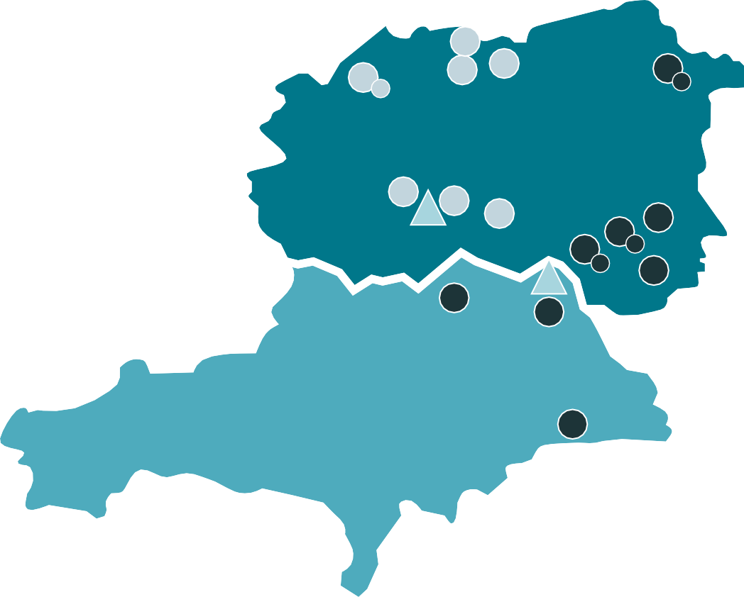
practicality of geographical proximity. This model is adaptable and scalable, allowing for the potential establishment of further hubs in our partnership areas.
C: Centre for Excellence
O: Operations Office
1: Wrenthorpe Academy & Pre-School
2: Sharlston Community School
3: Walton Primary Academy
4: Normanton Junior Academy
5: Lee Brigg Infant and Nursery School
6: Normanton Common Primary Academy
7: Crofton Infant’s School
8: Churchfield Primary School
9: King’s Meadow Academy & Pre-School
10: West End Academy & Pre-School
11: South Kirkby Academy
12: Ackworth Mill Dam School
13: Cherry Tree Academy & Pre-School
14: Newstead Academy
15: Kings Oak Primary Learning Centre
The map illustrates the locations of our academies. Number 15 is Kings Oak Primary Learning Centre, a school which has been granted permission to join Waterton Academy Trust.
The blue triangles on the map represent the central offices of our trust. These include our Centre for Excellence, located in Walton, Wakefield, and our Operations Offices situated in Cudworth, Barnsley. These strategic locations ensure efficient management and oversight of our trust’s operations and educational offer.

Academy Name | Joined | Type | PAN | LA | Hub
Walton Primary Academy | Sept 2014 | Primary | 315 | Wakefield | West
Normanton Common Primary Academy | March 2015 | Primary | 315 | Wakefield | West
Normanton Junior Academy | Aug 2015 | Junior | 360 | Wakefield | West
Lee Brigg Infant & Nursery School | Oct 2015 | Infant | 135 | Wakefield | West
Crofton Infant School | Dec 2015 | Infant | 180 | Wakefield | West
Sharlston Community School | July 2016 | Primary | 315 | Wakefield | West
Wrenthorpe Academy | April 2017 | Primary | 315 | Wakefield | West
Cherry Tree Academy | April 2017 | Primary | 315 | Wakefield | East
South Kirkby Academy | Sept 2016 | Junior | 240 | Wakefield | East
Ackworth Mill Dam School | July 2017 | Primary | 210 | Wakefield | East
Kings Meadow Academy | July 2018 | Primary | 315 | Wakefield | East
West End Academy | July 2018 | Primary | 210 | Wakefield | East
Churchfield Primary School | Dec 2019 | Primary | 420 | Barnsley | East
Newstead Academy (Special) | Sept 2023 | Special | 35 | Barnsley | East

7 Annual Report for Stakeholders 2022/23



Waterton Pre-Schools
R
T
O
N
W
A
T
E
In order to support our communities and ensure that our children get the best of starts to their educational journeys, the trust has opened four pre-school settings and has plans
to open more in the coming years. These pre-schools are a beacon of excellence in early childhood education, led by an Executive Headteacher and National Leader of Early Years Education.
Waterton Pre-Schools now operates 4 pre-schools.
The Meadow Pre-School at King’s Meadow Academy The Woodland Pre-School at West End Academy
Cherry Blossom Pre-School at Cherry Tree Academy
Wrenthorpe Pre-School at Wrenthorpe Academy (inspected by Ofsted in October 2022 and judged to be good in every area)

AT WATERTON PRE-SCHOOLS WE HAVE




151 PUPILS

Impact

EDUCATED AND CARED FOR IN 4 SETTINGS
SUPPORTED BY 27 EMPLOYEES



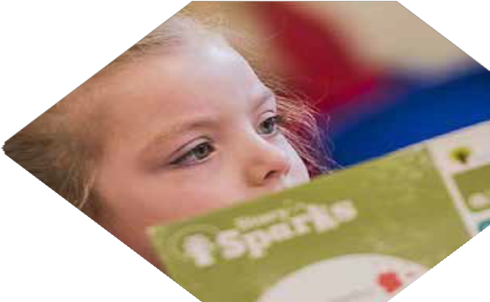
Our pre-schools aim is to provide parents with peace of mind and convenience. By opening pre-schools within the school premises, parents who already have children in the school benefit from a unified drop-off and pick-up point. This arrangement will ease daily routines and strengthen family ties.
The pre-schools are also able to specialise in preparing children for a seamless transition to school. Children will become familiar with the school environment, routines, and expectations, easing the transition into Reception. This familiarity will promote a sense of security and belonging, key components for successful early learning.
Through our expert-led curriculum, children develop essential skills and knowledge, laying a strong foundation for their educational journey.
Our focus on holistic development — encompassing emotional, social, physical, and intellectual development — ensures children are well- prepared and confident as they progress into primary education.
Parents who experience the high-quality early years education we offer are more likely to continue their child’s education within our schools and benefit from all that a Waterton Academy can offer their children.

8 Annual Report for Stakeholders 2022/23

Our New Special Academy
This term we celebrated the official opening of Newstead Academy. This marks a significant milestone for the academy, which has seen remarkable progress and positive developments in its early stages. Since its inception, Newstead
Academy has been a beacon of hope and excellence for pupils with Communication and Interaction needs,
building on the strength of our other specialist provision housed in Churchfield Primary School.
The children have settled in seamlessly, creating a positive
atmosphere that has paved the way for an increase in student
numbers after half-term.
The progress made by the pupils has been nothing short of phenomenal, filling the hearts of the staff with immense prid
e.
We have had some great parental feedback and a high level of interest
from prospective parents also.

Thankyou to the staff for going above and beyond everyday.
Parent of Newstead Academy student




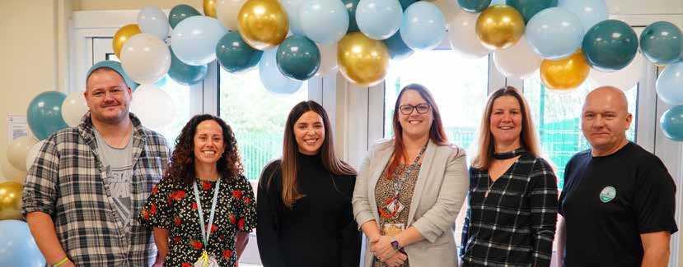



9 Annual Report for Stakeholders 2022/23

Our New Special Academy
A testament to the Academy’s success is the recent participation of two of its students, Archie and Emily, in Waterton’s Children’s Parliament. This event brought together
representatives from all Waterton academies, providing a

platform for young voices to be heard. Archie, a school councillor at Newstead, has made an incredible journey, re-joining education after a two-year gap and now shining as a representative of his peers. Emily, who faced challenges in a mainstream setting, is now thriving at Newstead; her experience at the Hepworth museum during the parliament event being
a highlight and a first for her.
Children’s Prime Minister and Deputy Prime Minister

Parental support and feedback have been overwhelmingly positive, with strong relationships being built. Even though many children arrive via transport, the Academy ensures constant communication
through the Tapestry app, sharing news and updates wid
ely with the parental community.

I know he is enjoying school and the change in [my child] around school is honestly nothing short of amazing and that’s absolutely down to the staff and the school.

I can’t wait for [my

The passion from staff to get the very best from the children is really evident.

child] to start, this is exactly what we have been wanting and he is going to do so well here, I can feel it.
I can’t believe the change in the boys since they have started, they are so much calmer at home and beginning to use more and more words which is incredible.




Newstead Academy stands as example of progress, inclusion, and excellence in education, ready to embrace the future and continue making a positive impact on the lives of its pupils and the wider community.
a shining

10 Annual Report for Stakeholders 2022/23

High Quality Education

Trust Offer
As a trust, Waterton has statutory and ethical obligations in relation to supporting our academies, and we look to meet these through the delivery of our Trust Offer. The trust has invested significantly in creating a substantial central team, and it is through this team and key external partners that the trust offer is delivered.

School Improvements

Finance SEND

^{HR} TRUST OFFER
Pre-school




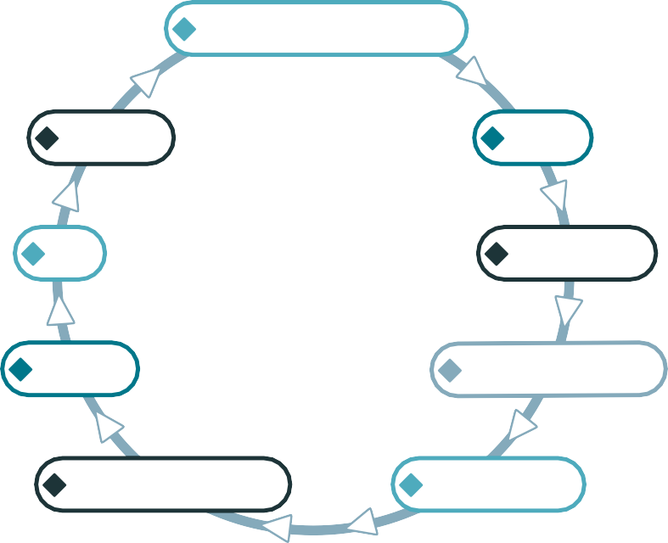

Estates Adult Education

Business Support Governance

To support its aims and meet its obligations, the trust provides each of its academies with access to the same trust offer. The offer is categorised into two main areas, the operations offer and education offer. Access to the trust offer is an entitlement regardless of current Ofsted rating, financial position, size, or provision status. The level of support provided
is tailored according to current need, however the entire offer remains accessible to all academies at all times.
At the heart of our offer is our commitment to ensuring that our academies can concentrate on their primary role of delivering outstanding teaching and learning through evidence-based practice. Our offer therefore looks, wherever possible, to drive school improvement through professional development, challenge and support, whilst simultaneously removing the business-based burdens that prevent headteachers and senior leaders from being in the classroom or involved in school improvement work.
The trust offer provides a range of services delivered or procured centrally in order to provide our academies with the best possible value. Central support is provided in the key areas of Safeguarding, Governance, School Improvement, Finance, HR, IT, H&S, Estates Management and Data Protection. The delivery of the core offer brings with it a cost that is incorporated into each academy’s operational budget and is an integral part of not only the Waterton funding model, but more importantly, the school improvement model.

11 Annual Report for Stakeholders 2022/23




Our Impact

Ofsted
As a group of schools, we have undergone sixteen Ofsted inspections. The table below demonstrates how each school has improved since they joined the Trust. The table illustrates that we’re good at helping schools improve and more importantly maintain high standards.

Academy Name | Date of conversion | Ofsted at conversion | Rating at conversion | Current Ofsted (Academic Year Inspected)
Ackworth Mill Dam School | July 2017 | Good | Requires Improvement | Good (2021-22)
Cherry Tree Academy | April 2017 | Inadequate | Inadequate | Requires Improvement (19-20)
Churchfield Primary School | Dec 2019 | Good | Good | Predecessor School Good
Crofton Infant School | Dec 2015 | Good | Requires Improvement | Good (2018-19)
Kings Meadow Academy | July 2018 | n/a | Inadequate | Requires Improvement (2022-23) - with good for behaviour and EYFS
Lee Brigg Infant & Nursery School | Oct 2015 | Outstanding | Outstanding | Outstanding (2021-22)
Newstead Academy (Special) | Sept 2023 | n/a | n/a | Pre-opening Inspection
Normanton Common Primary Academy | March 2015 | Good | Good | Good (2018-19)
Normanton Junior Academy | Sept 2015 | Inadequate | Inadequate | Good (2022-23)
Sharlston Community School | July 2016 | Good | Good | Good (2018-19)
South Kirkby Academy | Sept 2016 | Good | Requires Improvement | Good (2022-23)
Walton Primary Academy | Sept 2014 | Good | Good | Good (2021-22)
West End Academy | July 2018 | Good | Good | Good (2018-19)
Wrenthorpe Academy | April 2017 | Good | Good | Good (2018-19)

12 Annual Report for Stakeholders 2022/23





Ofsted comments
The part that the trust plays in these ongoing improvements is recognised by Ofsted, as illustrated by the comments below.
All staff feel part of an inclusive team because of the extensive support they receive from leaders in school and the trust. Lee Brigg 2021
The trust’s structured systems of regular review provide strong accountability for school leaders and effective support for school improvement. Normanton Common 2019
The trust provides rigorous support and challenge to leaders. Walton 2017 The trust provides challenge and support for leaders. Wrenthorpe 2020
Pupils have many opportunities to join a variety of groups that help to improve the school. For example, the trust’s ‘Children’s Parliament’ selects pupils to work together to promote sustainability. Normanton Junior Academy 2023
The trust provides effective leadership support where necessary. This has enabled the school to continue to improve. Sharlston 2019
The trust has provided the school with strong support. West End 2019
Pupils participate in ‘Waterton’s Got Talent’, ‘Waterton Chef of the Year’ and a variety of sporting competitions, including The Waterton Trust games. South Kirkby 2023

Three of our schools received positive Ofsted inspections in the last academic year.
South Kirkby Academy – in April 2023, South Kirkby Academy moved from previously ‘Requiring Improvement’ to achieving Good in every aspect of their work. The inspection report highlights the strength of leadership and the ambition that the headteacher and his team have for the success of every pupil.
Kings Meadow Academy – in September 2022, the school received its first inspection since joining Waterton Academy Trust. The school was judged to ‘Require Improvement’, but
with the strength in Early Years being recognised as ‘good’, as well as Behaviour and Attitudes. Given the school joined the trust with provision judged to be inadequate, we are pleased with the progress the school has made and
look forward to the next inspection when we believe the school will be judged as good overall.
Normanton Junior Academy – The school joined Waterton in 2015 after a number of inadequate Ofsted judgements.
In 2018, the trust secured the school’s first good judgement. This success has been built upon and in July 2023, Normanton Junior Academy was inspected.
The school continues to be a good school, with many strengths being recognised in the report – including provision for pupils’ wider development.

13 Annual Report for Stakeholders 2022/23

Attainment in 2023

Early Years
69% of pupils achieved a Good Level of Development (GLD) across the trust, which is above the national average for 2022 (65%)
and represents an increase in trust outcomes compared to 2022. We believe the quality of education in our Early Years to be extremely strong and improving year on year.

65%

NATIONAL 2022

67.7%

WATERTON 2022
69%

WATERTON 2023

79%

NATIONAL 2022

86.5%

WATERTON 2022

87.8%

WATERTON 2023

Year 1 Phonics
87.8% of pupils passed the phonics screening check in 2023, which is significantly higher than the national average for 2022 (75%) and represents a 1% increase in trust outcomes compared to 2022. We have invested heavily in the development of early reading across all our academies over the last few years and believe this to be an area of significant strength at Waterton Academy Trust.

Key Stage 1
Outcomes at the end of KS1 remain above national averages in all three core curriculum areas (Reading, Writing and Maths). Key Stage 1 continues to improve year on year, in all three subjects. The vast majority of our schools achieved outcomes which are in line with or above national averages for Reading, Writing and Maths.

76%

68%

68%
71%

60%

61%

63%
70%
72%

NATIONAL 2022
WATERTON 2022
WATERTON 2023
NATIONAL 2022
WATERTON 2022
WATERTON 2023
NATIONAL 2022
WATERTON 2022
WATERTON 2023




READING WRITING MATHS

14 Annual Report for Stakeholders 2022/23

Attainment in 2023

Key Stage 2
Outcomes in 2023 at the end of KS2 across the trust were in line with what we were expecting for most schools and subjects. Overall, 55% of pupils achieved the combined standard (Reading, Writing and Maths) in Waterton schools which
is just below the national average. The majority of our schools were in line with

73%

NATIONAL 2022

71%

WATERTON 2022

62%

WATERTON 2023

71%

NATIONAL 2022

75%

WATERTON 2022

75%

WATERTON 2023

or above the national average in the combined standard in 2023. Since 2022

73%

READING WRITING

we have sustained our attainment in Writing and made a small incremental improvement in Maths outcomes, however Reading is an area where we expect to see improvements in 2023- 24 as our Reading curriculum becomes further embedded. This is the first time in the ten year history of the trust that combined outcomes have been below the national average and we are confident that we will return outcomes

NATIONAL 2022
68%

WATERTON 2022
68%

WATERTON 2023

59%

NATIONAL 2022

59%

WATERTON 2022

55%

WATERTON 2023

for 2023/24 that are much improved.

Behaviour

MATHS COMBINED STANDARD

Over the past three years we have been working closely with several of our schools to further improve standards of behaviour. This has included ensuring schools access the work of the DfE Behaviour Hubs where appropriate. The trust has had no permanent exclusions in the last three years, and for the vast majority of our schools suspension rates are in line with or below the national suspension rate for the primary phase.

Attendance
Our aim is to ensure that our schools are places

where children attend regularly. We employ a full-time Education Welfare Officer who supports all our schools with evaluating the impact of the schools’ policies, procedures, and strategies to improve attendance.
Pupil attendance in 2022/23 improved by 0.3%
94%

NATIONAL 2022/23
93.8%

WATERTON 2022/23
23.2%

NATIONAL 2022/23
18%

WATERTON 2022/23

from 2021/22.

Safeguarding
ATTENDANCE PERSISTANCE ABSENCE




During 2022-23 all our schools received an external safeguarding audit. In summary, all of our schools are fully compliant in relation to safeguarding, and the majority of schools exemplify best practice in the quality of safeguarding practices demonstrated during the audit.

15 Annual Report for Stakeholders 2022/23

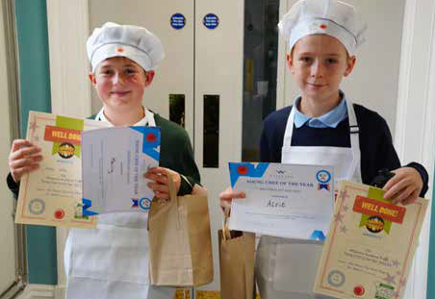

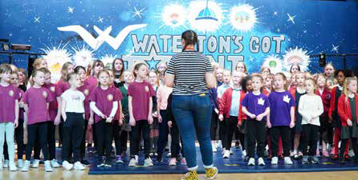


Attainment in 2023

Enrichment
The trust operates in some of the most underprivileged areas in the region, and indeed in the country. Some of our schools are situated in areas of high deprivation. As a trust we value and prioritise pupil voice, pupil health and well-being, as well as curriculum enrichment across the trust. By placing pupils’ voices at the forefront of our work, we ensure that their unique perspectives, needs, and concerns are not only heard but also integrated into the decision-making process, fostering a sense of ownership and empowerment.
We provide a range of opportunities for children to participate in, designed to enhance their experience of education in a Waterton school. This includes our elected Children’s Parliament, who meet with the Trust Board, CEO and Headteachers to discuss their priorities for improvement. The parliament received a letter of commendation from the former Prime Minister, Theresa May, congratulating them for their outstanding work. Creativity is fostered through our arts network. Our roaming art gallery and our annual ‘Waterton’s Got Talent’ event offer all our schools the opportunity to showcase the work and talents of our pupils. This fosters creativity, and also engages parents and carers in celebrating the work of pupils across the trust. To promote healthy lifestyles, children are given multiple opportunities to compete in sporting events, including an annual gathering of all schools at our MATlympics event. Healthy lifestyles and nutrition are also promoted and encouraged through our Waterton Young Chef of the Year competition. Such experiences not only enrich our pupils’ academic journeys ,but also contribute to their personal and social development. A snapshot of recent initiatives can be seen below.

KS2 Young Chef

KS1 Young Chef

Waterton Has Talent

Art initiatives

16 Annual Report for Stakeholders 2022/23



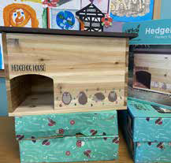
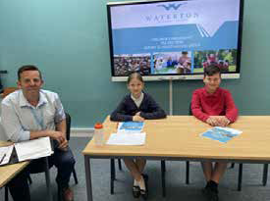


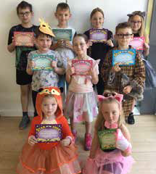

Snow Day Competitions

Fundraising - Dress
Like an Animal Day

Sports Fixtures
Child led initiatives: Hedgehog Houses

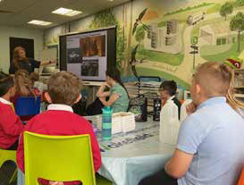


Waterton Eco Council

for MND
Fundraising

Girls Football

Children’s Parliament

MATlympics

Our aim is to ensure that every pupil in every Waterton school feels the benefit of being part of the trust, with their learning and experience of school being our number one priority.

17 Annual Report for Stakeholders 2022/23





School Improvement

Trust Offer
Central to our work with schools is the pledge to enable all our schools and their leaders to focus on their fundamental mission of delivering exceptional
teaching and learning grounded in evidence-based practices. This is achieved by striving to facilitate school improvement through continuous professional
development (CPD), challenge and support, while concurrently alleviating the administrative and business-related burdens
that can distract headteachers and senior leaders from classroom engagement and school improvement initiatives.

School Improvement
We know that sustainable and successful school improvement is achieved when school leaders are empowered and supported as agents of change. All our school leaders are active partners in the trust strategy for school improvement, contributing their own experiences as well as using research and evidence to drive improvements. Our approach to school improvement is founded on a clearly articulated shared moral purpose. We exist to make schools better places to learn and work; our core purpose is to transform the lives of the children and young people we serve through the
power of education.
We ensure that we have a balance between ‘quality assurance’ activity and activity that is ‘improvement’ focused and developmental. We challenge ourselves by asking what
impact our actions have on pupil outcomes, classroom practice and leadership capability.
Regular meetings between the CEO, the Deputy CEO and headteachers, as well as school visits, take place. Together, these visits and meetings review the progress all our
schools are making as set out in the school development plan, based on an accurate self- evaluation. To support school self-evaluation the trust brokers a series of reviews using
a combination of internal expertise and external support, in order to help us identify strengths in the trust as well as areas where development and improvement are needed.
We believe that schools should not be isolated but should, in a spirit of mutual benefit, welcome scrutiny and support from other schools (within and beyond the trust) as part of their contribution to a connected system. That is why our school leaders are active as peer reviewers, supporting one another in reaching our ambitious goals.

Partnerships
We are an outward-facing organisation dedicated to working in partnership with others to play our part in the system. We are driven by a shared commitment to school improvement and professional development, and over time have cultivated a number of important partnerships which not only contribute to improvement in Waterton academies, but also to the wider system.

18 Annual Report for Stakeholders 2022/23






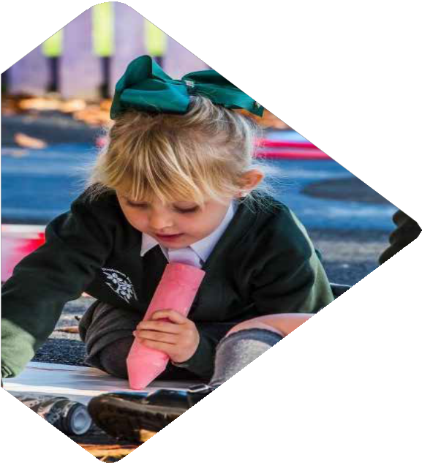
Workforce

Professional Development
By offering ongoing training, workshops, and access to external courses, we actively encourage our employees to enhance their skills and knowledge, build their professional
networks, and take an active role in the work of the trust. We continue to employ technology effectively to provide access to online training and networking, but we
balance this well with opportunities for face-to-face professional development at our training suite in the Centre for Excellence at Walton, as well as on-site in
our schools.
We support teachers and support staff in pursuing additional qualifications or certifications related to their roles. For example,
we are an approved apprenticeship provider and have been able to offer the level 3 teaching assistant qualification to all
our teaching assistants, as well as to schools and trusts externally. We also provide access to accredited
online professional development for all our staff in relation to statutory training and refresher training.
In addition, there is a significant percentage of our workforce currently enrolled on a range of the current
National Professional Qualifications (12.9%), which is an increase from previous years and demonstrates our
commitment to staff development.

19 Annual Report for Stakeholders 2022/23

Apprenticeships

Waterton Apprenticeships in 2022/23
In 2021, in response to organisational and local need, Waterton Academy Trust gained accreditation and began to deliver the L3 Teaching Assistant Apprenticeship. The program of training is research driven, evidence based and is externally quality assured
I really enjoyed the learning experience and have been able to put so much of the learning into practice. It does make you realise how important we are to the children. Learner

to ensure the highest possible standard. Training is developed and delivered by experienced senior leaders, all of whom are qualified teachers with a very strong understanding of good classroom practice.

Learners have become more proactive in their approach to the role, seeking out new strategies to help engage and support pupils. Headteacher

steady and appropriate pa embed into their practice.
Our first cohort of learners have all completed their training, with 14 Waterton colleagues and 6 external learners passing their
End Point Assessments between November 2022 and May 2023. Our second cohort, made up exclusively of Waterton staff members, are approaching the end of their apprenticeship. This is a group of 13 colleagues from 7 schools. Delivery to a small, consistent group has worked very well with extremely positive relationships in place between peers and the delivery team.
The program has been adapted for the second cohort, streamlining the training to 8 sessions delivered over 8 half terms. This is a
ce for trainees, who then take their learning back to classrooms and

Apprentices receive current and relevant high-quality training that improves the effectiveness of the support that they provide for their pupils in the classroom. Ofsted




20 Annual Report for Stakeholders 2022/23

Partnership with Nexus Multi-Academy Trust
In 2022-23 we developed a partnership with Nexus Multi-Academy Trust to begin to deliver the Teaching Assistant Level 3 Apprenticeship program to 21 of their teaching assistants who specialise in Special Educational Needs and Disabilities (SEND). We plan to delivery further cohorts and new apprenticeship programs, broaden our engagement with Nexus, and seek new partners to further diversify our offer to the wider system. This aligns with our strategic goal of enhancing educational opportunities for all schools in Wakefield and Barnsley.
Our Apprenticeships Offer in Numbers

WE HAVE




PROVIDED TRAINING TO COLLEAGUES IN 28 SCHOOLS
A 100% PASS RATE TO DATE, WITH 95% ACHIEVING A
DISTINCTION IN THE OBSERVATION OF PRACTICE
TRAINING HAS IMPACTED UP TO 2400 WATERTON PUPILS SINCE THE LAUNCH IN 2021




Initial teacher Training and Early Career Support
We place a strong emphasis on the professional development of Early Career Teachers (ECTs). We know that teachers early in their career really benefit from ongoing support as they refine their practice in the classroom and as such we have employed a dedicated ECT support leader. Over recent years, as a trust we have invested centrally in the capacity to train teachers – working with Leeds
Beckett University we have trained 55 teachers - as well as supporting teachers who are employed in our schools during their first few years in post.

WE HAVE
PROVIDED INITIAL TEACHER TRAINING TO 8 TRAINEE TEACHERS, AND SUPPORTED 15 EARLY CAREERS TEACHERS
IN THEIR FIRST OR SECOND YEAR
OF TEACHING IN OUR SCHOOLS.

21 Annual Report for Stakeholders 2022/23




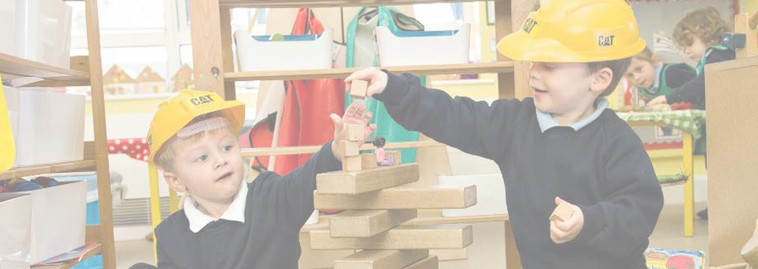

Finance and Operations

Trust Finance
The trust remains in a strong financial position, having managed the most challenging years in the education sector, due to unprecedented pay awards for both teaching and support staff; falling pupil rolls; shortfalls in Early years funding; and the ‘cost of living crisis’. As a result, the trust has suffered a reduction in our consolidated reserves, the first since the trust was established. Prior to this, our reserves increased year on year, and this has enabled the trust to invest further in the IT infrastructure, building maintenance and capital projects. Despite the ongoing challenges, we should still return a consolidated reserve position of approximately
£1.5m at the end of 2022/23, which equates to 9.46% of General Annual Grant (GAG) funding, which is the annual funding we receive from the government.
To manage these difficulties, challenging decisions have had to be made, including staffing restructures, spending reviews and a drive on cost efficiencies across the board. These actions have resulted in the trust operating as lean as possible. We are a forward-thinking trust and given the recent external cost pressures, will continue to maintain an appropriate level of reserves.
The trust receives School Condition Allocation (SCA), a capital funding grant to maintain and improve the condition of school buildings and grounds. To prioritise spending and target those schools most in need, condition surveys were commissioned; these reports provided us with a full understanding of the trust estate and any areas of risk. Proposed capital works and larger scale projects are included in our Asset Management Plan (AMP) in the short, medium, and longer term.
The Chief Operations and Finance Officer presents annual budgets to trustees for approval, prior to submission to the ESFA.
Robust budget monitoring procedures are in place to ensure that all individual school budgets remain on target and monthly management accounts are provided for trustees. Budgets are reforecast during the year as necessary.

22 Annual Report for Stakeholders 2022/23






Estates Developments in 2022/23
In 2022/23 school year, our estates team has worked hard to make it easier and simpler for all schools in the trust to handle repairs and maintenance. We’ve categorized these
tasks as Emergency, Essential, or Improvement, making it clearer
for everyone. This new system has been applied to all schools, giving headteachers better visibility into the work being delivered
and associated costs.
The trust estates team now provide a maintenance service. These colleagues handle some repairs in-house instead of immediately going to an outside contractor, which has greatly reduced our expenses on contractor call-outs.
In September 2022, a new contractor for compliance servicing and maintenance was secured. Our schools have high compliance levels, and with the support of the new SLA holder some long-standing issues have been resolved.
Additionally, we simplified our cleaning services by moving to a new provider. As a result of this successful change, services with the provider have been extended to include caretaking services for the trust in September 2023. This integrated approach has given us a more robust and well-managed facilities service for the entire trust.
In 2022/23 several high value projects have been delivered by the Estates team, including: Refurbishment of a disused Barnsley community building to create Newstead Academy; Full LED lighting upgrade to nine of the schools within the Trust;
Refurbishment of four new Waterton Pre-schools;
£3 Million decarbonisation pilot project at West End Academy with full new ground source heating system installed;
Re-pipe of central heating system at Kings Meadow Academy;
New central heating boilers fitted at Sharlston Community School; and New library created at Walton Primary Academy.
Our Estates team are currently supporting the central leadership team as we plan to deliver a new school to our Sharlston community under the Government’s Schools Rebuilding Programme.

23 Annual Report for Stakeholders 2022/23




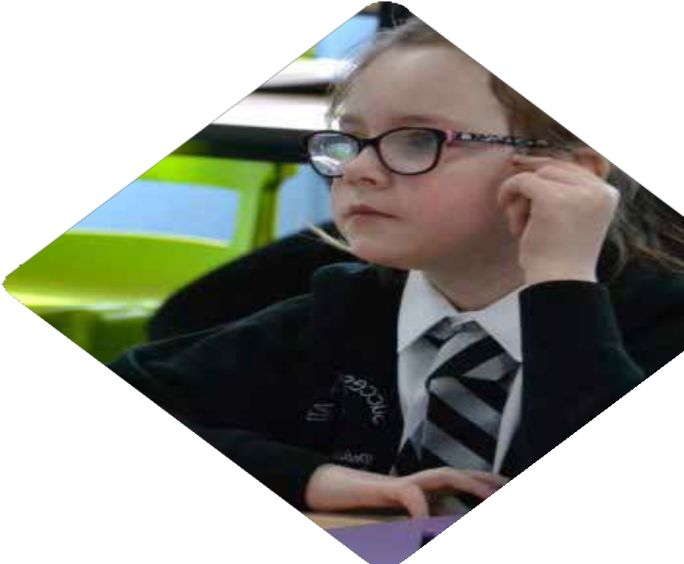
IT Developments in 2022/23
2022/23 has seen the Trust continue to drive forward advancements in ICT standards across all our schools and the central team. A key objective for all areas has been the move away from old technologies and making significant progress toward becoming a “cloud first” organisation.
We feel that have achieved this by investing in critical infrastructure, hardware and professional development.
Some key highlights include:
We have worked closely with EdTech leaders across all our schools to create a consistent approach to delivery and access to
Edtech resources and the curriculum. All our schools now have access
to online platforms and technologies that were not previously universally available. The Edtech group ( teacher from across the trust) are currently working on innovations to the IT curriculum.
The Trust has launched a new online portal that will provide a cloud based experience for all stakeholders. We have developed a cloud based staffroom, governor space and are currently developing further Edtech teaching and learning opportunities for pupils. This work will be built around our current Microsoft cloud platform.
Every parent now has access to the My Child at School App. The app is an extension of our MIS software and ensures parents are kept up to date with developments. The app allows parents to communicate directly with schools, facilitating payments for lunches and trips and much more. We aim to continue to develop this service throughout the coming year.
Many of our schools and settings have transitioned to a fully cloud based telephone system. This project is ongoing and over the coming year all our schools will be operating entirely in the cloud. By using cloud telephony, we not only save energy, but also benefit from the advances and flexibilities that these systems now offer.
11 out of 14 school of our schools have moved on to a much faster and reliable broadband arrangement. The remaining 3 will be transferred over by March 2024. This represents phenomenal progress towards meeting. the new DfE standards for school connectivity.
Walton Primary Academy is the latest of our schools to move away from the traditional fixed ICT suite model having successfully introduced a mobile ICT offer for pupils. The School’s PTA were instrumental in creating this opportunity. We will continue to invest in mobile technologies in all our schools over the coming year.

24 Annual Report for Stakeholders 2022/23

Governance and Leadership

Trust KPIs and Objectives
Our Board of Trustees have set Key Performance Indicators, in order to assess the effectiveness, efficiency, and overall performance of the trust. These KPIs provide stakeholders, including trustees, with a clear picture of how well the trust is meeting its objectives and managing its resources.
Our headline KPIs are:

Outcomes are excellent

Governance is robust Academies are good or better

Finances are secure

KPIs
Estate is fit for purpose






Reputation is strong Community contributor

Employer of choice

We have made significant progress towards meeting all our KPIs and believe that we are in a strong position in relation to all of them, with our main focus on ensuring all our academies are good or better and continuing to improve outcomes for all our pupils.

Objectives for 2023-2026
A summary of our current trust objectives can be found below. Our work to ensure that success truly is a shared experience revolves around the following:
Pillar 1: To develop a high quality and inclusive education: Our focus remains on ensuring all pupils achieve their full potential. Our efforts will be directed at enhancing
the quality of education across all our schools, with a particular emphasis on the wider curriculum and improving Reading. The plan includes supporting teachers in improving their teaching methods through continuous training and professional development. Support for pupils with special educational needs (SEND) remains a priority, with a particular focus on the role of teaching assistants. The objectives also involve creating a comprehensive
plan for pupils’ experiences at school, aligning trust-wide opportunities with the school curriculum and extracurricular activities to strengthen our personal development offer.
Pillar 2: School Improvement: We aim to support continuous improvement in all our schools through effective subject leadership. We are reviewing and enhancing our school improvement approach to benefit from the collective expertise of our entire team, ensuring improvements in all aspects of education. We are working to use

25 Annual Report for Stakeholders 2022/23






assessment data intelligently to guide decisions, allowing leaders and teachers to make informed interventions that positively impact student achievement. As we grow, we want to contribute to the overall improvement of the education system in
line with our commitment. Additionally, we’re sharing and spreading the best practices developed within Waterton, supporting other schools and trusts beyond our own with valuable insights.
Pillar 3: Workforce: This means ensuring that recruit the best people and hiring and grow and develop them in their roles. We value the well-being of both pupils and staff, and we’re making it a key part of our overall people strategy. We believe in
collaboration, so we’re building on partnerships with other schools and organisations to share best practices and learn from each other.
Pillar 4: Finance and Operations: We’re working on making sure our financial and central services are well-staffed, organised, and aligned with all aspects of our trust’s growth . We’re improving how we report and respond to funding challenges and changes in our priorities. Also, we’re developing a better strategy for buying things (procurement) to save money and increase capacity. Making sure our buildings meet regulations and are suitable for their purpose is a priority. Additionally, we’re focusing on having the right technology and digital systems in place that meets our needs. We want to maintain a level reserve of at least 8% of our income and eventually increase this to more than 10% over time. This helps us be financially prepared for unexpected situations.
Pillar 5: Governance and Leadership: We’re putting in place all the recommendations from the latest review of how we are governed. We want to make sure that newer members of our boards and committees understand our vision
and receive the support they need to visit schools and contribute meaningfully. Additionally, we’re working on improving how we manage risks by enhancing the processes of our audit and risk committee.

26 Annual Report for Stakeholders 2022/23

Governance
The Waterton governance model has been developed over time to ensure strong governance is present throughout all levels of the trust.
As a direct result of growth over several years, the trust has developed a somewhat bespoke hub model of governance. The benefits of the hub approach are many-fold; scalability, ease of commute, stronger joined up governance, greater collaboration, and a feeling of strong stakeholder voice at all levels of governance. Local Hub Boards represent a locality link between local ASCs and the Trust Board. They are able to support the Trust Board in their duties and likewise are a key conduit for local scrutiny and challenge arrangements.
BOARD OF MEMBERS
Custodians of governance arrangements including appointing trustees

ACADEMY STANDARDS COMMITTEE
Ensure that academies have a voice and promote community cohesion. Review, monitor and evaluate educational provision to foster an environment where all children reach their full potential.

ACS
MEMBERS

LHB

TRUSTEES

BOARD OF TRUSTEES
Ensure clarity of vision and strategic direction of the Trust, oversee financial management and hold leaders to account for educational performance.





LOCAL HUB BOARDS
Support the trust in executing its duties at locality whilst operating in line with its delegated powers, and ensuring there is a strong conduit
between ASCs and the Trust Board.

Waterton Members and Trustees are of the opinion that the hub model of governance ensures that the trust continues to meet its statutory and ethical duties in relation to governance.
To ensure that this position is further tested, the trust commissions external reviews of governance on approximately a five-year cycle.

27 Annual Report for Stakeholders 2022/23







External reviews of governance
Since its inception in 2014, the trust has commissioned two external reviews of governance.
In 2017 a National Governance Association (NGA) review recommend that several changes were required to facilitate growth and maintain strong governance. Those recommendations were acted upon, resulting in the current hub model in operation today.
In 2022 the trust commissioned a further external review
to be delivered by The Confederation of School Trusts (CST). The review was completed in March 2023 and the following findings reported to Members and Trustees in the same month.
The 2023 review identified several strengths, including:
This is a value led organisation in which trustees are unrelenting in their focus on ensuring the best possible education for children, this is at the core of their mission, vision, and values;
This is a really strong example of where the Trust Chair provides very effective support and challenge and the Trust Board provide clear strategic leadership, which has supported the CEO in his role. Relationships are professional, positive, and trusting, this enables Trustees to challenge in a constructive manner, which is well received by Executive Leaders;
The Head of Governance provides excellent support and advice, her organisation of systems and processes have given governance a high profile across the Trust;
Systems and processes of reporting are robust and provide relevant, timely information making discussion at all levels of the Governance purposeful; and
The structures of Boards and Committees provides appropriate scrutiny and strategic discussion.

Get Information about Schools (GIAS) is fully up to date, and details of the strength and expertise of our board of Trustees can be found
in Appendix 1, along with information about the Executive Leadership Team in Appendix 2.

28 Annual Report for Stakeholders 2022/23

Appendix 1: Board of Trustees

Steve Johnson Chair of Trustees Civil servant (Head of Reducing Reoffending HMP Leeds)

Joanne Henson Learning Partner for School Improvement (Early Years)

Jonathan Shaw Corporate Banking Manager – career in managerial roles across commercial
and corporate banking finance

Jonny Wathen Founding Director and CIO of The
TransforMATive Group undertaking digital transformations and improve organisational digital maturity (previously Chief Information Officer for a MAT; and a teacher / Head of Learning)
Andrew Goudie Vice Chair of Trustees Equity Release advisor (also worked in managerial roles in
the recruitment and leisure sector)

Kate Davies
CEO of a primary multi academy trust (South Yorkshire)

Steve Bates Director of training companies for the education, corporate and public sector

Larraine Harrison Education professional (retired) – previously
a teacher; Ofsted Inspector; primary school literacy consultant and advisory teacher for Wakefield LA













29 Annual Report for Stakeholders 2022/23






Appendix 2: Executive Leadership Team

Dave Dickinson
CEO
Dave has enjoyed a long and successful career in education. During this time, he has held many positions, from class teacher, through to his current position as CEO of Waterton Academy Trust. Dave has held the position of CEO of Waterton Academy Trust since 2014.
Dave has a strong track record in school improvement, leading improvements in a number of settings whilst employed in a wide range of roles, including as headteacher. Dave is a very experienced system leader. He has represented academies on the Wakefield School’s Forum, was a founding member and long standing chair of the Wakefield System Leaders’ Network, sat on the West Yorkshire Sub-Regional Group, sat as a board member on the Barnsley & Doncaster Teaching School Hub Strategic Group and acted as a representative CEO for the West Yorkshire and Lancashire region
at a number of Parliamentary and DfE events. Most recently, Dave accepted an invitation to sit on the newly appointed DfE Decarbonisation Board. Dave has delivered CPD for aspirant executive leaders on the NPQEL programme and mentored MAT
CEOs on behalf of the DfE. Dave is proud to have received an OBE for his contribution to education in 2018.

Marie-Claire Bretherton
Deputy CEO
Marie-Claire has a wealth of experience in the education sector. She has a proven track record of leading three very different schools
to secure improved outcomes for pupils, including in the most challenging of circumstances. This includes securing an outstanding judgement in two different Primary schools and leading a third school from Inadequate (Special Measures) to Good, in one of the most deprived wards in England. In 2012, Marie-Claire worked
with a group of school leaders in Lincolnshire to establish KYRA, a collaborative community for teaching, leadership, research, and school improvement partnerships that now serves over 60 primary schools. Her leadership was instrumental in developing this thriving community of schools over a 10-year period. Previously she served as Education Director in Anthem Schools Trust, before taking up her current position as Deputy CEO in Waterton Academy Trust.
She is a published author and sought after international speaker on leadership and school improvement.

30 Annual Report for Stakeholders 2022/23





Appendix 2: Executive Leadership Team

Pam Knox
COFO
Pam has a strong background in education finance and has held various positions in local government and schools, in both secondary and primary settings. Having been the CFO in of one of the early secondary school convertors in Wakefield, Pam has championed
the way in effective financial stewardship and management in an education setting.
Previous experience in an audit environment is proving valuable given the changing environment and the emphasis on due diligence and governance within the academy sector.
As COFO, Pam provides motivational leadership for the Estates,
HR, IT and Finance teams to ensure that the Trust is both compliant and efficient.
Pam sits on various networking groups to share best practice and collaborate with other business professionals.

31 Annual Report for Stakeholders 2022/23










Annual Report for Stakeholders 2022/23

www.watertonacademytrust.org

