



SEND TEACHING ASSISTANT REQUIRED
TO START SEPTEMBER 2026 (FULL TIME OR PART TIME CONSIDERED)

Following an increase in pupils at our academies, we are seeking to appoint an inspirational and motivated SEND Teaching Assistant to support inclusion for pupils within our successful academies.

Come and talk to us about your experience and learn more about the position, if you feel that you could have transferable skills and have an enthusiasm to support children to reach their potential.
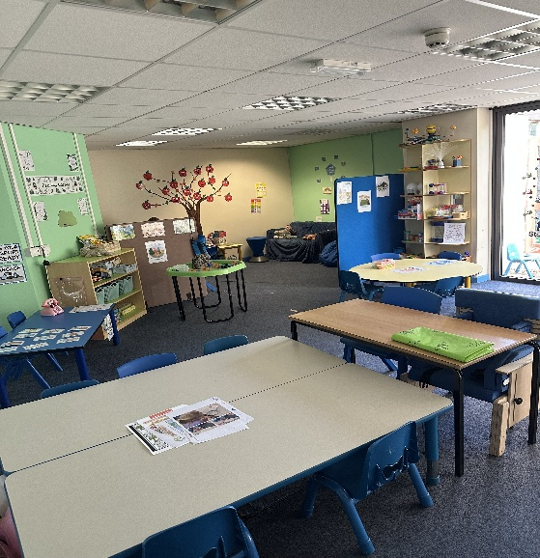
We are committed to making sure all our pupils have the chance to thrive and support them to meet their full potential. We offer an inclusive environment where continuous provision is tailored to the needs and abilities of pupils, no matter how varied. As part of our provision, you may work in our Garden Room or calm cabins where we use zones of regulation to provide a calm environment for any children who require re-regulation or a space for co-regulation.

We offer excellent training opportunities to progress professional skills and development in all areas of SEND provision. We also work closely with Gosberton House Academy.

Our inclusive SEND provision has been highlighted both by the SEND partners we work with and the external partners.

The successful candidate must be
- Patient, positive and have empathy for all pupils.
- Motivational and inspirational, fostering a love of learning in all pupils.
- Able to support children, under the direction of the class teacher and supported by the SENDCo’s, ensuring as far as can be reasonably expected, the safety and wellbeing of these pupils.
- Strong behaviour management skills.
- Support across intimate care needs.
- Able to understand how different pupils learn and the barriers some face to their learning.
- Able to support in the delivery of creative and innovative approaches to learning, driving differentiated planning and confident in resourcing to impact on all pupils’ learning.
- Successful in encouraging pupils to take responsibility for their own behaviour and support them where necessary.

We offer:
- An excellent opportunity to join a dedicated and successful SEND team.
- Two Good Academies which are part of the successful University of Lincoln Academy Trust.
- Effective and supportive team members who are fun and welcoming.
- Children who are full of learning potential and respond positively to a challenge.
- The opportunity to further your professional skills and development.

The successful candidate will support pupils across the curriculum both in and outside the classroom. Please apply via MyNewTerm on our website www.holbeachprimaryacademy.co.uk
If you would like any further information, an informal discussion or to arrange a visit, please contact in the first instance Mrs Sue Tully, PA to the Executive Team, on 01406 422397 or email enquiries@holbeachprimaryacademy.co.uk.

The closing date is midday on Friday 11th September 2026
Interviews to take place asap.

We reserve the right to interview and appoint prior to the closing date of the advert, should we identify an appropriate candidate. If you have not been invited for an interview within 4 weeks of the closing date, please assume that your application has been unsuccessful on this occasion.

We are committed to safeguarding and promoting the welfare of young people and expect all staff share this commitment. All posts will be subject to an enhanced DBS disclosure, medical and reference checks. Applicants may be subject to online checks.

