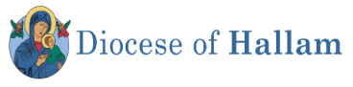

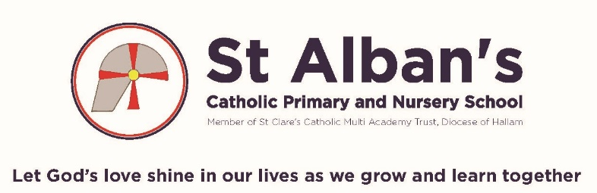
Early Years Practitioner Person Specification
 | Essential | Desirable
Qualifications / Attainments | - Full and relevant Qualification at NVQ/ CACHE Level 3 or equivalent  - Minimum Grade C GCSE in Maths and English or equivalent  - First Aid Qualification | - Specialist training in curriculum or learning area as appropriate  - Safeguarding Level 1 Certificate  - Paediatric First Aid Qualification
Experience | - Worked as an Early Years Practitioner with children from 9 months in a private or school Nursery or as a childminder  - Demonstrate an ability to use skills, expertise and experience to support Nursery aged children  - Ability to relate well to young children and adults  - Work constructively as part of a team, understanding roles and responsibilities within provision and your own position within these  - Can use ICT effectively to support learning  - Good communication skills  - Experience of working with children of relevant age in a learning environment  - Understanding of the varying needs of Nursery aged children | - Good understanding of child development and learning processes  - Knowledge of EYFS National Curriculum  - Full working knowledge of relevant policies/codes of practice/legislation  - Understanding of statutory frameworks relating to Early Years  - Ability to organize, lead and motivate a small team  - Supported a child with needs  - Led interventions  - Experience of working within a school and following school policies and guidelines
Personal Requirements | - Constantly improve own and team practice/knowledge through evaluation and professional development  - Calm and positive approach  - Sensitive to the needs of babies, children and their parents/carers | - Knowledge and understanding of the ethos within a Catholic School.

