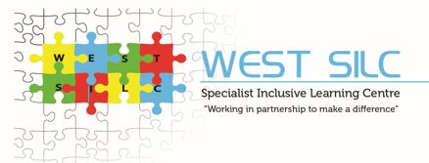

WEST SILC

CONNECT TEACHER

RECRUITMENT PACK

Michelle Wilman
Principal

Telephone: 0113 3862450
Email: info@westsilc.org
Website: www.westsilc.co.uk
Address: 4 Town Street, Stanningley, Leeds, LS28 6HL



Welcome to Our School

We are an all-age, 2-19, generic special school dedicated to nurturing learners with moderate, severe, profound and multiple learning difficulties, autism, communication challenges, sensory processing differences, and SEMH needs on their learning journey. Our provision is based on specialist sites and mainstream partnerships in the West of Leeds.
Each cohort of learners is primarily based within one specialist pathway, where they access a unique, expertly tailored curriculum built around their individual needs, interests and aspirations. As learners grow and progress, they can move flexibly between pathways - ensuring their journey always matches their evolving strengths and goals.

Our school is a place where every learner is seen, heard, and valued – and where every staff member is part of something truly meaningful.
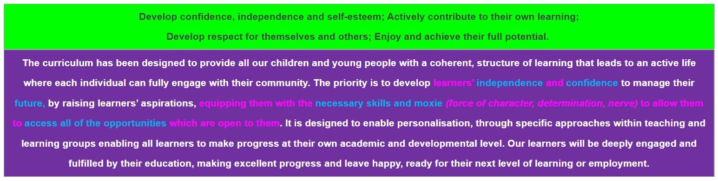
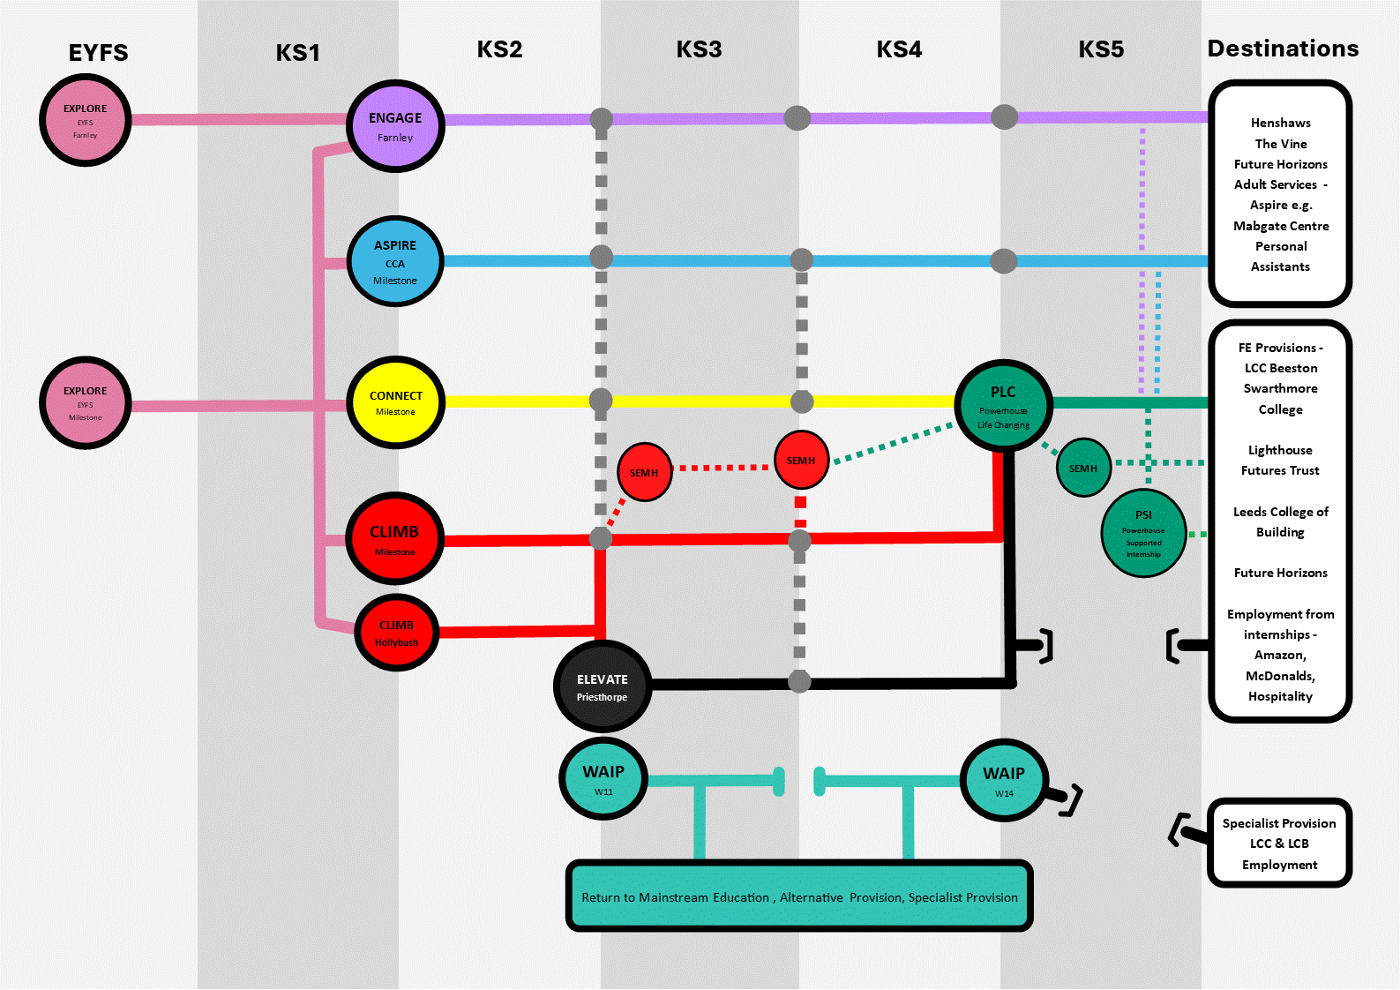

Come Connect with Us

The Connect Pathway supports learners in Key Stages 2–4 with significant communication, sensory and learning needs. Learners access a highly personalised and adapted National Curriculum delivered through Total Communication, sensory experiences, life skills and play-based learning.

What Makes Connect Special?
- Total Communication approaches including Makaton, Aided Language Displays, Objects of Reference and Intensive Interaction.
- Highly personalised learning matched to developmental need.
- Sensory-informed and regulation-focused practice.
- Weekly life-skills and community learning.
- Strong emphasis on communication, independence and preparation for adulthood.

The Connect Curriculum
English, Maths and Science are delivered through adapted schemes including Talk for Writing, Read Write Inc., White Rose Maths and practical science. Humanities, RE, Computing, Creative Arts and PE enrich learning through topics, drop-down days and experiential learning.

Teaching and Learning in Connect
Teaching is highly visual, practical and engaging. Staff use communication boards, photographs, task plans, symbols and sensory approaches to ensure all learners can access learning. Play, Attention Time and outdoor learning are key features.

Communication and Regulation
Learners are supported through Zones of Regulation, sensory circuits, hydrotherapy, rebound therapy, sensory integration programmes and personalised regulation plans. Staff build trusting relationships and help learners develop communication and self-regulation skills.

Connect Week
At the end of each term, Connect Week focuses on communication, transition, cultural capital, family engagement and personal development. These experiences help learners build confidence, resilience and independence.

Preparation for Adulthood
Life skills are embedded throughout the curriculum including travel training, road safety, money skills, personal care, community access and functional communication. Learners are supported carefully through transitions to post-16 provision.

On the West SILC website – watch our Connect Pathway video - Connect Pathway — West SILC

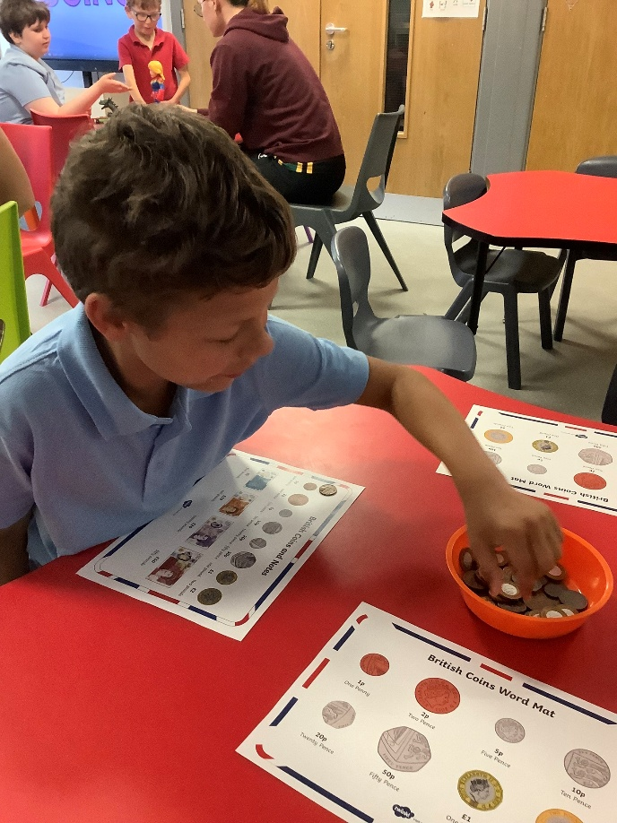

Your Role as a Connect Teacher

As a teacher in Connect, you will:
- Lead a small, nurturing class with high support
- Deliver a curriculum, matched to learner needs
- Work closely with support staff, therapists and families
- Embed Total Communication approaches, and sensory strategies
- Track progress through Evidence for Learning and EHCP outcomes
- Support emotional regulation using tools like Zones of Regulation
You’ll be part of a passionate, collaborative team who champion creativity, inclusion and compassion.

- A warm, welcoming and skilled staff team
- Bespoke induction and CPD tailored to SEND.
- Access to therapeutic and sensory resources.
- Opportunities to shape and develop the curriculum
- A culture that values wellbeing and collaboration
- Real opportunities to make a difference - every single day

What We Offer:

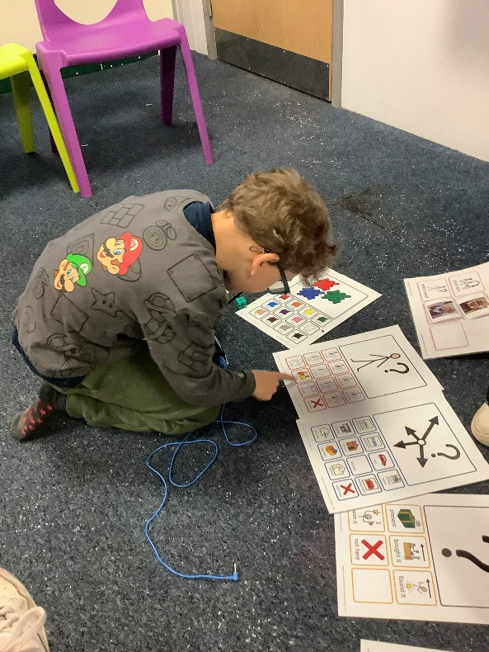

West SILC – Working in Partnership to Make a Difference
We aim for all our students to:
    - Develop confidence, independence and self-esteem.
    - Actively contributes to their own learning.
    - Develop respect for themselves and others.
    - Enjoy and achieve their full potential.

Job Description – Class Teacher
Job Title: Class Teacher
Salary: M1 – UPR3, Minimum SEN Allowance
Contract Type: Permanent
Reporting to: Pathway Leader / SLT
Location: West SILC
Core Purpose:
To deliver outstanding, engaging, and meaningful teaching to learners, ensuring their academic, personal, social and emotional development in line with their EHCPs.
Key Responsibilities:

- Teach a broad and balanced curriculum across a range of subjects, adapted creatively to the needs, interests and abilities of learners on your pathway – including contextualised, sensory, therapeutic and visual approaches.
- Facilitate learning that empowers and engages, enabling learners to make meaningful progress across both academic and personal outcomes.
- Plan and deliver high-quality, personalised lessons, ensuring sessions are purposeful, inclusive and rooted in each learner’s EHCP, strengths and communication style.
- Build positive, trusting relationships that promote learner wellbeing, emotional regulation and independence – using tools like Zones of Regulation, Makaton and structured visual supports.
- Inspire curiosity, motivation and joy through consistent routines, multi-sensory experiences, and meaningful enrichment, both inside and outside the classroom.
- Track and celebrate progress using Evidence for Learning, documenting every small step on our Learning Journeys and EHCP small steps.
- Work collaboratively with support staff, therapists and families, building strong partnerships to support holistic learner development.
- Champion the values and aspirations of the Pathway and West SILC, contributing to a culture of inclusion, respect and high expectations.
- Take the lead on an area of curriculum, developing engaging plans with clear goals and success criteria that support independence, life skills, and preparation for adulthood.
- Support the wider school vision by contributing to whole-school improvement, planning, and the development of inclusive policies and practices.
- Reflect on your practice and grow professionally, using feedback, performance management and CPD to continually refine and improve your impact.
- Support learners across the SILC, being flexible to teach on any site as needed, and always committed to making a difference wherever you’re based.

What this means in more detail:

Planning, Teaching and Class Management
You will:
- Plan engaging, progressive lessons that are tailored to each learner’s strengths, needs and next steps – always with high expectations and meaningful outcomes in mind.
- Set clear, ambitious teaching objectives, and choose exciting, relevant ways to teach and assess them.
- Use time effectively and plan tasks that challenge, motivate and support each learner to succeed.
- Stay responsive to learners’ profiles – including communication styles, EHCP targets and sensory needs – and adapt your teaching accordingly.
Your teaching will:
- Blend structure with creativity, using practical, sensory and therapeutic approaches that bring key ideas to life.
- Embrace a wide variety of resources – including ICT, assistive tech, and visual tools – to maximise accessibility and interest.
- Encourage participation, independence and joy in learning.
- Help every learner move closer to their personal potential, no matter their starting point.
In your classroom:
- You’ll create a calm, consistent and respectful learning environment.
- You’ll support learners to regulate their emotions and make positive behaviour choices.
- You’ll celebrate progress – not just in levels, but in confidence, engagement and relationships.
- You’ll ensure all learners are seen, supported and safe, and that their achievements compare positively with those in similar settings.

Monitoring, Assessment and Reporting
You will:
- Use assessment to drive learning – identifying what’s working, what’s next, and how to get there.
- Mark, monitor and reflect on work to inform planning and celebrate success.
- Set personalised targets and track progress through Evidence for Learning and our Strides assessment.
- Keep clear, purposeful records that highlight growth, inform interventions and shape next steps.
- Share progress meaningfully with learners, families, and the wider team – building trust and collaboration through transparency and care.

Pastoral Responsibilities
You will:
- Be a form tutor, providing structured pastoral support and a consistent point of contact to help learners feel secure, understood and ready to engage.
- Promote attendance, engagement, and participation in all areas of school life.
- Be responsible for reviewing and developing each child’s EHCPs, behaviour plans, risk assessments and personal profiles in your class.
- Be proactive in spotting and supporting learners’ challenges – working with colleagues and families to find solutions.
- Build positive, respectful relationships with families, carers and external professionals – always putting the learner’s wellbeing first.

Curriculum Leadership (Area to be Agreed)
As a curriculum lead, you will:
- Coordinate planning, resources and activities within your subject or focus area.
- Support colleagues in delivering exciting, relevant and inclusive learning experiences.
- Review and evolve the curriculum collaboratively, keeping learners’ needs and strengths at the heart of your decisions.
- Stay current with national and sector developments in your area, bringing fresh ideas to the team.

Professional Responsibilities
You will:
- Understand and fulfil your professional and legal duties – including those related to KCSIE, safeguarding and child protection.
- Model the school’s values in everything you do – from your appearance and conduct to your relationships with learners and staff.
- Engage fully with the life of the school – contributing to meetings, reviews, school events and working parties as needed.
- Stay committed to your own growth, seeking out CPD and using what you learn to enhance your impact.
- Positively contribute to school priorities – including wellbeing, equity and Every Child Matters agenda.
- Build positive relationships with families and governors, sharing your passion for what’s possible for our learners.
- Take on additional responsibilities in line with the evolving needs of the school – always with the goal of making a real difference.

General Duties:
- Safeguard and promote the welfare of all learners.
- Contribute to whole-school improvement, staff training, and the positive ethos of the Climb department.
- Fulfil professional duties outlined in the Teachers’ Standards.

Person Specification – Class Teacher (Climb Pathway)
NB. Essential criteria are the qualities that candidates must have to do the job. Desirable criteria are the extra qualities that will enhance a candidate’s job performance and aid short listing. Ensure that your written application and your performance through the selection process demonstrates these.

Criteria | Essential | Desirable
Qualifications | - Qualified Teacher Status (or to be achieved by July 2026) | - Additional qualifications in SEND, autism, or SEMH education  - Evidence of ongoing professional development in SEND or related fields
Experience | - Good or outstanding teaching experience in any setting (mainstream/SEND/PRU/AP)  - Ability to deliver engaging, multi-sensory, personalised lessons  - Able to track progress through formative and summative methods; assessing progress through small steps  - Experience of refining the National Curriculum and developing inclusive, adaptive teaching approaches to SEND learners  - Confidence in supporting emotional regulation and learner wellbeing  - Able to create appropriate EHCP outcomes and breaking down into smaller steps  - Successful strategies for supporting young people with social, emotional and mental health needs  - An understanding of the needs of parent/carers of children with SEND. | - Able to adapt teaching to outcomes from - Early Years to year 3 ARE  - Experience teaching learners with moderate to severe learning difficulties and additional needs  - Experience using Read Write Inc, White Rose Maths, or Talk for Writing, Colourful Semantics  - Delivering speech and language programmes, use of visuals, task plans, Makaton etc.  - Experience using Evidence for Learning assessment (or similar)  - Training in Zones of Regulation or similar approaches  - Knowledge of sensory integration, and therapeutic interventions  - Experience in holding annual reviews and associated paperwork  - An understanding of the needs of parent/carers whose children are at risk of disaffection/exclusion or developing mental health problems
Personal Qualities | - Passion for meeting the needs of neurodiverse learners and building positive relationships  - Strong team working and communication with professionals and families  - Reflective, creative, nurturing, and inclusive in approach  - Resilience and determination to succeed  - Good communication skills, able to establish credibility, trust and work collaboratively with pupils, school staff, other professionals and community groups  - Tactful, patient and sensitive | - Understanding of trauma-informed and attachment-aware approaches  - Experience leading a class team (e.g., HLTAs, support staff)  - Emotional self-awareness

Safeguarding & Equality | - Commitment to safeguarding, equality, and promoting a safe learning environment  - Enhanced DBS checks | - Experience contributing to safeguarding planning and behaviour support strategies, individual pupil risk assessments

