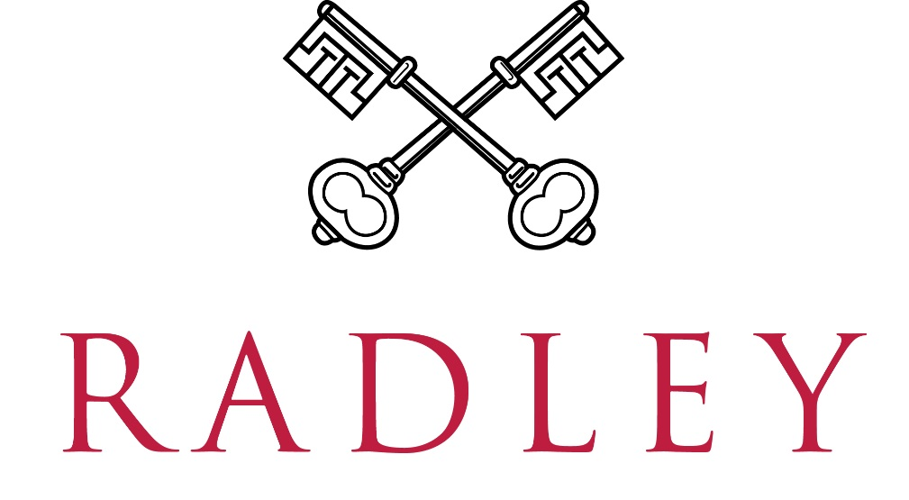

JOB DESCRIPTION
Job Title: IT Service Desk Lead
Reports to: Head of IT Services
Location: Radley College, Abingdon, Oxon
Responsible for: The day-to-day operation of the IT Service Desk, including leadership, support and development of Service Desk staff. Ensuring the delivery of high-quality customer-focused IT support services to staff and pupils, managing service processes, maintaining service standards and coordinating user-facing IT and AV support across the College.

KEY RESPONSIBILITIES

Leadership, Management and Service Ownership
- Provide leadership and direction for the IT Service Desk, ensuring the delivery of a high-quality, customer-focused service aligned to College objectives.
- Lead, motivate and develop Service Desk staff, fostering a culture of accountability, collaboration and continuous improvement.
- Take ownership of Service Desk performance, establishing and monitoring service standards, KPIs and team objectives.
- Analyse service trends, recurring issues and user feedback to identify opportunities for improvement and inform operational planning.
- Work closely with the Head of IT Services to develop and implement service strategies, policies and best practice.
- Ensure effective governance, reporting and oversight of Service Desk activities.
Service Desk Operations
- Lead the day-to-day operation of the Service Desk, ensuring incidents and requests are managed effectively and in accordance with agreed priorities.
- Manage workload, resources and service coverage to maintain an efficient and responsive support service.
- Act as an escalation point for complex, sensitive or high-impact support issues.
- Ensure service requests, incidents and problems are appropriately logged, prioritised and progressed through the ITSM platform.
- Produce service reports and management information to support performance monitoring and continual improvement.
- Maintain and develop Service Desk procedures, knowledge resources and operational documentation.
User Support and Customer Experience
- Ensure the delivery of an excellent customer experience through effective communication, responsiveness and proactive engagement with users.
- Provide hands-on support where required and maintain a visible Service Desk presence.
- Coordinate IT inductions, equipment handovers and user guidance for new staff and other users.
- Support the delivery of IT and AV services for teaching, learning, meetings and College events.
Asset, Access and Service Administration
- Coordinate the operational joiner, mover and leaver process with HR and IT colleagues.
- Manage administration of the College access-control system through the Service Desk.
- Maintain IT asset records, inventories, stock levels and loan-device processes.
- Oversee equipment procurement and managed-print administration.
Collaboration and Service Improvement
- Work collaboratively with colleagues across IT Services to deliver effective and joined-up support.
- Contribute to IT projects, change initiatives and service improvement programmes.
- Promote best practice and consistency in service delivery across the IT Services function.
- Develop effective working relationships with staff, pupils, suppliers and external partners.
- Represent the Service Desk function within meetings, projects and service planning activities.
- Undertake any other duties commensurate with the nature and level of the post.

OTHER DUTIES
- Such other duties which may reasonably be required.
- To attend necessary training as required by the College.

HOURS OF WORK
- Full time, all year. on site
- Monday to Friday, 9 am to 5 pm (some flexibility may be possible).
- Saturday mornings 8 am to 1 pm on a rota basis (approx. one in every six weeks during term time).

PERSON SPECIFICATION
- Excellent customer service and interpersonal skills, with the ability to build positive relationships with a wide range of users.
- Strong verbal and written communication skills.
- Experience leading, supervising or coordinating a customer-facing support function or team.
- Experience coaching, supporting and developing colleagues.
- Strong organisational skills, with the ability to manage workloads, priorities and service performance effectively.
- Good understanding of incident, request and service management principles.
- Good working knowledge of Microsoft 365 applications, including Teams, SharePoint, OneDrive, Word, Excel and PowerPoint.
- Ability to analyse information, identify trends and implement service improvements.
- Ability to develop, document and improve processes and working practices.
- Sound understanding of common IT support technologies, user administration and endpoint support.
- Ability to communicate effectively with both technical and non-technical audiences.
- Strong sense of ownership, accountability and initiative.
- Ability to work independently whilst contributing positively as part of a wider team.
- Commitment to delivering a high-quality, customer-focused service.
Desirable
- Experience working within an ITIL-aligned service management environment.
- Experience supporting Microsoft 365 and cloud-based services.
- Experience supporting Windows, macOS and mobile devices.
- Experience supporting audio-visual technologies within meeting rooms, classrooms or events.
- Experience working within a school, college or other educational environment.
- Experience producing service reports, performance data or management information.
- ITIL Foundation or equivalent service management qualification.

Radley College is committed to safeguarding and promoting the welfare of its pupils and expects all employees to share this commitment. Employees must, at all times, have regard to the need to safeguard and promote the welfare of children in line with the provisions of the Children Act 2004 (as amended) and Keeping Children Safe in Education (as amended) and be fully aware of, and understand, the duties and responsibilities that apply to their role in relation to these requirements. All employees must attend appropriate training in accordance with College and local Safeguarding Board stipulations.

