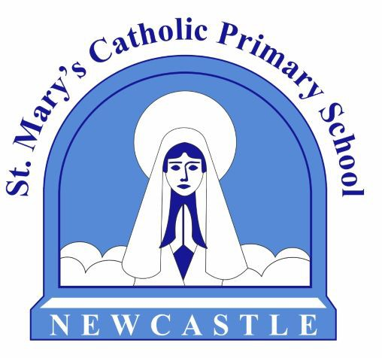

Vacancy - Class Teacher Year 2 (Temporary Maternity Cover)
St. Mary's Catholic Primary School
MS1-MS6
£32,916 - £45,352

Full-time (32.5 hours per week)
Start date: January 2026

St Mary’s Catholic Primary School is a two-form entry primary school, situated in the heart of Newcastle-under-Lyme. Our mission is
'Learning to Live Out Our Calling with Compassion and Love', and we would love to hear from applicants who feel that they could make a real difference to our school community. We are proud to offer supportive, positive and enthusiastic staff team, children who are eager to learn and very supportive parents. We are a school that is committed to continual improvement and where every child is encouraged to succeed.

We are seeking to appoint a dynamic, enthusiastic and motivated class teacher to work with us from January 2026. We are looking for an outstanding classroom practitioner who will fully support the school's commitment to ensure that all children achieve their full potential.

The successful candidate will:
- Be supportive of the Catholic ethos of the school.
- Demonstrate a thorough and up to date knowledge of teaching, learning and assessment.
- Have the ability to plan an exciting and challenging curriculum, which engages all learners and meets their needs.
- Possess a positive ‘can do’ attitude.
- Work effectively within a team.
We can offer you:
- Full support in your role from the Schools Governing Body, senior leadership team and staff.
- A modern, well-equipped school with excellent facilities and extensive school grounds.
- CPD opportunities to support you in your role.
- Well-behaved children who love to learn.
Visits to the school are welcomed and encouraged. Please contact Mrs Beeston on 01782 619685 to arrange a visit.

We are seeking applications from those of Catholic faith, all faiths and those of no faith, but who are supportive of our Christian values and ethos.

Application forms and further details are available from the school website www.stmarycatholicprimary.co.uk or www.ctkcc.co.uk or by contacting Mrs J Howarth at recruitment@ctkcc.co.uk or 01782 976176.

Closing date for applications: Monday 24th November 2025

All completed application forms should be returned via My New Term.
This position is subject to an Enhanced Disclosure check under the Rehabilitation of Offenders Act 1974. Further details regarding this check are available from schools or by visiting: www.dbs.gov.uk. St Mary’s is committed to safeguarding and promoting the welfare of children and young people/vulnerable adults and expect all staff and volunteers to share this commitment.

Interested candidates need to complete an application form.

e-mail: recruitment@ctkcc.co.uk

Further information can be found at:

www.stmarycatholicprimary.co.uk www.facebook.com/stmaryscps

