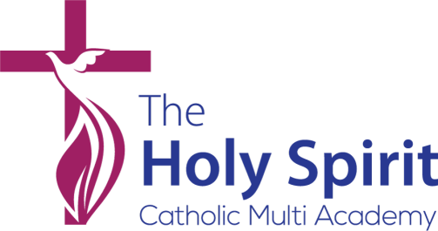

CLASS TEACHER - Primary

JOB DESCRIPTION

Title | Class Teacher
Job purpose | The teacher will:  - teach a class of pupils, and ensure that planning, preparation, recording, assessment and reporting meets their varying learning and social needs and ensures good progress;  - implement and deliver an appropriately broad, balanced, relevant and differentiated curriculum for pupils and support a designated curriculum area as appropriate;  - monitor and support the overall progress and development of pupils;  - contribute to raising standards of pupil attainment;  - share and support the school’s responsibility to provide and monitor opportunities for personal, social and cultural growth and enjoyment;  - maintain the positive ethos and core values of the school, both inside and outside the classroom;  - contribute to constructive team-building amongst teaching and non-teaching staff, parents and governors.
Responsible to | The post holder is responsible to:  - the Principal in all matters;  - the relevant member of the school leadership/senior management team in respect of curriculum and pastoral matters.
Duties and responsibilities specific to the post | The teacher will:  - Ensure the distinctive Catholic nature of the school is maintained and improved  - contribute actively to the achievement of the school’s development plan and its implementation.  - implement agreed school policies and guidelines;  - support initiatives decided by the Principal and the SLT and contribute to the achievement of the school development plan and its implementation;  - plan appropriately to meet the needs of all pupils, through differentiation of tasks;  - be able to set clear targets, based on prior attainment, for pupils’ learning;  - provide a stimulating classroom environment, where resources can be accessed appropriately by all pupils;  - keep appropriate and efficient records, integrating formative and summative assessment (assessment for learning) into weekly and termly planning;

- report to the Principal, senior management and parents on the development, progress and attainment of pupils;
- maintain good order and discipline amongst all pupils, in accordance with the school's behaviour policy;
- provide a positive role model, demonstrating clear verbal communication and articulation, empathy, respect and consideration.
- take part in and contribute to meetings; cooperate with and, where appropriate, advise the Principal and other colleagues in the review, development and management of a subject in the school;
- communicate and co-operate with specialists from outside agencies;
- plan for, organise and direct the work of support staff within the classroom;
- participate in the performance management system for the appraisal of their own performance, or that of other teachers and/or teaching assistants;
- identify the links between their own performance targets and their pupil’s progress taking responsibility for proactive CPD.
- meet the national standards for Qualified Teacher Status and be subject to the national conditions of employment for schoolteachers as set out in the current copy of the School Teachers' Pay and Conditions Document.

The Holy Spirit Catholic MAC is an organisation where safeguarding is our prime importance and we are stringent in our approaches to making sure all our children and adults are kept safe and well cared for. We will only appoint staff who can demonstrate that they share this commitment and who can take responsibility for the wellbeing of all children within all of our schools.

