


Peatmoor Community Primary School
Proud to be part of Grove Learning Trust
KS2 Class Teacher MAT cover
(Part time: 4 days a week – could be adapted for a full time ECT with appropriate non-contact time)
Recruitment Pack

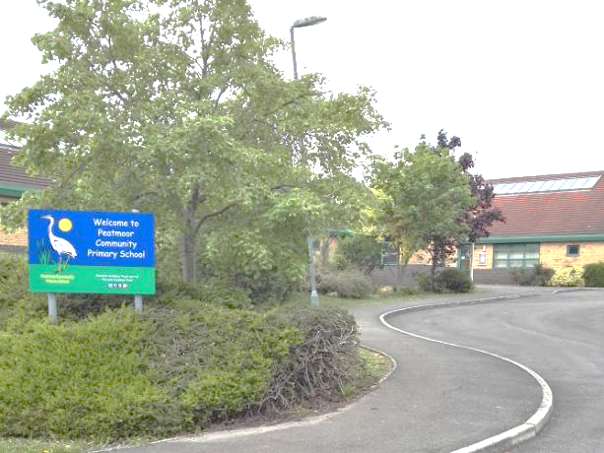

Advert Opens: 23/03/26 Advert Close 13/04/26

Contents

 | Page
Grove Learning Trust (GLT) Vision | 2
A snapshot of Peatmoor Community Primary School | 3
Our school values | 4
Safeguarding, Equal Opportunities & Data Protection | 5
Job Description | 6-10
Person Specification | 8
Recruitment Process | 11

Grove Learning Trust (GLT) Vision
Together, we will create remarkable schools in which all children can thrive.
As one organisation, Grove Learning Trust, with schools that are unique and united, share aspiration for our children, which is underpinned by a strong commitment to our values.

Trust >> Connect >> Collaborate

A snapshot of Peatmoor Community Primary School …

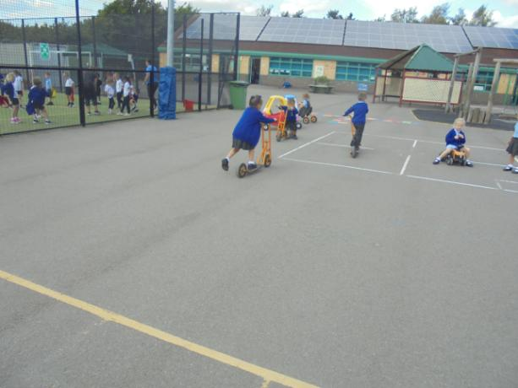








For further information about Peatmoor Community Primary School don’t forget to visit our school website: https://www.peatmoor.org.uk

Our School Values

Our Mission Statement is simply ‘Enjoy Learning, Enjoy Life’.

Every member of our school community is proud to contribute to the success of our school. Children here are motivated by learning and offered the most diverse opportunities that we can provide. Our environment encourages them to be respectful and well-behaved individuals, who develop high self-esteem and independence.
Being at Peatmoor is very much about being part of an exciting school community. We encourage the very best from our children and aim to help them realise their fullest potential so that they are ready to positively embrace each next stage and to recognise and celebrate their many talents. We also believe in fostering confident and constructive attitudes, which encourage our children to understand their role, contribution and responsibility both as part of our school and in the wider world. We nurture positive and friendly relationships with everyone whilst continuing to develop our links with the wider community.
Welcome
We are a 1-form entry primary school situated in West Swindon next to Peatmoor lagoon and the village centre. Being at Peatmoor is very much about being part of an exciting school community.
We benefit from superb teaching facilities and extensive outdoor spaces this includes a wildlife pond, tyre park, floodlit Astroturf pitch and EYFS Outdoor classroom which includes potting table, communication & language zone and active play frames, which enhances the learning we offer.

Safeguarding, Equal Opportunities and Data Protection

Safeguarding

Peatmoor Community Primary School is committed to safeguarding and promoting the welfare of all children. We expect all candidates to share this commitment. The successful candidate will be expected to undertake an enhanced Disclosure & Barring Service (DBS) and relevant identity, qualification and disqualification by association checks before a formal offer is made, contracting is undertaken and induction commences within our school.

Equal Opportunities

We are an equal opportunities employer and welcome applications from all suitably qualified persons regardless of their race, sex, disability, religion/belief, sexual orientation or age.

Data Protection Privacy Notice

As part of the recruitment process, we collect and process personal data relating to job applicants. We are committed to being transparent about how we collect and use that data and to meeting data protection obligations. For further information on how we collect and process data, please refer to the Data Protection Policy & Privacy Notice found on www.grovelearningtrust.co.uk

Year 5 Class Teacher – MAT Cover

Job Description
Peatmoor Community Primary School is strongly committed to protecting and safeguarding children and expects all staff and volunteers to embrace this commitment. All post-holders are subject to an Enhanced Disclosure and Barring Service (DBS) Check.

Job Title | Y5 Class Teacher
Location | Peatmoor Community Primary School
Salary Range | MPS
Reporting to: | Headteacher
Working Hours: | 4 days a week- Thursday is a non-working day. Could be adapted for a full time ECT, with appropriate non-contact time
Working Weeks | Term Time

Are you ready for an exciting new adventure?
Are you keen to be part of a forward-thinking creative team?
This is an exciting opportunity to work as part of a committed team focussed on pupil wellbeing. We promote positive behaviour, a growth mindset and collaboration.

Purpose of Post:
- To be an excellent classroom practitioner
- Have a positive impact on educational progress of their assigned pupils
- Have an interest in whole school self-evaluation and school improvement planning
- To be responsible for promoting and safeguarding the welfare of children and young people within the school.

Objectives/Key Tasks/Responsibilities:
In addition to carrying out the duties of a class teacher as outlined in the School Teachers’ Pay and Conditions Document, the Class Teacher will be expected to carry out the following where appropriate:
Objectives as a Class Teacher
- To ensure pupils make good progress towards individual learning goals
- To develop pupils’ spiritual, moral, social and cultural values
- To develop children’s self-esteem, self-discipline, confidence and independence

Objectives as a Coordinator (for non ECTs)
- To raise standards of pupil achievement in agreed curriculum areas
- To foster enjoyment and satisfaction in the study of these areas
- To increase staff confidence and competence in teaching these subjects
Key tasks as a Class Teacher
- Implement the school aims
- Work with colleagues to plan tasks in order to meet the individual needs of children
- Mark work and ensure that pupils receive regular feedback in an age-appropriate way
- Complete pupil records
- Participate in assessment arrangements agreed by the school and as legally required
- Liaise regularly with parents, reporting formally twice a year and in writing annually, as a minimum
- Direct the work of classroom assistants/voluntary helpers within your room
- Manage and maintain physical resources within the teaching area
- Maintain good order and discipline amongst pupils
- Safeguard pupils’ health and safety
- Attend staff meetings as required
- Participate in arrangements for further training and professional development

Key tasks as a Coordinator (for non ECTs)
- Facilitate the implementation of the National Curriculum in accordance with the school’s curriculum and subject policies
- Develop opportunities for parents to understand and support their children’s learning including the provision of homework in line with school policy
- Monitor the quality of teaching and learning in the agreed subjects including teachers’ plans
- Evaluate the effectiveness of the school curriculum in the above subjects in accordance with the school policy for assessment
- Provide information to staff, parents, governors and advisors about the work of the school and standards in the agreed subjects
- Promote and support the professional development of all staff within the subject in accordance with the school’s staff development policy
- Meet with colleagues to discuss approach and to help plan work
- Undertake appropriate staff development in order to develop professional effectiveness as coordinator
- Establish and maintain appropriate teaching and learning resources by negotiation with senior management

Principal Responsibility Areas:
- Review, develop and implement means for supporting pupils’ learning
- Monitor and evaluate learning programmes to ensure their effectiveness
- Secure and monitor resource allocation to ensure equality of experience
- Teaching of the National Curriculum, RE and the wider curriculum taking into account pupils’ individual needs
- Assessing, recording and reporting pupil progress in order to maximise achievement
- The management of human and physical resources to best effect
- Discipline, health and safety
- Developing self to enhance performance

Note: This job description is not your contract of employment, or any part of it. It has been prepared only for the purpose of school organisation and may change either as your contract changes or as the organisation of the school is changed. Nothing will be changed without consultation.
Person Specification:
Attributes |  | Requirement
 |  | Essential | Desirable
Qualifications and  Training |  | - Qualified Teacher status | - Degree and/or relevant qualifications
Experience and  skills |  | - Experience of a range of summative and formative assessment procedures  - Ability to match teaching to children’s individual needs  - Experience of working in KS2 | - A working knowledge of strategies and techniques for raising pupil attainment generally including different groups of pupils such as SEND, EAL and pupil premium  - Ability to manage and develop curriculum areas
Professional  development |  | - Active involvement in recent and relevant CPD  - Demonstrate self-awareness of professional development needs
Data analysis |  | - Ability to analyse, interpret and act on performance data
Improving teaching  and learning |  | - An excellent classroom practitioner able to lead by example  - Knowledge and experience of a range of teaching and learning styles and strategies including ICT | - Experience of observing and evaluating the quality of learning and teaching.
Working with  people |  | - Strong interpersonal skills  - Able to establish credibility with all staff  - Able to establish positive relationships with parents, carers, colleagues and governors | - Experience of working with other agencies or organisations
Resource  Management | - Proven ability to maximise resources  - Able to create a purposeful, orderly, supportive and stimulating environment for children’s learning |  | - Knowledge and understanding of management procedures
Knowledge of education | - Vision of education in a wider context than a single subject/school |  | - Experience of wider reading and educational issues
Key skills, qualities  and attributes | - High expectations and a commitment to raising standards of attainment  - Commitment to equal opportunities and equal value for students and colleagues  - Resilient, cheerful and positive  - Able to embrace change  - Good organisational and personal management skills  - Able to work effectively as a team member at all levels  - Commitment to safeguarding procedures  - Flexibility and commitment to share in development of our school |  | - Able to work independently and proactively  - Willing to contribute to extra-curricular activities

Personal Qualities
- Commitment to promoting the ethos and values of the school.
- Commitment to acting with integrity, honesty, loyalty and fairness to safeguard the assets, financial probity and reputation of the school.
- Ability to work under pressure and prioritise effectively.
- Commitment to maintaining confidentiality at all times.
- Commitment to safeguarding and equality.
- Embraces change well.
- Deals with difficult situations effectively.
Other Duties
- In accordance with the provisions of the Health and Safety at work Act 1974, take reasonable care for the Health and Safety of yourself, colleagues and pupils and co-operate with the school so far as is necessary, to enable the school to perform or comply with their duties under statutory health and safety provisions.
- To attend relevant meetings and participate in training opportunities and professional development as appropriate.
- Communicate professionally, where necessary, with parents.
- Support pupils in developing effective relationships with peers, younger pupils and adults by challenging anti-social behaviour e.g. racism.
- Provide support to pupils with cognitive and learning difficulties to develop effective learning strategies and support them working individually, as part of a group or with the whole class.
- Assist in personal, social, hygiene, welfare, including minor medical problems and behaviour support of pupils.

Additional duties and responsibilities:
- The post holder may be required to perform duties other than those given in the job description for the post. The duties and responsibilities attached to posts may vary from time to time without changing the general character of the duties or the level of responsibility entailed. Such variations are a common occurrence and would not of themselves justify the revaluation of a post. In cases, however, where a permanent and substantial change in duties and responsibilities of a post occurs, consistent with a higher level of responsibility, then the post would be eligible for re-evaluation.
- In fulfilling the requirements set out in this job description, the post holder will apply Grove Learning Trust’s commitment to equality by treating all employees fairly and without discrimination on the grounds of colour, race and ethnic or national origin, sexual orientation, age, marital status, disability, trade union association or religious beliefs.
- In addition, the job holder will always respect the need for confidentiality, whilst performing the duties of the role.

Safeguarding:
Grove Learning Trust is committed to safeguarding and promoting the welfare of children and young people at all times. The post holder will be responsible for promoting and safeguarding the welfare of all children with whom they come into contact, in accordance with the trust’s safeguarding policies. The post holder is required to obtain a satisfactory Enhanced Disclosure from the Disclosure and Barring Service (DBS). Safeguarding training is included in the induction of all GLT staff and annual refresher training must be attended.
Peatmoor Community Primary School is committed to safeguarding and promoting the welfare of all children. We expect all candidates to share this commitment. The successful candidate will be expected to undertake an enhanced Disclosure & Barring Service (DBS) and relevant identity, qualification and disqualification by association checks before a formal offer is made, contracting is undertaken and induction commences within our school.

For further details about safeguarding at Peatmoor, access our school website and click the ‘Our School’ tab

Recruitment Process
Applications
Download an application pack for this position by:
- Accessing My New Term and searching Swindon vacancies for Peatmoor Community Primary School.
- Speaking to a member of our school office
School Website
https://www.peatmoor.org.uk
Key dates:
Advert opens: 23/03/2026
Advert Closes: 13/04/2026
Shortlisting: w/c 13th April
Interviews: w/c 20th April
Start date: 01/09/2026
Candidates who are successful at the shortlisting stage will be notified shortly after the closing date. Candidates who have not heard from us by this point should presume that their application has not been successful on this occasion.
We reserve the right to interview prior to the closing date.
We will seek references for all shortlisted candidates prior to interview and in line with guidance in ‘Keeping Children Safe in Education’, online checks will also be made of shortlisted candidates.

