


Welcome
Trent College is an independent co-educational boarding and day school, located in Long Eaton, Nottinghamshire. Founded in 1868, we have been providing a first-class education for over 150 years.
Set in a beautiful 45-acre campus we enjoy state-of-the-art facilities, including modern classrooms, sports facilities, and boarding houses. With traditional foundations and a modern outlook, Trent College is renowned for providing an excellent education for its 1,200 pupils.
The Elms is our Nursery and Junior School which provides a stimulating and nurturing environment to our youngest children, aged 6 weeks to 11 years. The two schools work closely together and share the same vision, aims and ethos. Together, we give the highest priority to the quality of our academic provision. Alongside a strong focus on sports, music, drama and a wide range of co-curricular activities to develop our pupils’ character and resilience, to prepare them for the modern world.
Rated ‘Excellent’ across the whole school by the Independent Schools Inspectorate in 2021, Trent College has a strong academic record, with a high percentage of students achieving top grades in their examinations and going on to study at some of the best universities in the UK and abroad.
We have highly qualified and experienced teaching staff who are committed to providing an excellent standard of education. We also have a large population of support staff, ensuring that our friendly school and beautiful campus operate to the very highest standards.

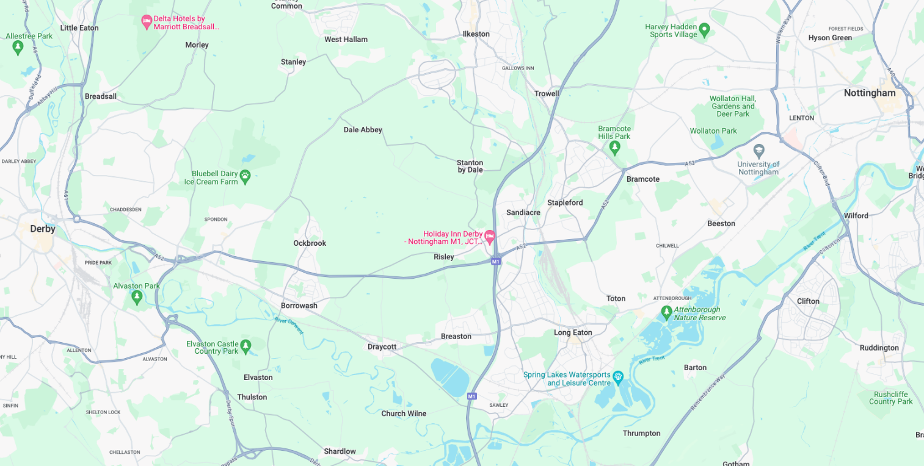
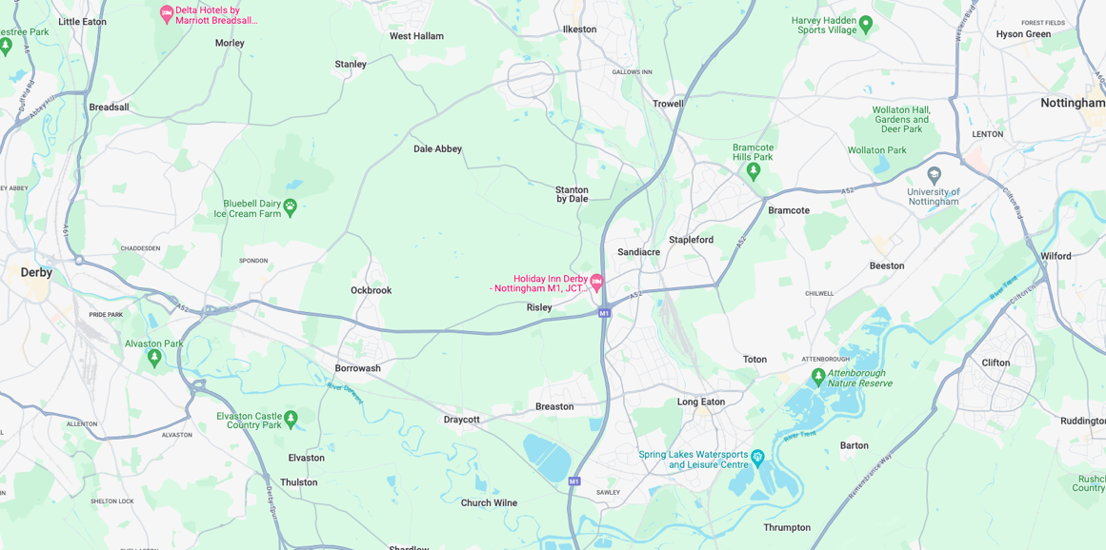


Our Location
Trent College and The Elms are conveniently situated on the border of Nottinghamshire and Derbyshire.
Ideally located at the heart of the UK’s motorway system, we are only 2 miles from junction 25 of the M1, which provides easy access to the M42 and A1.
Reaching Trent College by rail couldn’t be easier. Long Eaton boasts its own train station, located 1.5 miles from the schools. Rail routes through Long Eaton run along the Midlands Main
Line route, with direct routes to London, Loughborough, Leicester, Birmingham, Nottingham, Derby, Chesterfield and Sheffield.

Our Local Community
Working in partnership and serving the community are natural and very important values at Trent College and The Elms. We work with many local schools in Long Eaton and the wider Erewash borough to increase opportunities and aspirations, and to share the school’s excellent grounds, facilities and specialist staff.



Credit Controller

Job Description

The Finance Team is led by the Head of Finance and currently has a further 5 staff who are located in the Finance Offices. It is a small, busy team with friendly team members who work closely together.

Key Responsibilities

Key responsibilities of the role are included below, but it should be noted that these are not exhaustive, and the successful candidate is expected to be flexible to the varied demands of the team and the school overall.

Credit Control & Debt Management

- Monitor and manage the school’s accounts receivable, ensuring timely collection of fees and other charges
- Maintain regular, professional and empathetic communication with parents/guardians regarding outstanding balances
- Build effective relationships with parents/guardians to support positive and constructive resolution of overdue accounts
- Prepare and review aged debtor reports, highlighting areas of concern and escalating high-risk cases to the Head of Finance/Director of Finance as appropriate
- Maintain accurate and up-to-date records of all communications, payment arrangements and account activity
- Manage and reconcile debt arising through WisePay, ensuring accurate allocation and prompt follow-up




- Negotiate, implement and monitor agreed payment plans, ensuring compliance with agreed terms and escalating where necessary
- Support month-end processes relating to debtor balances and reporting
- Ensure all activity is carried out with a high degree of discretion, professionalism and sensitivity, recognising the confidential nature of financial information
- Undertake ad hoc duties as required to support the effective operation of the Finance team

Person Specification
Qualifications and experience
Essential
- Good general standard of education, demonstrating strong numeracy, literacy and verbal communication skills
- Proficient IT skills with knowledge and experience of Microsoft Excel and Word
- Experience of working in a busy administration office
Desirable
- Proficient in Excel.
- Experience of working within a credit control role.
- Experience of using wider management information systems and databases
- Experience of working in an education or charity organisation.

Skills and Personal Attributes
- Excellent organisation and administrative skills, able to organise a busy and varied workload
- Strong numerical skills
- Maintaining high standards of work output and able to work accurately when under pressure to meet deadlines
- Professional and flexible approach, with the ability to always maintain confidentiality and discretion
- Good interpersonal skills with an enthusiastic ‘can do’ attitude
- Self-motivated and able to work as part of a team
- Ability to multitask




Benefits
- Staff can enjoy complimentary lunches in the Obolensky Dining Hall during term time. Free car parking is available on site and staff have access to a cycle to work scheme.
- Staff are able to make free use of the school gym and leisure facilities at designated times.
- A flexible retirement plan run by TPT Solutions (formerly The Pensions Trust), including Death in Service benefit.
- Enhanced sick pay and maternity pay is available to staff.
- Staff are entitled to a fee remission for children attending the school, In line with our policy.
- We provide a range of benefits to support staff, including counselling, an employee assistance programme and 24/7 online GP consultations.

Terms and Conditions
- Part-time, 22.5 hrs (equivalent of 3 days per week), flexible on days and hours.
- Please note this is all year round, not term-time only.



Making an Application
Candidates who wish to apply for this post should complete the online application form.
If you have any questions about the role please email recruitment@trentcollege.net or telephone 0115 949 4949 (during term time).
The closing date for applications is included in the advert.
We reserve the right to close this advertisement early if we receive a volume of strong and suitable applications.

The school is committed to safeguarding and promoting the welfare of children and young people and expects all staff and volunteers to share this commitment.
Applicants will be required to undergo child protection screening appropriate to the post, including checks with past employers and the Disclosure and Barring Service (DBS). The school may carry out online searches on shortlisted applicants and all applicants will be required to provide details of their online profile, including social media account names/handles, as part of their application
The post is exempt from the Rehabilitation of Offenders Act 1974. The school is therefore permitted to ask job applicants to declare all convictions and cautions on a self-declaration form in advance of attending an interview (including those which are "spent" unless they are "protected" under the DBS filtering rules) in order to assess their suitability to work with children.



