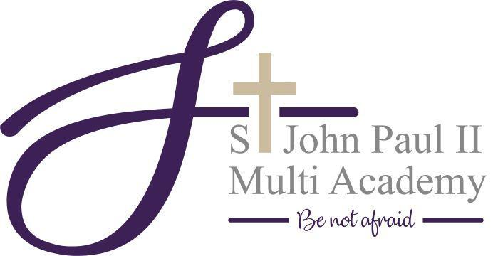

Job Title: HR Administrator
Grade: 2
Hours: Full-time but would consider Term-time

Responsible to: HR Business Partner

Job Purpose:

To provide high quality, proactive administrative support to the Central Service team and St John Paul ll Multi Academy. This role plays a key part in the efficient operation of the Trust’s HR function. The post-holder will be a first point of contact for a range of stakeholders and must demonstrate professionalism, discretion and initiative.

Main Duties / Responsibilities

General Administrative Support

- Deliver responsive, effective administrative support to the HR Business Partner and the wider HR team.
- Monitor HR email inbox, responding to or triaging queries as appropriate.
- Maintain well-organised digital and paper filing systems, ensuring records are stored securely and in line with GDPR.
- Prepare and format professional documents such as reports, letters, presentations, and spreadsheets.
- Maintain and administer the HR MIS system, ensuring records are up-to-date.
- Order office supplies and maintain stock levels of stationery and resources.
- Manage incoming and outgoing post.
- Act as a professional first point of contact for telephone, email and in-person enquiries to the HR team.

Meeting Support

- Coordinate diaries for HR team meetings.
- Prepare and circulate agendas and papers required for HR meetings.
- Take and distribute accurate minutes and action logs (where required) for HR related meetings.

Governance and Compliance

- Assist with tracking statutory compliance returns across the Trust that are related to HR, including updating any required registers.
- Maintain and update any HR logs and trackers.

HR and Recruitment Administration

- Provide administrative support for recruitment, such as advertising roles, scheduling interviews, and collating paperwork
- Confirm ‘offers of employment’ to newly appointed staff
- Lead the onboarding processes for new staff, including Right to Work checks, ID verification, reference requests and DBS applications
- Support with new staff induction planning and ensuring everything is set up for induction events.
- Produce contract of employments for new staff
- Maintain HR records and personnel files in line with data protection legislation and best practice.
- Attend relevant meetings and carry out any other relevant HR and administration tasks as directed by the HR Business Partner.

Monitoring

- Track the probationary review process, ensuring all new starters receive probationary meetings at 2, 4 and 6-month stages.
- Engage with any know ‘leavers’ by sending them an exit interview to complete, alerting any concerns or learnings to the HR Business Partner.

Project Support

- Support delivery of key HR projects or initiatives.
- Help coordinate logistics, paperwork, and follow-up actions for project meetings.
- Collate data and compile reports as directed by the HR Business Parner.

General Requirements

- Work collaboratively with all colleagues across the Trust, promoting a teamwork culture
- Uphold the vision and values of St John Paul ll Multi Academy
- Maintain confidentiality and data security at all times, especially when dealing with sensitive information.
- Undertake training as required to develop skills in line with role expectations.
- Carry out any other reasonable duties commensurate with the role as directed by the HR Business Partner
- Assist in ensuring the MAC policies and procedures are being adhered to, in particular ones that apply to HR.

Safeguarding

- The jobholder is expected to observe their obligations in accordance with the MAC policy, and to report any concerns that they may have regarding a child or young person’s welfare to the appropriate person

Special Conditions of Employment

Rehabilitation of Offenders Act 1974
- This job is exempt from the provisions of the Rehabilitation of Offenders Act 1974. Appointment to this job is subject to an enhanced DBS disclosure being obtained, and any relevant convictions cautions and reprimands being considered. Any convictions cautions or reprimands of relevance, obtained by the jobholder after enhanced DBS clearance has been acquired, must be disclosed to the Principal by the jobholder. Failure by the jobholder to do so, or the obtaining by the jobholder of a relevant conviction caution or reprimand, may be managed in accordance with JPIIMAC Disciplinary Procedure.

Health and Safety
- The jobholder is required to exercise their duty of care by taking responsibility for their own health and safety, and the health and safety of other people who may be affected by their acts or omissions (failure to act). Full guidance regarding health and safety is set out in the JPIIMAC Health and Safety Policy, and in any risk assessments relevant to the jobholder’s role or circumstances. Both can be accessed via the jobholder’s line manager and must be observed.

Equality and Diversity
- John Paul II Multi Academy is committed to equality and values diversity. As such it is committed to fulfilling its Equality Duty obligations, and expects all staff and volunteers to share this commitment. The Duty requires the MAC to have due regard to the need to eliminate unlawful discrimination, harassment and victimisation, advance equality of opportunity and foster good relations between people who share characteristics, such as age gender, race and faith, and people who do not share them. Staff and volunteers are required to treat all people they come into contact with, with dignity and respect, and are entitled to expect this in return.

Training and Development
- The MAC has a shared responsibility with the jobholder for identifying and satisfying training and development needs. The jobholder is expected to actively contribute to their own continuous professional development, and to attend and participate in any training or development activities required to assist them in undertaking their role and meeting their safeguarding and general obligations.

Mobility
- The jobholder may be required to transfer to any job appropriate to their grade at such a place as in the service of the MAC they may be required, in accordance with legitimate operational requirements and / or facilitating the avoidance of staffing reductions.
- This job description reflects the major tasks to be carried out by the jobholder and identifies the level of responsibility at which the jobholder will be required to work, as at the date on which the last review took place.

This job description may be subject to review and/ or amendment at any time to reflect the requirements of the job. Any amendments will be made in consultation with any existing jobholder, and will be commensurate with the grade for the job. The jobholder is expected to comply with any reasonable management requests

HR Administrator - Person Specification
The successful candidate will meet the following person specification. Please note that the listed criteria will form the basis of the selection process. Applicants should address all elements of the Person Specification, indicating experience and where appropriate citing supporting examples within their application.
Attributes | Essential | Desirable
Knowledge and Experience | - Successful experience of working in an administration role or busy office environment  - 5 GCSE’s which include at least a grade C in Maths and English  - Experience of general school office administration would be an advantage | - Successful experience of working in a school or Multi Academy role  - Engagement with wider educational partnerships spanning the primary, secondary and local authority sectors e.g. TSAs, MATs or the Diocese
Skills and Abilities | - Excellent administration processing skills.  - Has an understanding of own and others’ roles and contributions in relation to the business operation  - Outstanding communication skills; ability to communicate effectively at all levels  - Competent and confident in using Microsoft Office  - Ability to work independently to tackle problems creatively  - Self-motivated and a good time manager.  - Highly organised and able to manage competing priorities | - Ability to support initiatives for change  - Experience of advanced Excel skill including the use of pivot tables and macros.  - Receptive to new ideas and able to generate them  - Experience in drafting letters, minutes and reports  - Knowledge of GDPR and data handling  - Admin/Offices-based qualifications (e.g. NVQ, ECDL, Business Admin Level 2/3)
Personal qualities | - Motivation to work with children & young people / in an educational setting  - Excellent numerical and verbal skills, understanding and application  - A positive, enthusiastic outlook with the energy, drive, enthusiasm and determination to succeed  - Must be proactive not reactive  - Driving licence and car owner  - Commitment to and belief in equality of opportunity for all  - Ability to work as a supportive member of a team, acting flexibly to support colleagues at pressure points. | - Ability to cope resiliently with the responsibilities and demands of the post  - A team player with a can-do attitude

