



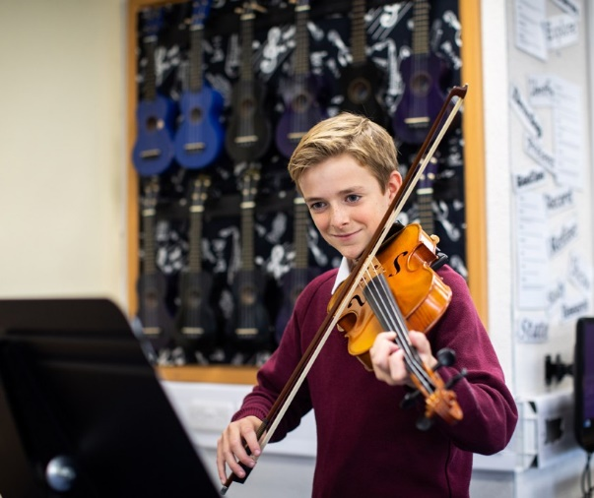
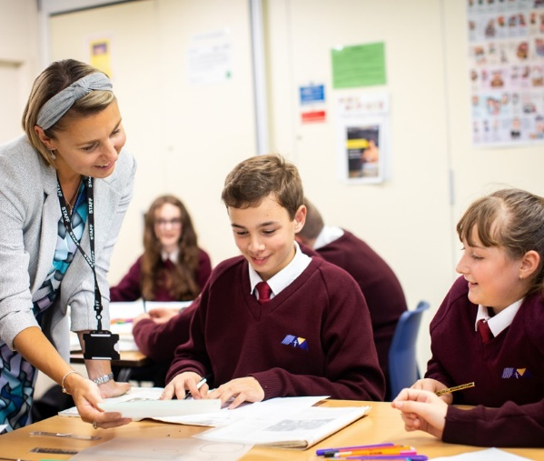
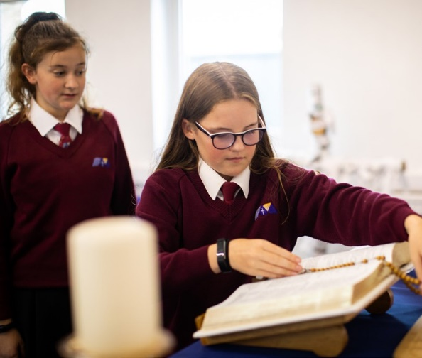
Teacher of Fine Art – 0.2 (1 day)

Start Date: September 2026
Salary: MPS/UPS
Line-manager: Head of Expressive Arts


Welcome
The St Thomas More Mission:

We the St Thomas More family, ‘aspire not to have more but be more’.

We aspire not to have the world but be more for the world.

#BeMore
am delighted to welcome you to St Thomas More Catholic Voluntary Academy.
I

We think that STM is a special place where every child is seen as an individual, and where nurturing the gifts and talents of our children is central to our mission. Our motto of ‘aspire not to have more but to be more’ summarises our ambition for our young people to #BeMore.

We achieve this by offering the highest quality of education possible, which includes a broad range of experiences aimed at developing the whole child and enabling all to grow in their faith in a safe and happy environment.

Our academic achievements and the standards of our pastoral care are excellent. We are very proud of the academic progress our students make and we are also very proud of the personal growth that they achieve during their time at St Thomas More.

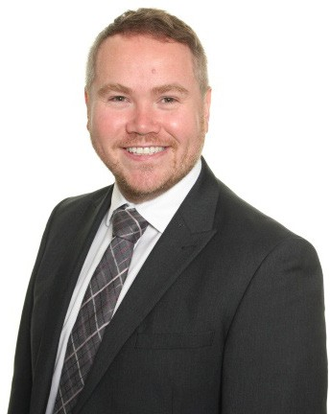
If you choose to join the St Thomas More family, you will be joining a school which strives for excellence through our strong Catholic faith, our commitment to high standards of achievement, our high expectations of behaviour and respect for all, and a belief in developing a love of learning and healthy living.

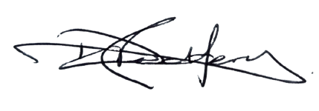

Mr D Redfern Headteacher

About this post

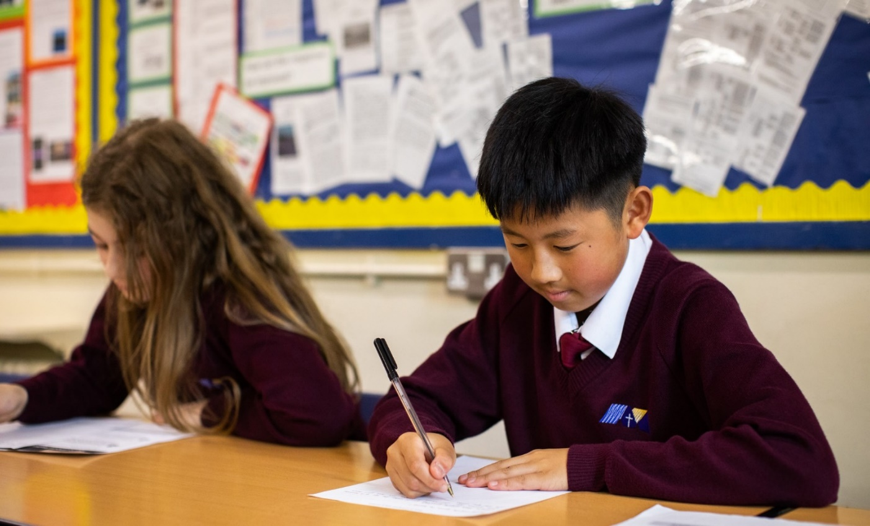
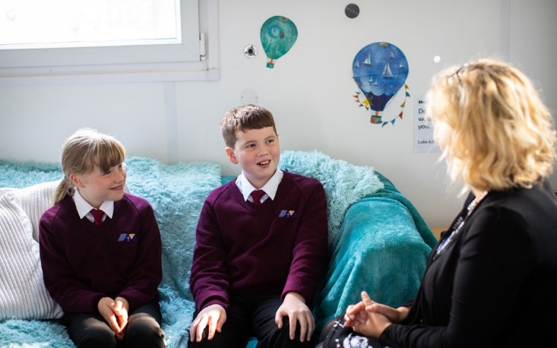

The Role

The Post
The successful candidate will teach Art across KS3 and KS4, nurturing students’ creativity, developing their artistic skills, and supporting them to fulfil their potential. They will play an active role in promoting and celebrating students’ enthusiasm and talent in Art, contributing to the vibrant artistic life of the school through exhibitions, clubs and wider enrichment opportunities.

We are seeking an enthusiastic, creative and committed Teacher of Fine Art to join our highly

successful and popular department from January 2026.

This is an exciting time to become part of our

thriving Expressive Arts Department as we continue

to build on our excellent reputation, embracing innovative curriculum developments and exploring fresh, inspiring approaches to teaching and learning

in the arts.

GCSE Fine Art (AQA 8202) – Course Overview and Teacher Profile

The Course We Offer
At GCSE, our pupils follow the AQA Art & Design specification (Fine Art). The course allows them to
develop ideas, refine techniques and create personal outcomes through a wide variety of media. Pupils
explore drawing, painting, printmaking, mixed media, 3D work and digital processes, with sketchbooks forming
a key part of their creative journey.

Assessment is through two components:
- Portfolio (60%) – a collection of work produced across the course, showing creativity, experimentation and progression.
- Externally Set Assignment (40%) – a practical exam responding to a theme set by AQA, giving pupils the opportunity to bring together their skills in a final piece.
The course is designed to be stimulating, flexible and student-centred, encouraging independent thinking and personal expression while ensuring students gain the skills and knowledge to progress to A-level Art or other creative pathways.

The Teacher We Are Looking For
We are seeking a teacher who is:
- Passionate about Fine Art – able to inspire young people with a love of creativity and a belief in the value of the arts.
- Skilled across media – confident in traditional and contemporary approaches: drawing, painting, print, 3D and digital.
- Knowledgeable about the AQA specification – understands assessment objectives and can guide students to meet them.
- Creative and innovative – keen to introduce new ideas, techniques and artists to broaden pupils’ experiences.
- An excellent classroom practitioner – strong at planning, differentiation and feedback, able to engage and motivate learners of all abilities.
- Organised and efficient – capable of managing coursework portfolios, preparing for moderation and meeting deadlines.
- Reflective and collaborative – willing to share good practice, contribute to the department vision and develop professionally.

In Short
We want a teacher who can bring energy, expertise and creativity to the role, helping our pupils to achieve highly and to discover the excitement and possibilities that Fine Art has to offer.

#BeMore

‘Aspire not to have more but to be more’
Saint Oscar Romero

Person Specification

 | Essential | Desirable | Evidence
Qualifications & Experience | - A Good Honours Degree  - Qualified teacher status | - Post-graduate qualification e.g. MA, PhD or EdD | Application form, letter & references
Skills & Knowledge | - The ability and willingness to collaborate effectively with colleagues.  - Effective prioritising work habits and strong organisational skills  - Experience of working in a pressured environment.  - Skillful, effective and confident  classroom teacher  - A knowledge and commitment to safeguarding and promoting the welfare of children and young people.  - Thorough understanding of the National Curriculum and KS4 exam context to support effective teaching and learning.  - Secure subject specific knowledge.  - Commitment to raising standards.  - Understanding and knowledge of developments in learning and teaching.  - Ability to work with a range of colleagues.  - Understanding of the range of needs of young people within age group.  - To be committed to the objective of raising achievement in the school.  - To help raise standards of learning for pupils  - Working with young people in a statutory or non-statutory setting.  Ability to form and maintain appropriate relationships and personal boundaries with children and young people.  - Motivation to work with children and young people.  - Effective classroom practitioner.  - Competent with ICT.  - Able to reflect on own practice.  - Very good communication skills.  - Good organisational skills and able to meet deadlines.  - Very good numeracy/literacy skills  - Use basic written/email correspondence conveying instructions, guidance or information  - Understanding of the range of needs of young people within age group.  - To have a flexible approach to work. | - Experience in developing therapeutic thinking support strategies to overcome barriers to learning  - Experience of delivering programs to support learning and monitoring and evaluating individuals and cohorts of students which has led to improved outcomes  - Experience of KS2-KS3 transition  - Working with young people in a statutory or non-statutory setting.  - Able to apply theory to professional practice.  - Ability to support Literacy across the Curriculum | Letter, references & selection process
Work related personal requirements | - Strong interpersonal, written and oral communication skills  - Genuine passion and a belief in the potential of every student, regardless of need – and the ability to raise the self-esteem and expectations of children and young people.  - Ability to meet deadlines  - Projects a professional image. |  | Letter, references & selection process
Personal qualities & skills | - Enthusiastic, sensitive, flexible, hardworking and the ability to remain calm  - Positive role model  - Ability to translate vision into reality  - High level skills of effective communication (both verbal and written) with all stakeholders, time management and prioritisation  - Ability to keep confidences  - Excellent interpersonal skills and organisational skills  - Ability to support and challenge  - Ability to inspire, motivate and influence others  - Integrity, honesty and fairness  - Excellent attendance record  - Good sense of humour  - This post is subject to an enhanced DBS disclosure  - Must be committed to safeguarding the welfare of children  - Willingness to participate in the extracurricular life of the school |  | Letter, references & selection process

Job Description

Main activities and responsibilities:

- Establish a good working relationships with students, providing a disciplined, motivated environment where standards of teaching and learning are consistently high;

- Plan and deliver differentiated work suitable to stretch all students in every teaching group, with particular reference to students’ Individual Education Plans;

- Provide personalised teaching, instruction and support; promoting appreciation, understanding and enjoyment of Science;

- Make maximum use of available resources to assist in teaching and learning;

- Mark classwork and homework effectively, in line with the schemes of work, as directed by the Head of Department/SLT;

- Monitor students’ progress, keeping a detailed record of the prior attainment and target levels / grades / outcomes for each child in each class, and an ongoing record of performance against these measures, completing regular assessments of students’ work and keeping up to date records;

- Plan and deliver appropriate opportunities to contribute to students’ spiritual, moral, social and cultural development;

- Provide plentiful opportunities for students to reach their full potential;

- Comply with the whole school assessment and reporting procedures;

- Assist in producing schemes of work, as appropriate;

- Follow departmental schemes of work and assessments;

- Attend calendared departmental meetings;

- Undertake the duties of a form tutor;

- Play a full and active role within the department and Pastoral team;

- Attend courses and undergo training as necessary and train any relevant personnel as required;

- Keep abreast of new initiatives by embracing professional development;

- Actively seek students’ views in reviewing teaching and learning and schemes of work; through student questionnaires and discussion, in order to continuously improve teaching and learning;

- Comply with the academy’s performance management policy on an annual basis;

- Attend calendared evening meetings as required;

- Provide clear, accurate and informative reporting to parents, whether oral or written, on student progress, as directed by the Head of Department, SLT or Headteacher.

- Contribute to departmental policies and developments;

- Contribute to the production of learning resources and internal test / examination papers;

- Ensure the requirements of the National Curriculum and external examinations are met, preparing students properly for internal and external examinations;

- Liaise with the Head of Department and Pastoral team with regard to any student whose progress is the cause of some concern or a real cause for celebration;

- Comply with all academy policies and procedures;

- Keep a full record of the attendance/absence of all students in lessons;

- Participate actively in the ‘rarely cover’ and duties programmes;

- Ensure the good order, appearance, dress and conduct of students, as they move around the academy.

Any other duties which may arise during the course of work and are authorised by the Headteacher or member of the Senior Leadership Team. Such duties will be commensurate with the general level of this post and will be subject to the skills and abilities of the post holder.

‘Aspire not to have more but to be more’
Saint Oscar Romero

St Thomas More Catholic Voluntary Academy, Palace Fields,

Buxton, Derbyshire,

SK17 6AF


enquiries@stm.srscmat.co.uk
01298 23167 scan the QR code to visit our website

