
Woods Avenue, Hatfield, Hertfordshire, AL10 8NN
Telephone: 01707 276 504

Woods Avenue, Hatfield, Hertfordshire, AL10 8NN
Telephone: 01707 276 504

Southfield School



Candidate Information Pack

Deputy Headteacher

Introduction
As part of our continued growth, we are delighted to invite an ambitious, forward-thinking, and inspirational Deputy Headteacher to join our experienced leadership team. This is a rare opportunity to step into a role with real influence, meaningful leadership responsibility, and the chance to positively shape young lives every day.

Working closely with the Headteacher and wider team, you will play a key role in shaping school improvement priorities, raising standards, and ensuring the best possible outcomes for every child.

Contract Type
This is a permanent role.

Closing Date
Friday 27th March 2026

Interview Date
w/c Monday 30th March 2026

Start Date
We are looking to appoint for a September 2026 start.

Please note: If we receive a high volume of applications, we may close this advert early. Southfield School reserves the right to interview and appoint candidates on receipt of applications before the closing date. We encourage you to submit your application as soon as possible.

Salary
L12 (£69,332) - L18 (£80,134) Fringe

About the School
Southfield is a primary school for over 100 pupils with Learning Difficulties, which include, Autism, Speech Language and Communication Needs, Global Developmental Delay, and associated conditions.
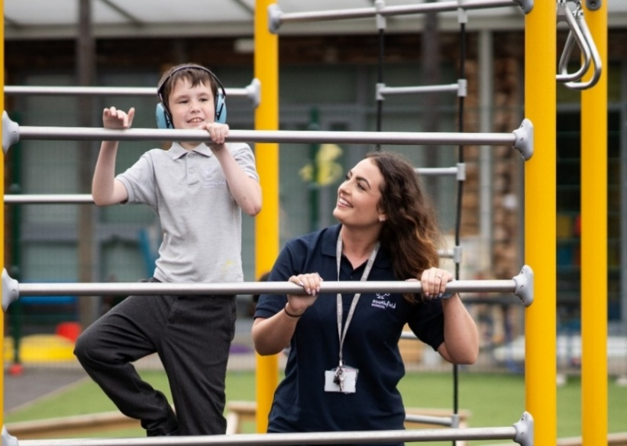
Admissions are via the Local Authority. Pupils attending Southfield are typically working at a significantly lower academic level, with cognitive abilities assessed at approximately 34 – 50% of their chronological age (in line with Hertfordshire descriptors, 2022).
We follow the Early Years Foundation Stage (EYFS) and Key Stage 1 National Curriculum, carefully adapting both to meet the individual strengths, interests, and needs of each individual pupil. Our curriculum is structured into three progressive phases, ensuring personalised learning pathways for all children.
Our Priorities

- Communication skills
- Self-Regulation
- Independence
- Functional literacy and mathematics
- Foundational learning
We work collaboratively with a variety of professionals, therapists and social care colleagues, to ensure a holistic approach to each child’s development.

In addition, partnerships wit sporting and creative arts organisations enrich our curriculum and provide enhanced learning opportunities both within school and in the local community.

Southfield is going through a period of rapid and exciting change, that you could be part of. It is a journey of challenge, in the pursuit of excellence, but one that provides huge rewards both personally, in your professional development and when you see the difference you make to the lives of our young people and their families.

About the Role
Working alongside a passionate leadership team, you’ll play a pivotal role in driving school improvement, nurturing staff development, and creating an environment where every pupil can thrive academically, socially, and emotionally.

As Deputy Headteacher, you will help deliver a high-quality, inclusive education service that reflects both school values and regulatory standards. Working closely with the Headteacher, senior leaders, and key stakeholders, you will champion high expectations, strengthen teaching and learning, and ensure outstanding outcomes for all pupils.
This position has been created as part of our ongoing commitment to strengthening and expanding our leadership team — offering you the opportunity to make a lasting strategic and operational impact within a growing school community.

Main Responsibilities
The Deputy Headteacher has the same professional duties as classroom teachers. In addition, the Deputy Headteacher is required:
- To undertake major responsibilities arising from the Headteacher’s professional duties which have been reasonably delegated to you.
- To undertake, as necessary, the full range of professional duties of the Headteacher in the event of the latter’s absence from school.
- To play a major role in supporting the Headteacher in monitoring the effectiveness of the school through self-evaluation and data analysis and to develop effective school development plans.
- To lead on the development of the curriculum across all pathways.
- To lead on assessment across school and produce reports as necessary in ensuring that all pupils are making expected progress.
- Highly visible leadership daily.
- Be a Deputy lead for Safeguarding and Child Protection, working within a team, supporting the DSL.
- Lead on continued professional development and training opportunities for all staff. Provide high quality professional leadership which secures the reputation, success and improvement of the school, ensuring the highest quality of education and care for pupils so that they best achieve and are safe and happy at school.
- In liaison with the Headteacher, initiate the agenda and lead teaching staff meetings, ensuring effective communication of information through holding regular meetings.
- Participate in recruitment and coordinate induction and mentoring arrangements for new employees in the team.
- Assist the Headteacher in mentoring of teachers and support staff and to take a lead role in the performance management of teachers and other staff.
- To act as a critical friend to the Headteacher, to provide effective professional challenge and support.
- Attending governor meetings, as required, and providing consultation and information to governors as pertinent to the focus of the governing body and delegated duties to the Headteacher.
- Model excellent professional conduct with colleagues, pupils, parents and the wider community.
- The duties outlined in this job description are in addition to those covered by the most recent School Teachers’ Pay and Conditions Document. It may be modified by the Headteacher, after discussion with you, to reflect or anticipate changes in the job, commensurate with the salary and job title.
- The job description will be reviewed at least twice a year as part of the Appraisal process.

Person Specification

SELECTION CRITERIA | Essential | Desirable | Measured by Application (AP), Presentation (P),  Interview (I)
QUALIFICATIONS AND TRAINING
Qualified Teacher Status (QTS) | √ |  | AP
Educated to degree level or equivalent | √ |  | AP
Evidence of being an outstanding teacher | √ |  | AP
Evidence of continuing professional development | √ |  | AP
Other relevant Professional Qualifications |  | √ | AP
Safeguarding experience as part of DSL team |  | √ | AP
Good understanding of how individuals with a range of SEND learn, engage and develop | √ |  | AP, P, I
Evidence of strong pupil-centred vision and values | √ |  | AP, P, I
A confident understanding of pedagogical approaches and strategy, applied within special education | √ |  | AP, P, I
Good knowledge of what the characteristics of an effective school are and successful strategies for improving outcomes | √ |  | AP, P, I
Good knowledge of current SEND educational initiatives and practice (national and local) | √ |  | I
EXPERIENCE
Recent and relevant experience as an effective Senior Leader | √ |  | AP
Recent evidence of leading significant initiatives at a strategic level | √ |  | AP, I
Evidence of commitment to a culture where all staff are motivated and feel supported | √ |  | AP, I
Evidence of multi-disciplinary working | √ |  | AP
Evidence of successful work with parents, carers, Governors, and the wider community | √ |  | AP, I
Experience in identifying emerging talents and coaching and mentoring individuals, leading to clear succession planning | √ |  | AP
INDIVIDUAL ABILITY AND QUALITIES
Capacity to work individually and/or as part of a team to influence change | √ |  | AP
Clear understanding of successful strategies for improving the quality of provision and pupils’ progress | √ |  | AP, P, I
Clear commitment to high expectations for children and young people’s learning and achievement | √ |  | AP, P, I
A good understanding of the features of high-quality practice for supporting young people with learning difficulties | √ |  | AP, I
Ability to manage difficult situations and problem solve calmly and confidently | √ |  | AP, I
Good written and verbal communication skills | √ |  | AP, P, I
Good interpersonal skills with both pupils and adults | √ |  | AP
Good planning, organisational, and management skills, with the ability to prioritise work and meet deadlines | √ |  | AP, I
Knowledge and understanding of The SEND Code of Practice | √ |  | AP, I
The ability to consistently inspire, motivate, and empower others | √ |  | AP, I
Emotional resilience | √ |  | P, I
A clear understanding of personal strengths and weaknesses, and a flexible approach to teamwork | √ |  | AP, I
A high level of professionalism and integrity | √ |  | P, I
A keen sense of humour and general positive approach | √ |  | AP, P, I

A word from our Headteacher


Are you bored with life? Looking for a new challenge? Have a desire to work in an environment where you can make a ‘real’ difference to the lives of young people? If so, Southfield School is the right environment for you.
We are a family with over 100 pupils. No two pupils are alike, and no two members of staff are alike. Our pupils all have challenging ASD and associated conditions.
Our school vision is to support all children, so they thrive during their time at Southfield School and are prepared socially, emotionally, and academically for their next steps in education. Collaboration with parents and carers and the entire multi-disciplinary team who support our pupils is vital and key to our success.
Everyone plays a part in the future of our pupils with staff skills being used in order that we have a huge range of skill set and expertise. Everyone makes a difference to the lives of our pupils and families.
We are looking for like-minded, resilient staff who are passionate and who can work in a team.
If you have yet to find what it is that you were meant to do with your life – Southfield School may be what you have been searching for.

Come and join us and make a difference to the lives of children every day.

Angela O’Rourke
Headteacher

Our Vision and Values

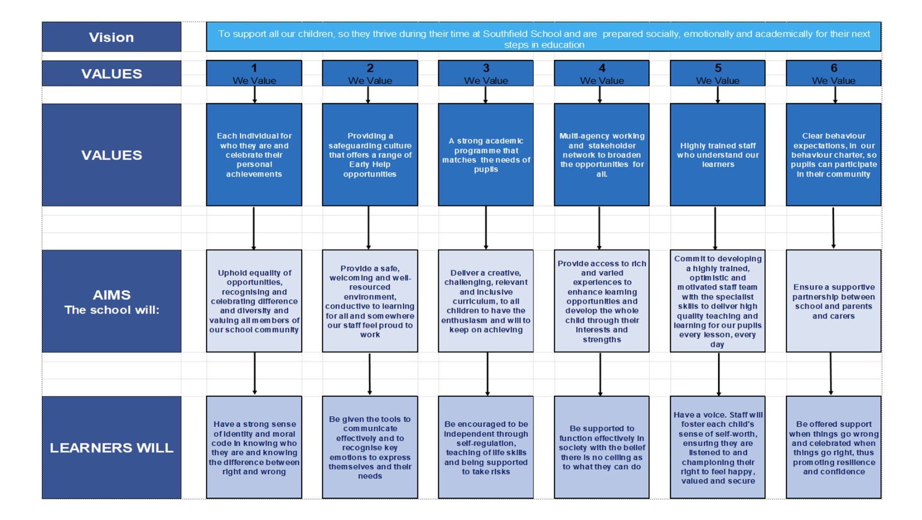
A Bright Future for ALL
What We Offer
Working at Southfield School is more than just a job – it’s a career with meaning, and whether you are working directly with our young people or in a supporting role, the work you do ultimately helps to change lives.

We recognise that our employees are the key to helping us achieve our ambitions and deserve to be valued and supported.

Our rewards and benefits include:
- 24 hour employee assistance programme (EAP) for advice, information and support
- Local Authority Cycle to Work Scheme.
- Long Service Awards.
- High quality training offered through face to face, virtual and through various providers free of charge.
- Free care parking on site.
- Contribution towards staff uniform.
- Free refreshments and staffroom area.
- Tax relief may be available on staff uniform.
- Staff recognition scheme.
- Highly supportive team environment.
- Support with career progression.
- Pension Scheme – Please follow the link for further information regarding Teacher Pensions and rates of contributions: http://www.teacherspension.co.uk/

Application Information

Visits to the school for potential candidates are warmly welcomed. Visits will be hosted by the Headteacher.
Please contact the school office to book an appointment by emailing: admin@southfield.herts.sch.uk
Equal Opportunities Monitoring Form
At Southfield School, we want our workforce to reflect the diversity of the community we
serve. It is our policy to ensure that job applicants and employees are treated justly, and are
recruited, selected, trained, and promoted on the basis of the job requirements, skills and
abilities. We will ensure that people are not disadvantaged by conditions or requirements, which cannot be shown to be justified as being necessary for the effective performance of
the job. You are under no obligation to complete this form, however if you do you are agreeing, under the Data Protection Act 2018 that Southfield School may hold and use personal information about you for monitoring purposes.

Safeguarding
Southfield School has a responsibility for and is committed to safeguarding and promoting
the welfare of children, young people, and vulnerable adults to ensure that they are
protected from harm. All conditional offers of employment are subject to the following pre-employment clearances:

Satisfactory Medical Clearance
All successful candidates complete a medical questionnaire and may be required to pass a
medical examination by the Southfield School.

Satisfactory References
It is the school’s practice to take up at least 2 references from your last two employers. Referees must not be a member of your family, or spouse/partner and the reference must be provided on letter headed paper or come from a work email address. If you are a recent school or further education leaver, one of your references must be from your school or college. Occasionally more than two references may be required, if this is the case, we will inform you before we contact former employers.
In line with our safer recruitment policy, we will take up references ahead of interview. Once we have received your references, we will call your referees to verify that the reference
is from them as part of the keeping children safe in education requirement. No employment
will be offered until 2 satisfactory references are received.
Social media checks are also conducted prior to interview.

Rehabilitation of Offenders Act 1974
The Rehabilitation of Offenders Act 1974 makes it unlawful for prospective employers to
consider offences in relation to which the person concerned is deemed to be rehabilitated. This means that after a certain period (dependent on the seriousness of the offence
and length and severity of the punishment), the person concerned is to be assessed as if the conviction has been ‘spent’ (i.e. treated as if it had never occurred). Rehabilitation periods vary according to the type and length of conviction originally incurred. All posts within the school are covered by the Rehabilitation of Offenders Act (Exemptions)
Order 1975 and DBS clearance is required and therefore detail must be given about all
convictions, whether spent or not.

Disclosure and Barring Service (DBS) (Previously CRB) Clearance
As all posts require a DBS check, the successful candidate will be required to complete the
appropriate DBS documentation. The successful candidate will be unable to take up the
appointment until the clearance is received from the DBS. The timescale for these checks is
outside the Southfield School’s control.

Prohibition from Teaching
All teaching appointments are subject to a check with the Department for Education to
ensure that you are not subject to a prohibition order or an interim prohibition order.

Evidence of Qualifications
We will need evidence of the qualifications (original certificates) you specify in your
application form. Originals must be brought to the interview for candidates who have been
short-listed. Copies will not be accepted.

Eligibility to work in the UK
To comply with the Asylum and Immigration Act 1996 (As AMENDED) (Immigration, Asylum
and Nationality Act 2006), all employers in the United Kingdom are required to make basic
documentation checks on every person they intend to employ. We ask all short-listed applicants to provide proof that they can be legally employed. We must see satisfactory proof in the form of original documentation before we can confirm any
offer of employment. If we do not see satisfactory proof, an offer of employment can be
withdrawn.

