
Appointment
Information Pack

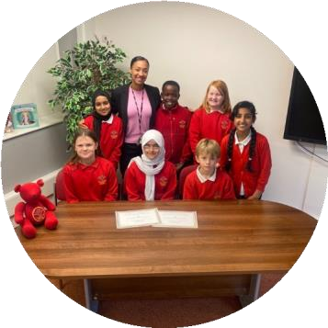



Vacancy | 0.5 Cover HLTA  EYFS through to Year 6
Location | Old Trafford Community Academy
Start date | 23rd February 2026
Closing date& time  Interview & Assessment | - Closing date for applications Friday 30th January 2026 at noon.  - Interviews w/c 9th February 2026
Salary | SCP Point 24

Welcome from the Academy Headteacher

Thank you for expressing an interest in the position of Cover HLTA at Old Trafford Community Academy.

This is an exciting opportunity for a Cover HLTA to join the OTCA team at our established and successful primary school, which is proud to be part of Focus Trust.

The role of Cover HLTA is a key role within the academy and is suited to an enthusiastic and highly skilled practitioner.

To succeed in this role you will need to be a committed practitioner, have excellent interpersonal skills. Insisting on high expectations for our children’s learning is crucial as this role involves supporting children to make progress.

Old Trafford Community Academy is committed to safeguarding children, and this commitment is reflected in our recruitment processes.

Please return your application to me at the academy as soon as possible, and by 12 noon on Friday 30th January. Applications should be completed on My New Term

We intend to hold interviews w/c 9th February 2026

I look forward to receiving your application.

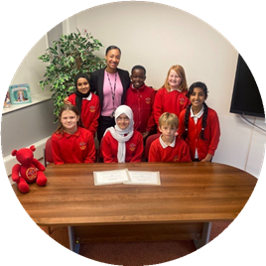
Nicole Davenport
Headteacher

Welcome from Chair of Governors

Dear applicant,
Thank you for taking the time to consider applying for the role of Cover HLTA at Old Trafford Community Academy. As Chair of the Governing Board, I would like to take this opportunity to tell you a little bit about the context of our school.
We are located in Trafford close to its border with Manchester and its city centre, and have over 350 children on roll. Our diversity is a real celebration as our children and families come from a wide range of backgrounds.
We converted to an academy on 1st April 2014. We value the highly skilled professional support and challenge that Focus-Trust provides. At the same time, we have maintained our place in the Trafford family of schools playing a full role in the Stretford and Old Trafford leadership cluster of primary schools. It is a feature of the educational dynamic in the area that Trafford has retained selection to grammar schools within its authority boundary.
Our children and our families are at the very heart of all that we do and the partnership with parents and the commitment of our staff, really allows our children to achieve well and become lifelong learners. The high quality of relationships that we develop with children, parents and colleagues allows everyone to feel a sense of community and belonging.
When you visit us, you will find children who are happy to be in school. We have a reputation for being friendly and welcoming with an exceptionally hardworking team of staff. Our recent Ofsted inspection recognised the progress we have made and confirmed we are working on the key areas for improvement. The full Ofsted report can be found on the school website.

I hope I have given you a flavour of Old Trafford Community Academy. We have every confidence that we will successfully recruit a Cover HLTA who would like to become a valued part of our school community and who will help us to continue to develop our vision to provide the best possible education for the benefit of our pupils, their families and the community in which they live.

Academy details

Academy | Old Trafford Community Academy
Address | Malvern St, Old Trafford, Manchester M15 4FL
Telephone | 0161 912 4875
Email | n.davenport@focus-trust.co.uk
Website | www.oldtraffordcommunityacademy.co.uk

Job Description

Academy/School | Old Trafford Community Academy
Job Family | Teaching Support
Job Title | Cover HLTA
Grade | FT Grade 6 – SCP 24-28
Accountable to | Headteacher
Line manager | Deputy Headteacher

Purpose of the role
To complement the professional work of teachers by taking responsibility for agreed learning activities under an agreed system of supervision. This may involve planning, preparing and delivering learning activities for individuals/groups or for whole classes as maybe required. Monitoring pupils and assessing, recording and reporting on pupils’ achievement, progress and development.
Responsible for the management and development of a specialist area within the school and/or supervision of other teaching assistants including allocation and monitoring of work, mentoring and training.
Main Duties:
Support for Pupils
- Establish rapport and respectful, trusting relationships with pupils, acting as a role model and setting high expectations
- Promote inclusion and acceptance of all pupils, and encourage pupils to interact and to work co-operatively with others and to engage in activities led by yourself and/or the teacher
- To assess, assist and support pupils, including those with special needs, to access a range of learning activities, through specialist skills, in-depth knowledge of the National Curriculum and theoretical knowledge of how pupils learn.
- The role may include supporting and implementing pupils’ personal programme, including social, health, physical, hygiene, and welfare matters. The pupil may also need assistance to access different areas of the school.
- Following appropriate training and in line with school procedures, to administer basic first aid and/or medication as required.
- Make effective use of ICT in learning activities and develop pupils’ competence and independence in its use.
- Develop and implement Individual Education Plans and Behaviour Plans
- Support with the development and implementation of Health Care Plans as appropriate
- Promote self esteem and independence and employ strategies to recognise and reward achievement of self-reliance.
- Provide specific feedback in discussion with pupils on their progress and achievement, in line with school policy.

Support for Teachers
- Within an established discipline policy, to anticipate and manage behaviour constructively, promoting self-control and independence.
- Support the role of parents in pupil learning and contribute to /lead meetings with parents to provide constructive feedback on pupil progress, achievement, problems etc
- Within an agreed system of supervision, plan and prepare creative and challenging teaching and learning objectives. Produce, evaluate and adjust lesson plans and learning resources, such as worksheets, as appropriate.
- Deliver learning activities, including those developed by self, which are part of local and national learning strategies, e.g. literacy, numeracy, KS1 & 2 or early years (as defined by the Principal/Headteacher), to pupils within an agreed system of supervision. To take into account individual pupil learning styles and needs to make adjustments to activities so pupils can engage with the subjects/topics being delivered. This will involve individual, group and whole class work and may take place when the teacher is not present.
- Monitor and evaluate pupil responses to learning activities through a range of assessment and monitoring strategies against pre-determined learning objectives.
- Provide objective and accurate feedback and reports as required on pupil achievement, progress, and other matters, both in lessons and other activities. Systematically record pupils’ progress and achievements, ensuring availability of appropriate evidence
- Administer and undertake routine marking of pupils’ work using an explicit mark scheme that does not require interpretation. Invigilate tests / examinations as required.
- Organise and manage an appropriate learning environment and resources.
- Select and prepare resources necessary to lead/support learning activities, taking account of pupils’ interests, language and cultural backgrounds
- Advise on appropriate deployment and use of specialist aid, resources and equipment.
- Assist with the development of displays of children’s work as required
- Provide appropriate administrative support for teachers as required to support with the effective and smooth running of the classroom and activities.
- To attend team/staff meetings and represent the school at external meetings as required

Support for the School
- Establish constructive relationships and communicate with other agencies/professionals, in liaison with the teacher, to support the achievement and progress of pupils. Take the initiative as appropriate to develop appropriate multi-agency approaches to supporting pupils
- Organise and deliver out-of-school learning activities within guidelines established by the school as may be required.
- Contribute to the identification and implementation of appropriate out of school learning activities, which consolidate and extend the school activities as may be required.
- Provide cover for classes within the agreed system of supervision. This could be regular planned cover for the teacher, e.g. for PPA time (Planning, Preparation and Assessment) or could be to cover for staff absences as appropriate in order best meet the needs of the school.

Supervision of Staff
- Supervise other teaching assistants and support with the recruitment, induction, training and mentoring of Teaching Assistants as may be required.
- To organise and monitor the workloads of teaching assistants and other staff falling under his/her remit, including ensuring cover is in place for absences
- To hold regular team meetings with managed staff
- To represent teaching assistants at meetings

Fulfill wider professional responsibilities
- Make a positive contribution to the wider life and ethos of the School and the Trust.
- Develop effective professional relationships with governors, colleagues, families knowing how and when to draw on advice and specialist support.
- To be willing and able to be part of a team of first aiders/fire wardens as may be required.
- Communicate effectively with pupils, school staff and visitors.
- To participate in training and other learning activities and performance development as required.
- To be aware of and comply with policies and procedures relating to child protection, health, safety and security, confidentiality and data protection, reporting all concerns to an appropriate person.

Personal and professional conduct
All Focus Trust staff are expected to demonstrate consistently high standards of personal and professional conduct. The following statements define the behaviour and attitudes which set the required standard for conduct throughout a career with the Trust.

All Staff must uphold public trust in the profession and maintain high standards of ethics and behaviour, within and outside the School, by:
- treating governors, pupils, staff, parents and visitors with dignity, building relationships rooted in mutual respect, and at all times observing proper boundaries appropriate to an adult working in an School environment;
- having regard for the need to safeguard pupils’ well-being, in accordance with statutory provisions;
- showing tolerance of and respect for the rights of others;
- not undermining fundamental British values, including democracy, the rule of law, individual liberty and mutual respect, and tolerance of those with different faiths and beliefs; and
- ensuring that personal beliefs are not expressed in ways which exploit pupils’ vulnerability or might lead them to break the law.

All staff working in the Focus-Trust must have proper and professional regard for the ethos, policies and practices of the School and the Trust, and maintain high standards in their own attendance and punctuality.

All staff must have an understanding of, and always act within, the statutory frameworks which set out their professional duties and responsibilities; and within the policies, handbooks and guidelines of the School and of the Focus-Trust.

General
The post holder will:
- Be expected to actively support the work and ethos of the Focus-Trust.
- Be expected to undertake such additional duties as may reasonably be requested by the Principal/Headteacher or their representative.
- Respect confidentiality of staff, pupils, families and visitors and not breach this trust. Any breaches of confidentiality must be reported to the Principal/Headteacher immediately.
- Participate in arrangements for appraisal and in the identification of areas in which s/he would benefit from training and undergo such training.
- Comply with and support all policies related to equal opportunities, child protection and safeguarding of children and colleagues.

This job description is neither exhaustive nor exclusive, and it may, after consultation with the post holder be subject to modification and amendment in accordance with Trust’s procedures.
Post holder: Signed ………………………………………… Name …………………………………..
Principal: Signed ………………………………………… Name …………………………………..
Dated: …………………………………………………..

About our Academy

Academy vision
Old Trafford Community Academy is a very special place. We have a wonderfully diverse school community, with an equally diverse range of strengths and needs. We are ambitious for all our children and committed to going the extra mile to remove barriers to learning. We aim to be a community school in the widest sense of the word, supporting children within the context of their family and their wider communities.

Our pupils
Our pupils are the best advertisement for our academy! They come from a diverse range of backgrounds, and work and play well together. The proportion of children eligible for pupil premium is well above average. The majority of children speak English as an additional language.

Our staff
We have a large and talented staff team. We believe that our children and their families need the very best staff to support them. We are therefore committed to supporting ongoing staff professional development. All new staff will be offered training and support, through an agreed induction programme.

Our geographical area
Old Trafford Community Academy is an inner-city primary academy serving a multi-cultural area. We are situated in the north of Trafford, very close to Manchester city centre. There is currently a regeneration of areas within and close to Old Trafford, with new homes being built.

Our facilities
We occupy a modern building, with good outdoor facilities. We are lucky to have large school grounds given that we are close to the town centre.

Our school organisation
We are a two-form entry school. Year groups plan together, and support each other in delivering the whole curriculum. The academy leadership team consists of Headteacher, Deputy Headteacher, Assistant Headteachers, Business Manager and Family and Child Well- being practitioner.

Our curriculum
Our curriculum is led by our Assistant Headteacher, supported by our subject leaders. We use Essential Writing and Power Maths to support our teaching. Much of our learning is through our termly academy-wide topics and schemes such as Kapow. We are supported by specialist teachers and coaches in music and PE/sports.

Our extended services
We have a range of extended services to support children and their families. This includes universal services for the whole community, alongside more targeted support where needed. For example, we employ an independent social worker to help us provide early intervention to support our children and families.

School Quick Facts

Type of school | Primary
Age range | 4-11
Location/LA | Trafford
Number of children | 350
Number of teaching staff | 19
Number of support staff | 10
% FSM | 50.9%
% SEN | 18.9%
% EAL | 68.6 %

Background to the Trust

Focus-Trust was incorporated in May 2012 as a primary trust. The Trust has links with the sponsor, Focus Education, but is an entirely separate legal entity. As with all academy trusts, the Trust is a company limited by guarantee and an exempt charity. The Trust’s offices are situated in a newly converted historic mill conversion in Chadderton, Oldham with excellent motorway networks to access our schools.

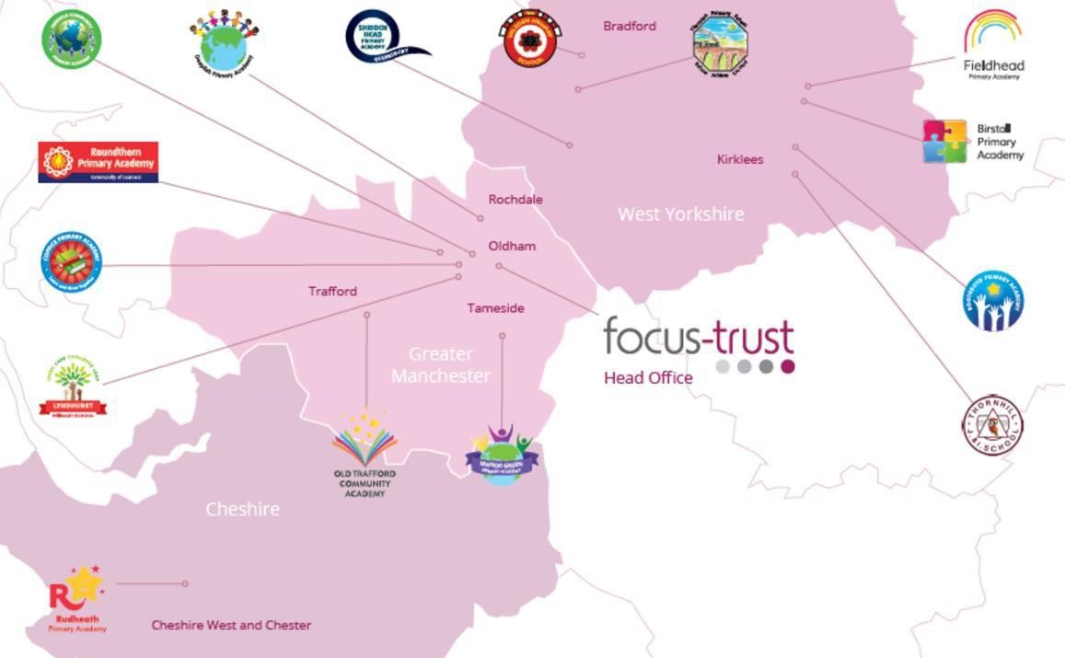

The defining feature of Focus-Trust is that it is a specialist primary phase trust. This means that the work of the Trust is driven by the distinctive needs of primary schools. Whilst the Trust has robust systems for accountability, each school has their own distinctive identity, ethos and culture, and this is a commitment to every school when they convert and join the Trust.
Focus-Trust currently has a small centrally employed team. The members of the team are highly skilled and committed to the vision, culture and values of the Trust.
All the schools within the Trust are willing partners who have actively chosen to join Focus-Trust and there is a very high degree of consensus, cooperation and commitment from within the group.
The Trust has robust policies and systems in place to govern and guide its work. These have been gradually implemented as the Trust has grown. The Trust has well-established productive relationships with trade unions and meets half termly with a group of national trade union representatives to discuss policy development. This has enabled us to introduce and change a range of policies in a streamlined and cooperative way.

Vision
‘Great schools at the heart of our communities’ - with our Community Champions and colleagues, we strive to ensure we are being civic leaders making a difference in the local and national communities and the community is supporting us.
Commitment
‘Learning together, making the difference’

Collective Efficacy
We have a well-developed and securely embedded culture of Collective Efficacy. By this we mean we have, ‘A shared commitment to work together on the things that matter to improve outcomes for all.’

The Focus-Trust Values
Professional honesty is at the heart of everything we do. The Trust knows the schools well because of the strong working partnership between academy leaders and the Trust Central Team. It is only by being honest and transparent with a balance of credible challenge and effective support, that we can move forward and get the best for all children and staff. Our work is underpinned by our values:
Care for children, adults and the learning environment
Dare to do things differently and have a go
Be fair, honest and inclusive – demonstrating integrity
Share expertise and best practice for the benefit of all learners

What you might want to know about Focus Trust

Pensions
Focus-Trust contributes to Teachers’ Pensions and Local Government pensions in the same way and with the same level of contribution as local authorities.
Continuous service
Focus-Trust recognises continuous service (as detailed within contracts of employments)

Employer Relations
Focus-Trust has a Trade Union agreement which recognises the teacher and support staff unions. This is further supported by an ongoing and productive relationship with key trade union officials.

Equality of opportunity
Focus-Trust is an equal opportunity employer, dedicated to a policy of non-discrimination in employment on any basis including age, gender, race, colour, nationality, ethnic origin, disability, gender, religion, age, marital status, sexual orientation and/or medical condition.

Safeguarding
Focus-Trust is committed to safeguarding and promoting the welfare of all children and young people. There is an explicit expectation that all employees share this commitment and adhere to all safeguarding policies and procedures. Applicants should be aware that the recruitment process will include an assessment of your suitability to work with children.

Dress code
We expect all colleagues to dress professionally and appropriately for the roles undertaken. We pride ourselves on the high standards of dress of both our pupils and staff; these standards are led by our colleagues who we expect to set an example.

Policies
Focus-Trust and the schools have a range of policies and handbooks that help to make clear our expectations and ways of working. These are always shared openly with staff and are accessible to everyone. There are several policies that prospective employees should be aware of when making an application. These can be found on the Trust website www.focus-trust.co.uk and school websites. All members of staff will be asked to sign a declaration as part of the induction process to acknowledge that they have read and understand the Code of Conduct and some of the key policies, e.g. Safeguarding and Child Protection, Health and Safety, Acceptable use of IT.

Right to work in the UK
Under the Asylum and Immigration Act 1996, it is a criminal offence to employ anyone who is not entitled to live or work in the United Kingdom. Applicants can expect us to ask for proof of this at interview stage, where you will be asked to provide some original documentation to confirm that you are eligible to work within the UK. Photographic proof of identity will also be required.

Validation of qualifications and identity
All shortlisted candidates will be asked to bring original certificates or relevant qualifications and identity documents to interview. These will be photocopied and kept on file and, if appropriate, may be confirmed as genuine with the relevant awarding bodies. The copies of the successful candidate will be retained on their personnel file. The copies of unsuccessful candidates will be treated as confidential waste and disposed of appropriately.

References and Social Media Checks
If you are shortlisted, we will take up references before the interview date. One of your referees must be your current or most recent employer. Two satisfactory references must be received before we can confirm any offer of an appointment. The information we request will relate to salary, length of service, skills and abilities, suitability for the job, disciplinary record and suitability to work with children. Copies of references or open references will not be accepted. On receipt of references, your referees may be contacted to verify any discrepancies, anomalies or relevant issues as part of the recruitment verification process.
In line with our safer recruitment policy, on line presence checks will be undertaken if you are shortlisted. This check is designed to complement the range of standard recruitment checks and allows us to identify a candidate’s online presence which potentially could damage the organisation’s reputation.

Knowledge and skills profile
This is an important part of your application and is your opportunity to explain how you meet the person speciation for the post. You should demonstrate your skills, knowledge and experience and give short examples. Describe how you match the requirement of the job; include experience gained from previous jobs, community or voluntary work. Ensure that the information you give is well organised, relevant and brief. You may find it helpful to use subheadings in order to keep your statement well focused. If you do not submit this profile, you will not be considered for short listing.

Disability
To comply with the Equality Act 2010, we are legally required to consider making reasonable adjustments to ensure that disabled people are not disadvantaged in the recruitment and selection process. We are therefore committed to meeting, wherever possible, any needs you specify on the application form. Please contact Natalie Harris if you need to discuss this in any detail. We will consider any reasonable adjustment under the terms of the Act to enable an applicant with a disability (as defined under the Act) to meet the requirements of the post.

Disclosure of a criminal record
Employment in this role is subject to an enhanced check with the Disclosure and Barring Service (DBS). Checks will also be made against the lists showing people barred from working with children. All checks must be satisfactory before any offer of employment can be confirmed and before commencement of work can take place.
Please complete the application on My New Term by 30th January 2026 at noon.
Thank you for taking the time to read this information pack.
We wish you every success in any application you may make.

