


Assistant Teacher Support
South Axholme Academy
Candidate
Information Pack
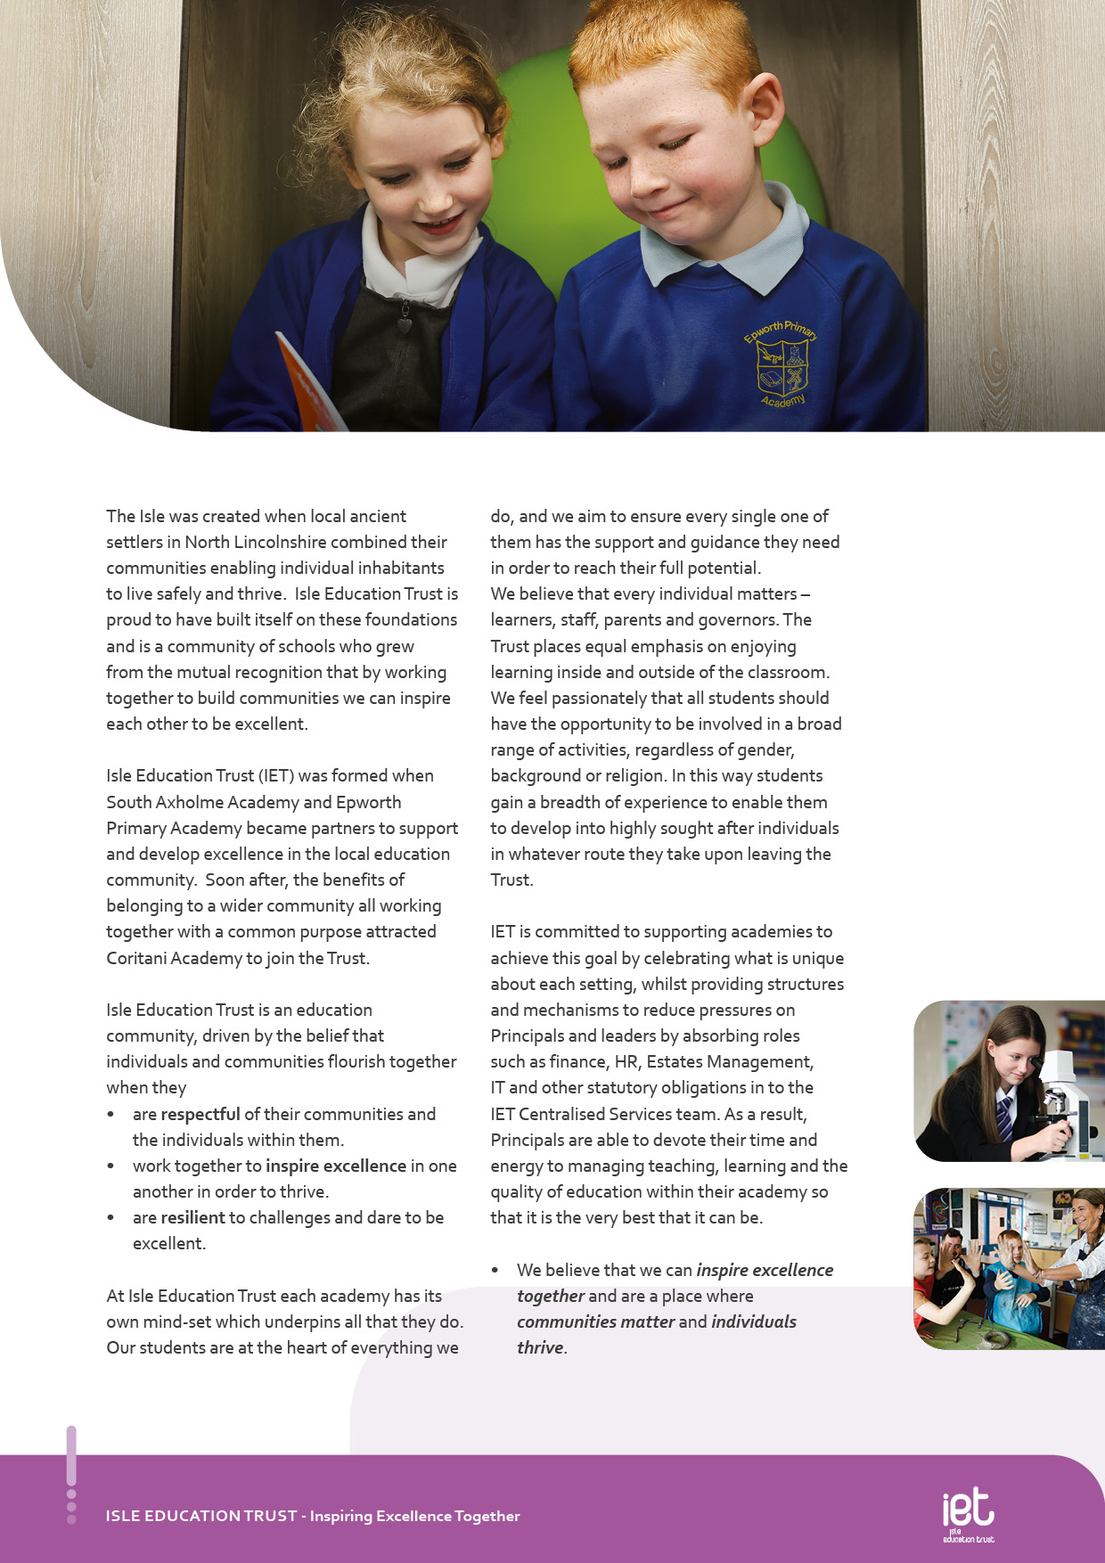
About IET

Dear Prospective Colleague,

Thank you for your interest in joining Isle Education Trust. I’m delighted that you're considering becoming part of our team—whether you’re looking to support students directly or contribute to the vital work that happens behind the scenes, your role matters deeply to us.
At Isle Education Trust, our vision is clear: Inspiring Excellence Together. Across our family of academies, we recognise that excellence doesn’t happen by chance—it’s built by a committed, skilled, and diverse team working together with shared purpose.
Our non-teaching colleagues are the backbone of our success. From safeguarding and administration to site management, finance, pastoral support, and everything in between, you help shape the culture and daily experience of our schools. Your expertise keeps our academies running smoothly, our environments safe and welcoming, and our pupils supported every step of the way.
We are proud to uphold values that guide our Trust:
- Respect – shown through honesty, consistency, and care.
- Resilience – demonstrated in our commitment to excellence, even in the face of challenge.
- Inspiration – sparked by individuals who lead by example and empower others to thrive.
When you join our team, you’ll find a community where your contributions are valued, your development is supported, and your wellbeing is prioritised. We offer professional learning opportunities, a culture of collaboration, and a genuine commitment to making our academies great places to work.
If you share our belief that every role within education is a chance to make a difference, I warmly invite you to explore opportunities across the Trust. We’d be thrilled to welcome you into our mission of inspiring excellence—together.
Warm regards,



Sarah Sprack
CEO, Isle Education Trust

Welcome from the CEO


Dear Prospective Colleague,
As Principal of South Axholme Academy, I am proud to lead a school with a rich history and an exciting future. Established as South Axholme School in 1961, we now serve approximately 930 students. In 2012, the school became an Academy, and the following year took a lead role in forming Isle Education Trust. The small size of the Trust enables close collaboration whilst allowing us to maintain autonomy over our curriculum and teaching to best meet the needs of our students and community.
Located in the historic market town of Epworth, North Lincolnshire, between Doncaster and Scunthorpe and within easy commuting distance of Rotherham, Sheffield, Leeds, East Yorkshire and Lincoln, South Axholme Academy draws students from over 25 primary schools across North Lincolnshire, Nottinghamshire, and Doncaster. We are regularly oversubscribed, which reflects the confidence families place in us.
Our academic outcomes consistently exceed the national average, reflecting our strong commitment to excellence. Equally important is nurturing the whole child by developing not only academic potential but also confidence, character, and wellbeing. Beyond the classroom, our vibrant calendar offers a wide range of events and enrichment opportunities, from sponsored walks and drama productions to sports clubs, educational visits, and community celebrations like Christmas carol concerts and senior citizens parties. Central to our ethos is the South Axholme Mindset—being Ready, Respectful, and Resilient—which guides everything we do and inspires everyone to Expect Excellence.
Knowing our students, staff, and families well allows us to provide a broad, balanced, and inclusive curriculum tailored to individual needs. As part of our commitment to support, we are developing a new study hub with North Lincolnshire Council, providing a smaller, focused environment for students who benefit from additional support.
South Axholme Academy is a vibrant, ambitious and welcoming school with a strong track record of excellence in all areas. As Principal, it is an honour to lead this community as we continue the next phase of our journey, one that I am confident will be filled with even greater success.
If you would like any further information about the role, or would like to arrange a visit, do get in contact by emailing admin@southaxholme-iet.co.uk or by ringing us on 01427 87212. I would be delighted to talk to you about our wonderful school!
Every best wish,



Stephanie Hamilton
Principal
South Axholme Academy

About the Academy

Job Purpose
To work under the direction of the classroom teacher to assist in the teaching and assessment of individual, or small groups of students. Manage student behaviour and ensure a safe learning environment.

The Assistant Teacher reports to the SENDCo.
Job Title Assistant Teacher Support
South Axholme Academy

Salary | £25,269 FTE
Job Details | 32.5 Hours (Term Time Only)
Location | South Axholme Academy
Required | Immediate Start
Application Close | 15 May 2026
Interview Date | TBC 2026

Job Description

Main Responsibilities

- Teach, supervise and assess individuals or small groups of students within the classroom, under the direction of the class teacher, to support progress and engagement in learning.
- Effectively manage student behaviour and respond appropriately to immediate issues or emergencies, in line with academy behaviour, safeguarding and health and safety policies.
- Support students to engage purposefully with the work set, providing additional assistance with literacy, numeracy and organisational skills where required.
- Provide timely and accurate feedback to the class teacher regarding student engagement, progress and any concerns or issues arising during lessons.
- Assist in the preparation, monitoring and maintenance of a safe, calm and secure learning environment that promotes positive attitudes to learning.
- Actively promote positive behaviour, high expectations and respectful relationships in line with academy values and policies.
- Undertake administrative duties commensurate with the role, including record keeping and supporting teaching and learning activities as required.
- Work closely with the Exams Coordinator to support the orderly, secure and efficient administration of public examinations.
- Act as an invigilator for both internal and external examinations, ensuring that examinations are conducted under formal conditions and in accordance with JCQ and academy regulations.
- When not required to undertake the duties outlined above, provide additional support across the academy, including undertaking alternative duties as directed.
- Be aware of and support differentiation, ensuring that all pupils have equality of access to learning opportunities and are supported to develop their full potential.
- Undertake any other reasonable duties as requested by the principal, members of the Senior Leadership Team, or the Data, Exams, Cover and Timetabling Manager.

Key Responsibilities and Accountabilities


INTERVIEWS:
Thursday 13th June 2024
CLOSING DATE:
Tuesday 11th June 2024 at 9:00am
- Work with all students ensuring equality of opportunity for all.
- Take responsibility for Safety and Welfare of all students, raising any concerns following the Academy/Trust protocols and procedures.
- Work proactively and effectively in partnership with all stakeholders.
- Carry out a share of statutory supervisory duties.
- Treat students with dignity and build relationships rooted in mutual respect and at all times observing proper boundaries appropriate to the professional position.
- Participate in CPD relevant to the role.
- Accompany teaching staff and students on visits, trips and out of school activities as required.
- Demonstrate an understanding of and take responsibility for promoting high standards of literacy including the correct use of spoken English and numeracy.
- Participate in arrangements for examinations and assessments.
- Take an active role in promoting good behaviour in and around the Academy/Trust.
- Ensure that students adhere to the uniform code and apply sanctions when this code is breached.
- Develop an academy learner mind-set – the attitudes, skills and learning habits needed to become an inspired, confident and independent learner.
- Be a positive role model and demonstrate consistently and effectively the positive attitudes, values and behaviour which are expected of students.
- Ensure compliance with data protection laws and safeguarding procedures.
- Work as a team member and identify opportunities for working with colleagues and sharing the development of effective practice with them.
- Regularly review the impact of their work and its impact on students’ progress, attainment and well-being, refining approaches where necessary and responding to advice and feedback from colleagues.
- Proactively participate with arrangements made in accordance with the Appraisal Policy.
- Have professional regard for the practice, ethos and policies of the Academy/Trust and maintain high standards in your own attendance and punctuality.
- Operate at all times within the stated policies and practices of the Academy/Trust.
- Contribute positively and effectively to the whole Academy/Trust ethos.
- Cooperate with other staff members to ensure a sharing and effective use of resources to the benefit of the Academy, individual departments and students.
- Attend and participate in appropriate calendared meetings.
- Take responsibility for own professional development and duties in relation to Academy policies and practices.
- Liaise effectively with staff, students, parents and governors.
- Ensure compliance with Health and Safety at Work Act 1974 and all other policies related to health and safety, and to ensure compliance with the Data Protection Act 1988.
- Carry out any other duties as directed by your Line Manager as may from time to time be agreed in accordance with the nature of the job described above.

We expect all Trust staff to:

This is not an exhaustive list of tasks and job descriptions will be continually reviewed and changed according to the needs of the Trust.

Post holders will be expected to be flexible in undertaking duties and responsibilities attached to their post and may be asked to perform duties, which reasonably correspond to the general character of the post and are commensurate with its level of responsibility. This job description is provided for guidance only and does not form part of the contract of employment.


Education, Qualifications and Relevant Experience | Essential | Desirable
Good literacy & numeracy skills | AI
Very good interpersonal and customer care skills | A I
Professional development relevant to the post |  | A
First Aid Qualification |  | A
Specialist Knowledge and Skills | Essential | Desirable
Experience of working in an educational setting or similar environment | A
Experience of working in a secondary school with students with Special Educational Needs | A
Experience of working with children / young people with Social Emotional and Mental Health Needs | AI
General understanding of school policies and procedures relating to health and safety, behaviour, attendance, equal opportunities, and child protection |  | I
Experience of MIS (Management Information System) & Data software | AI
Experience of Microsoft software packages (Word, Excel, Publisher) | AI
Basic understanding of child development and learning |  | AI
Practical Skills | Essential | Desirable
Flexible approach to work as well as good organisational and communication skills | AI
Ability to work collaboratively and effectively within a team | AI
Ability to work independently and to show initiative | AI
Ability to work under pressure, prioritise and meet deadlines | AI
Friendly, approachable, and non-confrontational manner combined with the ability to be firm | I
Ability to build and maintain successful relationships with students; treat them consistently, with respect and consideration, and demonstrate concern for their development as learners | I
The capacity to inspire and motivate others – both adults and students |  | I
Ability to use ICT for administrative purposes | A

Person Specification:

Personal Qualities & Essential Attributes | Essential | Desirable
A desire to work with young people and to support their education and achievements | AI
A professional approach in both manner and physical appearance | I
Able to demonstrate discretion, confidentiality, and commitment | I
Able to liaise sensitively with parents/carers recognising their role in the student’s learning | I
Enthusiasm, determination, and insistence on high standards | I
Flexible and good-humoured approach | I
A proven track record of excellent attendance and punctuality | I
A sense of humour and good sense of well-being | I
Able to work with or without supervision | AI
Commitment to safeguarding and promoting the welfare of children and young people | AI
High quality communication skills with the ability to develop positive relationships with students and adults of all levels | I
Ability to work as part of a team, understanding classroom roles and own position with the school hierarchy | I
High expectations of self and others | Essential | Desirable
A flexible and adaptable approach | A I
An innovator with the desire to continue to learn | AI
Resilience and the determination to be successful within this role and ambitious for the Academy and its students | I
Safeguarding | Essential | Desirable
Committed to promoting the welfare of all children and creating a safe environment in which children can learn; considering, always, what is in the best interests of the child | A I
Equal | Essential | Desirable
The ability to ensure that there is equality of access to educational attainment and that all aspects of equal opportunities are adhered to | I

KEY
A = assessed through the application process
I = assessed through the interview process


c
 Pension Scheme
All staff are enrolled in either the Teachers’ Pension Scheme or Local Government Pension Scheme, whichever is relevant.
 Continuous Professional Development
IET offers numerous opportunities for continued CPD for all staff including NPQs and apprenticeships

 Cycle to Work Scheme
Eligible staff may apply to purchase a new bike, e-bike or cycling accessories through this salary sacrifice scheme, making significant savings.

 Staff Wellbeing
This is a priority for the Trust. All staff have access to a free Employee Support Package, including 24/7, 365 days a year online and telephone support covering areas such as mental health, bereavement, financial advice and counselling.

 Healthcare
All staff have free access, 24/7, 365 days a year to an online doctor.

 Flu Vaccinations
All staff are able to request a free voucher for a flu vaccination in the Autumn term.

 Discounts
Through our employee benefits platform, staff can make significant savings through discounts and vouchers in a range of areas including restaurants, supermarkets, retail and holidays.

Trust Benefits:


Appointment Process
How to apply
To apply for this post, visit the IET website:

Isle Education Trust - Vacancies

Please note that the personal statement you provide as part of this process must be no longer than 1000 words.

Receipt of early applications from candidates with the appropriate experience, qualifications and personal qualities may result in an early interview being offered.

Isle Education Trust promotes equality of opportunity and welcomes applications from all sectors of society.

Isle Education Trust is committed to safeguarding and promoting the welfare of children and expects all staff and volunteers to share this commitment. All posts at Isle Education Trust are subject to an Enhanced Disclosure and Barring check.

