Managing Behaviour for Learning at All Saints
‘Let the children know that they are loved’
St Don Bosco
Our approach is underpinned by
Relationships, Routines & Restorative Practice.
It is rooted in our core values and communicated through a shared language that ‘falls from the mouth’ of every adult.

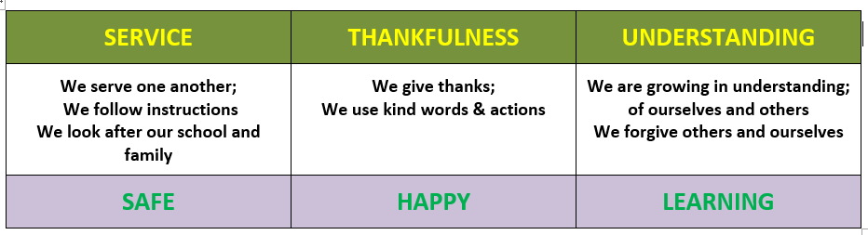

At All Saints, all staff understand and agree;
Behaviour is a form of communication.
Behaviour is a communication of an emotional need whether conscious or unconscious, and responding accordingly. Taking a non-judgemental, curious and empathetic attitude towards behaviour will encourage all adults in school to respond in a way that focuses on the feelings and emotions that drive certain behaviours, rather than the behaviour itself.

Equality of opportunity is not the same as equality of provision
Children are individuals. Our aim is always to allow equality of opportunity and to achieve this, we understand that provision will vary. Being ‘fair’ is not about everyone getting the same (equality) but about everyone getting what they need (equity).



Consistency builds trust
Our close work with families and the community has demonstrated that to enable a ‘secure base’ for our children and give them the best chance of being at their best, we need to provide a consistent, calm and emotionally stable environment for them.

Our approach is simple, equal and fair and we subscribe to a set of transformative consistencies that permeate our practice and interaction with the children:

We promote our Core Values
We use the language of our vision and core values to ensure a consistency of approach. Our Agreed rules are rooted in this framework and will be displayed prominently in every classroom and around the school. When discussing behaviour with a child we always ‘frame it’ using this language.

We give importance
The deepest desire in human nature is the desire to feel important. That’s why praise and reward work. Giving importance is different for everyone - we all value different approaches and have different interests but we are consistent in making the pupils in our school feel important.

We celebrate pro-social contributions
It is vital that we use good role models regularly. Therefore, every day, in every class, the children are used to model exemplar behaviours and positive contribution. Staff will make explicit the link between these behaviours and learning.

We teach routines
It is essential to establish routines that promote high standards of learning behaviour.

At All Saints’s Children are praised for:

- Taking turns in talking
- Waiting until asked to speak;
- Following instructions the first time they are given;
- Listening to each other;
- Answering questions in full sentences
- Moving quietly and carefully about the room and corridors;
- Entering and leaving the room in an orderly and sensible manner
- Doing their best to complete work in a given time.

Children are expected to work and talk quietly (unless the task specifically requires otherwise).
When moving around the school, children are expected to walk quietly. When entering Worship or Whole School gatherings, children are expected to do so in silence.
Adults will model the expected behaviours and also be silent at these times.

We restore relationships
We understand that positive and productive relationships with children are central to ensuring school is a secure base for them- adults take the lead with children who struggle to maintain positive relationships.
We use restorative conversations to restore the relationship between child and child or child and adult.
Each new session during the day presents an opportunity for children to have a ‘fresh start’.

We use a ‘stepped approach’ & we deliver consequences with dignity
Behaviour management begins at classroom level with a positive and proactive approach rooted in our committment to providing a ‘secure base’ for every child in our care.

We use a range of ‘pro active’ strategies to support children in maintaining pro social behaviours before escalating through the behaviour pathway. This could include:

- redirection
- distraction
- non-verbal strategies
- rule reminder
- gentle encouragement
- sitting with a teaching assistant or other adult
- sitting in another part of the room but still within the lesson
- peer led approaches – changing groupings, encouraging positive pairings

We follow up
We ensure ‘certainty’ at the classroom level. Teachers take responsibility for developing class and individual behaviour plans and interventions and implementing them. Teachers seek support with challenging behaviour but don’t delegate the responsibility.

We work in partnership
The ‘pincer movement’ between a dedicated teacher and a committed parent is very hard to escape.
The class teacher is responsible for taking the lead in developing a partnership with parents to ensure that they are fully involved in adjusting poor conduct and celebrating successful changes in behaviour.

We reflect and develop our practice.

