East Specialist Inclusive Learning Centre (SILC)

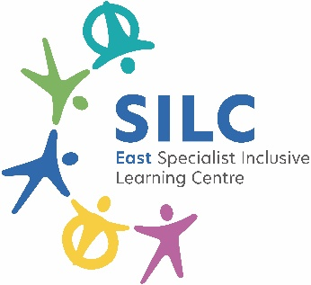Job Description

Job Title: | Transition Support Worker
Pay Band: | C1 FTE- £28,598 (Actual Salary- £24,597)
Responsible to: | A Nominated Senior Leader
Hours of Work: | 37 hours per week. Term-time only +5 days and additional hours as required which will be negotiated and remunerated

Values:
The four pillars of the East SILC are:
- Kindness
- Integrity
- Ambition
- Collective responsibility
Vision:
At the East SILC we believe in Exceptional Education for Exceptional Lives
Safeguarding:
The East SILC is committed to safeguarding and promoting the welfare of children and young people (learners) and expects all staff and volunteers to share this commitment. Appointments are made subject to a satisfactory enhanced Disclosure and Barring Service check (DBS formally CRB) and medical clearance from Leeds City Council’s Occupational Health Service.
All shortlisted candidates must complete a self-disclosure form before interview.
It is illegal to apply if you are on the children’s barred list.

The East SILC promotes diversity and wants a workforce which reflects the population of Leeds.

Role:

To support learners with next steps and in all aspects of preparing for the adult world, particularly at the Roger Cannon and Temple Moor sites. To be instrumental in working collaboratively with other colleagues to ensure families of learners are given the correct level of support to be enabled to make the right steps for progression through and out of the East SILC.

Main Duties:
- Communicate with learners to understand their goals and ambitions
- Assist learners to discover and overcome their personal barriers and set goals
- Provide classroom support to learners as required
- Keep records and documentation and prepare appropriate reports
- Liaise with next step providers to ensure strong level of opportunities are available for learners
- Liaise with parents around next step opportunities
- Provide targeted support to parents where required to enable positive destinations for learners, particularly for those year 10 and 11 learners identified as not remaining with East SILC post 16
- Support the staff team working with the learner to enable bespoke transition experiences where needed
- Work with other SILC team members to ensure good transition support provision across the SILC
- To support with careers interviews and EHCP across the SILC and support these where needed
- To attend any conferences across Leeds that may be of benefit to learners in the SILC in agreement with other colleagues, and cascade information and opportunities to the right colleagues within the SILC
- To have a working knowledge and understanding of the Leeds Local Offer and other providers to ensure learners and families are provided with choices in potential destinations.

Special Conditions of Service:
- Requirement to occasionally work out of school hours and off school premises as required by the school.
- Working across the East SILC.
- Appropriate and professional work wear
- The school and grounds have a no smoking policy.

Whilst every effort has been made to explain the main duties and responsibilities of the post, each individual task may not be identified. Employees will be expected to comply with any reasonable request from the Executive Principal to undertake work of a similar level that is not specified in this job description
This job description is current at the date shown. It will be reviewed at least annually and, it may be changed by the Executive Principal to reflect or anticipate changes in the job commensurate with the grade and job title.

