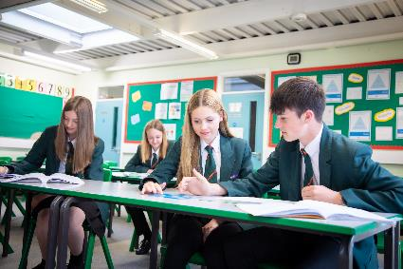
Teaching Assistant
Part-time (2 days a week) - fixed term for one year (1/9/26 – 31/8/27)
Salary Grade 2, pro rata
Are you looking for a new opportunity in an innovative and supportive 11-18 Catholic school? Now part of the St Gabriel the Archangel Catholic Multi – Academy Trust, the largest multi-academy in the Archdiocese of Birmingham. Blessed William Howard is looking to recruit dynamic, forward-thinking and inspirational staff to join us on our journey to success. With a strong Catholic ethos that puts ‘love’ at the heart of its community, the school provides a haven where all can flourish. Situated just outside the town centre and easily accessed by train, bus or the M6, Blessed William Howard is proud of its strong community links and its beautiful grounds.

Further details and application forms can be accessed via My New Term https://mynewterm.com/
We are committed to safeguarding and promoting the welfare of children and expect all staff and volunteers to share this commitment. All appointments are subject to an enhanced DBS check, satisfactory references, and pre-employment medical clearance. In line with Keeping Children Safe in Education (KCSIE), online searches will also be carried out for shortlisted candidates. This post is exempt from the Rehabilitation of Offenders Act 1974.

Blessed William Howard is proud to be part of the St Gabriel the Archangel Catholic Multi-Academy Trust. A company limited by guarantee registered in England & Wales with company number 08146661. Registered Office Address: Station Road, Cheadle, Staffordshire ST10 1LH. Telephone: 01538 493777.

About the role:
We are seeking to appoint a caring, enthusiastic and committed Teaching Assistant to support students with Special Educational Needs and Disabilities (SEND) across the whole school. This is a fantastic opportunity to work with young people facing a range of educational challenges, helping them to develop their skills, achieve their potential and improve their life chances.
The successful candidate will:
- Be inspirational, engaging students and fostering a positive and enthusiastic learning environment.
- Be determined to help every student achieve their full potential.
- Have a genuine passion for supporting the needs of young people with SEND.
- Ideally have an understanding of Education, Health and Care Plans (EHCPs)
and how to support students effectively.
- Be a positive team player with excellent communication and interpersonal skills.
This is a term-time only position, working 2 days per week, and is offered on a
fixed-term basis for one year. The salary will be Grade 2, pro rata to hours and weeks
worked.
Start Date: September 2026
Application Deadline: 14 August 2026 at 7am
Interview Date: TBC

Teaching Assistant - Grade 2
Part-time (2 days a week) - fixed term for one year
Teaching Assistant - Grade 2
Part-time (2 days a week) - fixed term for one year

Why Blessed William Howard?

- A Christian community with a caring, secure and
disciplined environment.
- A wide range of extra-curricular activities.
- High academic standards.
- A commitment to success for all.
- Ongoing CPD for all staff

“There is a warm atmosphere and the quality of relationships between all members of the school community are a particular strength. Pupils and staff are friendly, helpful, polite and welcoming to visitors.” Diocesan Section 48 Report

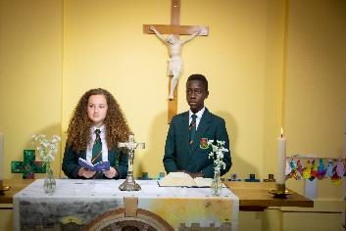

Blessed William Howard
Catholic High School, Stafford ST17 9AB
Part of the St Gabriel the Archangel Catholic
Multi – Academy Trust

