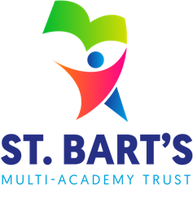
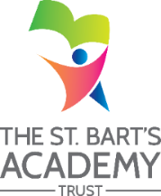
ST. BART’S MULTI-ACADEMY TRUST
Job Description

Job Title: | Apprentice Teaching Assistant
School Name: | Meir Heath Academy
Hours: | 37.5 hours per week
Contract Length/Type | 12 months in the first instance

JOB PURPOSE
An apprentice Teaching Assistant is required to join our small and successful primary school. We want the successful candidate to share our vision of providing creative and stimulating learning opportunities to develop the whole child. The successful apprentice will help to provide a safe and happy learning environment which enables every child to flourish.
KEY DUTIES / RESPONSIBILITIES
Under the guidance of the class teacher/supervisor, the successful candidate will be involved in working with individuals or small groups of children to support the education, personal and social development of pupils and establishing positive relationships to assist pupils complete structured learning activities. Duties may include:
- Support to implement learning activities working with individual or small groups of pupils,
- Support to assist the development of varying skills that support pupils' learning,
- Support in producing learning resources,
- Assist in pupil supervision,
- Support in monitoring and recording of pupil progress and developmental needs,
- Reporting pupil progress to line managers,
- Work within the school’s policy and procedures,
- Working to the relevant apprenticeship standard/framework and completing work in a timely manner,
- To support children at lunchtimes ensuring behaviour is consistent with school’s expectations and provide activities where necessary
- To support children in out-of-school care provision; providing activity support
- To the accountabilities above, the apprentice may be required to undertake any of the duties normally associated with a Teaching Assistant to support with their training and development.
This school is committed to safeguarding and promoting the welfare of children and young people and expects all staff and volunteers to share this commitment by:
- Raising all concerns regarding the behaviour, progress or wellbeing or safety of pupils.
- Actively promoting and safeguarding the welfare of children and young people by adhering to the school’s safeguarding and associated policies
- Demonstrate an understanding of legal requirements, national policies and guidance on the safeguarding of children and young people.
- Know how to identify abuse or neglect and follow safeguarding procedures.

Apprenticeship

The successful apprentice will be expected to apply themselves to the apprenticeship with commitment and diligence.

The apprentice will also be required to commit and work to the school's values and ethos.

As part of this role the successful candidate will be expected to work towards completing the apprenticeship framework, Teaching Assistant Level 3.

ST. BART’S MULTI-ACADEMY TRUST
Person Specification

Job Title: | Apprentice Teaching Assistant

PERSON SPECIFICATION
The successful candidate would also have the following skills:

• Good team player
• Good communicator with parents, teachers and pupils
• Good time management skills
• Good organisational skills
• Knowledge and understanding of confidentiality
• Ability to use ICT

Experience of working with or caring for children of a relevant age in a voluntary or work experience capacity is desirable.

Applicants wishing to apply for this position should ideally have GCSE Maths and English at grade C/4 or equivalent although this is not an essential requirement for the role.

The successful candidate will also be required to complete functional skills initial assessments in Maths and English. Maths and English functional skills must be completed as part of the apprenticeship, if prior achievement at GCSE C/4 has not previously been achieved.

