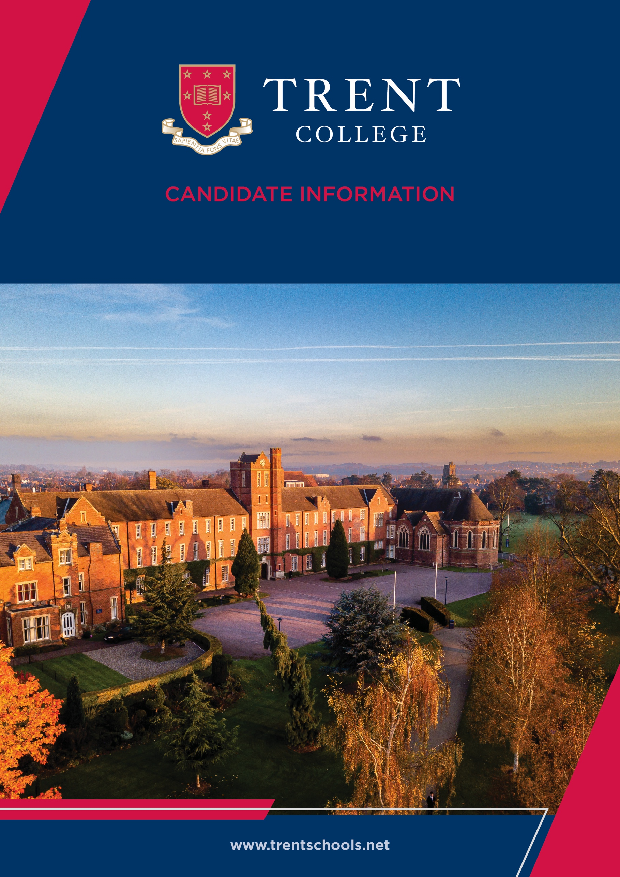


Welcome
Trent College is an independent co-educational boarding and day school, located in Long Eaton, Nottinghamshire. Founded in 1868, we have been providing a first-class education for over 150 years.
Set in a beautiful 45-acre campus we enjoy state-of-the-art facilities, including modern classrooms, sports facilities, and boarding houses. With traditional foundations and a modern outlook, Trent College is renowned for providing an excellent education for its 1,200 pupils.
The Elms is our Nursery and Junior School which provides a stimulating and nurturing environment to our youngest children, aged 6 weeks to 11 years. The two schools work closely together and share the same vision, aims and ethos. Together, we give the highest priority to the quality of our academic provision. Alongside a strong focus on sports, music, drama and a wide range of co-curricular activities to develop our pupils’ character and resilience, to prepare them for the modern world.
Rated ‘Excellent’ across the whole school by the Independent Schools Inspectorate in 2021, Trent College has a strong academic record, with a high percentage of students achieving top grades in their examinations and going on to study at some of the best universities in the UK and abroad.
We have highly qualified and experienced teaching staff who are committed to providing an excellent standard of education. We also have a large population of support staff, ensuring that our friendly school and beautiful campus operate to the very highest standards.

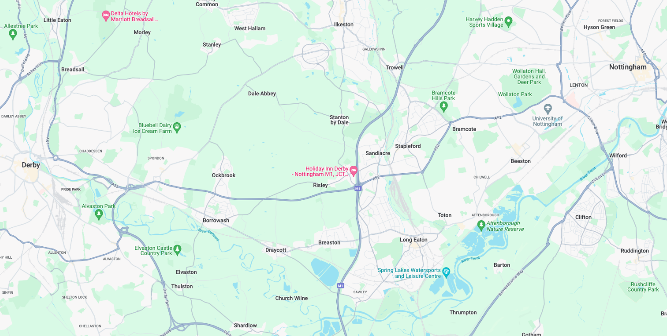
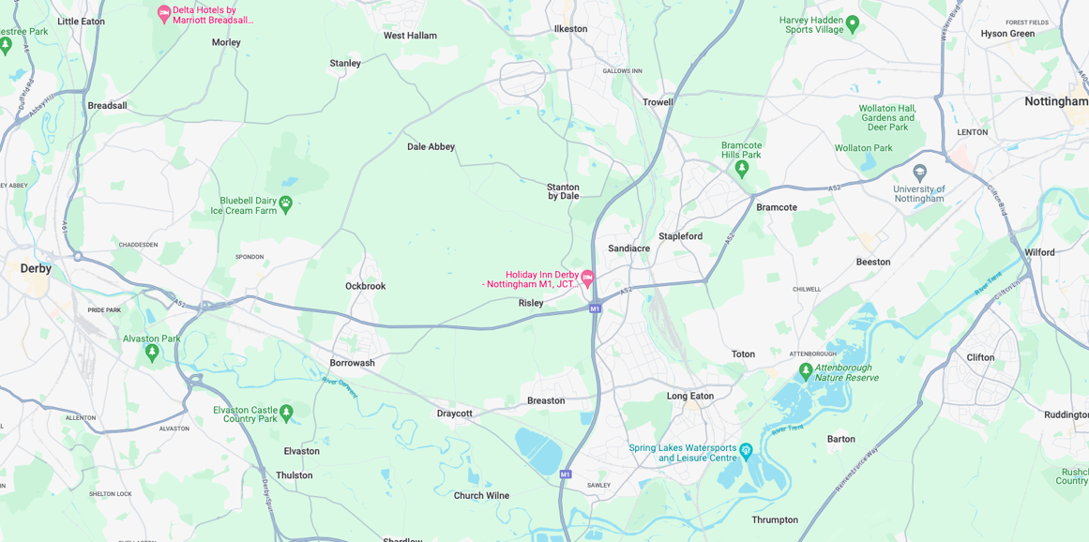


Our Location
Trent College and The Elms are conveniently situated on the border of Nottinghamshire and Derbyshire.
Ideally located at the heart of the UK’s motorway system, we are only 2 miles from junction 25 of the M1, which provides easy access to the M42 and A1.
Reaching Trent College by rail couldn’t be easier. Long Eaton boasts its own train station, located 1.5 miles from the schools. Rail routes through Long Eaton run along the Midlands Main
Line route, with direct routes to London, Loughborough, Leicester, Birmingham, Nottingham, Derby, Chesterfield and Sheffield.

Our Local Community
Working in partnership and serving the community are natural and very important values at Trent College and The Elms. We work with many local schools in Long Eaton and the wider Erewash borough to increase opportunities and aspirations, and to share the school’s excellent grounds, facilities and specialist staff.



Visiting Music Teacher

Classical Guitar

Job Description
The Music Department requires an exceptional and inspirational Teacher of Classical Guitar to join the department, which is already highly successful and collaborative. The successful candidate will be required to teach individual lessons.

Key Responsibilities
- Deliver high-quality individual classical guitar lessons to pupils as allocated by the Director of Music.
- Monitor and report on student progress in line with the school’s reporting schedule.
- Prepare students for and enter them into examinations, festivals, and competitions.
- Rehearse and lead ensembles as directed.
- Identify and support potential scholarship and exhibition candidates.
- Maintain professional conduct, representing the school positively at all times.
- Respond to school communications (including emails) in a timely and professional manner.
- Meet deadlines set by the Director of Music or Music Administrator.
- Report concerns in relation to the school’s Child Protection, Bullying and Welfare policies.
- Report concerns regarding underperformance, commitment or attendance to the Director of Music.
- Attend required training and INSET sessions.




Person Specification

Essential
- Strong subject knowledge and performance ability in Classical Guitar.
- Proven ability to teach and inspire students across a range of abilities.
- Experience of preparing students for graded exams and performance opportunities.
- Ability to work collaboratively within a busy music department.
- Strong organisational skills and ability to meet deadlines.
- Excellent communication skills, both written and verbal.
- Commitment to safeguarding and student wellbeing.
- Professional, reliable, and approachable manner.

Desirable
- Experience of directing ensembles or group performances.
- Track record of student success in exams, competitions, or scholarships.
- Familiarity with working in a school or educational setting.
- Interest in contributing to a vibrant co-curricular music programme.





Benefits
- Part time – Variable hours
- Competitive Salary
- Staff can enjoy complimentary lunches in the Obolensky Dining Hall during term time.
- Free car parking is available on site and staff have access to a cycle to work scheme.
- Staff are able to make free use of the school gym and leisure facilities at designated times.
- A flexible retirement plan run by TPT Solutions (formerly The Pensions Trust), including Death in Service benefit. OR A defined contribution pension scheme is available to join, provided by AVIVA, with a generous employer contribution. Members also benefit from death in service and income protection.
- Enhanced sick pay and maternity pay is available to staff.
- Staff are entitled to a fee remission for children attending the school, In line with our policy.
- We provide a range of benefits to support staff, including counselling, an employee assistance programme and 24/7 online GP consultations.

Terms and Conditions
- Part time, variable hours.
- Rate of Pay: Teach £35.91, Ensemble/Concert £29.31, Admin £13.16



Making an Application
Candidates who wish to apply for this post should complete the online application form.
If you have any questions about the role please email recruitment@trentcollege.net or telephone 0115 949 4949 (during term time).
The closing date for applications is included in the advert.
We reserve the right to close this advertisement early if we receive a volume of strong and suitable applications.

The school is committed to safeguarding and promoting the welfare of children and young people and expects all staff and volunteers to share this commitment.
Applicants will be required to undergo child protection screening appropriate to the post, including checks with past employers and the Disclosure and Barring Service (DBS). The school may carry out online searches on shortlisted applicants and all applicants will be required to provide details of their online profile, including social media account names/handles, as part of their application
The post is exempt from the Rehabilitation of Offenders Act 1974. The school is therefore permitted to ask job applicants to declare all convictions and cautions on a self-declaration form in advance of attending an interview (including those which are "spent" unless they are "protected" under the DBS filtering rules) in order to assess their suitability to work with children.



