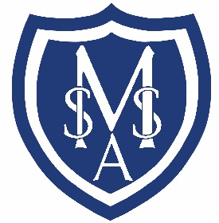

St Mary’s CE Academy, Stotfold

VACANCY

Midday Assistant

We are looking to appoint a Midday Assistant to join our lunchtime team to start early 2026.

The role will be a hybrid of working in our School Kitchen and as a Midday Supervisor. Hours will be between 1.5 and 3 hours each day depending on role, term time only plus INSET days with possible extra hours at times of high need or staff absence. Responsibilities will include supporting the kitchen and midday staff in delivering a high quality and healthy lunchtime experience, cleaning and tidying the kitchen and dining hall and supervising the children. This is a physical role and involves an amount of manual handling. The role will be paid at NJC Scale 1D, commencing at £12.85 per hour.

The successful applicant will need to be flexible and willing to promote the positive and friendly ethos of the school.
We are committed to the well-being of every child and every person in our school community and we expect all employees, volunteers and contractors to share this commitment.

The post will be subject to the disclosure of criminal records through the DBS process.al

If you are interested please apply via My New Term or contact the office for further details

St Mary’s CE Academy, Stotfold
Rook Tree Lane
Stotfold, Hitchin
Hertfordshire
SG5 4DL
01462 730343
e-mail: admin@stmarysacademystotfold.co.uk
website: www.stmarysacademystotfold.co.uk

Applications will close once a suitable candidate has been interviewed and appointed.

