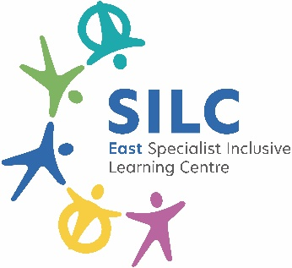 | External Job Advertisement  East SILC John Jamieson School  Hollin Hill Drive,  Leeds,  LS8 2PW  Tel: 0113 2930236  www.eastsilc.org
Post: | Lunchtime Supervisory Assistant
Salary Details: | A1 – FTE- £24,413 (Actual Salary- £6,171.00)
Hours: | 10 Hours Per Week (2 hours daily)- Term Time Only
The East Specialist Inclusive Learning Centre (SILC) is a 2-19 generic special school with 470 learners on roll. All our learners have special learning needs and some have physical/ medical difficulties. The East SILC is a complex organisation which operates on a variety of sites to provide a range of outreach services across the city, including partnerships with primary and secondary providers, the city-wide Physical Difficulties and Medical Service including a moving and handling service, as well as the Medical Needs Teaching Service for Leeds.
Do you want to join a team making a difference to learner’s lives?

An opportunity has arisen for Lunchtime Supervisory Assistants to work at the East SILC based at John Jamieson and Jack Clark but as with any post could be based at any of our sites across the SILC. These will be permanent posts subject to a 6 month probationary period, to start as soon as possible;
The main duties will be:
- To attend to the learner’s personal needs and implement related personal programmes, including social, physical, hygiene, first aid, toileting and feeding as required.
- To supervise and support learners during the lunch break ensuring their safety.
- To establish good working relationships with learners, acting as a role model and being aware of and responding appropriately to individual needs.
- To encourage learners to interact with others and engage in playground activities.
- To encourage learners to act independently as appropriate.
- Any other duties commensurate with the grade as directed by your line manager.
- To ensure promotion and support of Equal Opportunities and Health and Safety.

To apply please visit eastsilc.org/News/Vacancies.
Closing date for applications: |  | July 2026
Interviews to take place: |  | TBC- Interviewing as we going
The East SILC is committed to safeguarding and promoting the welfare of children and young people (learners) and expects all staff and volunteers to share this commitment. Appointments are made subject to a satisfactory enhanced Disclosure and Barring Service check (DBS formally CRB) and medical clearance from Leeds City Council’s Occupational Health Service.

All shortlisted candidates must complete a self-disclosure form before interview.
It is illegal to apply if you are on the children’s barred list.

The East SILC promotes diversity and wants a workforce which reflects the population of Leeds.

