
Teaching Assistant

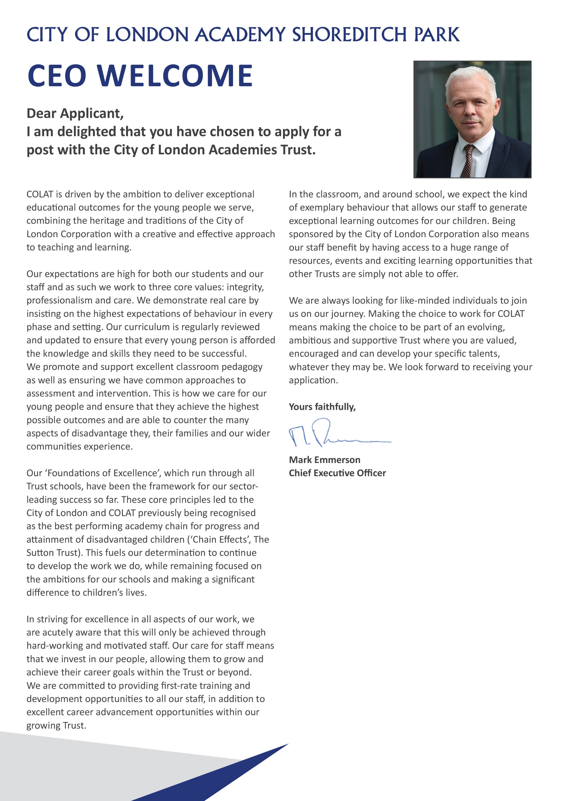

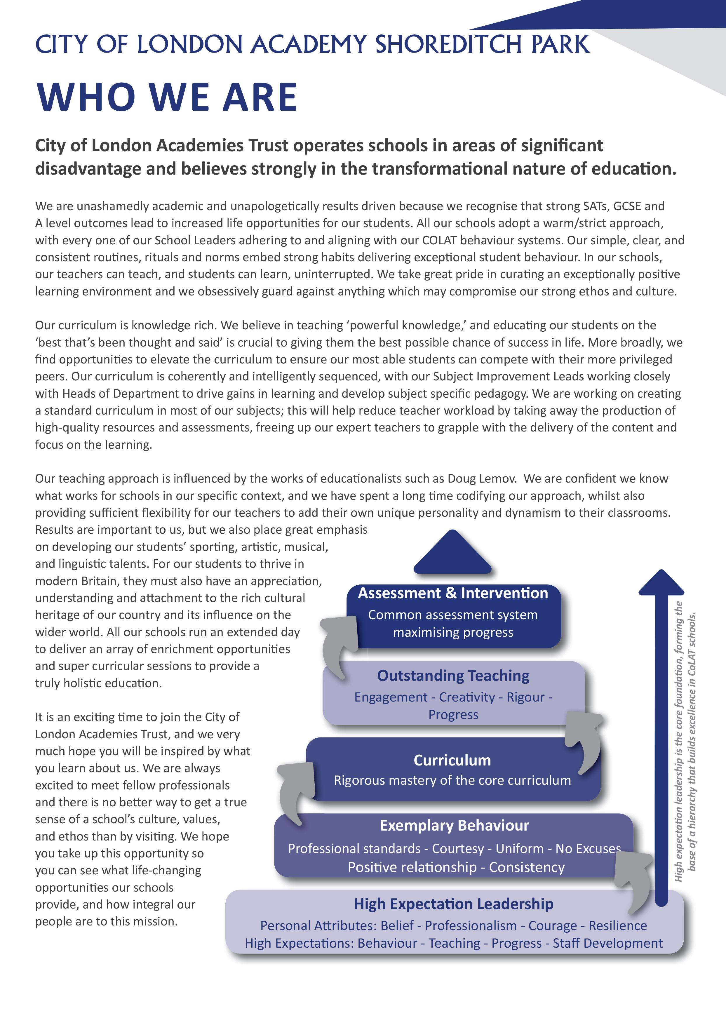

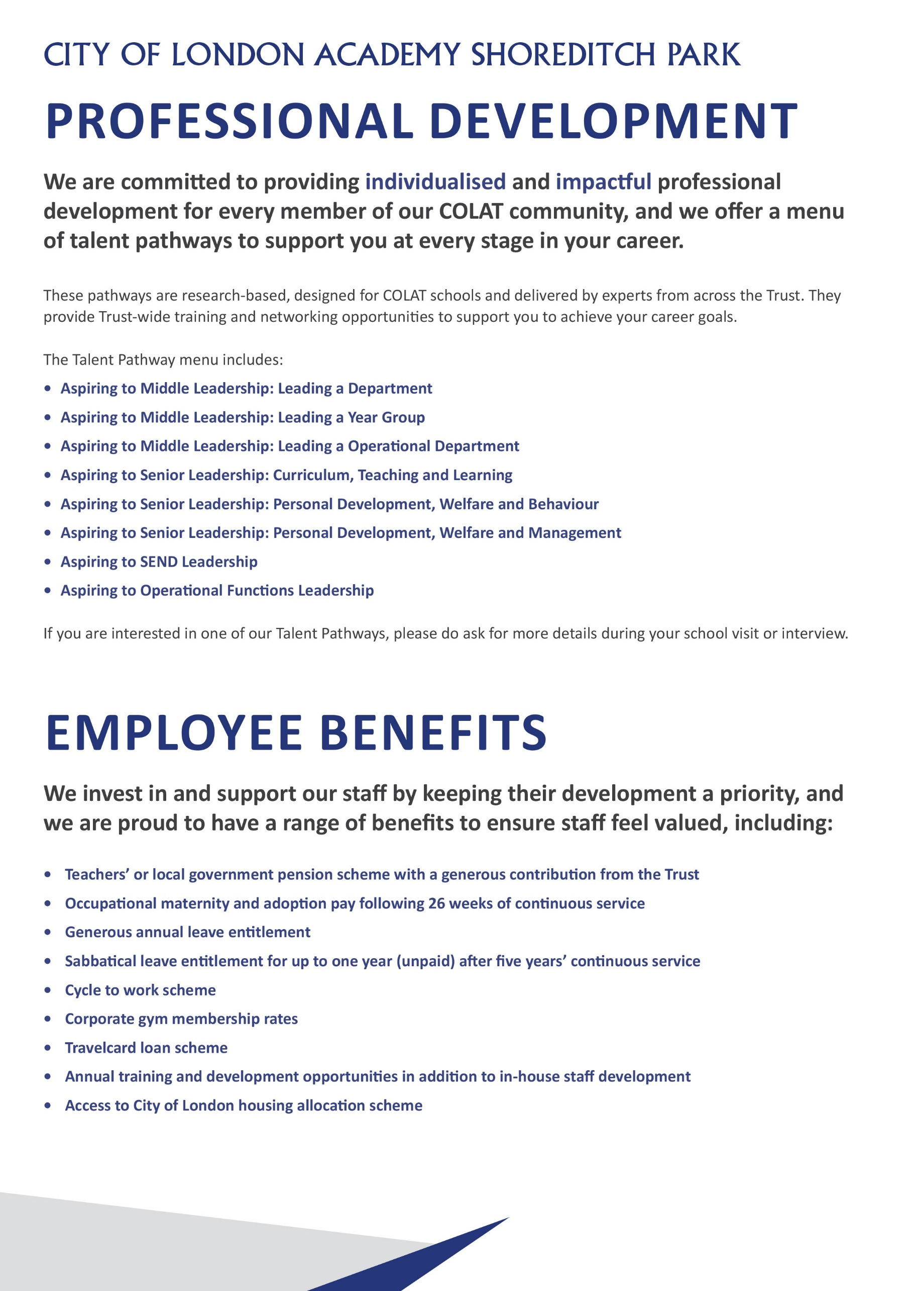
Principals Welcome

City of London Academy Shoreditch Park

We are currently looking to appoint driven and highly skilled staff members to our talented and experienced staff body who will help us achieve outstanding outcomes (progress 8 of +1 and above) and who are willing to stay the course to achieve this.

If you are aligned with our vision, values and mission to improve students’ life chances, we want to hear from you.

We are looking for candidates who will contribute to improving every aspect of the school’s provision, even the outstanding elements. The successful candidate will have an eye for detail, recognise excellence when they see it and not be afraid to challenge underperformance when standards are not as high as they should be. You will have the necessary skills and qualities to support the school to achieve its objectives. You will be someone who wants to contribute to all aspects of academy life and who has a constant eye on outcomes for students.

Our staff body is characterised by a relentless focus on student outcomes and supporting students from disadvantaged backgrounds, as well as the attention to detail and high expectations that are required to do so. We have extremely strong behaviour routines with line ups, single file silent corridors and family dining: all the key components of a warm/strict school.

Our Senior Leadership Team is committed to providing the highest quality training and support for staff to enable them to flourish and develop whatever their role in the school.

City of London Academy Shoreditch Park opened in September 2017 and is now a full, thriving school with the highest academic outcomes in the City of London Academies Trust. We are looking for members of staff who will join our mission to continually drive up our progress 8 score of +0.37. Our long-term vision is to become the best school in the country, and to achieve this we need the best teachers and support staff in the country.

Whatever their background or starting point, we aim to teach our students the skills, knowledge and values that will enable them to become happy, successful and employable young adults. Our culture balances expectations of self-discipline with the positive support from teachers that enable students to feel happy and safe in school.

If you share this moral imperative, then we welcome your application for this role.

I look forward to hearing from you.



Holly Arles
Principal

Teaching Assistant - Job Description

Post: Teaching Assistant

Accountable to: Deputy SENCO

Salary: Pay Scale: Scale Points 7 - 10
£28,872 to £30,139 (Actual: Pro Rata Salary)
£31,980 to £33,384 (Full Time Equivalent)

Working Pattern: Term time only, 35 hours per week

Location: City of London Academy Shoreditch Park, 40 Hyde Road, N1 5JU

Disclosure level: Enhanced

Teaching Assistant will be expected to:
- Support students with a range of needs both inside and outside the classroom
- Teach specific groups of students as required in order to ensure that they access the curriculum and meet their academic targets.
- Deliver the Lexia morning intervention programme for students in need of literacy support.
- Complement teachers’ delivery of the curriculum and contribute to the development of students and school policies and strategies.
- Work collaboratively with teaching staff, and assist teachers in the planning cycle and the management/preparation of resources.
- Receive specific instructions from the HLTA, Subject Leaders and teachers.
- Provide in-class support for students whose behaviour or needs in the classroom are an obstacle to their achievement and that of others.
- Support teaching and other staff in maintaining discipline and following up incidents.
- Assist in securing the strategic vision of the academy in line with the broad educational vision of the City of London Academies Trust, establishing the academy as a leading provider of high quality education for its students.
- Support the academy team in creating a professional culture of high expectations in which students feel safe, valued and motivated to succeed.
- Provide the consistent day to day support necessary to ensure all stakeholders are able to be fully committed to students’ achieving outstanding outcomes.
- Undertake additional responsibilities to support the smooth running of the academy where required.

Key Accountabilities

Be accountable to the CoLAT through the Principal, Governing Body and CEO/Executive Principal for:
- The effective promotion and implementation of the agreed vision and key principles within the academy, including the principles of simplicity, efficiency and effectiveness.
- Support in the delivery of academy policy in key areas.
- Reporting to the Senior Leadership Team and CoLAT as required.

Contribute (with the academy team) to:
- Developing the aspirations and self‐belief of all students and by doing so securing high quality learning, outcomes and progress for all students.
- Establishing and maintaining the academy as a centre of excellence in the community.
- Developing a rich partnership with families and community to maintain a learning community that strives for personal growth.
- Effective planning for improvement for the academy.
- Ensuring efficient and effective use of resources.
- Developing strong productive relationships with a wide range of stakeholders.

Supporting students
- Teach small groups of students.
- Mentor small groups of students.
- Develop an understanding of the educational needs of the students involved.
- Assist students to learn as effectively as possible in class, group and individual situations.
- Establish a supportive relationship with students.
- Encourage the integration of students into classes.
- Support the inclusion of students in all aspects of school life.
- Help promote and reinforce students’ confidence and self-esteem.
- Help keep students on task and build motivation.
- Undertake break and lunchtime duties where needed to support students who find these unstructured times difficult, such as students with ASD.
- Where required, support students with particular duties relating to their physical needs.

Supporting the HLTA
- Be a Personal Adviser, directly responsible for monitoring the academic progress and emotional wellbeing of a small group of students.
- Contribute to the evaluation of intervention/support programmes by providing regular feedback about students to teachers.
- Contribute to statutory reviews of students’ statements/EHCPs.

Leadership of self and others by:
- Liaising with and advising other members of the academy team in order to ensure students’ needs are met.
- Providing an approachable and supportive presence for staff, students, parents and the local community.
- Setting high standards and expectations for personal, student, and staff behaviours and actions in support of the achievement of the academy’s intended outcomes.
- Helping to develop and maintain respect across all stakeholders, inspiring individuals to contribute positively to shared ideas and plans for the academy.
- Playing a part in creating a positive, inclusive climate that carries the academy’s vision forward.
- Regularly reviewing own practice, setting personal targets and taking responsibility for own development.
- Maintaining open professional dialogue with the Director of Learning & Engagement about the identification of academy strengths and weaknesses, ensuring a proactive approach to solving potential or existing difficulties.
- Being committed to a collaborative vision of excellence and equality that sets high standards for every student and member of staff.

Assist in management of the organisation by:
- Liaising with all academy staff, parents and students where required.
- Liaising with external agencies as appropriate.
- The effective use of ICT.
- Where applicable undertaking additional administrative tasks including stock recording, ordering etc.
- Working within a defined organisation structure which enables effective and efficient ways of working and support the achievement of the academy’s objectives.
- Acting in accordance with policies and legislation affecting the conduct of the academy, particularly those that govern health and safety matters and employment rights.
- Undertaking any other duties commensurate with the post as reasonably delegated by the Principal and Governing Body.

Standards/Quality Assurance and Additional Responsibilities
- Participate in staff training and development.
- Develop relationships with governors, LEAs and neighbouring schools/academies.
- Adhere at all times to professional business standards of dress, courtesy and efficiency in line with the ethos and specialism of the academy.
- Attend team and staff meetings.
- Compile statistical returns as required.
- Attend and participate in Open Evenings and other events where required.
- Uphold the academy’s behaviour code and uniform regulations.

Key Organisational Objectives
The postholder will contribute to the academy’s objectives in service delivery by:
- Following Health and Safety requirements and initiatives as directed.
- Sharing the Academy’s commitment to safeguarding and promoting the welfare of children and young people.
- Ensuring compliance with Data Protection legislation.
- At all times operating within the school’s Equalities policies, demonstrating commitment and contribution to improving standards of attainment.
- Ensuring customer care and quality assurance initiatives.
- Fulfilling the role of Student Personal Adviser and/or mentor if required.
- Contributing to the maintenance of a caring and stimulating environment for young people.

Safeguarding Children
COLAT is committed to safeguarding and promoting the welfare of children and young people. We expect all staff to share this commitment and to undergo appropriate checks, including enhanced DBS checks.

The above responsibilities are subject to the general duties and responsibilities contained in the Statement of Conditions of Employment. The duties of this post may vary from time to time without changing the general character of the post or level of responsibility entailed.

The person undertaking this role is expected to work within the policies, ethos and aims of the Trust and to carry out such other duties as may reasonably be assigned. The post holder will be expected to have an agreed flexible working pattern to ensure that all relevant functions are fulfilled through direct dialogue with employees, contractors and community members.

English Duty
This role is covered under part 7 of the Immigration Act 2016 and therefore the ability to speak fluent spoken English is an essential requirement for this role.

Teaching Assistant – Person Specification

 | Essential | Desirable
Qualifications
Educated to degree level or equivalent
Teaching assistant qualification
Experience, Skills and Knowledge
Ability to use ICT to raise attainment
Ability to provide high-quality support and feedback to staff
Ability to provide high-quality support to students with additional needs
Knowledge of the SEND Code of Practice
Knowledge of the statutory requirements for students with an EHCP
Collaborative teaching methods and working with colleagues in the preparation, assessment and monitoring of work
Experience of managing staff
Experience of setting up, using, maintaining and developing student support systems
Demonstrable experience of improving student outcomes
Personal Qualities
Ability to organise and prioritise workload and work on own initiative
Excellent written and oral communication at all levels
Ability to work under pressure while maintaining a positive, professional attitude
Ability to ensure that deadlines are met
Ability to work as part of a team
Ability to work independently
Attention to detail in communication and planning
Ability to problem-solve
Ability to develop good relations with staff and pupils and the wider school community
Well-organised
Well-presented
Fast and accurate keyboard skills
Good understanding of database systems to produce reports and statistics
Ability to communicate with and support parents, maintaining a calm professional and friendly attitude even in difficult situations or conversations
Ability to liaise effectively with a wide range of staff at different levels
Safeguarding and child protection policies and procedures
Developments in the National Curriculum
Other
Commitment to safeguarding and promoting the welfare of children and young people
Willingness to undergo appropriate checks, including enhanced DBS Checks
Motivation to work with children and young people
Ability to form and maintain appropriate relationships and personal boundaries with children and young people
Vision and values aligned with the academy’s high aspirations and high expectations for children, staff and families
Commitment to working with others to secure the best outcomes for children
Skilful management and understanding of how to secure strong relationships with other academy staff, families, trustees and other external relationships
Understanding of different social backgrounds of students
Understanding the needs of students and the appropriate strategies to support them

Our Values and Vision
The City of London Academies Trust, sponsored by the City of London Corporation, aims to provide high-quality education for students and pioneer educational innovation. We are driven by the ambition to provide world-class experiences and deliver exceptional educational outcomes for the young people we serve.

All City of London academies draw upon the traditions, institutions, heritage and historical successes of London to furnish each of their diverse communities with life-transforming learning experiences. In doing so, we believe that the young people we serve develop into successful, compassionate young adults, who make a positive contribution to their local, national and global communities.

Our schools are characterised by a common understanding of what makes outstanding schools, based on five key principles which are known as our 'Foundations of Excellence'​.

Our Staff
Our staff have high expectations, are consistent and driven to provide the best teaching and opportunities for our students. Teachers work in a well-disciplined environment where they are able to teach creative and engaging lessons, and all staff are given exciting opportunities to develop and learn from exceptional practitioners.

Equal Opportunities
The postholder will be expected to carry out all duties in the context of and in compliance with the COLAT Equalities policies.

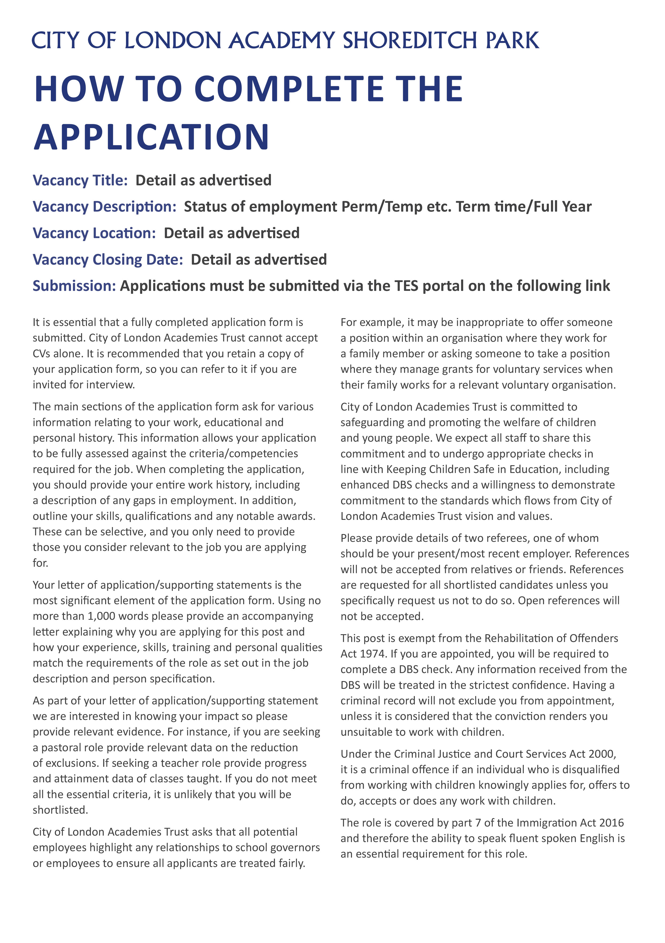
Wednesday 9th September 2026
Applications to be submitted by the My New Term
City of London Academy Shoreditch Park
Permanent
Teaching Assistant



