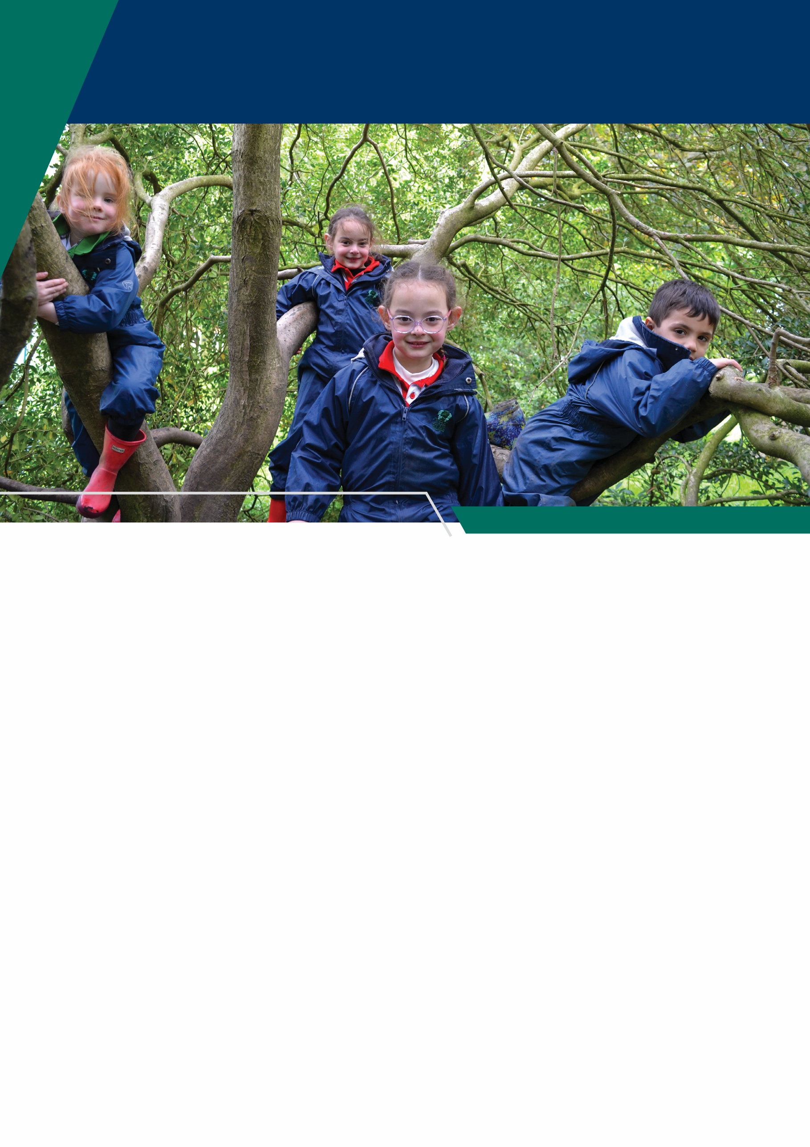

Welcome
The Elms is an independent co-educational school for children aged from 6 weeks to 11 years old. Located in Long Eaton, Nottinghamshire, The Elms is part of Trent College, and enjoys a beautiful, shared 45-acre campus with state-of-the-art facilities, including modern classrooms and sports facilities, as well as dedicated Nursery and Pre-School buildings, and wonderful outdoor learning facilities.
The Elms journey begins in the Nursery, which was recently rated ‘Outstanding’ in all areas. Here learning through play and exploration builds confidence and curiosity about the world around them.
As children progress through the school, the focus on exceptional pastoral care and inspirational teaching, along with a vast array of enrichment opportunities, ensure that our children leave us with the independence and resilience to embark successfully upon their senior school education.
Our EYFS setting was rated ‘Outstanding’ by the Independent Schools Inspectorate in 2025, we have highly qualified and experienced teaching staff who are committed to providing an excellent standard of education. We also have a large population of support staff, ensuring that our friendly school and beautiful campus operate to the very highest standards and our pupils are happy and flourish.

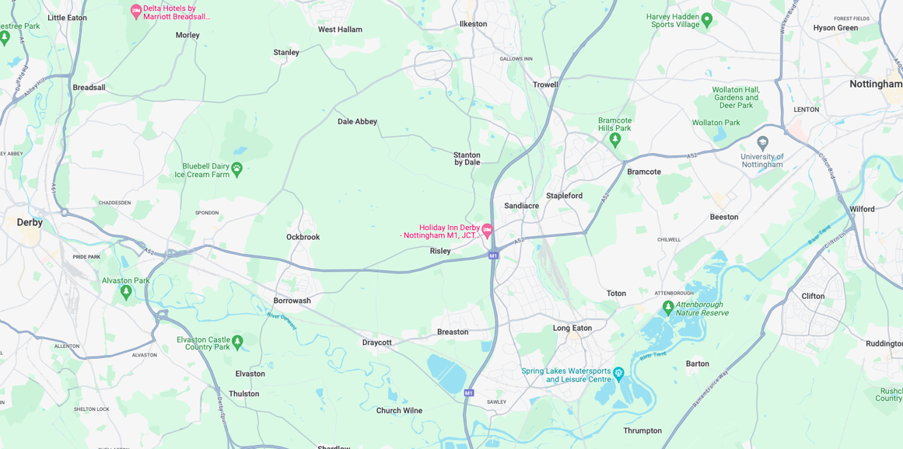


Our Location
Trent College and The Elms are conveniently situated on the border of Nottinghamshire and Derbyshire.
Ideally located at the heart of the UK’s motorway system, we are only 2 miles from junction 25 of the M1, which provides easy access to the M42 and A1.
Reaching Trent College by rail couldn’t be easier. Long Eaton boasts its very own train station, located 1.5 miles from the schools. Rail routes through Long Eaton run along the Midlands Main Line route, with direct routes to London, Loughborough, Leicester, Birmingham, Nottingham, Derby, Chesterfield and Sheffield.

Our Local Community
Working in partnership and serving the community are natural and very important values at Trent College and The Elms. We work with many local schools in Long Eaton and the wider Erewash borough to increase opportunities and aspirations, and to share the school’s excellent grounds, facilities and specialist staff.

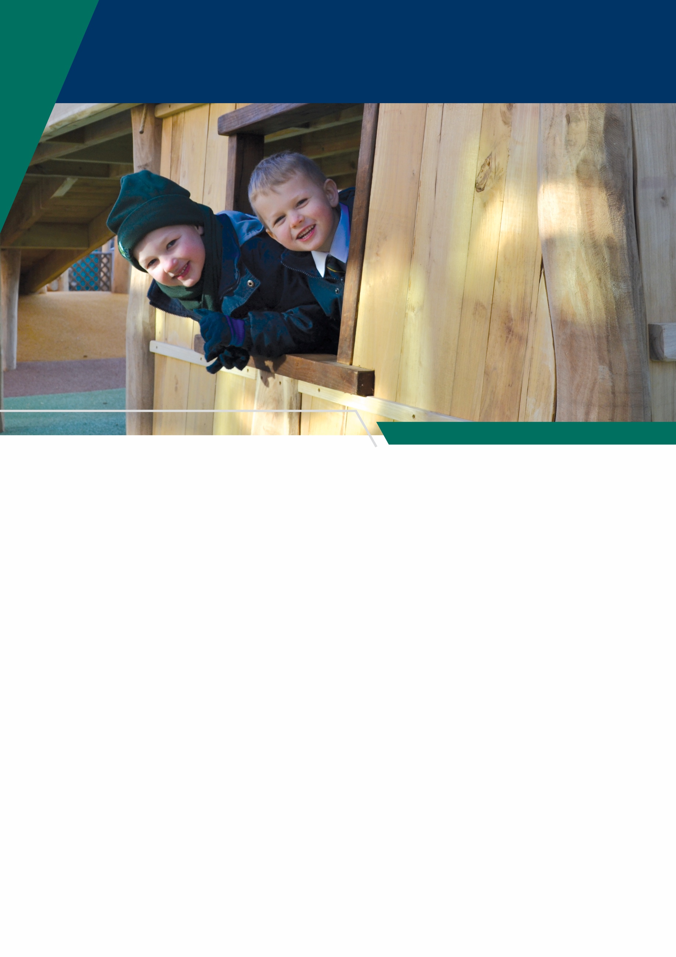

Nursery Nurse – Level 3

Job Description
• To work alongside the Nursery Leader and staff team to ensure that The Elms Nursery provides the highest possible care to children in our setting.
• To work with reference to current legislation, Ofsted and ISI guidance, and EYFS.
• To ensure that health and safety and security measures are constantly upheld, monitored and maintained, within the nursery environment.
• To plan and deliver activities that meet the EYFS that are suitable to the age range of children in your care and individual requirements.
• To work with staff members, parents, and outside professionals to meet the needs of all children.
• To be responsible on a day-to-day basis for the safety and care of children, working in line with all policies and procedures to the highest standards.
• Be pro-active in safeguarding and child protection.
• To record your key children’s developmental progress in line with nursery procedures, and the EYFS.
• To work with parents to maintain good relationships and meet the needs of all children and families.
• To work as part of a team, sharing duties and can work independently.



• To develop good working relationships with parents and treat any information regarding families and children in strictest confidence, unless there are safeguarding concerns.
• To attend ALL out of working hour’s activities, e.g. training, staff meetings, parent’s evenings, events, etc.
• To be flexible within your role to help other members of staff where required.
• To undertake domestic jobs within the nursery where required e.g. preparation of snack meals, cleaning of equipment, putting out bins, doing the laundry, etc. when required.
• Use Tapestry to complete observations, weekly write ups and daily diaries.
• To constantly strive to improve your practice by attending relevant training courses.
• On a daily basis feedback to parents through written and verbal communication.
Specific Tasks
• Communicate on a level which children understand and react to, allowing them time to make decisions and choices regarding their activities.
• Allow all activities to be fun with children being allowed to explore as many aspects of activities as they chose.
• Planning, setting up and clearing away daily activities in line with planning and routines.
• Changing nappies, toileting and keeping children clean. Providing support and care for children as required.
• To encourage children to become independent through allowing them to make choices and encouraging participation with setting up and clearing away during activities and mealtimes.
• Carry out daily risk assessments in line with nursery procedures
• Maintaining high standards of hygiene and safety which are appropriate for the needs of the children.
• To ensure The Elms Nursery meets the needs of individual children from differing cultures and religious backgrounds, and stages of development, ensuring that all children are treated with respect and given equal opportunities.


Person Specification

Qualifications & Training
- Relevant childcare qualification (e.g. Level 3 in Early Years/Childcare or equivalent)
- Sound knowledge of the Early Years Foundation Stage (EYFS)
- Understanding of safeguarding and child protection procedures
- Commitment to ongoing professional development and training

Experience
- Experience working with children in a nursery or early years setting
- Experience of planning and delivering age-appropriate activities in line with EYFS
- Experience observing, assessing, and recording children’s development
- Experience of working in partnership with parents and/or carers

Knowledge & Skills
- Strong understanding of child development and early years practice
- Knowledge of current legislation, including EYFS, safeguarding, and health & safety requirements
- Ability to create a safe, stimulating, and inclusive environment for children
- Competent in using observation systems
- Good written and verbal communication skills
- Ability to build positive relationships with children, parents, and colleagues
- Ability to work both independently and as part of a team
- Strong organisational skills and ability to follow routines and procedures
- Understanding of equality, diversity, and inclusion within an early years setting

Personal Attributes
- Caring, patient, and nurturing approach to working with children
- Proactive and committed to safeguarding and promoting the welfare of children
- Enthusiastic, creative, and adaptable
- Professional, reliable, and punctual
- Flexible and willing to support the wider team when required
- Discreet and able to maintain confidentiality at all times



Benefits
- Staff can enjoy complimentary lunches in the Obolensky Dining Hall during term time. Free car parking is available on site and staff have access to a cycle to work scheme.
- Staff are able to make free use of the school gym and leisure facilities at designated times.
- A flexible retirement plan run by TPT Solutions (formerly The Pensions Trust), including Death in Service benefit.
- Enhanced sick pay and maternity pay is available to staff.
- Staff are entitled to a fee remission for children attending the school, In line with our policy.
- We provide a range of benefits to support staff, including counselling, an employee assistance programme and 24/7 online GP consultations.

Terms and Conditions
- The salary for this role is £17,370.60 per annum (Actual)
- This is a permanent all year-round role. The working hours are 25.5 hours per week,.

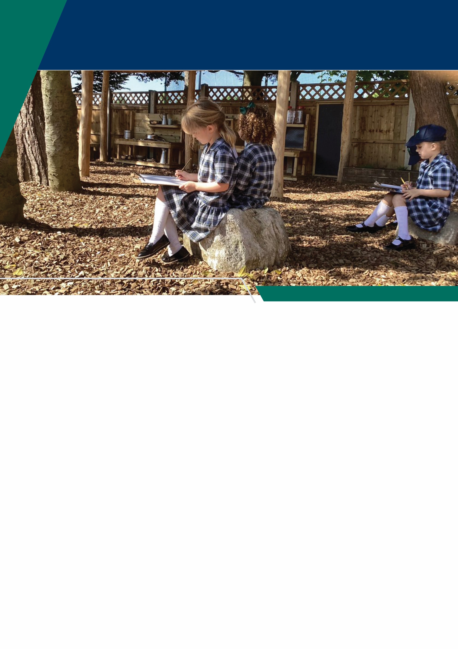

Making an Application
Candidates who wish to apply for this post should complete the online application form.
If you have any questions about the role please email recruitment@trentcollege.net or telephone 0115 949 4949 (during term time).
The closing date for applications is included in the advert.
We reserve the right to close this advertisement early if we receive a volume of strong and suitable applications.

The school is committed to safeguarding and promoting the welfare of children and young people and expects all staff and volunteers to share this commitment.
Applicants will be required to undergo child protection screening appropriate to the post, including checks with past employers and the Disclosure and Barring Service (DBS). The school may carry out online searches on shortlisted applicants and all applicants will be required to provide details of their online profile, including social media account names/handles, as part of their application
The post is exempt from the Rehabilitation of Offenders Act 1974. The school is therefore permitted to ask job applicants to declare all convictions and cautions on a self-declaration form in advance of attending an interview (including those which are "spent" unless they are "protected" under the DBS filtering rules) in order to assess their suitability to work with children.



