


Assistant Teacher
Coritani Academy outreach at Epworth Primary Academy
Candidate
Information Pack
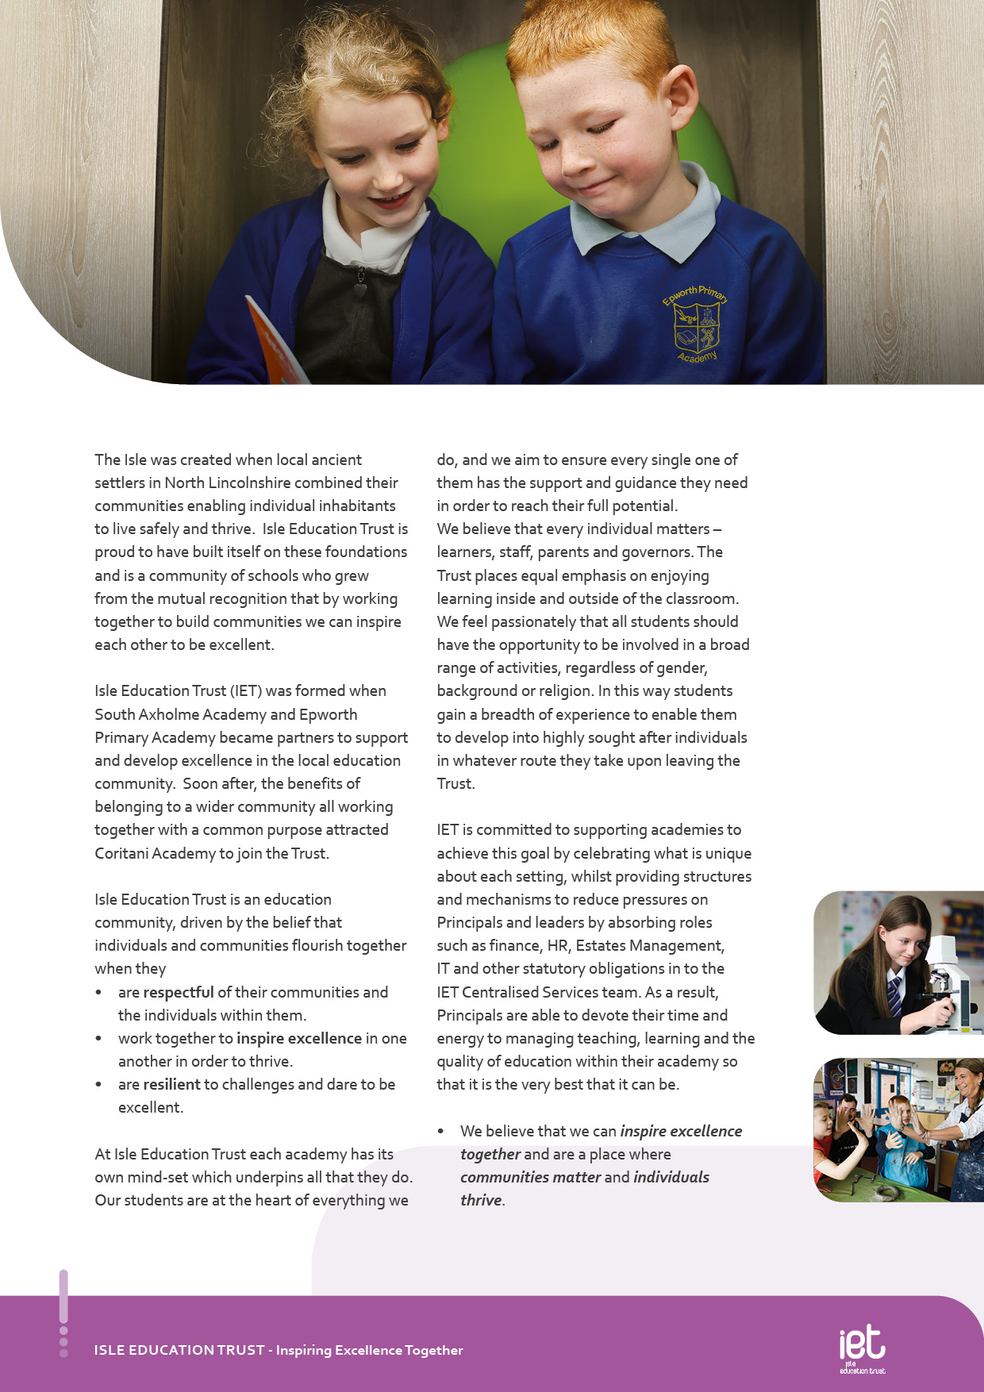
About IET

Dear Prospective Colleague,

Thank you for your interest in joining Isle Education Trust. I’m delighted that you're considering becoming part of our team—whether you’re looking to support students directly or contribute to the vital work that happens behind the scenes, your role matters deeply to us.
At Isle Education Trust, our vision is clear: Inspiring Excellence Together. Across our family of academies, we recognise that excellence doesn’t happen by chance—it’s built by a committed, skilled, and diverse team working together with shared purpose.
Our non-teaching colleagues are the backbone of our success. From safeguarding and administration to site management, finance, pastoral support, and everything in between, you help shape the culture and daily experience of our schools. Your expertise keeps our academies running smoothly, our environments safe and welcoming, and our pupils supported every step of the way.
We are proud to uphold values that guide our Trust:
- Respect – shown through honesty, consistency, and care.
- Resilience – demonstrated in our commitment to excellence, even in the face of challenge.
- Inspiration – sparked by individuals who lead by example and empower others to thrive.
When you join our team, you’ll find a community where your contributions are valued, your development is supported, and your wellbeing is prioritised. We offer professional learning opportunities, a culture of collaboration, and a genuine commitment to making our academies great places to work.
If you share our belief that every role within education is a chance to make a difference, I warmly invite you to explore opportunities across the Trust. We’d be thrilled to welcome you into our mission of inspiring excellence—together.
Warm regards,



Sarah Sprack
CEO, Isle Education Trust

Welcome from the CEO

Welcome from the Executive Principal Academy
Do you want to work at a school that really makes a difference to children’s lives? To be part of a school with very small class sizes, where trust and human relationships are central to all that we do? To belong to a community where the curriculum is built for each individual child and children are made to feel safe and valued? To be challenged and feel a sense of fulfilment every day? To inspire a small group of learners and to be inspired?

If this sounds like the place for you then come and join us at Coritani Academy.

We are a small academy offering academic qualifications to learners who need a school community with a more individual approach to learning than you would traditionally find in a mainstream school. We deliver relationship-based education, a learning experience for students that is truly unique and tailored to the needs of the individual child. Our staff are open and caring and have a passion and desire to ensure that students achieve excellent outcomes at the end of their time with us.

The Academy offers a safe and welcoming environment for children from Year 3 to Year 13.
Low admission numbers mean that we can offer one to one and small group learning that is truly matched to individual need. Class sizes at the Academy are a maximum of 8 children.
Our belief is that students will thrive when they feel safe and supported within their surroundings and once we have this right the best start in life we can give them is a good set of academic results.

Our Academy boasts results well above the national averages for similar alternative Academies and in some cases for mainstream schools. We have an excellent track record of re-engaging students in education and ensuring they achieve excellent results that allow them to move on to their next steps in life.

Our learners are proud of their academy, and those who have left to go on to successful placements at college, school sixth forms or back in to mainstream school continue to visit and contact the academy into their adult lives.

Thank you for taking the time to put together your application we hope to see you as part of the team soon. Until then we would encourage you to view our website or come in and visit the Academy in person to find out more.

Dave Flowitt
Executive Principal


Ethos and Values
Our Academy works with local schools and local authorities to ensure that learners who need an individual approach to learning have a quality educational alternative. We believe that every young person should have the opportunity to succeed by being motivated and inspired.
Our aim is to inspire learners with quality education and support through the development of the Coritani Mindset, to meet their personalised learning need, make them safe and ensure that they are ready to develop into respectful members of their communities.

Objectives of the Academy
To provide support to students to help them re-engage and be ready for education
To provide a safe and inspiring environment in which students can develop into respectful adults
To ensure all our students have access to the same opportunities as students in mainstream schools through an inspiring, broad and balanced curriculum

Coritani Mindset
Inspire Excellence, Safe, Respectful, Ready
At Coritani Academy everyone works collectively using the Coritani Mindset, a set of values that we have all agreed together to help us to be successful in our lives. Coritani Mindset Inspires Excellence and encourages students to be safe, respectful, ready in all that they do.

The School Day
The school opens for staff at 8:25am with a staff briefing each day at 8:30am. Learners arrive between 8:45am and 9:15am. And have a 30-minute lunch break. The day school ends at 2:30pm. Staff complete joint PPA and training from 2:30pm until 3:30pm each day. In addition, staff meet formally once a week and are involved in a full programme of CPD.
Staff are given generous PPA time within the Academy Day and most complete planning and marking within these working hours.

Staff involvement
The small school structure of the Academy is such that every member of staff and often learners are invited to participate in policymaking though the final decisions must rest with the principal who is responsible to Governors for the conduct and curriculum of the Academy. Nevertheless, consultation is real and decisions are arrived at by discussion and an exchange of opinions. Such a consultative decision-making process can only work effectively if all staff accept the personal responsibilities this brings.

The demands on staff are considerable; in the classroom, in preparation, in marking, in attending meetings, in CPD work, in out-of-school activities and in parent-teacher contact, however, it is a rewarding job that presents staff with many opportunities which in turn brings great benefit to the Academy and to the teachers themselves as professionals.
About the Academy

Job Purpose
To work as part of the Coritani Academy team at Coritani or within an outreach provision for the Trust. The successful candidate will work as an Assistant Teacher, lead interventions with learners and step up to lead teaching and learning in the classroom when cover is required within the Academy. The hours will be to fit around staff absence. Support and training will be given to allow staff to develop as classroom teachers.

To work under the direction of the SLT to teach and assess whole classes planned by the teacher. To be solely responsible for a class of students ensuring they are engaged in learning activities set by a teacher. Managing student behaviour and ensuring a safe environment.

The assistant teacher reports to the class teacher.

Job Title Assistant Teacher

Salary | £32,544 FTE / £23,926.56 ACTUAL
Job Details | 32.5 hours  Term Time Only  Permanent
Location | Based at Epworth Primary and working at Coritani or outreach provisions for Isle Education Trust
Required | September 2026
Application Close | 09:00 Monday 18th May 2026
Interview Date | Wednesday 20th May 2026

Job Description

Job Description

To work to the National standards for Teaching Assistants including:
- In the absence of a teacher, to be solely responsible for a class of students, ensuring they are engaged in learning activity.
- Plan, Teach and assess individual or small groups of students within the classroom
- Be aware of and support differentiation and ensure that pupils have equality of access to opportunities to learn and develop.
- Effectively manage student behaviour and any other immediate issues or emergencies that arise in accordance with academy policy.
- To support students to engage with the work provided, including providing support where necessary with literacy, numeracy and organizational skills.
- To liaise with teachers/other relevant staff with regard to work set for a class and ensure you are suitably equipped and informed to be able to effectively supervise the assigned lesson.
- To feedback to the class teacher on student engagement in the set work and also any other issues that may have arisen.
- To help prepare, monitor and maintain a safe and secure learning environment.
- To undertake student registration of a class as required.
- To undertake administrative duties relevant to the role
- To act as invigilator for both internal and external exams under formal conditions
- When not required to undertake any responsibility falling within the above, you may be directed to provide additional support in the academy with duties of a different nature.

Any other reasonable duties as requested by the Principal or SLT

Key Responsibilities and Accountabilities


INTERVIEWS:
Thursday 13th June 2024
CLOSING DATE:
Tuesday 11th June 2024 at 9:00am
- Work with all students ensuring equality of opportunity for all.
- Take responsibility for Safety and Welfare of all students, raising any concerns following the Academy/Trust protocols and procedures.
- Work proactively and effectively in partnership with all stakeholders.
- Carry out a share of statutory supervisory duties.
- Treat students with dignity and build relationships rooted in mutual respect and at all times observing proper boundaries appropriate to the professional position.
- Participate in CPD relevant to the role.
- Accompany teaching staff and students on visits, trips and out of school activities as required.
- Demonstrate an understanding of and take responsibility for promoting high standards of literacy including the correct use of spoken English and numeracy.
- Participate in arrangements for examinations and assessments.
- Take an active role in promoting good behaviour in and around the Academy/Trust.
- Ensure that students adhere to the uniform code and apply sanctions when this code is breached.
- Develop an academy learner mind-set – the attitudes, skills and learning habits needed to become an inspired, confident and independent learner.
- Be a positive role model and demonstrate consistently and effectively the positive attitudes, values and behaviour which are expected of students.
- Work as a team member and identify opportunities for working with colleagues and sharing the development of effective practice with them.
- Regularly review the impact of their work and its impact on students’ progress, attainment and well-being, refining approaches where necessary and responding to advice and feedback from colleagues.
- Proactively participate with arrangements made in accordance with the Appraisal Policy.
- Have professional regard for the practice, ethos and policies of the Academy/Trust and maintain high standards in your own attendance and punctuality.
- Operate at all times within the stated policies and practices of the Academy/Trust.
- Contribute positively and effectively to the whole Academy/Trust ethos.
- Cooperate with other staff members to ensure a sharing and effective use of resources to the benefit of the Academy, individual departments and students.
- Attend and participate in appropriate calendared meetings.
- Take responsibility for own professional development and duties in relation to Academy policies and practices.
- Liaise effectively with staff, students, parents and governors.
- Ensure compliance with Health and Safety at Work Act 1974 and all other policies related to health and safety, and to ensure compliance with the Data Protection Act 1988.
- Ensure compliance with data protection laws and safeguarding procedures.
- Carry out any other duties as directed by your Line Manager as may from time to time be agreed in accordance with the nature of the job described above.

We expect all Trust staff to:

This is not an exhaustive list of tasks and job descriptions will be continually reviewed and changed according to the needs of the Trust.

Post holders will be expected to be flexible in undertaking duties and responsibilities attached to their post and may be asked to perform duties, which reasonably correspond to the general character of the post and are commensurate with its level of responsibility. This job description is provided for guidance only and does not form part of the contract of employment.


Qualifications |  | Essential |  | Desirable
Good literacy & numeracy skills (Level 3) |  | A
Further academic qualifications relevant to post |  |  |  | A
First Aid Qualification |  |  |  | A
Experience | Essential |  | Desirable
Experience of working in an educational setting or similar environment |  |  | A
Experience of working with young people aged 11 to 18 |  |  | A
General understanding of school policies and procedures relating to health and safety, behaviour, attendance, equal opportunities and child protection |  |  | I
Knowledge of School Management Information Systems |  |  | A
Experience of Microsoft software packages (Word, Excel, Publisher) |  |  | AI
Basic understanding of child development and learning |  |  | A I
Practical Skills | Essential |  | Desirable
Ability to manage the behaviour of students to promote a calm working environment | A I
Ability to motivate students | I
Ability to work collaboratively and effectively within a team | A I
Ability to work independently and to show initiative | A I
Ability to work under pressure, prioritise and meet deadlines | A I
Friendly, approachable and non-confrontational manner combined with the ability to be firm | I
Ability to build and maintain successful relationships with students; treat them consistently, with respect and consideration, and demonstrate concern for their development as learners | I
The capacity to inspire and motivate others – both adults and students |  |  | I
Ability to use ICT effectively to support learning |  |  | A
A desire to work with young people and to support their education and achievements | A I
A professional approach in both manner and physical appearance | I
Able to demonstrate discretion, confidentiality and commitment | I R
Able to liaise sensitively with parents/carers recognising their role in the student’s learning | I R
Enthusiasm, determination and insistence on high standards | I
Flexible and good humoured approach | I
A proven track record of excellent attendance and punctuality | R
An understanding classroom roles and own position with the school hierarchy | I
High expectations of self and others | Essential |  | Desirable
A flexible and adaptable approach | A I
An innovator with the desire to continue to learn | A I
Resilience and the determination to be successful within this role and ambitious for the Academy and its students | I
Safeguarding Students | Essential |  | Desirable
Committed to safeguarding and promoting the welfare of children and young people | I
Equal Opportunity | Essential |  | Desirable
The ability to ensure that there is equality of access to educational attainment and that all aspects of equal opportunities are adhered to | I

Person Specification:

Personal Qualities and Essential Attributes | Essential | Desirable
A desire to work with young people and to support their education and achievements | A I
A professional approach in both manner and physical appearance | I
Able to demonstrate discretion, confidentiality and commitment | I
Able to liaise sensitively with parents/carers recognising their role in the student’s learning | I
Enthusiasm, determination and insistence on high standards | I
Flexible and good-humoured approach | I
A proven track record of excellent attendance and punctuality | I
An understanding classroom roles and own position with the school hierarchy | I
High expectations of self and others | Essential | Desirable
A flexible and adaptable approach | A I
An innovator with the desire to continue to learn | A I
Resilience and the determination to be successful within this role and ambitious for the Academy and its students | I
Safeguarding Students | Essential | Desirable
Committed to safeguarding and promoting the welfare of children and young people | I
Equal Opportunity | Essential | Desirable
The ability to ensure that there is equality of access to educational attainment and that all aspects of equal opportunities are adhered to | I

KEY
A = assessed through the application process
I = assessed through the interview process


c
 Pension Scheme
All staff are enrolled in either the Teachers’ Pension Scheme or Local Government Pension Scheme, whichever is relevant.
 Continuous Professional Development
IET offers numerous opportunities for continued CPD for all staff including NPQs and apprenticeships

 Cycle to Work Scheme
Eligible staff may apply to purchase a new bike, e-bike or cycling accessories through this salary sacrifice scheme, making significant savings.

 Staff Wellbeing
This is a priority for the Trust. All staff have access to a free Employee Support Package, including 24/7, 365 days a year online and telephone support covering areas such as mental health, bereavement, financial advice and counselling.

 Healthcare
All staff have free access, 24/7, 365 days a year to an online doctor.

 Flu Vaccinations
All staff are able to request a free voucher for a flu vaccination in the Autumn term.

 Discounts
Through our employee benefits platform, staff can make significant savings through discounts and vouchers in a range of areas including restaurants, supermarkets, retail and holidays.

Trust Benefits:


Appointment Process
How to apply
To apply for this post, visit the IET website:

Isle Education Trust - Vacancies

Receipt of early applications from candidates with the appropriate experience, qualifications and personal qualities may result in an early interview being offered.

Isle Education Trust promotes equality of opportunity and welcomes applications from all sectors of society.

Isle Education Trust is committed to safeguarding and promoting the welfare of children and expects all staff and volunteers to share this commitment. All posts at Isle Education Trust are subject to an Enhanced Disclosure and Barring check.

