


South Axholme Academy
Teacher of English: (FT or PT)
Candidate
Information Pack
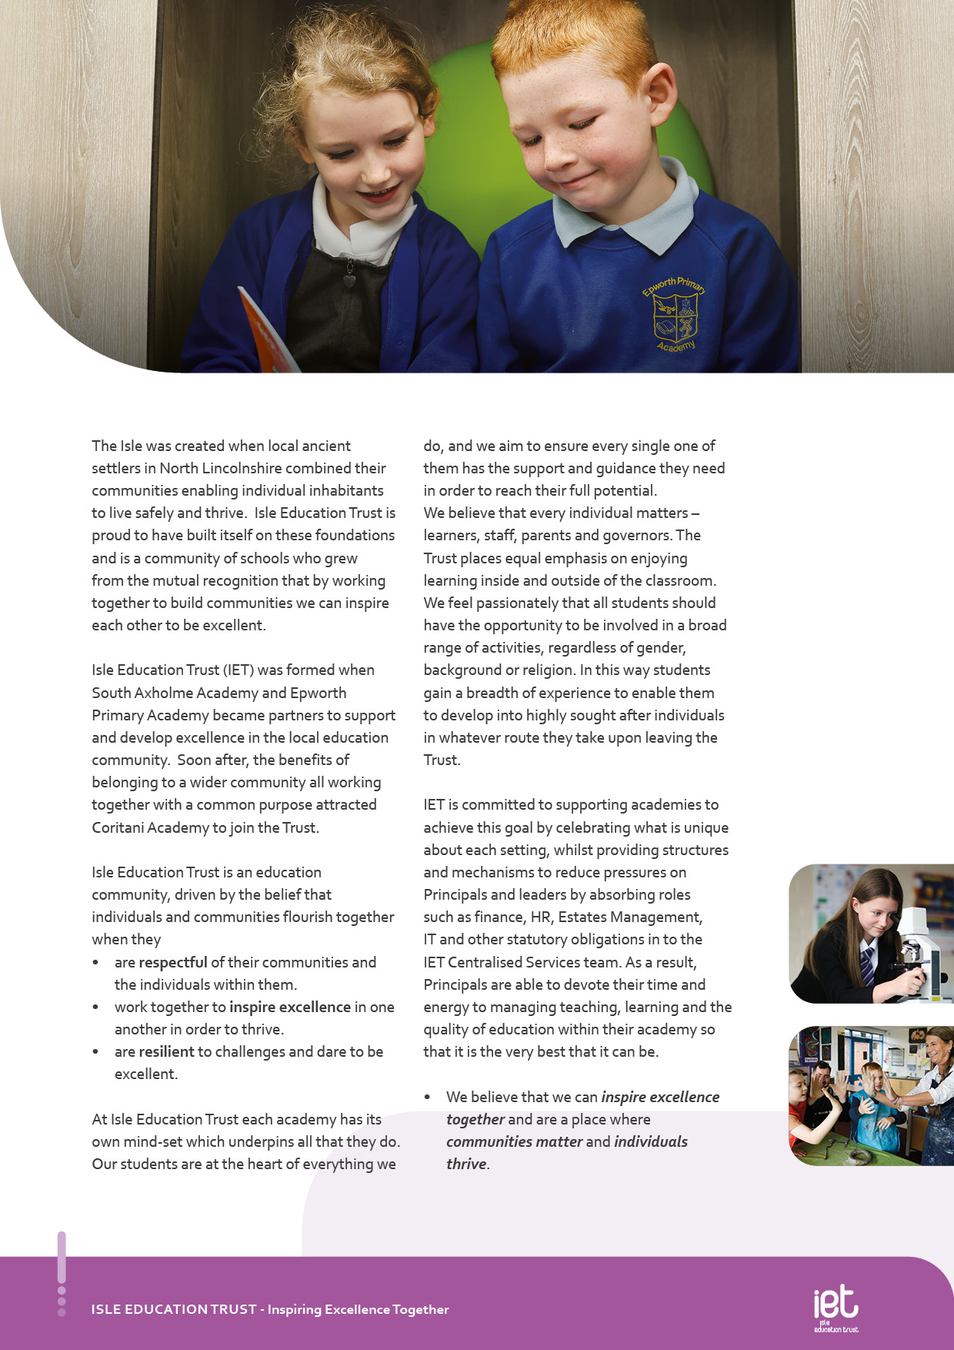
About IET


Dear Prospective Colleague,

Thank you for your interest in joining Isle Education Trust. Whether you are at the start of your teaching journey or bringing a wealth of experience, I’m delighted that you’re considering becoming part of our community.

At Isle Education Trust, our vision is simple yet powerful: Inspiring Excellence Together. We believe in creating environments where individuals thrive and communities flourish. Across our 6 academies - South Axholme Academy, Coritani Academy, Epworth Primary Academy, Alkborough Primary Academy, Kirton Lindsey Primary academy and Burton upon Stather Primary Academy—we are united by a shared commitment to high standards, inclusive practice, and a deep sense of belonging.

Our values are not just words on a page—they shape how we work, how we support one another, and how we grow. We ask every member of our team to:

Be respectful – acting with honesty, consistency, and care.
Be resilient – embracing challenges and daring to be excellent.
Be inspirational – leading by example and lifting others through our actions.

We know that great teachers change lives. That’s why we invest in your development, champion your wellbeing, and celebrate your successes. Whether it’s through high-quality CPD, collaborative networks across the Trust, or leadership pathways, we are committed to helping you thrive professionally and personally.

Our academies are vibrant, welcoming places to work—where innovation is encouraged, support is ever-present, and every voice matters. If you share our belief in the power of education to transform lives, I warmly invite you to explore the opportunities within our Trust.

We look forward to the possibility of welcoming you to our team.

Warm regards,



Sarah Sprack
CEO
Isle Education Trust

Welcome from the CEO
b
Dear Prospective Colleague,
As Principal of South Axholme Academy, I am proud to lead a school with a rich history and an exciting future. Established as South Axholme School in 1961, we now serve approximately 930 students. In 2012, the school became an academy, and the following year took a lead role in forming Isle Education Trust. The small size of the Trust enables close collaboration whilst allowing us to maintain autonomy over our curriculum and teaching to best meet the needs of our students and community.
Located in the historic market town of Epworth, North Lincolnshire, between Doncaster and Scunthorpe and within easy commuting distance of Rotherham, Sheffield, Leeds, East Yorkshire and Lincoln, South Axholme Academy draws students from over 25 primary schools across North Lincolnshire, Nottinghamshire, and Doncaster. We are regularly oversubscribed, which reflects the confidence families place in us.
Our academic outcomes consistently exceed the national average, reflecting our strong commitment to excellence. Equally important is nurturing the whole child by developing not only academic potential but also confidence, character, and wellbeing. Beyond the classroom, our vibrant calendar offers a wide range of events and enrichment opportunities, from sponsored walks and drama productions to sports clubs, educational visits, and community celebrations like Christmas carol concerts and senior citizens parties. Central to our ethos is the South Axholme Mindset—being Ready, Respectful, and Resilient—which guides everything we do and inspires everyone to Expect Excellence.
Knowing our students, staff, and families well allows us to provide a broad, balanced, and inclusive curriculum tailored to individual needs. As part of our commitment to support, we are developing a new study hub with North Lincolnshire Council, providing a smaller, focused environment for students who benefit from additional support.
South Axholme Academy is a vibrant, ambitious and welcoming school with a strong track record of excellence in all areas. As Principal, it is an honour to lead this community as we continue the next phase of our journey, one that I am confident will be filled with even greater success.
If you would like any further information about the role, or would like to arrange a visit, do get in contact by emailing admin@southaxholme-iet.co.uk or by ringing us on 01427 87212. I would be delighted to talk to you about our wonderful school!
Every best wish,



Stephanie Hamilton
Principal
South Axholme Academy
Welcome from the Principal

Job Purpose
To deliver high-quality and engaging English lessons that foster strong literacy skills, critical thinking, and a lasting appreciation of language and literature. The role supports students’ academic achievement and personal development in line with South Axholme Academy’s core values of being Ready, Resilient, and Respectful. As part of a dedicated and collaborative teaching team, you will contribute to a culture of high expectations and continuous improvement, equipping students with the knowledge, skills, and confidence to succeed in further education, employment, and life.

The post reports to the Subject Leader of English.

Job Title Teacher of English

Salary | MPS/UPS
Job Details | Full time or Part time Teacher of English
Location | South Axholme Academy
Required | September 2026
Application Close | Monday 18 May 2026
Interview Date | Wednesday 20 May 2026

Job Description


Teaching and learning
- Deliver high-quality teaching in accordance with the Academy’s schemes of learning and relevant examination board specifications.
- Collaborate with departmental colleagues to plan, refine, and implement cohesive schemes of learning that reflect the Academy’s curriculum intent.
- Provide a high-quality learning experience for all students by employing a range of evidence-informed teaching strategies, aligned with the Academy’s Teaching and Learning Framework, underpinned by Rosenshine’s Principles of Instruction.
- Adapt teaching effectively to meet the diverse needs of students, including those with SEND, EAL, and different prior attainment profiles, ensuring all learners make strong progress and that syllabus content is thoroughly covered.
- Work closely with teaching assistants, pastoral staff, and other professionals to promote positive student outcomes and maintain high standards of behaviour for learning.
- Set meaningful and appropriate work for students who are absent, ensuring continuity of learning.
- Consistently demonstrate best practice in subject-specific pedagogy, classroom management, and professional conduct in line with the Teachers’ Standards and the Academy’s expectations.
Assessment and reporting
- Provide timely, meaningful, and subject-specific feedback to students in accordance with the Academy’s and department’s marking and feedback policies, ensuring it supports progress and deepens understanding.
- Monitor and track both class-wide and individual student performance using Academy systems, identifying trends and implementing strategies for improvement where necessary.
- Communicate effectively with all relevant stakeholders — including pastoral teams, senior leaders, and support staff — regarding student progress, areas of concern, and interventions.
- Liaise with parents and carers to discuss student progress, including attendance at consultation evenings and other formal meetings, in a professional and constructive manner.
- Work in accordance with the SEND Code of Practice, ensuring students with additional needs receive appropriate, tailored feedback and support to access the curriculum and make sustained progress.
- Participate in departmental and whole-school moderation and standardisation to ensure consistency, accuracy, and fairness in assessment and reporting.
- Maintain accurate records of assessments and use data effectively to inform teaching, planning, and reporting, contributing to target setting and intervention planning as appropriate.

Key Responsibilities and Accountabilities

Wider Professional Responsibilities
- Collaborate effectively with colleagues within the English department, the pastoral team, and other relevant staff across the Academy to support student progress and uphold the Academy’s values and expectations.
- Contribute to departmental development by creating and sharing high-quality teaching resources, supporting the ongoing improvement of teaching and learning across the subject.
- Engage fully in performance management, including the target-setting process, and actively participate in subject-specific professional development opportunities.
- Offer constructive input and ideas during department meetings and other professional forums, supporting a culture of continuous improvement and collaboration.
- Fulfil the role of a form tutor, providing daily pastoral care, monitoring student well-being, attendance, and academic progress, and acting as a key point of contact between the Academy and parents/carers.
- Promote the personal development of students through structured tutor time activities, aligned with the Academy’s values of being Ready, Resilient, and Respectful, and contribute to the delivery of the General Studies programme where appropriate.
.
.

g the Work of the


INTERVIEWS:
Thursday 13th June 2024
CLOSING DATE:
Tuesday 11th June 2024 at 9:00am
- Work with all students ensuring equality of opportunity for all.
- Take responsibility for Safety and Welfare of all students, raising any concerns following the Academy/Trust protocols and procedures.
- Work proactively and effectively in partnership with all stakeholders.
- Carry out a share of statutory supervisory duties.
- Treat students with dignity and build relationships always rooted in mutual respect and observing proper boundaries appropriate to the professional position.
- Participate in CPD relevant to the role.
- Accompany teaching staff and students on visits, trips and out of school activities as required.
- Demonstrate an understanding of and take responsibility for promoting high standards of literacy including the correct use of spoken English and numeracy.
- Participate in arrangements for examinations and assessments.
- Take an active role in promoting good behaviour in and around the Academy/Trust.
- Ensure that students adhere to the uniform code and apply sanctions when this code is breached.
- Develop an academy learner mind-set – the attitudes, skills and learning habits needed to become an inspired, confident and independent learner.
- Be a positive role model and demonstrate consistently and effectively the positive attitudes, values and behaviour which are expected of students.
- Work as a team member and identify opportunities for working with colleagues and sharing the development of effective practice with them.
- Regularly review the impact of their work and its impact on students’ progress, attainment and well-being, refining approaches where necessary and responding to advice and feedback from colleagues.
- Proactively participate with arrangements made in accordance with the Appraisal Policy.
- Have professional regard for the practice, ethos and policies of the Academy/Trust and maintain high standards in your own attendance and punctuality.
- Always operate within the stated policies and practices of the Academy/Trust.
- Contribute positively and effectively to the whole Academy/Trust ethos.
- Cooperate with other staff members to ensure a sharing and effective use of resources to the benefit of the Academy, individual departments and students.
- Attend and participate in appropriate calendared meetings.
- Take responsibility for own professional development and duties in relation to Academy policies and practices.

We expect all Trust staff to:

This is not an exhaustive list of tasks and job descriptions will be continually reviewed and changed according to the needs of the Trust.

Post holders will be expected to be flexible in undertaking duties and responsibilities attached to their post and may be asked to perform duties, which reasonably correspond to the general character of the post and are commensurate with its level of responsibility. This job description is provided for guidance only and does not form part of the contract of employment.

- Liaise effectively with staff, students, parents and governors.
- Ensure compliance with Health and Safety at Work Act 1974 and all other policies related to health and safety, and to ensure compliance with the Data Protection Act 1988.
- Ensure compliance with data protection laws and safeguarding procedures.
- Carry out any other duties as directed by your Line Manager as may from time to time be agreed in accordance with the nature of the job described above.

 | Education, Qualifications and Relevant Experience | Essential | Desirable
 | Degree with Qualified Teacher Status (QTS) in English or recognised equivalent. | A
 | Experience of working in a secondary school |  | A
 | Evidence of recent participation in a range of CPD. |  | A I
 | Specialist Knowledge and Skills | Essential | Desirable
 | Evidence of being an excellent teacher with a record of raising achievement. | A I
 | Strong subject knowledge with the ability to adapt lessons to meet the needs of different groups of learners. | A I
 | Knowledge of National Curriculum expectations. | A I
 | Confident user of data with the ability to measure the impact of in-class interventions. |  | A I
 | Interpersonal and Communication Skills | Essential | Desirable
 | Ability to form and maintain appropriate relationships and personal boundaries with children and young people. | A I
 | Ability to work collaboratively and effectively within a team. | A I
 | Emotionally resilient. | A
 | Well-developed interpersonal and communication skills (including written, oral and presentation). | A I
 | Strong behaviour management skills. | A I
 | Able to develop and maintain good relationships with staff, parents/carers and the wider community. | A I
Personal Qualities & Essential Attributes |  | Essential | Desirable
High standards of professionalism, punctuality, appearance and behaviour. |  | I
Ability to demonstrate discretion, confidentiality and commitment. |  | I
Enthusiasm, determination and insistence on high standards. |  | I
Flexibility. |  | I
Equal Opportunities |  | Essential | Desirable
A commitment to promoting equality and diversity, providing an inclusive and co-operative environment in which all students and individuals working for and on behalf of the organisation feel respected and able to give of their best. |  | A

Person Specification:

Safeguarding | Essential | Desirable
Committed to promoting the welfare of all children and creating a safe environment in which children can learn; considering, always, what is in the best interests of the child. | A I
Health and Safety | Essential | Desirable
Aware of Health & Safety and Safeguarding as appropriate to role. | A I

KEY

A = assessed through the application process
I = assessed through the interview process


c
 Pension Scheme
All staff are enrolled in either the Teachers’ Pension Scheme or Local Government Pension Scheme, whichever is relevant.
 Continuous Professional Development
IET offers numerous opportunities for continued CPD for all staff including NPQs and apprenticeships

 Cycle to Work Scheme
Eligible staff may apply to purchase a new bike, e-bike or cycling accessories through this salary sacrifice scheme, making significant savings.

 Staff Wellbeing
This is a priority for the Trust. All staff have access to a free Employee Support Package, including 24/7, 365 days a year online and telephone support covering areas such as mental health, bereavement, financial advice and counselling.

 Healthcare
All staff have free access, 24/7, 365 days a year to an online doctor.

 Flu Vaccinations
All staff can request a free voucher for a flu vaccination in the Autumn term.

 Discounts
Through our employee benefits platform, staff can make significant savings through discounts and vouchers in a range of areas including restaurants, supermarkets, retail and holidays.

Trust Benefits:


Appointment Process
How to apply
To apply for this post via My New Term, visit the IET website:

Isle Education Trust - Vacancies

Please note that the personal statement you provide as part of this process must be no longer than 1000 words.

Receipt of early applications from candidates with the appropriate experience, qualifications and personal qualities may result in an early interview being offered.

Isle Education Trust promotes equality of opportunity and welcomes applications from all sectors of society.

Isle Education Trust is committed to safeguarding and promoting the welfare of children and expects all staff and volunteers to share this commitment. All posts at Isle Education Trust are subject to an Enhanced Disclosure and Barring check.

