

Candidate information pack

Welcome from Jen Rylance, the Headteacher, Thornhill Junior & Infant School.

Dear applicant,

Thank you for taking an interest in the Educational Teaching Assistant vacancy at Thornhill Junior and Infant School.

Our popular School is situated in the village of Thornhill, Dewsbury, West Yorkshire, serving a large residential area of private and local authority housing. The school’s planned admission number is 420 and the school’s admission limit is 60 per year group. The number of children on roll currently stands at 353. Approximately 42% of our children are entitled to free school meals, 15% have Special Educational Needs and 5% come from homes where English is not their first language.
Our school is popular with local families and has a reputation for being friendly and welcoming. There are good links with the local community through various activities, and we enjoy positive relationships with neighboring schools as part of the Dewsbury Learning Partnership.
Key messages from our most recent Ofsted report in 2024:
- At Thornhill Junior and Infant School, pupils are happy and grow in confidence. They show curiosity in their learning. Pupils build their self-esteem in a safe and positive atmosphere.
- The school maintains a calm and orderly environment. Pupils behave respectfully both in and outside the classroom. They follow instructions, engage well in group discussions and listen to each other.
- The school prepares pupils well for life in modern Britain. It adapts the curriculum expertly to broaden pupils’ horizons. They are taught and remember essential life skills. Pupils learn how to stay safe and make empowered choices.
- The school offers a broad and ambitious curriculum. Pupils’ respectful and engaged behaviour contributes to their progress across the curriculum. They are well prepared for the next stage of their education.
- The school identifies, assesses and meets the needs of pupils with special educational needs and/or disabilities well. They are fully immersed in this inclusive curriculum, supported by trained staff who provide both academic and emotional assistance.
- Pupils’ personal development and cultural awareness are expertly enriched by tailored curriculum decisions. For example, the extensive music offer allows pupils to learn about a range of musicians from different cultures.
- Pupils understand equality and advocate for fairness. These experiences help pupils become independent, compassionate and well-rounded individuals. They articulate their thoughts clearly and express themselves with maturity. Pupils are ambitious for their future.
- Leaders support staff well-being and workload. The trust and school ensure that staff, including early-career staff, receive the professional development that they need. Leaders at all levels provide effective wraparound support and challenge.
I am extremely proud to be the Headteacher at Thornhill Junior and Infant School and believe it is a rich and vibrant place to learn and work. I would be very happy to answer any questions that you may have.
We hope that you will find this information pack helpful in finding out more about this post. You are very welcome to make an appointment to visit the school and meet with me. Please contact the school office on 01924 453259, to make an appointment.
If you would like a further conversation about any aspect of this post or about working as part of Focus-Trust, please do not hesitate to email thornhill@focus-trust.co.uk or contact the school office who will arrange a telephone call.
Please contact us if you require any further information.
Jen Rylance
Headteacher



Welcome from Paul Spencer, Chair of Governors

Dear applicant,

Thank you for taking the time to consider applying for the post of Educational Teaching Assistant at Thornhill Junior and Infant School. As Chair of the Governing Body, I would like to take this opportunity to tell you a little bit about the context of our school.

Thornhill Junior and Infant School is a two-form entry school, situated in Thornhill on the outskirts of Dewsbury, West Yorkshire. We have PAN of 420 primary aged pupils with an admission limit of 60 pupils per year group. A small percentage of pupils come from homes where English may not be the first language.

We are proud to be part of the Focus Academy Trust and recognise the value of support, ethos, challenge, and collective efficacy embodied within the trust.

This is a very friendly school where children are happy, and staff work exceptionally well as part of a team. The large staff of teachers and teaching assistants are led by a dedicated, highly respected Senior Leadership Team.

There are 15 spacious and well-equipped classrooms. The school has a large hall which is used as a gymnasium, dining room and assembly hall. Our school is surrounded by secure playgrounds and a large, grassed area which includes an orchard. The building is a mixture of old and new and there has been much renovation and interior development over the last five years.

We offer a wide range of extra-curricular activities and clubs, and the school is renowned as a lead in music provision.

Parents are made very welcome in the school and provide much valuable support; they run the ‘Friends of Thornhill’ group which organises social and fund-raising activities.
Our school is popular with local families and has a reputation for being friendly and welcoming. There are good links with the local community through various activities and positive relationships with neighboring schools, including the local High School.

I hope I have given you a flavor of Thornhill Junior and Infant School and that it makes you feel that you would like to become a part of our school community.

Yours sincerely,

Paul Spencer
Chair of the Governing Body

3

Academy details
Address
Thornhill Junior & Infant School
Edge Lane
Thornhill
Dewsbury
West Yorkshire
WF12 0QT

Telephone 01924 453259
Website www.thornhilljischool.co.uk

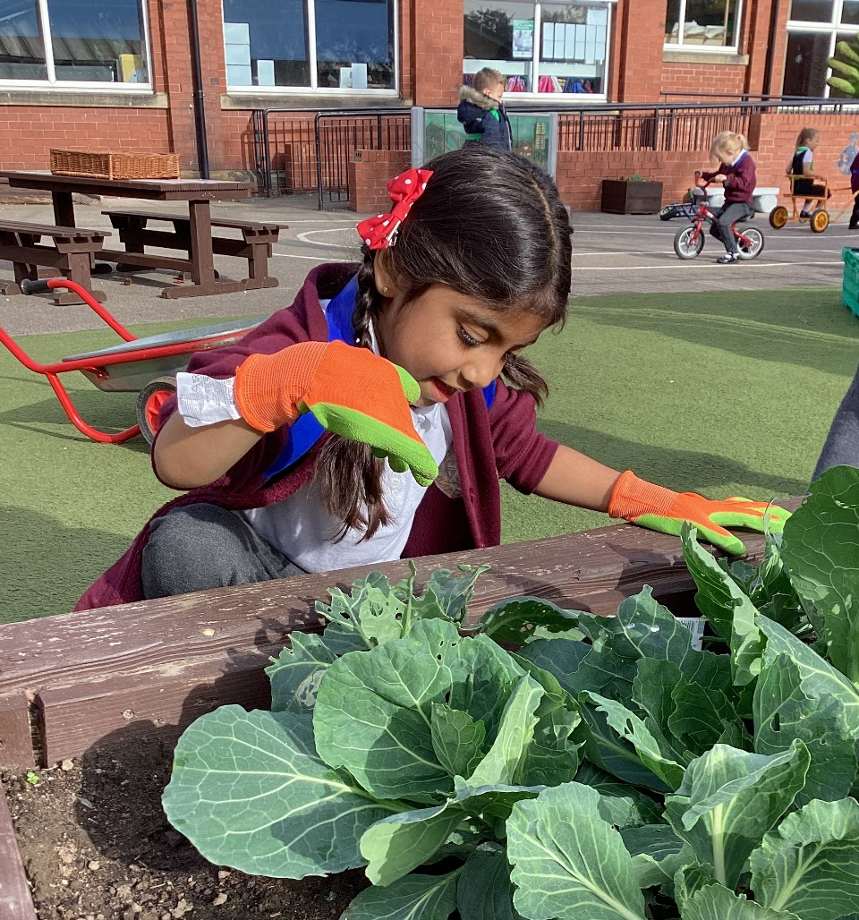

Job Description

Academy/School | Thornhill Junior & Infant
Job Family | Teaching Support
Job Title | Educational Teaching Assistant
Grade | FT Grade 3 – SCP 9-13
Accountable to | Headteacher/Principal
Line manager

Purpose of the role
To work under the direct instruction of teaching/senior staff, usually in the classroom with the teacher, to support access to learning for pupils and provide general support to the teacher/s in the management of pupils and the classroom.

Main Duties

Support for Pupils
- Establish rapport and respectful, trusting relationships with pupils, acting as a role model and setting high expectations.
- Supervise and support all pupils, including those with special needs, and in any key stage, to undertake agreed learning activities / programmes linked to local and national curriculum and learning strategies, e.g. literacy, numeracy, KS1 or KS 2 or early years.
- Adjusting activities according to pupil responses and needs, including for those with special educational needs.
- The role may include supporting and implementing pupils’ personal programme, including social, health, physical, hygiene, and welfare matters. The pupil may also need assistance to access different areas of the school. Following appropriate training and in line with school procedures, to administer basic first aid and/or medication as required.
- Promote inclusion and acceptance of all pupils by encouraging them to interact with each other and to engage in activities led by the teacher.
- Promote self-esteem and independence amongst pupils.
- Support the implementation of Individual Education Plans, Behaviour Plans and Health care plans.
- Provide feedback to pupils on their progress and achievement under the guidance of a teacher, in line with school policy.
- Use ICT effectively to support learning activities

Support for teachers
- Promote good pupil behaviour, dealing promptly with conflicts in line with school behaviour policies.
- Establish constructive relationships with parents and carers, promoting the School’s home/school liaison policy
- Assist the teacher with the preparation of teaching and learning materials and resources.
- Provide detailed feedback to teachers on pupils’ achievement, progress, problems etc. as requested.
- Undertake pupil record keeping as requested and assist with the collation of pupil reports as requested by the teacher, which may involve data inputting.
- Maintain a purposeful, orderly and supportive environment, in accordance with lesson plans.
- Assist with the display of pupils’ work.
- Prepare, maintain and use equipment/resources required to meet the lesson plans/learning activity and assist pupils in their use.
- Administer and mark straightforward routine tests, e.g. spelling or mental arithmetic, and invigilate tests as required
- Provide clerical and basic administrative support for teachers, e.g. photocopying, filing, collecting money, checking deliveries and placing goods in stock and maintaining records of stock, administering coursework, production of work sheets for agreed activities
- To attend team/staff meetings as required

Support for school
- To support others within the classroom and the School, contributing to the achievement of School objectives by working as part of a team
- Assist with activities outside the classroom, working as part of a team to oversee pupils and support Activity Leaders, e.g. Breakfast Club or accompanying to swimming lessons. (If this is an agreed part of the working pattern)
- Accompany teaching staff and pupils on visits, trips and out-of-school activities as required and take responsibility for a group under the supervision of a teacher
- To be flexible to the ever changing needs of the children and the school and work across all key stages as required.

Fulfil wider professional responsibilities
- Make a positive contribution to the wider life and ethos of the School and the Trust.
- Develop effective professional relationships with governors, colleagues, families knowing how and when to draw on advice and specialist support.
- To be willing and able to be part of a team of first aiders/fire wardens as may be required.
- Communicate effectively with pupils, school staff and visitors.
- To participate in training and other learning activities and performance development as required.
- To be aware of and comply with policies and procedures relating to child protection, health, safety and security, confidentiality and data protection, reporting all concerns to an appropriate person.
Personal and professional conduct
All Focus Trust staff are expected to demonstrate consistently high standards of personal and professional conduct. The following statements define the behaviour and attitudes which set the required standard for conduct throughout a career with the Trust.

All Staff must uphold public trust in the profession and maintain high standards of ethics and behaviour, within and outside the School, by:
- treating governors, pupils, staff, parents and visitors with dignity, building relationships rooted in mutual respect, and at all times observing proper boundaries appropriate to an adult working in an School environment;
- having regard for the need to safeguard pupils’ well-being, in accordance with statutory provisions;
- showing tolerance of and respect for the rights of others;
- not undermining fundamental British values, including democracy, the rule of law, individual liberty and mutual respect, and tolerance of those with different faiths and beliefs; and
- ensuring that personal beliefs are not expressed in ways which exploit pupils’ vulnerability or might lead them to break the law.

All staff working in the Focus-Trust must have proper and professional regard for the ethos, policies and practices of the School and the Trust, and maintain high standards in their own attendance and punctuality.

All staff must have an understanding of, and always act within, the statutory frameworks which set out their professional duties and responsibilities; and within the policies, handbooks and guidelines of the School and of the Focus-Trust.

General
The post holder will:
- Be expected to actively support the work and ethos of the Focus-Trust.
- Be expected to undertake such additional duties as may reasonably be requested by the Principal/Headteacher or their representative.
- Respect confidentiality of staff, pupils, families and visitors and not breach this trust. Any breaches of confidentiality must be reported to the Principal/Headteacher immediately.
- Participate in arrangements for appraisal and in the identification of areas in which s/he would benefit from training and undergo such training.
- Comply with and support all policies related to equal opportunities, child protection and safeguarding of children and colleagues.

This job description is neither exhaustive nor exclusive, and it may, after consultation with the post holder be subject to modification and amendment in accordance with Trust’s procedures.

Signed …………………………………………………………… Post holder

Signed ……………………………………………………………… Line manager

Dated ………………………………………………………………

Job Title – Educational Teaching Assistant
Person specification

Knowledge, Experience and Skills

 |  | Essential/  Desirable | How identified
Experience
Experience of using computer packages for word processing, spreadsheets, databases and researching information |  | E | App/SP
Experience of team working to work effectively with others and meet deadlines and goals |  | E | App/SP
Experience in using and maintaining accurate and quality electronic and paper-based systems |  | E | App/SP
Experience of working with young people with different abilities in a classroom/school environment or similar setting |  | E | App/SP
Experience of contributing to reports on pupils’ achievement and progress in a timely manner. |  | D | App/SP
Experience of working with learning resources and helping with their preparation to support learning programmes |  | E | App/SP
Skills and abilities
Communication skills to liaise sensitively and effectively with parents and carers |  | E | App/SP
Ability to relate well to children and adults |  | E | App/SP
Effective organisational skills and ability to work to deadlines |  | E | App/SP
Team-work skills to work collaboratively with colleagues, understanding classroom roles and responsibilities and your own position within these |  | E | App/SP
Interpersonal and communication skills to build and maintain successful relationships with colleagues and pupils, treat them consistently with respect and consideration |  | E | App/SP
To demonstrate and promote the positive value, attitudes and behaviour you expect from pupils with whom you work |  | E | App/SP
Able to work from instructions and use own initiative to make minor decisions. |  | E | App/SP
Ability to interpret information and solve straight forward problems in order to meet the needs of the children |  | E | App/SP
Understand and recognise the importance of ensuring a secure and safe environment for children and young people in which to learn and develop |  | E | App/SP
Able to continually improve own practice/knowledge through self evaluation and learning from others |  | E | App/SP
Knowledge
Understanding of the relevant policies/codes of practice and awareness of relevant legislation in the context of your role. |  | E
General understanding of national/foundation stage curriculum and other relevant learning programmes/strategies |  | E | App/SP
Understanding of equal opportunities and an awareness of potential barriers children may have around learning |  | E | App/SP
Basic understanding of a child’s development and learning. |  | E | App/SP
Child protection
Understands why safeguarding is important when working with children. |  | E | App/SP
Ability to deal with sensitive issues in a supportive and effective manner with confidentiality and data protection principles in mind |  | E | App/SP
Qualifications and training
Willingness to gain a paediatric first aid certificate (as required) |  | E | App
Literacy and Numeracy skills equivalent to Level 1 of the National Qualification & Credit Framework |  | E | App
NVQ 2 for Teaching Assistants or equivalent qualification or experience |  | E | App
Willingness to undertake training in relevant learning strategies e.g. literacy/ Key Stage 3, subject specific, Special Needs, behaviour management etc |  | E | App
Completion of Department for Education Teacher Assistant Induction Programme (or to complete within first term) |  | E | App
Personal qualities and attributes
Moral purpose (Equality, children and adults treated with respect) | E |  | SP/Ref
Child centered | E |  | SP/Ref
Integrity – Responsible adult role model and being a positive influence | E |  | SP/Ref
Self-motivated | E |  | SP/Ref
Enjoys challenge | E |  | SP/Ref
Works to deadlines, with accuracy and attention to detail | E |  | SP/Ref
Enthusiastic and optimistic | E |  | SP/Ref
Self-awareness, knowledge of strengths and limitations | E |  | SP/Ref
Able to remain calm and focused | E |  | SP/Ref
To be flexible and adaptable to the ever-changing needs of the school | E |  | SP/Ref
Reliable – good attendance | E |  | SP/Ref

About Our School

Thornhill Junior and Infant School vision:

‘Together we will make the difference’.

Thornhill Junior and Infant school aims to nurture: happy, confident, inquisitive, responsible citizens with high aspirations for themselves and others.

We seek to achieve this through:

- Working together to create a happy school full of learning, laughter and friendship where individual contributions and opinions are valued.
- Promoting each pupil’s self-esteem by building and developing individual strengths and talents so that children feel able to take risks within a safe, positive environment.
- Providing opportunities to explore, investigate and question the world around them through a broad and balanced curriculum enabling children to develop their natural inquisitiveness.
- Creating a stimulating environment, with high quality teaching, where children are encouraged to think for themselves, express their opinions and take responsibility for their learning.
- Supporting children to make the right choices for themselves and others, enabling them to make a valuable contribution to society and become responsible citizens.

Our pupils
The very large majority of pupils are of White British heritage and some have a first language other than English. The proportion of pupils known to be eligible for free school meals is above average. The proportion of disabled pupils or who are supported on the SEND register are above average. Attainment on entry is broadly in line with age-related expectations.

Our staff
Our leadership team comprises the Headteacher, Deputy Headteacher, two Assistant Headteachers and two senior leaders. In addition to teachers and teaching assistants, we have behaviour and pastoral leads who work with children and families, staff and outside agencies to offer support for wellbeing and develop parental engagement. The running of the school is also supported by admin, site, kitchen and lunchtime teams.

Our facilities
Thornhill is a two-form entry school. The classrooms are light and spacious and well equipped to ensure the children have a learning environment conducive to the 21st century. We are extremely fortunate to have large grounds which have been designed and developed to support children’s learning.

Our school organisation
Our pupil admission number is 420 and there are two classes for each year group, from Reception to Year 6. In addition to class teachers, learning is supported in classes by teaching assistants – the number of these depends on needs within classes and year groups.

Our curriculum
We offer a broad and balanced curriculum which gives the children a wide range of experiences to develop the whole child. Our curriculum is geared to giving children a firm grounding and the necessary skills to succeed in an ever-changing world as well as providing them with the solid foundations of Reading, writing and Maths. We are very proud to be an Arts Mark School as well as having achieved the Platinum Sing Up Award.

Our extra-curricular activities
As well as our extensive range of music clubs we have lots of other extra-curricular activities that run throughout the year including; football, cooking, Scalextric, board games, homework, Lego and arts and crafts. We have an After School and Holiday Club to provide affordable childcare and to meet the needs of our working parents.

School Quick Facts

Type of school | Primary
Age range | 4-11
Location/LA | Kirklees
Number of children | 353
Number of teaching staff | 21
Number of support staff | 40
% FSM | 42.49%
% SEN | 15 %
% EAL | 5.38 %

Our geographical area

Our popular school is situated in the village of Thornhill, Dewsbury, West Yorkshire, serving a large residential area of private and local authority housing.

Thornhill Junior & Infant School is one of two in the village.

In addition to our partner academies within Focus-Trust, we work collaboratively with schools in our local partnership and with a range of secondary schools in the nearby areas to which our pupils transfer at the end of Year 6.

Facts about Thornhill

- Thornhill is a village and former township in Dewsbury, Kirklees, West Yorkshire, England.
- It is situated on a hill on the south side of the River Calder, and has extensive views of Dewsbury, Ossett and Wakefield.
- Historically, Thornhill was part of the West Riding of Yorkshire.
- The village is known for its collection of Anglo-Saxon crosses.
- Thornhill was a centre for coal mining and stone quarrying during the Industrial Revolution.
- Thornhill Parish Church, dedicated to St. Michael and All Angels, is a Grade I listed building.
- The village is also home to the Grade II* listed Thornhill Rectory, which was built in the 18th century.
- The village has a community academy, Thornhill Community Academy, which was featured in the Channel 4 documentary series ‘Educating Yorkshire’.
- Thornhill is also home to a rugby league club, Thornhill Trojans, which plays in the National Conference League.

What you might want to know about Focus Trust
Who are we?
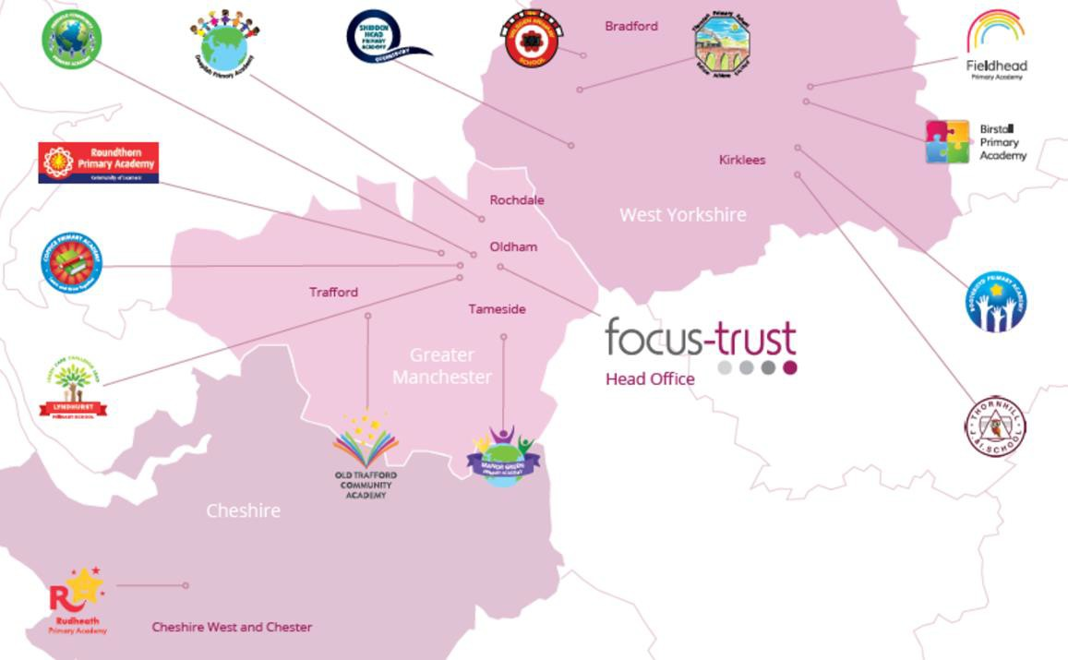
Focus-Trust was incorporated in May 2012 as a primary trust. The Trust has links with the sponsor, Focus Education, but is an entirely separate legal entity. As with all academy trusts, the Trust is a company limited by guarantee and an exempt charity. The Trust’s offices are situated in a newly converted historic mill conversion in Chadderton, Oldham with excellent motorway networks to access our schools.

The defining feature of Focus-Trust is that it is a specialist primary phase trust. This means that the work of the Trust is driven by the distinctive needs of primary schools. Whilst the Trust has robust systems for accountability, each school has their own distinctive identity, ethos and culture, and this is a commitment to every school when they convert and join the Trust.

Focus-Trust currently has a small centrally employed team. The members of the team are highly skilled and committed to the vision, culture and values of the Trust.

All the schools within the Trust are willing partners who have actively chosen to join Focus-Trust and there is a very high degree of consensus, cooperation and commitment from within the group.

The Trust has robust policies and systems in place to govern and guide its work. These have been gradually implemented as the Trust has grown. The Trust has well-established productive relationships with trade unions and meets half termly with a group of national trade union representatives to discuss policy development. This has enabled us to introduce and change a range of policies in a streamlined and cooperative way.

Equality of opportunity

Focus-Trust is an equal opportunity employer, dedicated to a policy of non-discrimination in employment on any basis including age, gender, race, colour, nationality, ethnic origin, disability, gender, religion, age, marital status, sexual orientation and/or medical condition.

Safeguarding

Focus-Trust is committed to safeguarding and promoting the welfare of all children and young people. There is an explicit expectation that all employees share this commitment and adhere to all safeguarding policies and procedures. Applicants should be aware that the recruitment process will include an assessment of your suitability to work with children.

Right to work in the UK

Under the Asylum and Immigration Act 1996, it is a criminal offence to employ anyone who is not entitled to live or work in the United Kingdom. Applicants can expect us to ask for proof of this at interview stage, where you will be asked to provide some original documentation to confirm that you are eligible to work within the UK. Photographic proof of identity will also be required.

Validation of qualifications and identity

All shortlisted candidates will be asked to bring original certificates or relevant qualifications and identity documents to interview. These will be photocopied and kept on file and, if appropriate, may be confirmed as genuine with the relevant awarding bodies. The copies of the successful candidate will be retained on their personnel file. The copies of unsuccessful candidates will be treated as confidential waste and disposed of appropriately.

References and Social Media Checks

If you are shortlisted, we will take up references before the interview date, unless you state otherwise on your application form. However, two satisfactory references must be received before we can confirm any offer of an appointment. One of your referees must be your current or most recent employer. The information we request will relate to salary, length of service, skills and abilities, suitability for the job, disciplinary record, and suitability to work with children. Copies of references or open references will not be accepted. On receipt of references, your referees may be contacted to verify any discrepancies, anomalies, or relevant issues as part of the recruitment verification process.

In line with our safer recruitment policy, on-line presence checks will be undertaken if you are shortlisted. This check is designed to complement the range of standard recruitment checks and allows us to identify a candidate’s online presence, which potentially could damage the organisation’s reputation.

Disability

To comply with the Equality Act 2010, we are legally required to consider making reasonable adjustments to ensure that disabled people are not disadvantaged in the recruitment and selection process. We are therefore committed to meeting, wherever possible, any needs you specify on the application form. Please contact the named person on the advert, if you need to discuss this in any detail. We will consider any reasonable adjustment under the terms of the Act to enable an applicant with a disability (as defined under the Act) to meet the requirements of the post.

Disclosure of a criminal record

Employment in this role is subject to an enhanced check with the Disclosure and Barring Service (DBS). Checks will also be made against the lists showing people barred from working with children. All checks must be satisfactory before any offer of employment can be confirmed and before commencement of work can take place.

Dress code

We expect all staff to dress professionally and appropriately for the roles undertaken. We pride ourselves on the high standards of dress of both our pupils and staff; these standards are led by our staff who we expect to set an example.

Knowledge and skills profile

This is an important part of your application and is your opportunity to explain how you meet the person specification for the post. You should demonstrate, using no more than 2000 characters, your skills, knowledge and experience and give short examples. Describe how you match the requirements of the role; include experience gained from previous jobs, community, or voluntary work. Ensure that the information you give is well organised, relevant, and brief. You may find it helpful to use sub-headings to keep your statement well focused. If you do not submit this profile, you will not be considered for short listing.

Policies

Focus-Trust and the schools have a range of policies and handbooks that help to make clear our expectations and ways of working. These are always shared openly with staff and are accessible to everyone. There are several policies that prospective employees should be aware of when making an application. These can be found on the Trust website www.focus-trust.co.uk and school websites. All members of staff will be asked to sign a declaration as part of the induction process to acknowledge that they have read and understand the Code of Conduct and some of the key policies, e.g. Safeguarding and Child Protection, Health and Safety, Acceptable use of IT.

Pensions

Focus-Trust contributes to Teachers’ Pensions and Local Government pensions in the same way and with the same level of contribution as local authorities.

Employer Relations

Focus-Trust has a Trade Union agreement which recognises the teacher and support staff unions. This is further supported by an ongoing and productive relationship with key trade union officials.
Thank you for taking the time to read this information pack. We wish you every
success in any application you may make.

Thornhill Junior & Infant School
Edge Lane
Thornhill
Dewsbury
WF12 0QT

E: thornhill@focus-trust.co.uk

