


JOB PROFILE
Job Title: | Catering Assistant | School/Department: | Rossett School
Salary Grade: | Point 3, £13.45 per hour | Working Hours: | 20.75 hours per week, Monday to Friday, plus opportunity for additional hours on evenings and weekends
Contract Type: | Part-time, Permanent, Term time only plus training days | Location: | Rossett School
Responsible to: Executive Chef
Role summary:
To assist in the operation of a high quality and efficient large-scale catering service offering students a wide range of nutritious and delicious snack and lunch options as well as providing exceptional events catering for the Trust. To provide effective support for the Executive Chef to optimise income generation.

Red Kite Learning Trust is committed to safeguarding and promoting the welfare of students and expects all colleagues and volunteers to share this commitment.
Special conditions of service:
No smoking policy, including e-cigarettes.
Role specific responsibilities:
- Preparation and cooking of food as directed
- Events catering for the Trust.
- Preparation of desserts, pastries and traybakes
- Preparation of counter areas before service both in the main kitchen
- Setting out and removal of dining furniture as required
- Serving of food and drinks during break and lunch service
- Operating ‘thumbprint’ cashless system during service
- Developing a friendly and helpful atmosphere to all customers
- Complying with all Health & Safety rules and regulations
- Cleaning dining areas and kitchen after service to maintain a high standard of hygiene
- Maintaining a high standard of personal hygiene
- Flexibility to work evenings and weekends.

RK People responsibilities:
- Contribute to the overall aims and values of our Trust, appreciate and support the roles of other members of the wider team and attend and participate in relevant meetings as required
- Comply with all Trust policies and procedures including child protection, health, safety, welfare, security, confidentiality and data protection, reporting any concerns to the appropriate person
- Contribute to ensuring safeguarding procedures are in place and used effectively at all times
The role holder must demonstrate a flexible approach to the delivery of the role. Consequently, the role holder may be required to perform work not specifically identified in the job profile but which is in line with the general scope, grade and responsibilities of the role.
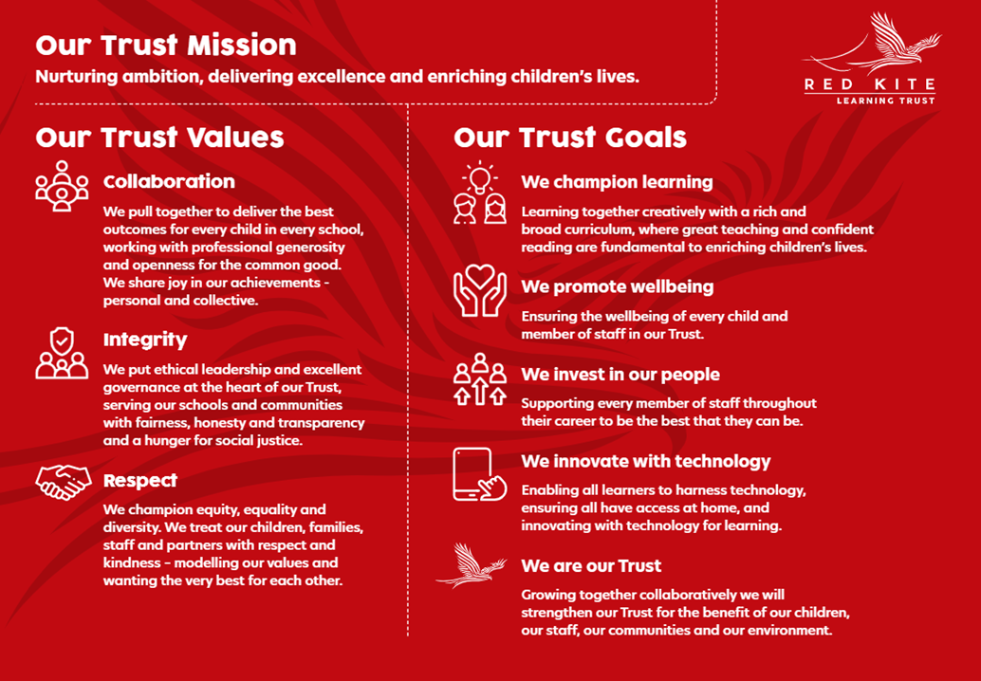
PEOPLE PROFILE
Aptitudes and Characteristics |  |  |  | Essential | Desirable
Excellent cooking skills |  |  |  | *
Ability to work flexibly and collaboratively as part of a team as well as on own |  |  |  | *
Reliable, hardworking, well-motivated and positive |  |  |  | *
Good communication skills (students and staff) |  |  |  | *
Enthusiasm, flexibility and commitment |  |  |  | *
Qualifications, Knowledge and Experience |  |  |  | Essential | Desirable
City & Guilds Catering Level 1/2 or equivalent |  |  |  |  | *
Large scale catering experience |  |  |  |  | *
Experience of large scale preparing desserts and traybakes |  |  |  |  | *
Knowledge of Health & Safety regulations |  |  |  | *
Knowledge of Food Based Standards |  |  |  | *
Safeguarding and Promoting the Welfare of Students |  |  |  | Essential | Desirable
An appropriate motivation to work with children and young people |  |  |  | *
Ability to maintain appropriate relationships and personal boundaries with children and young people |  |  |  | *
Emotional resilience in working with challenging behaviours and appropriate attitudes to the use of authority and maintaining discipline |  |  |  | *

