Thank you for your interest in the

teacher of Science position

and your interest in joining the

Archbishop Ilsley family



Proud to be part of the St Teresa of Calcutta Multi Academy Company

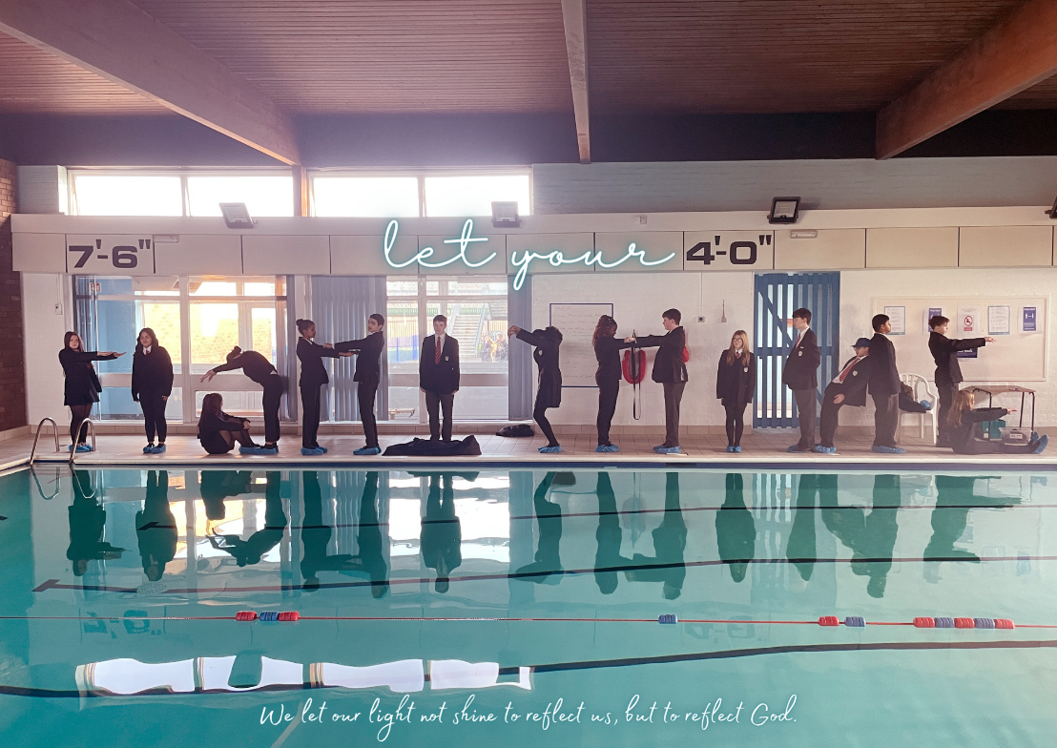

Welcome from our Head Teacher



Thank you for your interest in joining Archbishop Ilsley Catholic School.

The ethos of Ilsley is quite simple. As a Catholic school, we want pupils to “let (their) light shine.” We want pupils to believe in themselves and strive to fulfil their vocation, whatever that may be. Pupils are polite and friendly and a real joy to work with. They are the main benefit to working at Ilsley.

We have great facilities: as well as a spacious staffroom (we have briefing twice a week in here), we have a well-stocked library, a sports hall, gym, fitness suite, astroturf and a muga, as well as a swimming pool.

I hope you find this application pack informative and useful. If you read some of our recent newsletters, which you can find here https://www.ilsley.bham.sch.uk/communication/abi-update/ or scroll through our posts from our Twitter account @ABIllsey, you will also get a flavour of what day-to-day life is like at Ilsley. I highly recommend you come to visit the school.

Simply email recruitment@ilsley.bham.sch.uk and Rebecca, or one our TLR holders, would be pleased to give you a tour and hear your ideas about the role.
I look forward to receiving your application and meeting you in person.

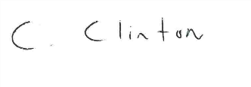
Ciaran Clinton

Welcome to the Science Department at Archbishop Ilsley
Dear potential candidate,
We are a well-resourced department of 11 colleagues passionate about delivering the high quality, deeply engaging science lessons our pupils and students need and deserve. Fundamental to our ethos is the conviction that all pupils and students are entitled to well planned, skilfully taught science education that sparks interest and develops understanding of its fundamental importance to modern life.
Your support will be instrumental to the success of the department’s science delivery across key stages 3 – 5. You will make a vital contribution to the AQA GCSE success of our pupils through efficiently managing existing well-established systems and the implementation of strategic improvements to enhance effectiveness. There is also opportunity to teach AQA Physics, Chemistry or OCR Biology A level to a relatively large group of very keen students.
This role provides an exciting opportunity for an innovative, self-motivated colleague to develop their career by making a significant contribution to the drive to improve the science programme at Archbishop Ilsley Catholic School.
I hope you enjoy reading this pack and look forward to seeing you soon.
Rebecca Gashi
Head of Science


Teacher of Science
Full time (negotiable)
Permanent contract
Start Date: 1st September 2026

Do you want in a school where staff happiness and workload are the priority? Do you want to work in a school where the Headteacher and Head of Department will listen to your views and value you as a person? Do you want to work in a school, where staff are committed, supportive and friendly – they genuinely enjoy each other’s company? If the answer to these questions is yes, then why not come and visit Archbishop Ilsley Catholic School?

Archbishop Ilsley are looking to expand their Science provision due to increasing demand at sixth form. We are looking to appoint an inspirational and talented science teacher. Due to a flexible curriculum and bespoke timetabling, we would welcome applications from biologists, chemists or physicists.

The Science department offers the following:
- The opportunity to be a creative scientist;
- The opportunity to make a genuine difference to the lives of our pupils;
- A supportive and friendly collaborative team environment;
- An outstanding KS3 curriculum;
- Good results at GCSE and A Level;
- Very good pupil uptake for A Level.

The successful applicant will:
- Be a committed team player;
- Have the ability to deliver excellent pupil and student outcomes;
- Be an innovative and inspirational teacher;
- Have the ability to engage and inspire pupils and build excellent relationships;
- Be committed to their personal and professional development;
- Make a positive contribution to the school’s distinctive ethos.

Archbishop Ilsley is a large oversubscribed Catholic Secondary School in Acocks Green on the border of Hall Green and Yardley in Birmingham that caters for pupils between the ages of 11 and 18. There are 210 pupils in each year and the sixth form is predicted to grow considerably over the next five years. GCSE and A Level results are strong.

Deadline for applications: 9 am on Friday 20th March.
Interviews are likely to take place on Friday 27th March.
Please send your completed CES application form to recruitment@ilsley.bham.sch.uk

Qualities and Attributes | Essential | Desirable | Evidenced By
Education and Training

Qualified Teacher Status | ✔ |  | CES Teacher Application form
Computer based Honours Degree | ✔ |  | CES Teacher Application form
Quality of Education

The ability to plan an engaging, yet rigorous, well sequenced series of lessons | ✔ |  | Letter of application/Interview
An excellent classroom practitioner with a strong track record in observations | ✔ |  | Letter of application/Interview
A range of strategies for keeping pupils engaged and focused | ✔ |  | Letter of application/Interview
Knowledge of current developments in teaching and learning. | ✔ |  | Letter of application/Interview
Excellent subject knowledge including all topics studied at Key Stage 3 and GCSE | ✔ |  | Letter of application/Interview
Personal Qualities and Characteristics

Enthusiasm and commitment to teaching young people | ✔ |  | Interview
Good communication and interpersonal skills | ✔ |  | Interview
Excellent organisational skills | ✔ |  | Letter of application/Interview
A team player that looks forward to working with other like-minded colleagues in a thriving department | ✔ |  | Letter of application/Interview
Ability to work under pressure and meet deadlines | ✔ |  | Letter of application/Interview

Person specification for the role of Teacher of Science

What staff say about working at Archbishop Ilsley Catholic School

“Staff are really friendly…really supportive… not judgmental.” Male teacher

“Colleagues are fantastic… very supportive.” Female maths teacher

“I love it… so glad I made the move.” Female RS teacher

“It’s lovely here… people are so kind… offering to do things for you.” Female PE teacher

“We’re a great unit… we’re a family.” Male DT teacher

“Everyone made me feel welcome.” Female member of the admin team

“Staff are phenomenal… we’re a community.” Male RS teacher

“I absolutely love it here.” Female D&T teacher

“I really like working here… staff are great.” Female member of support staff

“People are lovely… very supportive of each other. It’s not just a job.” Female maths teacher

“I love working here… I 100% feel at home.” Male Humanities teacher

“I’m not Catholic but I don’t feel excluded… we’re one big family.” Female Humanities teacher

“I feel privileged to work here.” Female TA

“There is great camaraderie… there is a buzz in the staffroom.” Female TA

“Staff are really talented and loyal and willing… people care.” Female English teacher

“We have phenomenal staff… we have the best middle leaders.” Male member of SLT

“I love this school… there are so many amazing people here… the pastoral team are amazing.” Female member of support staff

“I feel really lucky to work here.” Female PE teacher

“Ilsley is the centre of the community.” Male PE teacher

“I love this school… I love teaching here.” Male Humanities teacher

“Teachers are so open minded… they say ‘we’ll try it’.” Male TA

“Archbishop Ilsley is an extension of our own family.” Female D&T teacher

“I don’t think there is a person I would go to for help, and they would say no… it would be a ‘YES’ – without a doubt.” Female Art teacher

Staff happiness is our priority. Things that make Ilsley a special place to work

- Friendly and welcoming staff

- Duke of Edinburgh – the best in Birmingham! A must for lovers of the outdoors and we’re always looking for more volunteers.

- A swimming pool! (Staff can swim between 7am and 8am Tuesday and Thursday)

- Football after school on a Wednesday on the astroturf (everyone welcome)

- Basketball in the gym after school on Friday (all are welcome)

- Global Links Club – the opportunity to be part of a group who run weekly training sessions for Year 12 pupils who wider their horizons and prepare them for their 16 day trip. We have been to Cambodia, Peru and Nepal and have another trip planned for Peru.

- St Patrick’s Day Parade – the only school to have a ‘float’ at the parade in Digbeth. Come along and get involved!

- Spacious staffroom

- Secret Saints (presents in pigeon holes)

- An active Well-Being Committee

- Strong and supportive union presence who work harmoniously with the headteacher

- An understanding of those juggling work and family life – time off for children’s first day at school, nativities, sports day etc

- No unnecessary meetings

- A workable feedback policy

- Great extra-curricular opportunities (theatre, Houses of Parliament, dance competitions, Berlin, Battlefields, National Trust membership)

- Whole school events for the pupils (Black Country Museum, Blackwell, Y8 Valentine’s disco)

- Half termly staff breakfast (briefing in the canteen)

- End of term celebrations

Job description

Post Title: Teacher of Science
Start date: 1st September 2026

Post Purpose:
- To uphold the Catholic Life and Mission of the school.
- To raise standards of pupil attainment and achievement within their area of curriculum responsibility.
- To be accountable for pupil progress within the curriculum area.

Reporting to: Head of Science
Working Time: Full time permanent contract (negotiable)
Salary/Grade: MPS/UPS
Disclosure Level: Enhanced

General Duties

Teaching Science to designated classes of pupils and general welfare of a tutor group in accordance with the requirements of the latest School Teachers’ Pay and Conditions Document and the National Standards for Qualified Teacher Status, having due regard to the requirements of the National Curriculum, the school’s aims and objectives, schemes of work and any policies of the Governing Body. To share in the corporate responsibility for the well-being and discipline of all pupils and to actively support the aims and values of Archbishop Ilsley Catholic School.

Specific Duties
- Teaching
  - Plan work in accordance with departmental schemes of work and programmes of study.
  - Liaise with relevant colleagues on the planning of units of work for collaborative delivery.
  - Work in collaboration with Teaching Assistants attached to any teaching group.
  - Take into account pupils’ prior levels of attainment and use them to set targets for future improvements.
  - Set work for pupils absent from school for health or disciplinary reasons.
  - Maintain good discipline by adherence to the Teacher Standards.
  - Set high expectations for pupils’ behaviour by establishing a purposeful working atmosphere in accordance with the school’s behaviour policy.
  - Set appropriate and demanding expectations for pupil’s learning, motivation and presentation of work.
  - Develop own subject knowledge to a high level of expertise.

- Pastoral Work
- Have a full understanding of the procedures for safeguarding.
- Undertake responsibility for a tutor group as required, including supporting their attendance.
- Be the first point of contact for parents of pupils in the tutor group.
- Monitor and set targets for attendance as well as social and academic progress of individuals in the tutor group.
- Promote good attendance and monitor in accordance with the school’s attendance policy.
- Deliver the designated tutor time programme.

Assessment, recording & reporting

  - Mark, monitor and return work within a reasonable and agreed time span providing constructive oral and written feedback and clear targets for future learning as appropriate.
  - Carry out assessment programmes (e.g. reports) as agreed by the school or faculty.
  - Attend the appropriate parents’ evenings to keep parents informed as to the progress of their child.
  - Be familiar with the SEND Code of Practice for identification and assessment of Additional Educational Needs and keep appropriate records on Individual Education Plans for pupils.

Professional Standards

  - Support the aims of the school to promote a ‘learning community’.
  - Treat all members of the community, colleagues and pupils, with respect and consideration.
  - Treat all pupils fairly, consistently and without prejudice.
  - Set a good example to pupils in terms of appropriate dress, standards of punctuality and attendance.
  - Promote the aims of the school by attendance at and participation in events such as open evenings, options evenings and the like (as appropriate to your responsibilities.)
  - Support the ethos of the school by upholding the behaviour code, uniform regulations, etc.
  - Take responsibility for their own professional development and participate in staff training when provided.
  - Reflect on their own practice as well as the practices of the school with aim of improving all that we do.
  - Read and adhere to the various policies of the school.
  - Participate in the management of the school by attending various team and staff meetings.
  - Undertake duties as prescribed within school policies.
  - Ensure that all deadlines are met as published in the school calendar.
  - Undertake professional duties that may be reasonably assigned to them by the Head teacher (e.g. cover, etc).
  - Be proactive and take responsibility for matters relating to health and safety.

This job description may be amended at any time in discussion between the Head Teacher and yourself but in any case will be reviewed before the commencement of the next Performance Management cycle.

Signatures:

This job description is current at the date below but will be reviewed on an annual basis and following consultation with you, may be changed to reflect or anticipate changes in the job requirements which are commensurate with the job title and grade.

Signed………………………………(Teacher) Signed……………………………….(Head Teacher) Date………….

Our Safeguarding commitment

Archbishop Ilsley is committed to safeguarding and promoting the welfare of all its pupils. We believe that:
- Our young people have the right to be protected from harm, abuse and neglect;
- Our people have the right to experience their optimum mental and physical health;
- Every child has the right to an education and young people need to be safe and to feel safe in school;
- Young people need support that matches their individual needs, including those who may have experienced abuse;
- Our young people have the right to express their views, feelings and wishes and voice their own values and beliefs;
- Our young people should be encouraged to respect each other’s values and support each other;
- Our young people have the right to be supported to meet their emotional, social and mental health needs as well as their educational needs. Our school will ensure clear systems and processes are in place to enable identification of these needs. Including consideration of when mental health needs may become a safeguarding need;
- Our school will contribute to the prevention of abuse, risk/involvement in serious violent crime, victimisation, bullying (including homophobic, biphobic, transphobic and cyber bullying), exploitation, extreme behaviours, discriminatory views and risk-taking behaviours.

All staff and visitors have an important role to play in safeguarding young people and protecting them from abuse and considering when mental health may become a safeguarding issue.

Please be aware, as part of our rigorous safer recruitment process, we will undertake the following pre-appointment checks if you are successful on the interview day:
- Verification of identity – including an original birth certificate;
- Eligibility to work in the UK;
- An online search;
- DBS Barred List (if a teacher, cover supervisor or pastoral lead);
- Enhanced DBS check;
- That you are not subject to a prohibition order or GTCE restriction;
- That you are not subject to a TS128 prohibition from a management position (if grade 4 or HOD or SLT);
- Qualifications (including degree certificate and A Level results);
- QTS certificate;
- Overseas check may be made if you have lived abroad;
- Two references will be requested and verified.

This position is only available for candidates who have the right to work in the UK. We regret that we cannot sponsor candidates from abroad or provide a work visa. As a new employee you will be expected to uphold and promote our strong safeguarding culture.

