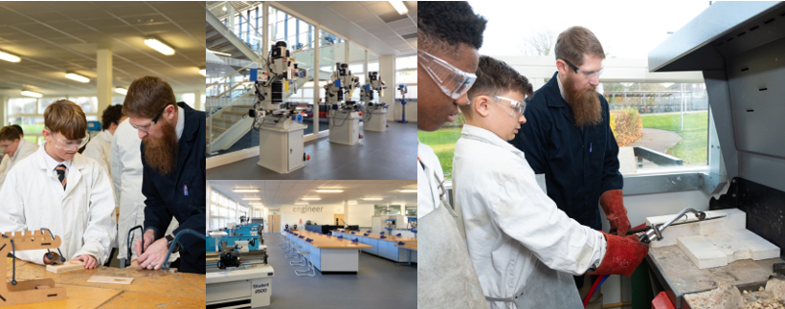


Head of Faculty: Art, Design and Technology

At Northfleet Technology College, our Design and Technology Team stimulate creativity, curiosity and conscience to develop Technicians, Designers and Engineers who are passionate about problem solving and developing a better future.
The Faculty currently comprises an experienced Design and Technology team, supported by a dedicated Technician, alongside a strong Art and Design team, all based in fully equipped specialist teaching areas. In addition, funding and planning permission have been approved for a new multi-million-pound extension, which will include a state-of-the-art Food Technology suite, enabling the team to further expand and enrich the curriculum offer. Our new Head of Faculty will play a key role in developing these new teaching spaces.
At NTC, we are committed to developing learners who are curious, creative, and caring, equipping them with the personal skills and attributes needed to become valued members of the local and wider community.
Design and Technology is a popular and growing subject at all Key Stages, with student uptake increasing year on year. We are looking for a leader who is keen to share their expertise and enthusiasm, helping to further develop a focused, ambitious, and inspiring learning environment for both students and staff.
The curriculum is taught across:
- Key Stage 3
- Key Stage 4 (WJEC Technical Award in Engineering)
- Key Stage 5 (BTEC Engineering)
Teaching takes place in mixed-ability groups, with learning appropriately differentiated to meet the full range of student needs and abilities. Lessons are built around authentic, engaging, and complex questions, problems, or practical challenges, encouraging students to investigate, design, and respond creatively. Debate, collaboration, and ‘learning outside the box’ are actively encouraged to support our ethos of developing Curious, Creative and Caring learners.
The faculty also delivers a range of exciting after-school activities, designed to enhance learning and develop students’ interpersonal and social skills. These enrichment opportunities extend beyond the national curriculum, with the aim of broadening student experience. Creative initiatives and innovative ideas are strongly encouraged and welcomed.
This is an excellent opportunity for a committed and enthusiastic professional to lead a supportive, friendly, and dedicated team, united in achieving the highest possible standards for both staff and students, and in shaping the future of Design and Technology at NTC.

