
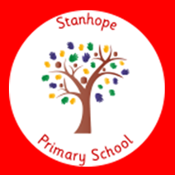

Stanhope Primary School

Class Teacher Application Pack
Start date of Tuesday 1st September

Full time
Permanent Position
Salary: MPS

Closing Date: Friday 15th May at 9am
Interview Date: Thursday 21st May 2026

A unique time to join our committed and passionate team wanting the best for the pupils they teach and to secure rapid improvement working with our school community. You are welcome and encouraged to contact school to discuss the vacancy / look around and meet our Headteacher.

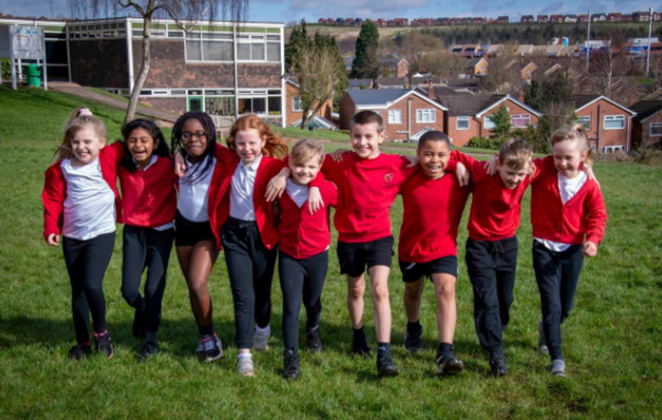

Come and join our team at Stanhope where we are on a transformational
journey to improve and create a sustainable love of learning for every child who attends our school!

Letter from Headteacher

Letter from our recently appointed Headteacher:

Thank you for taking the time to look at this application pack. We are seeking an aspirational and committed teacher who can join our team at a pivotal moment of leadership change and contribute meaningfully to our transformative school improvement journey.

We are looking for a classroom teacher who has high expectations for behaviour and attainment, and who can work effectively across our primary school. It is intended that the teaching post for 2026-27 be based in KS1. Experience in delivering Phonics to an exceptionally high standard is desirable and experience of transition between EYFS and KS1 again would be desirable. Our school uses Little Wandle Letters and Sounds Revised as an SSP.

Our school is currently rated Requires Improvement by Ofsted, and we are focused on strengthening our quality-first teaching offer to ensure greater consistency and impact. Our vision at Stanhope is:

“Creating a love of learning for LIFE!”

Alongside the expectation that children follow The Stanhope Way:

Be Kind, Be Safe, Be your Best Self.

We believe that getting to know pupils and their families is paramount. Across our community, we are establishing greater consistency to ensure that pupils’ social, emotional, and physical wellbeing remains a priority, supported through the delivery of our One Life programme.

Our pupils are fantastic each one individual, with a wide range of talents and diversity that we celebrate fully. We want to motivate and inspire our children to be ambitious for their futures through a well-rounded, language-driven curriculum that secures knowledge, and provides opportunities for pupils to articulate their ideas, opinions, and understanding.

Our staff team is friendly, supportive, and committed. We are fortunate to have an excellent learning environment, including woodland areas, extensive grounds, and cooking facilities within classes.

Alongside the Flying High Partnership, staff work collaboratively, engage in research-informed practice, and reflect on the most effective approaches to teaching and learning. We are a team that talks about teaching, strives to improve, and wants to help children develop learning habits that challenge them and extend their skills beyond Maths and English.

The teacher we appoint will be someone with initiative, strong interpersonal skills, and the ability to work as part of a team to make a significant impact on the direction of our school.

I would be very happy to speak with you if you are interested in the post or have any questions.

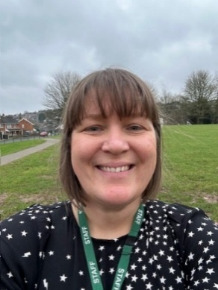
Kind regards,

Nicky Bridges
Headteacher

