Wroughton Junior School

Recruitment Pack: Special Educational Needs and Disabilities Coordinator

Welcome

Thank you for your interest in joining our team. At Wroughton Junior School, we are proud to be a welcoming, inclusive and ambitious school where children thrive both academically and personally. Our dedicated staff work together to create a nurturing environment that inspires curiosity, celebrates individuality and prepares every child for future success.
We are delighted you are considering becoming part of our team and look forward to sharing more about the values, opportunities and culture that make Wroughton Junior School a special place to learn, work and grow.




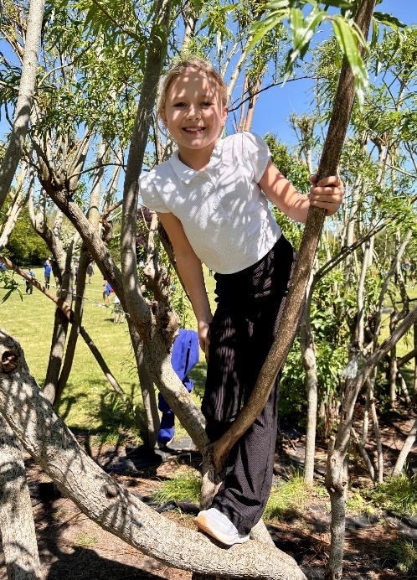

School Vision & Values

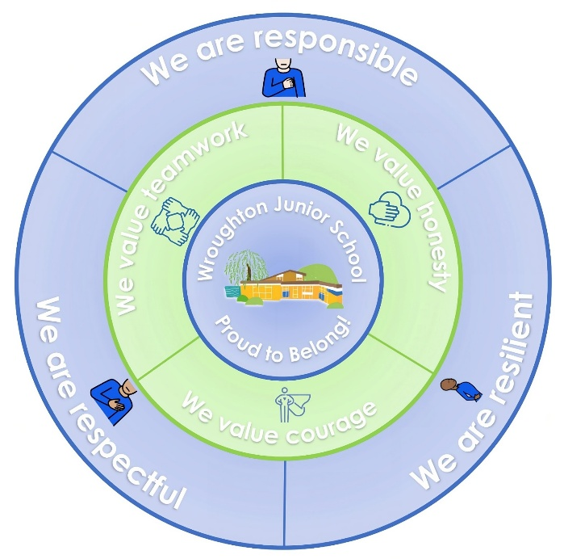
Proud to Belong!
At the heart of everything we do is our motto, "Proud to Belong." It reflects our belief that every child, member of staff and family should feel valued, supported and inspired to be the very best version of themselves. We are proud of our school, our achievements and, most importantly, the strong sense of community that makes our school such a special place to learn and work.
Our vision is underpinned by a set of core values which guide our decisions, shape our relationships and create the culture we aspire to every day.
We are Responsible
We are Respectful
We are Resilient
We value Honesty
We value Teamwork
We value Courage
We achieve more together than we ever could alone. Collaboration, partnership and a shared commitment to excellence are central to our success.
As a member of our team, you will be joining a school that is ambitious for every child, committed to continuous improvement and dedicated to providing an exceptional learning environment. We are seeking professionals who share our values, are passionate about education and who are eager to contribute to a community where everyone can truly be “Proud to Belong”.
We look forward to receiving your application and learning more about the skills, experience and enthusiasm you could bring to our school.

Job Description

Job Title | Special Education Needs and Disabilities Coordinator (SENDCo)
Pay Scale | MPS / UPS + TLR
Term | Permanent
Hours | 1.0 (0.8 SENDCo + 0.4 Teaching Commitment)  The teaching commitment will be working in a range of classes to build relationships with children around the school.  We would be willing to look at a reduced 0.8 contract with a reduced teaching commitment for the right candidate.
Line Manager | Headteacher

Our Special Educational Needs and Disabilities Coordinator (SENDCo) is responsible for ensuring that pupils with special educational needs and disabilities receive the support they need to reach their full potential. This is a leadership role that involves working with teachers, parents, and external agencies to coordinate effective SEND provision throughout the school.

General Duties and Leadership
- Strategic development: Work with the headteacher and Trust to set the strategic direction for the school's SEND policy and provision.
- Policy oversight: Manage the day-to-day operation of the school's SEND policy and monitor its effectiveness.
- Budget management: Advise on the allocation of the school's budget and resources to meet the needs of pupils with SEND.
- Compliance: Keep up to date with national and local SEND policies and legal requirements, ensuring the school meets its responsibilities under the Equality Act (2010).

Support for Pupils
- Assessment: Oversee the process of assessing pupils to identify their special educational needs and disabilities.
- Individualised plans: Develop, implement, and monitor Individual Education Plans (IEPs) or Education, Health and Care (EHC) plans for pupils with SEND.
- Provision coordination: Coordinate provision for all children with SEND, ensuring that appropriate support is in place.
- Monitoring progress: Track and analyse the progress of pupils with SEND and use this data to inform future strategies.

Working with Staff
- Guidance and advice: Provide professional guidance and support to fellow teachers on how to effectively meet the needs of pupils with SEND in the classroom.
- Training: Contribute to and lead staff training on special educational needs and inclusive teaching strategies.
- Team management: Manage and support the work of teaching assistants and who work with SEND pupils.

Communication and Liaison
- Parent collaboration: Build and maintain strong relationships with parents and carers, keeping them informed about their child's progress and the support they are receiving.
- External agencies: Act as the key point of contact for external agencies, such as educational psychologists, health services, and the local authority.
- Transition planning: Work with other schools and early years providers to ensure a smooth transition for pupils with SEND.

Requirements
- Qualified teacher status (QTS): All SENDCos must be qualified teachers.
- NASENCo qualification: A National Award for Special Educational Needs Coordination (NASENCo) is required within three years of appointment for those without prior experience as a SENDCo.
- Leadership skills: The ability to lead, inspire, and motivate other staff to foster a whole-school commitment to supporting pupils with SEND. I
- Interpersonal skills: Excellent communication, empathy, and emotional intelligence for building relationships with pupils, parents, and colleagues.

Person Specification

Qualifications | Essential | Desirable
Qualified Teacher Status (QTS) | ✔
National Award for SEN Coordination (or commitment to achieve within three years) | ✔
Professional Qualities | Essential | Desirable
Strong knowledge of the SEND Code of Practice and current legislation | ✔
Proven experience working with children with a wide range of SEND needs | ✔
Ability to assess, plan, implement and review provision | ✔
Experience of working with parents, carers and external agencies | ✔
Strong organisational and administrative skills | ✔
Ability to lead and deliver training for staff | ✔
Proven skills in monitoring and evaluating interventions | ✔
High standard of written and oral communication | ✔
Experiences of coordinating or leading SEND provision in a school setting |  | ✔
Knowledge of a wide range of evidence-based strategies and interventions | ✔
Experience supporting children with EHCPs and managing the statutory assessment process | ✔
Familiarity with assistive technologies to support learning |  | ✔
Experience of line managing teaching assistants or support staff |  | ✔
Understanding of safeguarding procedures in a SEND context | ✔
Personal qualities | Essential | Desirable
Empathy and understanding of children’s diverse needs | ✔
Commitment to promoting inclusion and high expectations for all learners | ✔
Strong interpersonal skills and relationship building | ✔
Resilience and calmness under pressure | ✔
Reflective practitioner open to learning | ✔
Flexible, adaptive and solution focussed | ✔
Ability to inspire and motivate colleagues through collaborative leadership | ✔
Creativity in developing innovative approaches to inclusion | ✔
Patience and persistence in supporting children with complex needs | ✔
A sense of humour and positive outlook | ✔
Commitment to wider school life and community engagement | ✔

Recruitment Process

We would really like to meet any candidates, show you around and introduce you to children and staff. Visits can be arranged by contacting our school office team.

Telephone: 01793 812339
e-mail: office@wroughton-juniors.co.uk

Accessing the application Pack

You can apply for this position by:

- Accessing My new Term and searching Swindon vacancies for Wroughton Junior School
- Accessing our school website Wroughton Junior School - Vacancies
- Speaking to a member of our school office team

More information about our school can be found on the school website: www.wroughton-juniors.co.uk

Key Dates:

Advert Opens: | 2 September 2026
Advert Closes: | 22 September 2026
Shortlisting: | 22 September 2026
Interviews: | 1 October 2026

Candidates who are successful at the shortlisting stage will be notified shortly after the closing date. Candidates who have not heard from us by this point should presume that their applications have not been successful on this occasion.

We reserve the right to interview prior to the closing date.

We will seek references for all shortlisted candidates prior to interview and, in line with guidance in ‘Keeping Children Safe in Education’,

Online checks will also be made of shortlisted candidates.

Safeguarding, Equal Opportunities and Data Protection

Safeguarding

We are committed to safeguarding and promoting the welfare of all children. We expect all candidates to share this commitment. The successful candidate will be expected to undertake an enhanced Disclosure & Barring Service (DBS) and relevant identity, qualification and disqualification by association checks before a formal offer is made, contracting is undertaken and induction commences within our school.

For further details about safeguarding, please visit our school website.

Equal Opportunities

We are an equal opportunities employer and welcome applications from all suitably qualified persons regardless of their race, sex, disability, religion/belief, sexual orientation or age.

Data Protection Privacy Notice

As part of the recruitment process, we collect and process personal data relating to job applicants. We are committed to being transparent about how we collect and use that data and to meeting data protection obligations. For further information on how we collect and process data, please refer to the Data Protection Policy & Privacy Notice found on www.grovelearningtrust.co.uk

