
Site Manager

Dear Applicant,
Thank you for your interest in the position of Site Manager at Churchtown Primary School.

The Endeavour Learning Trust board and I are delighted to provide the enclosed information about the role and our School. I hope you find it helpful and on behalf of the whole school community, I would like to take this opportunity to extend a very warm welcome.

Endeavour Learning Trust is a growing Trust in the North West. In our family of schools at this point in our growth, we have four secondary schools and six primary schools formally within the Trust.

Our mission and values provide a clear framework for us to work to. We are absolutely committed to serving our communities to ensure that every child achieves their potential by providing the highest quality educational experience in a truly inclusive way.

As a Trust, we don’t believe in a one-size-fits-all approach for our schools or our students. We respect and celebrate individuality, working with a clear determination to support our children, colleagues and communities both collectively, and individually, to flourish and thrive through a rich and transformational provision.

We believe in the value of collaboration, and everybody working with the Trust shares a collective responsibility for the success of all of our children. We also recognise that we will never be successful in delivering our vision for our young people unless our colleagues are supported, nurtured and developed to achieve their full potential with us. That’s why we are equally committed to ensuring every colleague benefits from the best possible employment experience where high-quality CPD and a sincere approach to supporting wellbeing enable our colleagues to achieve their own aspirations for their career.

We hope the enclosed information will give you good insight into our School & Trust.

We look forward to viewing your application.

Yours faithfully,
David Clayton
Chief Executive

Endeavour Learning Trust’s Mission and Values
We will serve our communities to ensure that every child realises their potential
We pledge that our schools will be transformational places of academic excellence that offer a true richness of experience, providing all children with the same opportunities to flourish and develop their unique skills, qualities and talents.
We will work collaboratively with our colleagues, parents and carers and our partners to remove any barriers that place limitations on our children, creating schools that are happy and harmonious places at the centre of their community.
Our Values
Individuality
We are firmly committed to recognising, celebrating and investing in the individuality of all of our children and young people, each of our colleagues and the distinct ethos and identity of each of our schools, whilst remaining united by our core values. We don’t believe in a “one size fits all” approach, and will adapt our provision to meet individual needs.
People centred
Our work is driven by our responsibility to every individual within our Trust community. Every person deserves to be treated with respect, dignity and kindness. We demonstrate empathy and humility in our approach, ensuring that our Trust provides an environment where every individual feels confident to be their true authentic self.
Belonging
Equity of opportunity is central to our practice and we will be relentless in our endeavour to identify and remove barriers that prevent full inclusion. Our culture extends beyond tolerance to one where difference is embraced and every individual is valued and celebrated for their unique contribution to our community. Every individual is a full member in our community.
Transformation
We believe in the promise of each individual across the Trust and will ensure we inspire, support and challenge in proportionate measure, so that we all thrive and are able to achieve our own individual successes. We are bold in our approach, stretching perceived boundaries, to go further for our children, colleagues and communities. We continually develop our approach to respond to changes in the communities we operate within to support every child, colleague and partners to realise their potential.
Togetherness
We are a proud family of schools bonded by our Trust vision, priorities and values. We work as one team in school, across our Trust and with our wider partners for the benefit of the communities we serve. Our collaborative approach inspires us to be bold and brings us together in ways that help us to make a difference. We are better together.


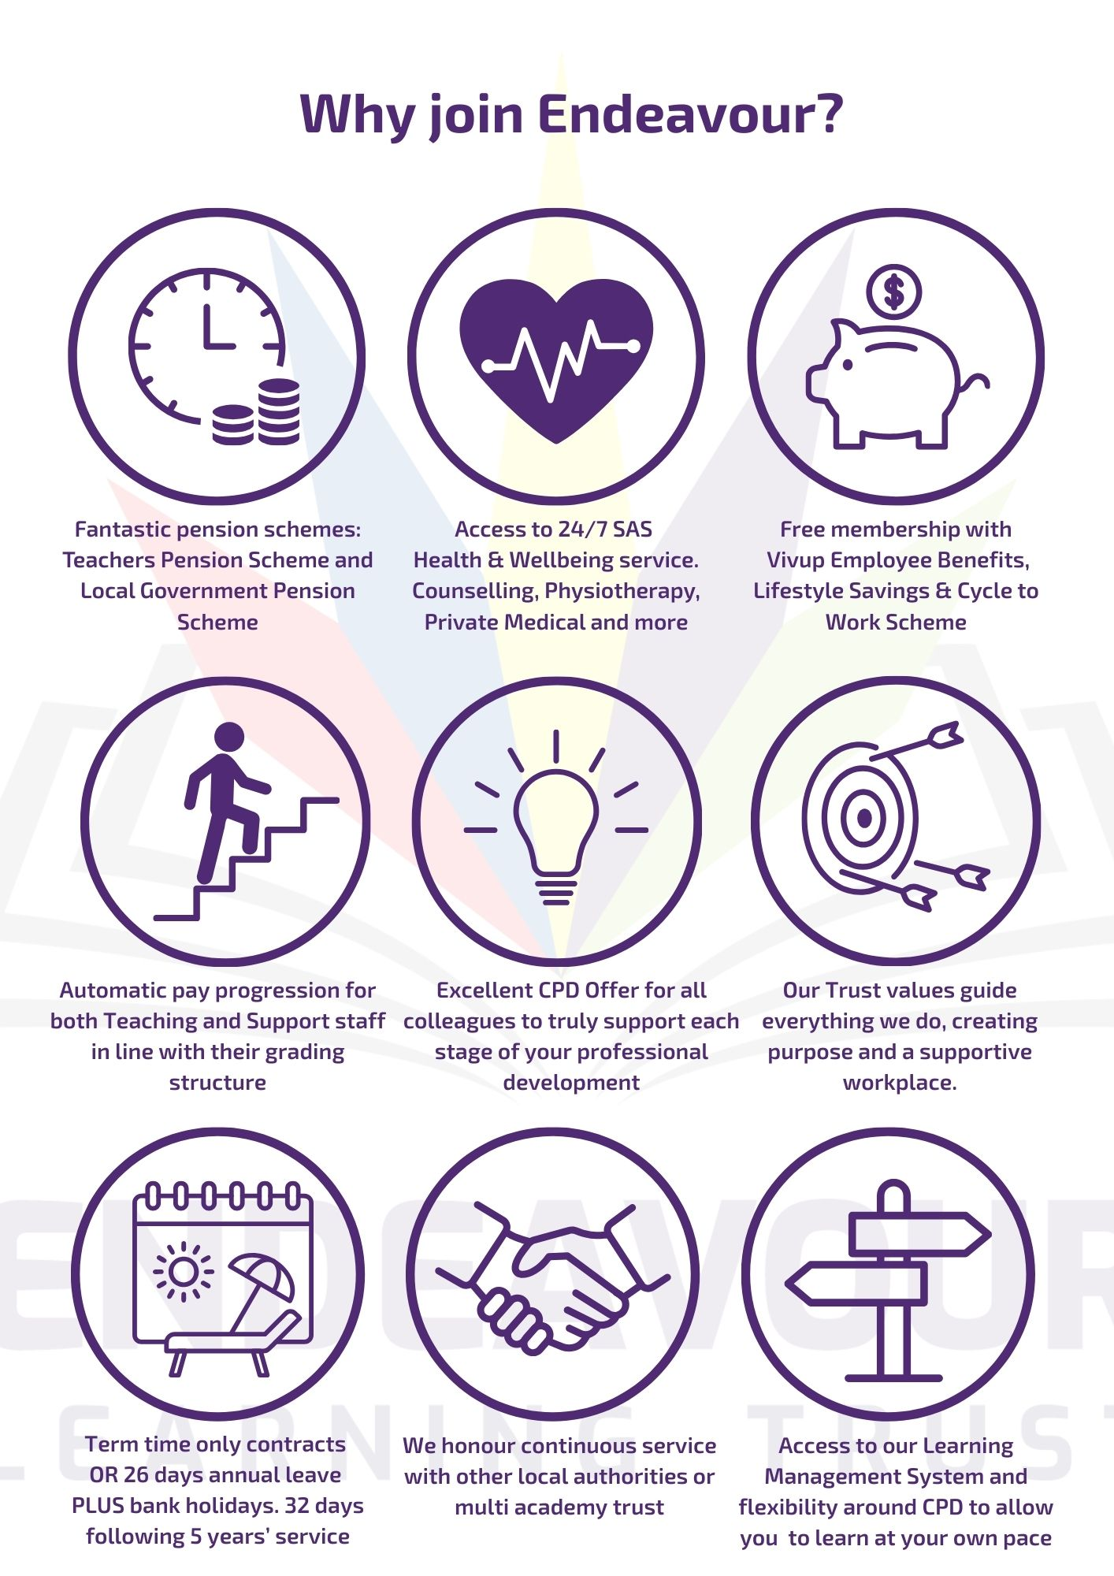

ENDEAVOUR LEARNING TRUST
OUR SCHOOLS

Dear Applicant,
Thank you for your interest in the position of Site Manager at Churchtown Primary School.
I am delighted to send you the enclosed information about our school. I hope you will find it helpful and on behalf of the whole school community, we would like to take this opportunity to extend a very warm welcome.
Churchtown Primary is part of Endeavour Learning Trust and has thrived as part of a successful family of schools. Our children are hardworking, enthusiastic and keen to work with their teachers and the support staff to get the very best out of each and every day at school.
Ours is a happy school; we work together for the good of the team and we are a team where everyone is valued as an individual. In our school we have high expectations but also a pragmatic emphasis on challenge and support. This counts for children and staff, teaching and non-teaching, everyone wants the best for everyone else.
In our team, our staff are committed to improving the experience of our children with a genuine desire to help them become the best person they can be. They are wholly optimistic and driven to making the school the very best it can be. Underpinning all we do is a commitment to developing the children in our school to become kind, well rounded and confident learners. We want to develop young people who believe in, and have the skills, to realise their own worth and potential.
The Trustees and our Local Academy Council are extremely proud of the school’s journey and successes to date. We are committed to promoting an ethos and culture of high aspiration and celebration, whilst providing a friendly and inclusive environment underpinned by a pastoral care system that values every member of the school community.
At the core of these roles lie curriculum and teaching and learning. The successful candidates will have experience of leading a broad, balanced and inspiring curriculum and high quality teaching and learning. Most important to this end is a genuine sense of collaborative effort. The impact of the curriculum will be evidenced through the analysis of student performance and outcomes.
If you would like to visit us or if you would like to discuss any aspect of this post further, please do not hesitate to contact us.

Yours faithfully,

Mrs Jinnie Payne
Headteacher

Site Manager
Full time, Permanent & All year round
Grade 6 SCP 11-19
£28,142 - £32,061 per annum

Are you a hands-on problem solver who takes pride in keeping things running smoothly? Do you want to be part of a warm, welcoming school community where your work truly makes a difference?
At Churchtown Primary School, we’re more than just a school—we’re a thriving, friendly community that values teamwork and a positive environment. We’re looking for a dedicated and proactive Site Manager to help keep our school safe, well-maintained, and running efficiently.
In this role, you’ll play a key part in ensuring our children, staff, and visitors enjoy a safe, clean, and welcoming environment every day. From maintenance and security to overseeing site operations, you’ll be the backbone of our school’s daily function.
If you have practical skills, a can-do attitude, and a passion for creating a great school environment, we’d love to hear from you!
As a Manager of our School Site you will:
- Ensure that the security and standard of the school site is maintained to operate effectively and to provide a high-quality environment for children, staff and visitors.
- Organise and manage the work of the site supervisor and cleaning team.
- Provide the appropriate induction of external contractors and supervise their work to ensure they work in a safe manner.
- Be responsible for all aspects of Health and Safety connected with the school premises and site.
This post is full time, permanent and all year round. Working Monday to Thursday 10am – 6pm and Fridays 10:30am – 6pm.
Starting with 26 days annual leave plus public/bank holidays.
HOW TO APPLY
To apply, please complete our online application form and include a personal statement to support your application and outline the relevant skills and experience you can bring to Endeavour Learning Trust.
Applications should be submitted by 9.00am on Monday 26th January 2025
Interviews are to be held on Monday 2nd February 2025
If you require any further information please contact our Operations Manager, Claire at c.pearce@churchtown.org.uk
SAFEGUARDING
Endeavour Learning Trust is committed to safeguarding and promoting the welfare of children, young people and vulnerable adults and expects all staff and volunteers to share this commitment and individually take responsibility for doing so.
Please note that in line with Keeping Children Safe in Education, an online search will be carried out as part of our due diligence on shortlisted candidates.

JOB DESCRIPTION

To organise and manage the site, taking the lead on all related matters, including managing the site supervisor(s) and cleaners to the agreed quality standards, taking a lead role on Health & Safety and ensuring security of the site and related resources.
To contribute ideas and strategies and provide an active input in relation to all matters concerning the school site.

Main Duties
Contribute to the provision of a facilities management service which supports the Trust’s objectives and to ensure value for money achieved through practices, to include, but not be limited to, the following functions:
- Cleaning and site supervisor management
- Planned preventative maintenance and reactive maintenance
- Health and Safety
- Security
- Repairs and Maintenance
- Asset Management
- Compliance Management using our web-based compliance tool (Iamcompliant)

Supervision
To organise and manage the work of the site supervisor(s) and cleaning team.
Undertake recruitment, selection, induction and appraisal of site supervisors and cleaning staff and allocate duties and hours of work.
Planning own work and that of site supervisors and cleaning staff. Provide/arrange the appropriate induction and training of site supervisors
Monitor the progress of the site supervisor team and identify appropriate training and development opportunities for team members to increase the effectiveness of the function
Provide the appropriate induction of external contractors and supervise their work to ensure they work in a safe manner.
Security
Act as keyholder and carry out security procedures for the buildings and grounds. The routine and non-routine opening and closing of premises and grounds. Responding to calls outside normal working hours as a result of break-ins etc. and/or the setting off of the burglar alarm(s).
Cover sickness and annual leave of site supervisors to ensure security procedures are continued in their absence.
Providing access, where possible, to the premises and classrooms in the event of snow or minor flooding or similar emergency situations.
Dealing with enquiries from employees of the Endeavour Learning Trust, school and contractors.
Monitor and manage the school CCTV system
Maintenance
To monitor the work of site supervisors and cleaning team to ensure that the school buildings and premises are maintained to a high standard and are safe for staff, pupils and visitors.
To undertake maintenance duties and repairs, refurbishment and decorating to maintain and raise school standards.

To assume initial responsibility for the resolution of all site-related issues and to identify and prioritise maintenance requirements and prepare and organise planned maintenance programmes.
In accordance with the Endeavour Learning Trust Estate Manager, draw up, or assist in the drawing up of site maintenance plans and specifications for work to be undertaken by contractors and arrange for works to be undertaken.
Monitoring the progress of projects involving outside contractors. Monitoring the grounds maintenance function, including managing the contract for the provision of grounds maintenance.
Monitoring and ensuring the cleanliness of the school premises and furnishings, including managing the cleaning contract where one exists. Ensuring that all caretaking equipment is in a safe and working condition and arranging for their repair as appropriate.
To arrange for the site supervisors (including the postholder) to carry out first-line repairs which are not beyond the competence of the staff concerned.
Monitoring and management of the premises and asset management system.
Other duties
Testing portable electrical equipment if trained and accredited to do so. To support the out-of-school hours letting of the school premises when needed.
Maintenance of inventory in respect of equipment. Carrying out an annual check of equipment against the Inventory.
To investigate opportunities for recycling of the school’s waste, and offer advice and guidance to school staff on appropriate recycling systems.
By involving pupils and staff of the school, to constantly seek ways of improving the working surroundings and of managing the premises in a more efficient and cost-effective way.
To undertake training as appropriate.
Health & Safety
To be responsible for all aspects of Health and Safety connected with the school premises and site, including the completion of appropriate risk assessments, and ensuring compliance with all statutory regulations.
Ensuring the implementation and compliance with appropriate Codes of Practice throughout the school (in relation to premises and site/cleaning issues) in liaison with the Trust Estates Manager.
Monitoring the appropriate Health and Safety procedures in use in the school and reporting any issues to the Head Teacher, Operation Manager & Trust Estates Manager.
To ensure that the appropriate staff within the school are fully aware of COSHH legislation.
To develop and implement policies and procedures in the area of Health and Safety within the school.
To design and deliver Health and Safety training for staff within the school
To undertake regular testing of the school burglar and fire alarm system, and to maintain appropriate records in relation to this.
To act as fire marshal for fire alarm drills and activations and communicate with the school leaders and emergency services when required.

Endeavour Learning Trust is committed to safeguarding and promoting the welfare of children, young people and vulnerable adults and expects all staff and volunteers to share this commitment and individually take responsibility for doing so.

Finance
To be responsible for monitoring the delegated maintenance budget and regularly reporting budgetary information in relation to this to the Headteacher.
General
Use of IT including the designated online estate management software Iamcompliant (training provided)
To fully participate in the School’s appraisal scheme where appropriate. The duties may be varied by the Headteacher / Estates Manager to meet changed circumstances in a manner compatible with the post held.
Service Development
To develop and maintain the schools Preventative Maintenance Programme (PMP) which takes account of the short, medium, and long term needs of the school, ensuring that all necessary site, plant, equipment checks, and updates are carried out on a timely basis. Schedules to fully take account of the academic calendar and the day to day needs of the school.
To ensure health and safety work is prioritised in accordance with the relevant maintenance manuals and any other requirements.
To maintain the school’s register of legislative and operational compliance.
Support the development and implementation of works identified and funded within various maintenance programmes.
Regular review and update of Operational and Maintenance manuals ensuring all changes to buildings/facilities are fully acknowledged and incorporated.
Support the delivery of the school staff and contractor induction programme in all areas of risk management, health and safety and the safe use and working of equipment and buildings.
Initiate all investigations into building-related defects, instigate repair works, source and procure materials, undertake measured and condition surveys and provide technical and cost advice, as required.
Ensure that all statutory and insurable plant and fabric maintenance works are carried out on time and in accordance with statutory requirements and support the insurance inspection process of installed plant, systems and equipment.
Assist with the effective management and operation of the school’s Building Management System (BMS).
Ensure that contractor control and health and safety procedures are in place and followed, ensure random monitoring to ensure compliance.
Support for the School
To take reasonable care for the health and safety of both yourself and others with whom you come into contact and who could be affected by your work.
To comply with the school’s health and safety rules, reporting any health and safety concerns to the Trusts Estates Manager.
To work within the Trust’s policies and procedures
To contribute to the provision of an effective environment for learning
To support and encourage the Trust’s ethos and its objectives, policies and procedures.
To uphold the Trust’s policy in respect of child protection and safeguarding matters
Undertake any other duties reasonably requested by the CEO/Headteacher

Endeavour Learning Trust is committed to safeguarding and promoting the welfare of children, young people and vulnerable adults and expects all staff and volunteers to share this commitment and individually take responsibility for doing so.

 | PERSON SPECIFICATION  KEY CRITERIA | Essential (E)/  Desirable (D)
QUALIFICATIONS | 5 GCSEs (or equivalent) A* - C including English and Mathematics/Grade 9 to 5 or Level 3 Qualification | D
QUALIFICATIONS | First Aid Qualification (qualification not essential at point of application, training will be given if required) | D
QUALIFICATIONS | Knowledge of Health and Safety guidelines | E
QUALIFICATIONS | Knowledge of COSHH guidelines | E
QUALIFICATIONS | Professional development relevant to post | E
EXPERIENCE AND KNOWLEDGE | Successful experience of undertaking a caretaker or site supervisory function | E
EXPERIENCE AND KNOWLEDGE | Experience of supervising staff | E
EXPERIENCE AND KNOWLEDGE | Experience of writing maintenance programmes | D
EXPERIENCE AND KNOWLEDGE | Experience of planning and programming work | D
EXPERIENCE AND KNOWLEDGE | Experience of testing portable electrical equipment | D
EXPERIENCE AND KNOWLEDGE | Experience of budget management | D
EXPERIENCE AND KNOWLEDGE | Practical experience of monitoring contract arrangements | D
EXPERIENCE AND KNOWLEDGE | Demonstrate experience of basic DIY, maintenance and repair skills | E
EXPERIENCE AND KNOWLEDGE | Demonstrate experience of using powered tools and equipment relevant to the role | E
SKILLS AND ATTRIBUTES | Ability to relate well to young people | E
SKILLS AND ATTRIBUTES | Ability to form effective and appropriate working relationships/boundaries with young people | E
SKILLS AND ATTRIBUTES | Demonstrate that they are able to prioritise their workload with conflicting deadlines, whilst maintaining a high level of accuracy and attention to detail | E
SKILLS AND ATTRIBUTES | Problem solve and create innovative solutions | E
SKILLS AND ATTRIBUTES | Demonstrate an ability to lead and manage the work and outcomes of other people as well as working in a team. | E
SKILLS AND ATTRIBUTES | Demonstrate that they can train and develop staff | E
SKILLS AND ATTRIBUTES | Demonstrate that they are able to resolve conflict | E
SKILLS AND ATTRIBUTES | Demonstrate that they are able develop effective working relationships | E
SKILLS AND ATTRIBUTES | Demonstrate they have a positive approach to customer care and service delivery | E
SKILLS AND ATTRIBUTES | Excellent time management and organisation skills with the ability to effectively prioritise their workload to deadlines. | E
SKILLS AND ATTRIBUTES | A calm and organised nature | E
SKILLS AND ATTRIBUTES | The ability to communicate confidently and effectively, in varied situations, using a range of methods | E
SKILLS AND ATTRIBUTES | The ability to respond effectively to challenges | E
SKILLS AND ATTRIBUTES | A flexible approach to working practices | E
SKILLS AND ATTRIBUTES | The ability to maintain successful working relationships with other colleagues | E
SKILLS AND ATTRIBUTES | A commitment to contributing to the wider school, Trust and its community | E
SKILLS AND ATTRIBUTES | Ability and willingness to travel between sites, as required | E
SKILLS AND ATTRIBUTES | Ability and willingness to work occasionally outside of contracted hours (e.g. Parent evenings, lettings) | E
SKILLS AND ATTRIBUTES | Ability and willingness to respond to emergency call outs | E
SKILLS AND ATTRIBUTES | The ability to maintain successful working relationships with other colleagues | E
OTHER | Clearance through the Disclosure and Barring Service | E
OTHER | Compliance and adherence to the documents ‘Keeping Children Safe in Education’, ‘Guidance for Safer Working Practice’ & ‘Guidance for Conduct’ | E

Endeavour Learning Trust is committed to safeguarding and promoting the welfare of children, young people and vulnerable adults and expects all staff and volunteers to share this commitment and individually take responsibility for doing so.

