


Inclusion and Wellbeing Officer
South Axholme Academy
Candidate
Information Pack
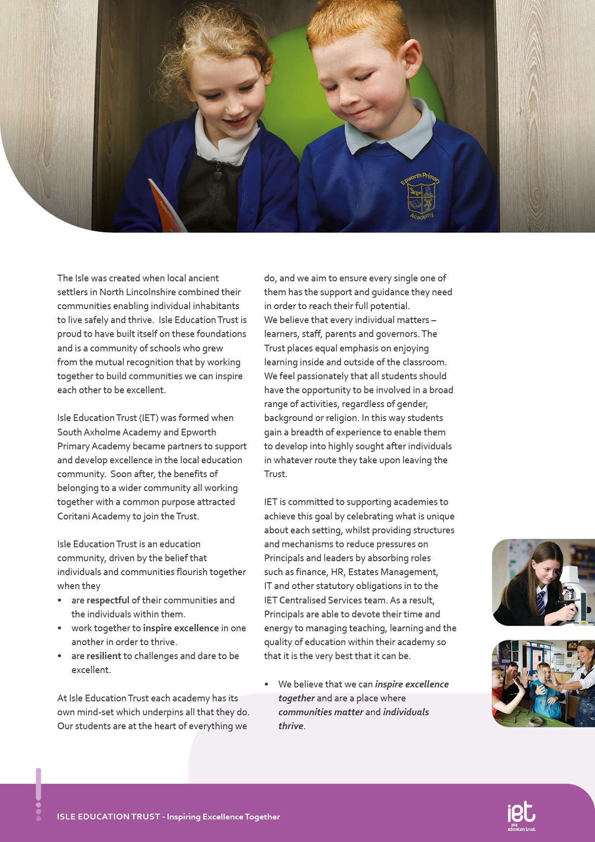
About IET

Dear Prospective Colleague,

Thank you for your interest in joining Isle Education Trust. I’m delighted that you're considering becoming part of our team—whether you’re looking to support students directly or contribute to the vital work that happens behind the scenes, your role matters deeply to us.
At Isle Education Trust, our vision is clear: Inspiring Excellence Together. Across our family of academies, we recognise that excellence doesn’t happen by chance—it’s built by a committed, skilled, and diverse team working together with shared purpose.
Our non-teaching colleagues are the backbone of our success. From safeguarding and administration to site management, finance, pastoral support, and everything in between, you help shape the culture and daily experience of our schools. Your expertise keeps our academies running smoothly, our environments safe and welcoming, and our pupils supported every step of the way.
We are proud to uphold values that guide our Trust:
- Respect – shown through honesty, consistency, and care.
- Resilience – demonstrated in our commitment to excellence, even in the face of challenge.
- Inspiration – sparked by individuals who lead by example and empower others to thrive.
When you join our team, you’ll find a community where your contributions are valued, your development is supported, and your wellbeing is prioritised. We offer professional learning opportunities, a culture of collaboration, and a genuine commitment to making our academies great places to work.
If you share our belief that every role within education is a chance to make a difference, I warmly invite you to explore opportunities across the Trust. We’d be thrilled to welcome you into our mission of inspiring excellence—together.
Warm regards,



Sarah Sprack
CEO, Isle Education Trust

Welcome from the CEO


Dear Prospective Colleague,
As Principal of South Axholme Academy, I am proud to lead a school with a rich history and an exciting future. Established as South Axholme School in 1961, we now serve approximately 930 students. In 2012, the school became an Academy, and the following year took a lead role in forming Isle Education Trust. The small size of the Trust enables close collaboration whilst allowing us to maintain autonomy over our curriculum and teaching to best meet the needs of our students and community.
Located in the historic market town of Epworth, North Lincolnshire, between Doncaster and Scunthorpe and within easy commuting distance of Rotherham, Sheffield, Leeds, East Yorkshire and Lincoln, South Axholme Academy draws students from over 25 primary schools across North Lincolnshire, Nottinghamshire, and Doncaster. We are regularly oversubscribed, which reflects the confidence families place in us.
Our academic outcomes consistently exceed the national average, reflecting our strong commitment to excellence. Equally important is nurturing the whole child by developing not only academic potential but also confidence, character, and wellbeing. Beyond the classroom, our vibrant calendar offers a wide range of events and enrichment opportunities, from sponsored walks and drama productions to sports clubs, educational visits, and community celebrations like Christmas carol concerts and senior citizens parties. Central to our ethos is the South Axholme Mindset—being Ready, Respectful, and Resilient—which guides everything we do and inspires everyone to Expect Excellence.
Knowing our students, staff, and families well allows us to provide a broad, balanced, and inclusive curriculum tailored to individual needs. As part of our commitment to support, we are developing a new study hub with North Lincolnshire Council, providing a smaller, focused environment for students who benefit from additional support.
South Axholme Academy is a vibrant, ambitious and welcoming school with a strong track record of excellence in all areas. As Principal, it is an honour to lead this community as we continue the next phase of our journey, one that I am confident will be filled with even greater success.
If you would like any further information about the role, or would like to arrange a visit, do get in contact by emailing admin@southaxholme-iet.co.uk or by ringing us on 01427 87212. I would be delighted to talk to you about our wonderful school!
Every best wish,



Stephanie Hamilton
Principal
South Axholme Academy

About the Academy

Job Title Inclusion and Wellbeing Officer
South Axholme Academy

Salary | £27,683 Fulltime Equivalent (based on 37hrs)  £20,532.89 (actual)
Job Details | 32.5 Hours (Term Time Only)
Location | South Axholme Academy
Required | September 2026
Application Close | Friday 7 August 2026
Interview Date | Tuesday 11 August (flexibility available)

Job Purpose
To manage and support the wellbeing, safeguarding and attendance of students, to ensure that every child achieves their potential and that barriers to this are removed or minimised.

The Inclusion Officer will be required to liaise on an informal and a formal basis with a wide range of individuals and agencies, including the SLT, Subject Leaders and Class Teachers, the SENDCo, the admin team, parents, family support officers and social workers.

The Inclusion and Wellbeing Officer reports to the SENDCo.
Job Description


INTERVIEWS:
Thursday 13th June 2024
CLOSING DATE:
Tuesday 11th June 2024 at 9:00am
Wellbeing and Pastoral Support
- Promote and champion the South Axholme Mindset, fostering a culture where students are Ready, Resilient and Respectful.
- Support student welfare, behaviour, safety, engagement and achievement, ensuring every student is able to access learning successfully.
- Act as a key Academy contact for students requiring wellbeing, mental health or emotional support, providing early intervention and appropriate signposting.
- Deliver evidence-informed interventions to improve students' emotional wellbeing, resilience, self-esteem and emotional regulation.
- Develop and promote preventative health and wellbeing strategies through assemblies, awareness campaigns, workshops and Academy initiatives.
- Promote positive mental health and emotional resilience across the Academy community.
- Act as an advocate for vulnerable students, removing barriers to learning and promoting positive outcomes.
- Champion students vulnerable to underachievement, helping to close gaps in attainment, attendance and personal development.
- Work collaboratively with teaching and pastoral staff to promote positive attitudes to learning positive relationships and successful classroom engagement.
- Support students in developing strategies for emotional regulation, resilience and successful reintegration into learning following periods of dysregulation or absence linked to wellbeing.

Inclusion and Hub Provision
- Lead the day-to-day operation of the Academy Hub, ensuring it provides a calm, nurturing environment that supports students to regulate and successfully return to learning.
- Coordinate Hub interventions, wellbeing programmes and planned regulation breaks for identified students.
- Monitor the impact of Hub provision and evaluate outcomes for individual students.
- Work closely with the SENDCo, pastoral leaders and teaching staff to ensure barriers to learning are identified and reduced.
- Contribute to the development and review of individual support plans, safety plans, risk assessments and personalised wellbeing strategies.
- Support the successful reintegration of students following suspension, prolonged absence, medical needs or emotional wellbeing concerns.
- Operate Academy reward and sanction systems in collaboration with pastoral staff.

Main Responsibilities

We expect all Trust staff to:

=
Safeguarding and Multi-Agency Working
- Work closely with the Designated Safeguarding Lead and Deputy Designated Safeguarding Leads to ensure students receive appropriate support.
- Maintain accurate, timely and professional records on CPOMS and other Academy systems in line with safeguarding procedures.
- Liaise with parents, carers and external agencies to coordinate effective support for individual students.
- Attend multi-agency meetings and contribute to safeguarding, wellbeing and support plans as required.

Communication, Data and Reporting
- Maintain accurate records relating to student wellbeing, behaviour, interventions and achievement.
- Monitor wellbeing and behaviour data to identify trends and evaluate the impact of interventions.
- Produce reports for senior leaders on wellbeing provision and emerging student needs.
- Communicate effectively with parents, carers, colleagues and external professionals to ensure joined-up support for students.
- Assist Senior Leaders in monitoring student behaviour, wellbeing and engagement through the Academy's Management Information System and reporting processes.

Personal Development and Staff Support
- Promote student voice and encourage students to contribute to the continued development of the Academy's wellbeing provision.
- Support the delivery of the Academy's Personal Development programme through activities that promote resilience, healthy relationships, emotional literacy and positive mental health.
- Provide advice and guidance to staff on supporting students with social, emotional and mental health needs.
- Contribute to staff training and the sharing of effective practice relating to inclusion, wellbeing and trauma-informed approaches
- Deliver evidence-informed interventions to improve students' emotional wellbeing, resilience, self-esteem and emotional regulation.
- Develop and promote preventative health and wellbeing strategies through assemblies, awareness campaigns, workshops and Academy initiatives.
- Promote positive mental health and emotional resilience across the Academy community.
- Act as an advocate for vulnerable students, removing barriers to learning and promoting positive outcomes.
- Champion students vulnerable to underachievement, helping to close gaps in attainment, attendance and personal development.
- Work collaboratively with teaching and pastoral staff to promote positive attitudes to learning, positive relationships and successful classroom engagement.
- Support students in developing strategies for emotional regulation, resilience and successful reintegration into learning following periods of dysregulation or absence linked to wellbeing.
I



Education, Qualifications and Relevant Experience | Essential | Desirable
Good literacy & numeracy skills | AI
Very good interpersonal and customer care skills | A I
Professional development relevant to the post |  | A
First Aid Qualification |  | A
Specialist Knowledge and Skills | Essential | Desirable
Experience of working in an educational setting or similar environment | A
Experience of working in a secondary school with students with Special Educational Needs | A
Experience of working with children / young people with Social Emotional and Mental Health Needs | AI
General understanding of school policies and procedures relating to health and safety, behaviour, attendance, equal opportunities, and child protection |  | I
Experience of MIS (Management Information System) & Data software | AI
Experience of Microsoft software packages (Word, Excel, Publisher) | AI
Basic understanding of child development and learning |  | AI
Practical Skills | Essential | Desirable
Flexible approach to work as well as good organisational and communication skills | AI
Ability to work collaboratively and effectively within a team | AI
Ability to work independently and to show initiative | AI
Ability to work under pressure, prioritise and meet deadlines | AI
Friendly, approachable, and non-confrontational manner combined with the ability to be firm | I
Ability to build and maintain successful relationships with students; treat them consistently, with respect and consideration, and demonstrate concern for their development as learners | I
The capacity to inspire and motivate others – both adults and students |  | I
Ability to use ICT for administrative purposes | A

Person Specification:

Personal Qualities & Essential Attributes | Essential | Desirable
A desire to work with young people and to support their education and achievements | AI
A professional approach in both manner and physical appearance | I
Able to demonstrate discretion, confidentiality, and commitment | I
Able to liaise sensitively with parents/carers recognising their role in the student’s learning | I
Enthusiasm, determination, and insistence on high standards | I
Flexible and good-humoured approach | I
A proven track record of excellent attendance and punctuality | I
A sense of humour and good sense of well-being | I
Able to work with or without supervision | AI
Commitment to safeguarding and promoting the welfare of children and young people | AI
High quality communication skills with the ability to develop positive relationships with students and adults of all levels | I
Ability to work as part of a team, understanding classroom roles and own position with the school hierarchy | I
High expectations of self and others | Essential | Desirable
A flexible and adaptable approach | A I
An innovator with the desire to continue to learn | AI
Resilience and the determination to be successful within this role and ambitious for the Academy and its students | I
Safeguarding | Essential | Desirable
Committed to promoting the welfare of all children and creating a safe environment in which children can learn; considering, always, what is in the best interests of the child | A I
Equal | Essential | Desirable
The ability to ensure that there is equality of access to educational attainment and that all aspects of equal opportunities are adhered to | I

KEY
A = assessed through the application process
I = assessed through the interview process


c
 Pension Scheme
All staff are enrolled in either the Teachers’ Pension Scheme or Local Government Pension Scheme, whichever is relevant.
 Continuous Professional Development
IET offers numerous opportunities for continued CPD for all staff including NPQs and apprenticeships

 Cycle to Work Scheme
Eligible staff may apply to purchase a new bike, e-bike or cycling accessories through this salary sacrifice scheme, making significant savings.

 Staff Wellbeing
This is a priority for the Trust. All staff have access to a free Employee Support Package, including 24/7, 365 days a year online and telephone support covering areas such as mental health, bereavement, financial advice and counselling.

 Healthcare
All staff have free access, 24/7, 365 days a year to an online doctor.

 Flu Vaccinations
All staff are able to request a free voucher for a flu vaccination in the Autumn term.

 Discounts
Through our employee benefits platform, staff can make significant savings through discounts and vouchers in a range of areas including restaurants, supermarkets, retail and holidays.

Trust Benefits:


Appointment Process
How to apply
To apply for this post, visit the IET website:

Isle Education Trust - Vacancies

Please note that the personal statement you provide as part of this process must be no longer than 1000 words.

Receipt of early applications from candidates with the appropriate experience, qualifications and personal qualities may result in an early interview being offered.

Isle Education Trust promotes equality of opportunity and welcomes applications from all sectors of society.

Isle Education Trust is committed to safeguarding and promoting the welfare of children and expects all staff and volunteers to share this commitment. All posts at Isle Education Trust are subject to an Enhanced Disclosure and Barring check.

