United Communities – Dukesgate Community Hub

Job Description

1. JOB DETAILS
Job Holder:  Job Title: Community Hub Co-ordinator  Reporting to: Senior Youth and Community Development Lead – Marlborough Road and Dukesgate | Date: 1st September 2026  Term: 31st August 2029 (initially)  Salary:£23,003.00 - £28,310.00 Annually (Actual)  Hours: 30 hours per week, to be used flexibly to meet the needs of the community

2. JOB PURPOSE

To support the day to day running of the community hub including community engagement, bookings and finance administration, activity and events coordination and delivery, and marketing and communications.

3. DIMENSIONS

As a Community Hub Co-ordinator, you will lead a variety of projects focused on the effective running of the Dukesgate Community Hub. A key part of your role will involve planning and implementing initiatives and systems that support our mission of creating a sustainable and inclusive space for all community members. This includes leading on bookings and events, processing invoices, engaging local organisations and residents to participate in community-driven activities, and providing strong project management to ensure the hub meets its goals and serves as a vibrant resource for the community.

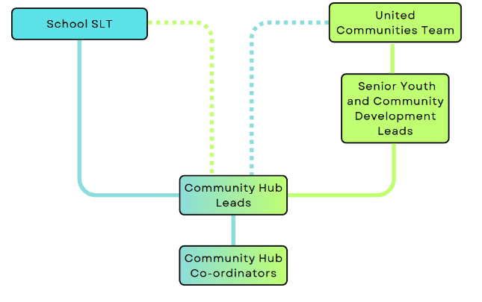
4. ORGANISATION CHART

5. KNOWLEDGE, SKILLS AND EXPERIENCE REQUIRED

- Experience of working/volunteering in education, youth and/or community sectors.
- Strong written and oral communication skills.
- Excellent organisational skills and attention to detail.
- Proficient in the use of IT including experience of using social media for business.
- Experience of invoicing and managing bookings.
- Ability to manage competing priorities to challenging timescales.
- Ability to understand, analyse and interpret a range of information sources.
- Ability to work effectively and develop professional relationships with a diverse range of stakeholders.
- An intellectual curiosity, openness to learning and ability to innovate to achieve results.
- Strong emotional intelligence and ability to engage peers and develop credibility working with community members, young people, and internal and external colleagues.

6. KEY RESULT AREAS

- Oversee and manage all bookings for the Dukesgate Community Hub, ensuring efficient scheduling and resource allocation.
- Generate and issue invoices, maintaining clear communication with clients to ensure timely payments and resolution of inquiries.
- Provide comprehensive project support for the community hub, enhancing the delivery of community services.
- Coordinate youth and community voice and active participation through local steering and stakeholder groups.
- Respond to inquiries and manage the community hubs social media accounts, fostering community engagement and information sharing.
- Plan, coordinate, and support community functions and events, ensuring smooth operations and high-quality experiences for participants.
- Maintain and update the community hub’s website, social media platforms, and promotional materials to effectively communicate activities and opportunities.
- Prepare necessary resources and materials for community events, enabling smooth execution and participant engagement.
- Coordinate with external providers to source, order, and manage inventory of equipment and resources needed for community activities.
- Delivery of community hub activity and participation in cross campus initiatives as appropriate.

7. COMMUNICATIONS AND WORKING RELATIONSHIPS

- Promote and safeguard the welfare of children, young people and adults you are responsible for/or encounter.
- Be aware of and comply with policies and procedures relating to safeguarding, health, safety and security, confidentiality and data protection, reporting all concerns to an appropriate post holder.
- Be aware of, support and ensure equal opportunities for all.
- Contribute to the overall ethos/work/aims of the school and community hub.
- Communicate with community members, organisations and colleagues across the cluster.
- Communicate with children, young people and adults from the school and community.
- Participate in training and other learning activities and performance management as required.

8. SCOPE FOR IMPACT

This role will be central to the smooth running of the Dukesgate Community Hub, with the potential to impact children, young people, families and local communities close to the
Dukesgate Academy.

This is a key role, contributing to the development and sustainability of community hub activity.

9. JOB DESCRIPTION AGREEMENT
Job Holder's Signature | Date:
Manager's Signature | Date:

