

KS2 Part time/Job Share

CLASS TEACHER

Head Office
The Diocese of Coventry Multi Academy Trust St James’ C of E Academy

Candidate Information

Barbridge Road Bulkington Bedworth CV2 9PF
KS2 part time/Job share Class Teacher
All Saints’ CofE Academy, Leek Wootton
Together, pursuing life in all its fullness

Our Trust
Thank you for your interest in joining The Diocese of Coventry Multi Academy Trust, we are delighted to provide you with an application pack. It is hoped that the information provided will be of interest and will help you to begin your journey with us.


The Diocese of Coventry Multi Academy Trust was incorporated in 2013 and is one of over 2,500 Multi Academy Trusts in England. The trust is now home to twenty-two academies spread across the Diocese of Coventry. This scale makes us one of the 100 largest Multi Academy Trusts in the country.

Our vision, “together, pursuing life in all its fullness”, is based on John 10:10 and reflects the Church of England’s vision for education. You will see this come to life in all of our academies every day. We offer a vision of human flourishing for all, one that embraces excellence and academic rigour, but sets them in a wider framework. We offer opportunities for children to realise their God given potential and flourish.

Our strategic plan focuses on five key stakeholder groups and recognises
that these groups will flourish together, far better than they will flourish alone. We aim to:
- Support colleagues to flourish
- Support children to flourish
- Support those involved with governance to flourish
- Support families to flourish
- Support the wider church school family to flourish

To work with us, you must aspire to be an outstanding colleague, be prepared to go the extra mile and be comfortable with high levels of accountability for the progress of over 5,000 children. You must be willing to share and learn. Above all else, you must like young people and aspire to make them outstanding citizens.

In return, we offer excellent working conditions, first class professional development, genuine career development and opportunities for growth. All of our teachers are offered membership of the Teachers Pensions Scheme and all support staff are offered membership of the Local Government Pension Scheme.
In short, we believe our Trust has a bright future and are looking for bright people to help us get there.

Thank you once more for your interest in The Diocese of Coventry Multi Academy Trust and in the position available. I hope that this introductory letter has given you a clear sense of our vision and I hope that this pack gives you a feel for what we need. We look forward to hearing from you and exploring your future with us through our selection process.

Michael Cowland, Chief Executive Officer

What our employees say about us

In our 2024 staff survey, the Trust scored above national benchmarks in almost every area. Support from colleagues is a particular strength of working for us: our staff value the respect and support they receive from their colleagues. Leadership is also an area of significant strength and staff rate their leaders highly. Finally, job satisfaction and employee communication are rated highly and above national benchmarks.

Staff support and relationships

How comfortable are you with asking your colleagues for help when you need it? | 93%
How respected by your colleagues do you feel? | 91%

Leadership

Leadership dynamics | 10% higher than national benchmark
Professional support from line manager | 3% higher than national benchmark

Job satisfaction and communication

Effective and regular communication with employees | 90%
Job satisfaction | 5% higher than national benchmark

Our Diocese
Diocese of Coventry
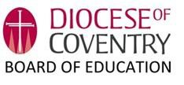
The Diocesan Board of Education seeks to serve and equip the church school family in a variety of ways. The Diocesan Director of Education, Reverend April Gold, is supported by a team of highly qualified, experienced and well-regarded professionals who aim to:

- ‘be there’ for our church school family and act as a central reference point supporting pastorally and professionally;
- facilitate creative and flexible networking between schools;
- promote excellence and distinctiveness within the family of church schools/academies and beyond;
- share best practice collectively;
- provide professional development: for staff at all stages of their careers and for governors;
- facilitate collaborative school improvement partnerships through the growth of our six CofE majority MATs;
- support the process of academy conversion;
- promote the establishment of new church schools;
- represent church schools to the wider church, to diocesan groups, in the press, and in public and community debate;
- champion inclusion and equality including advising on admissions policies and managing appeals;
- protect the status of church schools
- and promote the importance and the continuance of the voluntary sector.

‘Our schools are a hugely significant part of the Church family of the Diocese. Seeking to build communities of care and understanding, they witness to God’s love for each and every person, and reflect God’s desire for the world to be a better place for us all to live in. I believe they are at the heart of the Church’s mission to the nation and play a very important role in the life of their own parishes and communities.
As a Diocese, our 76 Church of England schools serve 18,500 children, and their families. The 2000 members of staff and all the volunteers who support, as governors, directors, and other contributors, are seeking to offer both an excellent education and ensure that all our young people have the opportunity to live life to the full. We aim to do this by living, telling and sharing the values of Jesus Christ. Thank you for being willing to share in this journey with us!’

Bishop of Coventry

KS2 TEACHER
About the Role

The Trust is looking to appoint an inspirational and highly effective part time/job share KS2 Class Teacher, who is committed to supporting All Saints’ C of E Academy to educational excellence and further developing the distinctive Christian character of educational provision and the school community.

In return we can offer:

- A support network of professional colleagues
- A strong culture of professional development
- The opportunity to be part of an aspirational organization and contribute to its development and growth plans
- We are offering a salary of £47,472 per annum FTE
- Eligibility to join the Pension Scheme

Applications

Thank you for your interest in this post. Interested candidates are welcome to speak to us for more information
about this fantastic opportunity. Please contact Tracey Mafe, our Academy Business partner, directly on tracey.mafe@greenleek.covmat.org for an informal discussion about the post.
Please note the closing date for applications is 21st June 2026 Completed applications and supporting
documents should be submitted via My New Term.

We welcome all applications regardless of age, disability, gender reassignment, marriage and civil partnership, pregnancy and maternity, race religion and belief, sex and sexual orientation.

Interviews will take place during week commencing 22nd June 2026
Job Description

KEY PURPOSE

To take responsibility for the education and welfare of a designated class of children in accordance with the current School Teachers’ Pay and Conditions document, Teacher Standards and having due regard to the requirements of the National Curriculum and school policies
ACCOUNTABILITIES

The appointee will be line managed by the Head Teacher

PRINCIPAL RESPONSIBILITIES

This will include to:

- plan work for the class in accordance with national, Multi Academy Trust and school curriculum policies and in co-operation with subject and phase leaders to ensure that the children experience a broad, balanced, relevant and stimulating curriculum.
- have a shared responsibility for the planning, teaching and assessment of core subjects: maths, English (writing), reading and spelling. The role also includes a shared subject leadership responsibility for maths which includes working with Origin Maths Hub to implement a new maths curriculum.
- ensure a close match between the learning experience offered, and the individual needs of the children in the class, so as to give each child an opportunity to achieve to the maximum of his/her capability.
- make appropriate educational provision for children with SEN and those learning EAL, with support from the SENCo and EAL Co-ordinator.
- where possible, to make sure that the majority of the children’s work is closely linked to first-hand practical experience.
- provide children with opportunities to manage their own learning and become independent learners.
- create a secure, happy and stimulating classroom environment, maintaining the highest standards of organization and discipline.
- foster each child’s self image and esteem and establish relationships which are based on mutual respect.
- maintain a high standard of display both in the classroom and in other areas of the school.
- arrange for resources, equipment and materials to be available in such a way that they are properly cared for, easily accessible and will encourage the children to become more responsible for their own learning.
- work closely with colleagues to undertake medium and short term planning and the implementation of agreed schemes of work.
- assess children’s progress, maintain records and provide written reports to parents and carers in accordance with school policies.
- communicate and consult with parents and carers and with outside agencies, as necessary, about children’s progress and attainment.
- ensure that the school’s aims and objectives in relation to the curriculum, equal opportunities and discipline are promoted in every day classroom organization and practice.
- liaise with support staff both school based and from the Multi Academy Trust and from other external bodies as required.
- take responsibility for the management of other adults in the classroom.
- take up the opportunity for continuous professional development through self-directed reading, courses and in-service training.
- participate and contribute to staff meetings and meetings which relate to school management, curriculum and administration.
- maintain a positive ethos and core values both inside and outside the classroom.
- implement and support the school policies and procedures.
- undertake any other reasonable and relevant duties and training as requested by the SLT in accordance with the changing needs of the school.
- take responsibility for curriculum subject area(s) as agreed with the Headteacher which could include:
- Promote the teaching of the agreed subject throughout the school, according to the requirements of the National and MAT Curriculum schemes of work and any other new initiatives from the Department for Education.
- In Conjunction with the Headteacher or other senior staff, be responsible for the implementation and management of the school’s policy for agreed subject area(s).
- Review the policy and adapt it as appropriate.
- Develop a scheme of work for subject suitable to the needs of the children aged 7 – 11.
- Take responsibility for maintaining and evaluating all material resources with a system of easy accessibility.
- To consult with colleagues and be responsible for ordering resources within an agreed budget in full consultation with the Headteacher.
- Offer support and advice to colleagues.

SUPPORTING THE WORK OF THE MULTI ACADEMY TRUST

As part of the Diocese of Coventry Multi Academy Trust, the Deputy CEO - Education will be expected to develop and maintain strong, positive relationships with colleagues in the Multi Academy Trust, within the family of Multi Academy Trust academies and the Diocesan family of schools.

STRENGTHENING THE COMMUNITY

Academies exist in a distinctive social context, which has a direct impact on what happens inside the school. Academy leadership should commit to engaging with the internal and external school community to secure equity and entitlement. All staff should collaborate with other schools in order to share expertise and bring positive benefits to their own and other academies. They should work collaboratively at both strategic and operational levels with parents and carers and across multiple agencies for the well-being of all children.

This will include:

- Building a school culture and curriculum which takes account of the Church Foundation and the richness and diversity of the school’s communities.

- Creating and promoting positive strategies for challenging harassment of any kind.

- Ensuring learning experiences for pupils are linked into and integrated with the wider community, the local church and diocesan communities.

- Ensuring a range of community-based learning experiences, including building links with local churches and Coventry Diocese.

- Collaborating with other agencies in providing for the academic, spiritual, moral, social, emotional and cultural well-being of pupils and their families

- Creating and maintaining an effective partnership with parents and carers, (including those who may be described as ‘hard to reach’, those with learning disabilities and those for whom English is an additional language), to support and improve pupils’ achievement and personal development.

- Building bridges with the school’s diverse communities, seeking opportunities to invite the whole range of parents and carers, community figures (including clergy and church representatives), businesses or other organisations into the school to enhance and enrich the school and its value to the wider community.

- Contributing to the development of the education system by, for example, sharing effective practice, working in partnership with other schools and promoting innovative initiatives.

- Co-operating and working with relevant agencies to protect children.

SAFEGUARDING CHILDREN AND SAFER RECRUITMENT

Our Trust is committed to safeguarding and promoting the welfare of children and young people and expects all staff and volunteers to share this commitment. The successful candidate will be required to undertake an enhanced criminal record check via the DBS. Further information about the Disclosure and Barring Service is available from the DBS website at: Disclosure and Barring Service - GOV.UK (www.gov.uk)

The Trust will ensure that:

- The policies and procedures relating to safeguarding and safer recruitment are fully implemented and followed by all staff.
- Sufficient resources and time are allocated to enable the designated person and other staff to discharge their responsibilities in relation to safeguarding, including taking part in strategy discussions and other inter-agency meetings and contributing to the assessment of children.
- All staff and volunteers feel able to raise concerns about poor or unsafe practice in regard to children, and that such concerns are addressed sensitively and effectively in a timely manner in accordance with agreed whistle blowing practices.

DATA PROTECTION

The post holder must meet the requirements of the General Data Protection Regulation Act 2018 at all times, especially concerning conﬁdentiality, treatment of personal information and records management.

ADDITIONAL DETAILS

Whilst every effort has been made to explain the main duties and responsibilities or the post, each individual task undertaken may not be identified. Staff will be expected to comply with all Trust policies and procedures and any reasonable request from a manager to undertake work of a similar level that is not specified in this job description. This job description will be reviewed annually and the Chief Executive reserves the right to alter the content of this job description, after consultation with the post-holder, to reflect changes to the job or services provided, without altering the general character or level of responsibility.

Person Specification  Personal Qualities,  Qualifications and Experience |  | Measured By
 |  | Essential | Desirable | Application | Interview Process | References
Qualifications and Experience
1 | Honours degree or equivalent |  | X | X
2 | Qualified Teacher Status | X |  | X
3 | Relevant higher degree or equivalent |  | X | X
4 | Evidence of continuous professional development relating to curriculum,  teaching and learning | X |  | X | X
Professional Experience and Knowledge
1 | To teach across the primary age range |  | X | X | X
2 | Substantial, successful, relevant and recent teaching experience in primary school or Academy | X |  | X | X | X
3 | Successful experience of raising standards for all, with measureable outcomes | X |  |  | X | X
4 | Knowledge and understanding of safeguarding requirements and good practice | X |  |  | X
5 | Knowledge of recent developments in the National Curriculum |  | X | X | X
6 | Experience of supporting children with Special Educational Needs in an inclusive environment | X |  | X | X
7 | Experience of using ICT effectively in classroom teaching | X |  |  | X
8 | An understanding of the role of parents as partners in education | X |  | X
9 | A commitment to, and evidence of, promoting diversity and equal opportunities within the workplace, classroom, curriculum and employment practice | X |  | X | X
10 | Understanding the distinctive Christian character of a Church school |  | X | X | X
11 | A commitment to Professional Development | X |  | X | X
Leading Teaching and Learning
1 | A proven track record in ensuring the highest possible standards in teaching and learning | X |  | X | X | X
2 | Good understanding and application of best practice in teaching of phonics and knowledge of the use of APP |  | X | X | X
3 | Successful experience of positive behavior management and developing a pupil focused, inclusive and effective, learning environment so that behavior and attendance are outstanding | X |  |  |  | X
Personal Qualities
1 | Has high expectations and personal integrity with the ability to promote and sustain the values, culture and Christian ethos of the school | X |  | X | X
2 | Is articulate and approachable with excellent interpersonal communication skills both verbally and in writing | X |  | X | X
3 | Is an outstanding, reflective, practitioner with high quality teaching skills and high expectations for pupils’ learning and attainment | X |  | X | X | X
4 | An exemplary record of health and punctuality |  | X |  |  | X
5 | To provide a secure, stimulating and well organized learning environment | X |  | X
6 | To ensure effective curriculum delivery through differentiation | X |  | X
7 | To work collaboratively and effectively as part of a team | X |  | X | X
8 | To work with colleagues in providing for the intellectual, physical, social, spiritual and emotional needs of the children | X |  | X | X
Person Specification

I hereby confirm that I have received a copy of the Job Description for the post of Class Teacher KS2 part time/job share fixed term.

Signed ………………………………………………… Date …………………………..
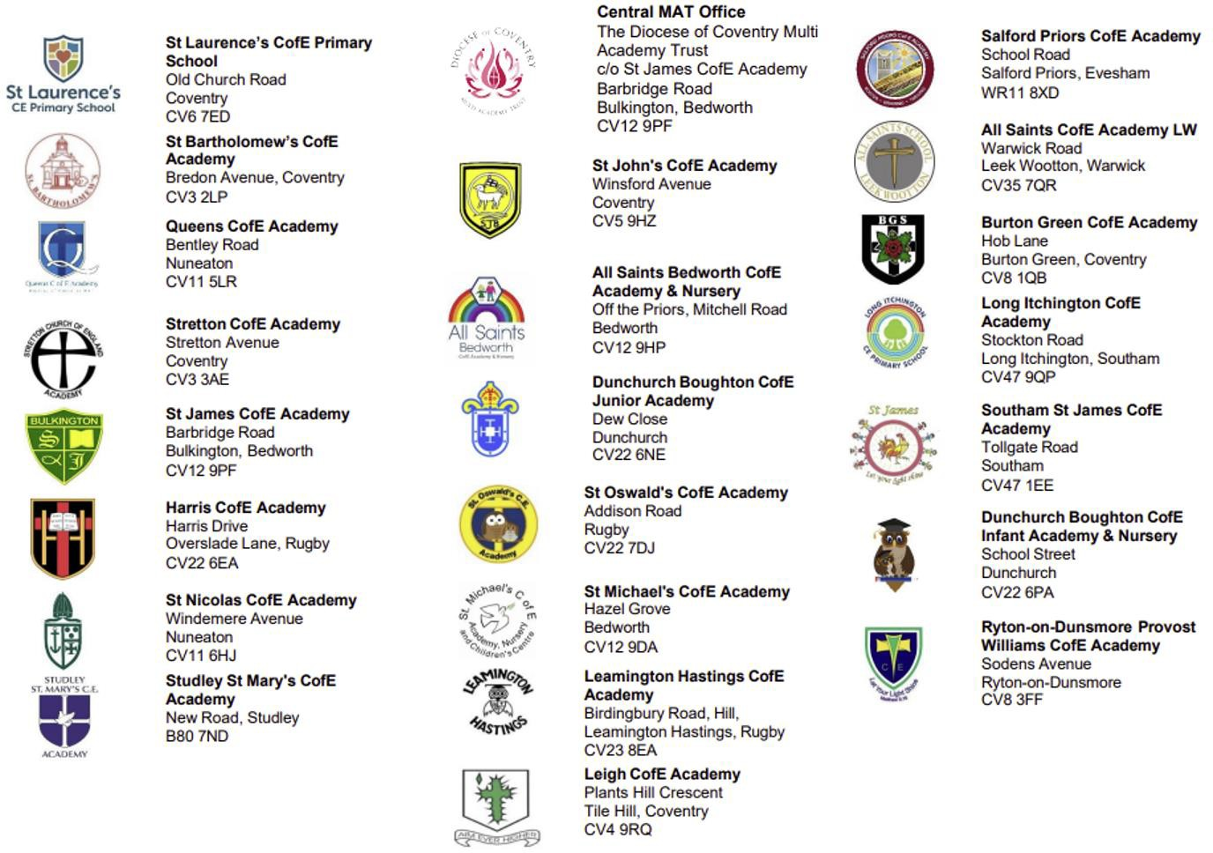
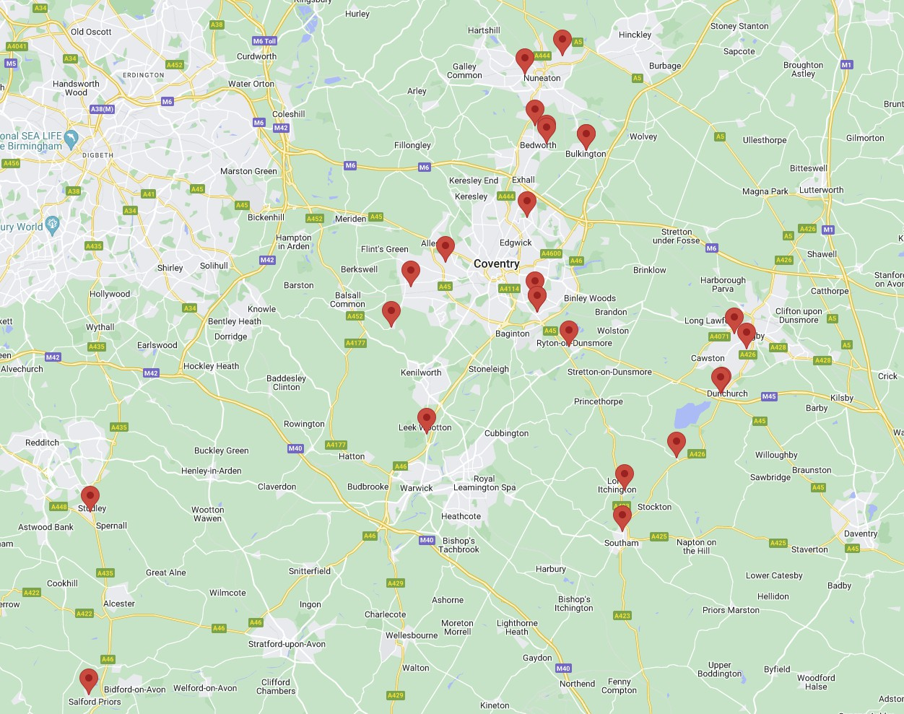
Our Academies

