

Job Title Class Teacher
Location Orchard Wood Primary School
Grade MPS or UPS
Hours Full time

Person Specification

A. Training and qualifications | Essential | Desirable
Qualified Teacher Status | ✓
A good honours degree in a relevant subject | ✓
Evidence of continuous training and commitment to further professional development |  | ✓

B. Knowledge, Skills and Understanding | Essential | Desirable
Current knowledge of Child Protection & Safeguarding policies/procedures | ✓
Effective provision for the individual needs of all children | ✓
Effective strategies for assessment and planning | ✓
Experience of subject leadership |  | ✓
Experience of middle leadership |  | ✓
Experience of assessment for learning (AfL) | ✓
Experience of using strategies to continuously raise standards of all children, including those with additional needs/SEND and more able | ✓
Experience of using strategies to improve the learning & achievement of all children, including those with additional needs/SEND and more able | ✓
An up-to-date understanding of the National Curriculum | ✓
Experience of coordinating curriculum coverage across year groups |  | ✓
Ability to work effectively within a team of staff, governors and the MAT | ✓
Ability to establish, develop and maintain positive working relationships with parents, governors and the community | ✓
Ability to create a happy, challenging and effective learning environment | ✓
Effective written and oral communication | ✓



Agora Learning Partnership
Charitable company limited by guarantee
Registered in England and Wales No 10290954 Registered Office: The Orchard Primary School, Gammons Lane, Watford, WD24 5JW

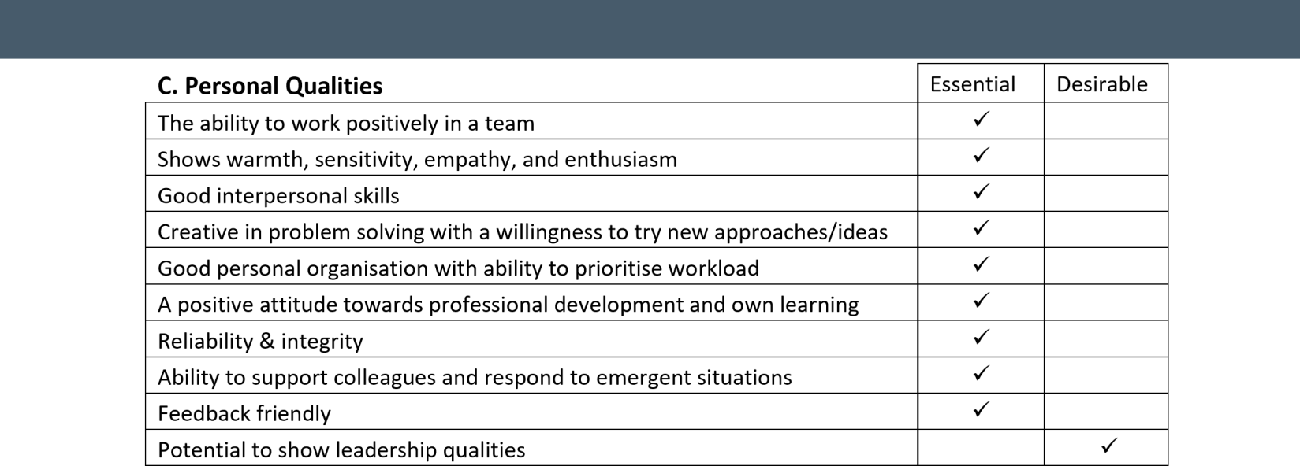

Demonstrate consistently good or outstanding classroom practice, including confident use of ICT | ✓
Sound understanding of current educational issues including the requirements from the Ofsted framework | ✓

D. Equal Opportunities | Essential | Desirable
Commitment to equality of opportunity for all regardless of gender, disability, religion, and ethnic origin. | ✓

This post is subject to receipt of two satisfactory references (obtained prior to interview), a satisfactory enhanced DBS check and occupational health clearances.

