APPLICANT INFORMATION PACK

Bordesley Green Girls’ School & Sixth Form
School Administrator, Data

Maternity Cover
September 2026

Letter from Headteacher
September 26
We are delighted you are interested in joining the Team at Bordesley Green Girls’ School & Sixth Form.
Bordesley Green Girls’ School is a vibrant 11-18 school at the heart of the community. We pride ourselves on providing a truly inclusive education, enabling all staff and students to reach their full potential. Our most recent Ofsted report (April 2022) rated our school as ‘Good’.
It is an exciting time to join Bordesley Green Girls’ as we are now in year two of our ambitious strategic plan. We are proud of the school’s achievements and values and look forward to continuing with the excellent progress made in recent years to make this a truly outstanding school.
At the heart of our philosophy is our BGGS school motto: Bringing Girls Greater Success. We care about the progress our students make and are committed to their success. Each student has access to a broad and balanced curriculum and a wealth of experience and opportunities. We aim for every student to grow in confidence and knowledge, leaving us prepared for responsible adulthood, becoming future leaders and having a positive impact on the community.
All our staff work tirelessly to create an atmosphere where the students can perform at their best. Our priorities are to develop innovative and inspirational teaching and learning to ensure our students become effective, independent learners. This approach undoubtedly has led to excellent outcomes both at GCSEs and at Level 3 qualifications.
We celebrate attitudes and attributes by promoting our RESPECT values: at Bordesley Green Girls' our students are Resilient, Enterprising, Student leaders, Polite and respectful, Engaged in learning, Confident communicators and Team players.
Our leadership team is very strong. Each member of the leadership team has key roles and responsibilities. We have made great progress by working together, transparently, flexibly and honestly.
All key stakeholders have a voice and as a school we are approachable and listen to their concerns or thoughts about the school. Community support is a huge strength of the school and we have a growing range of partnerships with universities, colleges and successful businesses.
Our Governing Body has highly esteemed academics on the board as well as finance and safeguarding experience from leading practitioners in their field. Together, the Governors, the Senior Leadership Team and staff all work in harmony to deliver a great education for our students.
We encourage applications from colleagues with a diverse range of skills and experience. We work hard and we celebrate our achievements. We are a school which wants our staff to succeed every bit as much as our students. We are committed to professional development of our staff.
Wishing you good luck and we look forward to receiving your application.
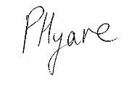
Ms Pritpal Hyare
Headteacher
School Administrator, Data

Salary: Grade 3, Point 9 – 22 (Job evaluation pending)
Full time; Term Time plus 10 days
(to be worked in the summer holidays to facilitate provision of student data, 6th form enrolment and Exam results)
Maternity Cover
Start Date: 2 November 2026

The Governing body are seeking to recruit a reliable and flexible person to join Bordesley Green Girls School and Sixth Form. You should have great communication skills and be able to converse confidently with students, staff and parents. Excellent timekeeping and attendance are an essential requirement for this role.
The successful candidate will be someone with outstanding organisational skills, who completes work with calm efficiency, enjoys problem solving and is skilled in manipulating data. Excellent IT and communication skills are essential, as are the ability to work collaboratively and to contribute to the continuous improvement of data management practices of the school.
The key responsibilities for this post are administration and maintenance of student data on various databases and systems; preparation, production and delivery of reports regarding assessment data; data analysis as required; and deputising for the Exams Officer as required.
Our ideals candidate will have:
- Excellent interpersonal skills
- Excellent communication skills with a “can-do” attitude
- An ability to work within a team and independently
- Excellent time management and organisational skills
- Excellent IT Skills, including excel and word etc
What we will offer you:
- a supportive and caring culture
- a knowledgeable and friendly Team
- active CPD and generous coaching/line management support
- wellbeing support including 24/7 Employee Assistance Programme/confidential counselling, access to wellbeing advice, flexible working culture
- access to generous benefits, such as pension scheme (LGPS)
This post is covered by Part 7 of the Immigration Act (2016) and therefore the ability to speak fluent spoken English is an essential requirement for this role.
Informal visits can be accommodated. Please contact via the Main School office on 0121 464 1881 to arrange this.
An applicant information pack and application form can be downloaded from our website at www.bordgrng.bham.sch.uk.
We regret that we are unable to accept CVs.
Interested candidates should email their completed application form to HR@bordgrng.bham.sch.uk by the closing date: 12 noon on Friday 25 September 2026.
If you have not received a response within 10 working days of the closing date, then please assume that your application has not been shortlisted on this occasion.
An online search will be carried out on short-listed candidates to help identify any incidents or issues that can be discussed at interview.

Bordesley Green Girls’ School and Sixth Form School is committed to the safeguarding and welfare of children and young people and expects all staff and volunteers to share this commitment. An enhanced DBS clearance is required for all successful applicants. This post is exempt from the Rehabilitation of Offenders Act 1974

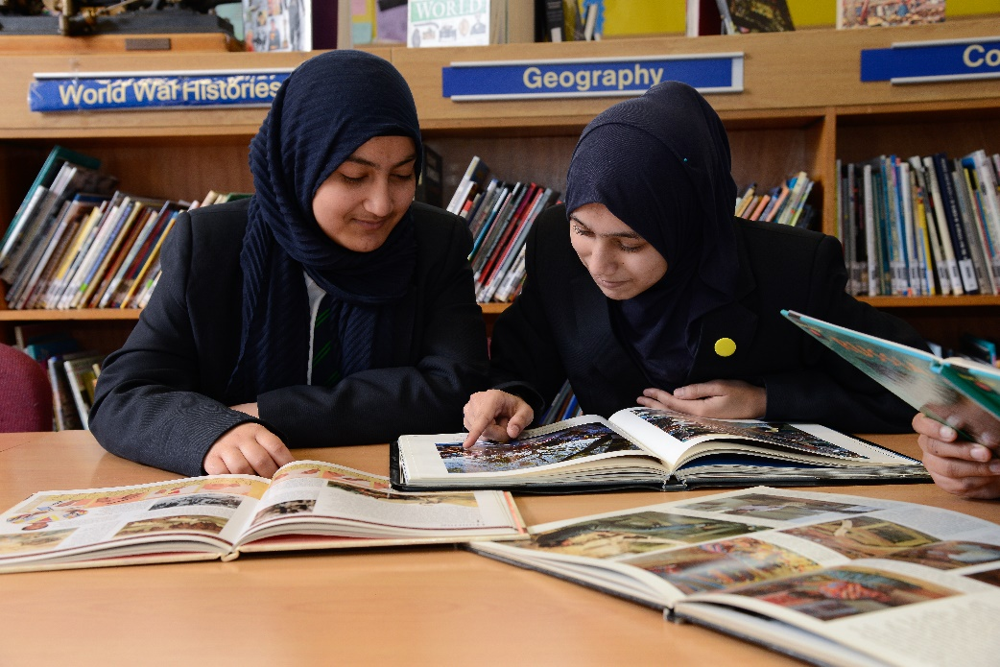

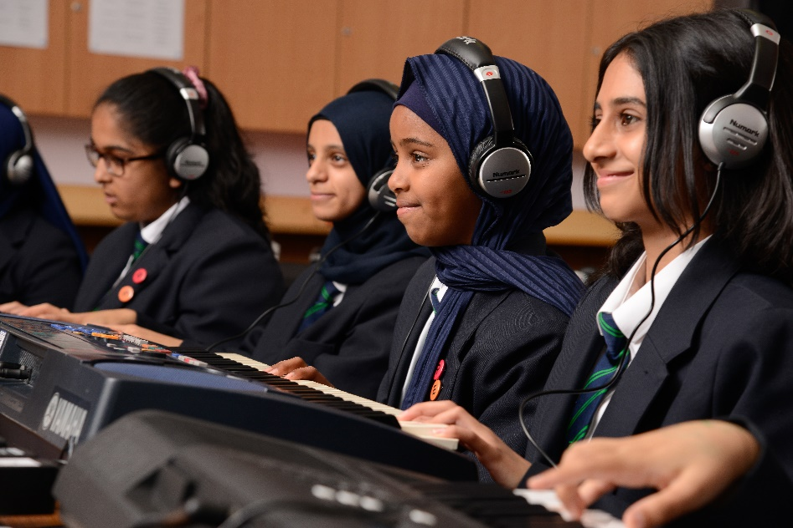

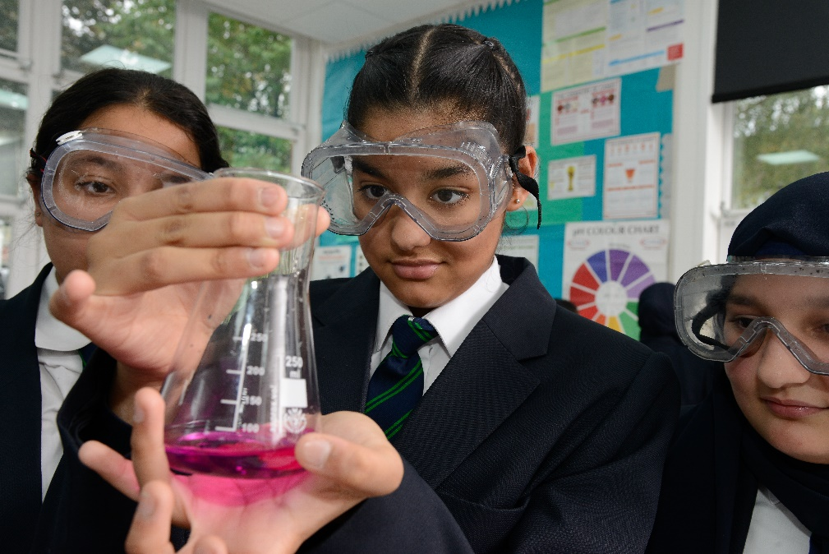

Our School

Bordesley Green Girls’ School is an 11-18 multicultural, inclusive comprehensive school situated on the eastern side of the City of Birmingham. We have 968 students on roll, including 324 in the Sixth Form, 62.9 full time equivalent (FTE) teaching staff and 45.8 FTE support staff.

Visions and Values
Our school will:
- Provide a learning environment
- Deliver a rich curriculum
- Offer a whole-school experience
- Develop partnerships
- Offer an enrichment programme
- Be a safe place to learn
We will be a learning community founded on:
- Respect
- Collaboration
- Ambition
Our students demonstrate our core values by being:
- Resilient
- Enterprising
- Student Leaders
- Polite and respectful
- Engaged in learning
- Confident communicators
- Team players

What you will get in return from our School

Professional development is key to our ongoing success, so we invest in your development through training, mentoring and progression opportunities through apprenticeships and other routes.

We also offer An Employee Assistance Programme and employee benefits package
Competitive pension scheme (Local Government Pension Scheme)

Curriculum Arrangements
We are very proud of the breadth and depth in our curriculum for all our students.
The curriculum is delivered through the taught curriculum and the enrichment curriculum. Learning happens in lessons, form-time, assemblies, games, educational visits, enrichment and enterprise days, school productions, and community work.
Throughout the curriculum, our students have regular opportunities for learning beyond the classroom through enriching learning experiences and extra-curricular activities.
Our inclusive curriculum is personalised to the needs of our students, and regardless of ability, each student is supported but also challenged in their learning.
The timetable for the school is based on a two-week cycle and comprises of a 25-period week with five periods per day, each period lasts 60 minutes. Lessons can be either single or double periods (usually sixth form lessons and double periods).

The Curriculum at Key Stage 3
Our three-year KS3 programme of study ensures that there is no narrowing of the curriculum. Students secure depth of knowledge and skills and are prepared for an inspirational and challenging KS4. Students are taught in five teaching groups per year in most subjects: one class of high prior attainers and four mixed ability classes
The Key Stage 3 curriculum: English, Mathematics, Science, PE, RE, PSHE, Design Technology, Art, Computing, French, Geography, History, Drama, Music and a second language (Arabic, Spanish or Urdu).

The Curriculum at Key Stage 4
In our Key Stage 4 Core curriculum, all students study English, Mathematics, Science (Separate or Combined Science), PE, RE and PSHE. At Bordesley Green we encourage our students to study a diverse option and the full range of English Baccalaureate subjects: our EBacc entry rate is consistently over 85%.
In addition to the core curriculum all students will choose up to four option subjects:
One language (Arabic, French, Spanish or Urdu),
A humanities subject (either Geography or History) and
Any combination of further two subjects from Art, Business, Computer Science, Design Technology, Health and Social Care, Hospitality and Catering, Music and Sport studies.

The Curriculum in the Sixth Form
We currently offer a wide range of courses at Bordesley Green Girls’ and are confident that students can choose combinations of courses on which they are most able to succeed.

Students can enrol on 3 different pathways: A Level programme of study over two years, Level vocational and technical programme of study over two years, or Level 2 BTEC study over one year alongside retaking GCSE Mathematics and English. Most A Level students will study three A levels, with some more able students taking four A Levels or an Extended Project Qualification. Enrichment is an important part of our KS5 curriculum: students are able to choose from a range of activities including sports, arts and STEM projects.
For further information about the Curriculum Arrangements, please visit the following link: http://www.bordgrng.bham.sch.uk/Curriculum/ and BGGS_Sixth_Form_Prospectus.pdf

Outcomes
Bordesley Green Girls’ School & Sixth Form has enjoyed success in its Key Stage 4 and Key Stage 5 examinations. Across most of the headline measures our outcomes have continued to improved year on year. There has been a significant increase in the number of students achieving grades 4+ in Maths & English and 5+ in Maths and English in the past 3 years.

The Progress 8 scores have continued to improve and put us in the significantly above average category.

Outcomes at Key Stage 4
- Students consistently make excellent progress at BGGS: Overall Progress 8 +0.6 in 2024 was significantly above the national average
- The percentage of girls attaining the strong pass, grades 9-5 in Maths and English in 2024 was 46.9%
- There is no gap between disadvantaged and non-disadvantaged girls
- Progress 8 for English was significantly above average in 2024 (0.94) and in the highest 5% of all schools

Outcomes at Key Stage 5
- The A Level average grade in 2023 was C+, in line with the Birmingham average. The Level 3 vocational average grade was Distinction, above both national and Birmingham averages.
- The average point score in applied general and technical levels was in the highest 20% nationally in 2023 and 2024
Senior Leadership Team
The roles and responsibilities of our SLT are detailed on our website:
http://www.bordgrng.bham.sch.uk/Senior-Leadership-Team/

Sixth Form
Bordesley Green Girls’ School became an 11-18 school in September 2011 admitting its first sixth form cohort. The sixth form was opened as a consequence of the school’s “high performing” status and our Sixth From has gone from strength to strength in this time Applications exceed places each year.
The Hearing Resource Base (HRB)
The school has a SEND resource base for the hearing-impaired students named the HRB with a staff of: 1 full time and 2 part time Teachers of the Deaf and 2 full time Teaching Assistants. HRB students receive in class support from both Teachers of the Deaf and Teaching Assistants. Students may be withdrawn to the HRB for specialist pre/post tutoring, subject based interventions and speech and language developmental work
We currently have 12 deaf students from year 7-12. All students have a severe to profound hearing loss and the majority have cochlear implant processors. All students use radio aid systems in class to communicate with mainstream staff and use speech or a combination of speech and BSL (British Sign Language).

For further information please look at our HRB page on the school website, which will give you further details about our provision. We have also produced an in-depth video of our day to day running of the HRB. http://www.bordgrng.bham.sch.uk/Video-about-the-HRB

Job Description – School Administrator, Data
Grade: GR3 (Point 9 – 22)
(Job evaluation pending)
- Job Purpose
  - This job manages essential data administration support including inputting, cleansing, analysing and distributing data across school systems. It ensures the integrity of pupil and staff records and supports statutory census returns. It supports the production of a range of data and assessment reports for school leaders and governors.

- Key Responsibilities

Administration- Pupil Data
  - Maintaining student data within the school MIS, including administration of data checking and updates to maintain complete and accurate data, which may include Free School Meals, attendance, pupil premium and SEND information
  - Designing and producing a range of pupil lists and reports as required by staff and leaders
  - Providing data administration for the school assessment and reporting cycle

Data Analysis and Reporting
  - Supporting the reporting of data to students, parents and carers and wider stakeholders
  - Supporting the production of detailed analysis and evaluation of data and management information
  - Supporting the preparation of statutory and non-statutory returns

Data Systems
  - Providing training and support for uses of the school MIS data and other related data systems
  - Supporting compliance with GDPR, including FOI and SAR requests
BGGS and Sixth Form is committed to safeguarding and promoting the welfare of children and young people and expects all staff and volunteers to share this commitment. An enhanced DBS check must be completed for all successful applicants.

Person Specification – School Administrator, Data

Method of Assessment (MOA)
AF Application Form | C Certificate | I Interview | T Test or Exercise | P Presentation

Criteria | Essential | MOA
Education/  Qualifications  NB: Full regard must be paid to overseas qualifications. | - Hold GCSEs (or equivalent) at Grade C/4 in English and Mathematics  - Hold Level 3 qualification or equivalent demonstrable experience | AF/C/I
Experience  Relevant work and other experience | - Have experience in educational administration or a similar data-focused administrative role  - Be experienced in handling sensitive information whilst maintaining strict confidentiality protocols | AF/I
Skills & Ability  e.g. written communication skills, dealing with the public etc. | - Be proficient in using management information systems, Microsoft Office applications and data analysis tools  - Be highly proficient in the use of spreadsheets  - Be able to speak an appropriate standard of spoken English -Part 7 of the Immigration Act (2016)  - Have excellent attention to detail and accuracy in data entry, data management and data analysis tasks.  - Be skilled in producing mail-merged documents and a range of data analysis reports  - Be able to both work independently and make a positive contribution to team work  - Be skilled in maintaining accurate records and ensuring data integrity effectively.  - Be capable of managing multiple administrative tasks, meeting deadlines effectively and remaining calm under pressure.  - Be able to collate, analyse and present data effectively for the purposes of reporting  - Demonstrate thorough understanding of data protection legislation and confidentiality requirements in schools. | AF/I /T
Other | - Have a flexible and adaptable approach to supporting varied school operational needs. | AF/I
Training | - Demonstrate a commitment to undertaking ongoing training and professional learning | AF/I

Bordesley Green Girls’ School and Sixth Form School is committed to the safeguarding and welfare of children and young people and expects all staff and volunteers to share this commitment. An enhanced DBS clearance is required for all successful applicants.

