


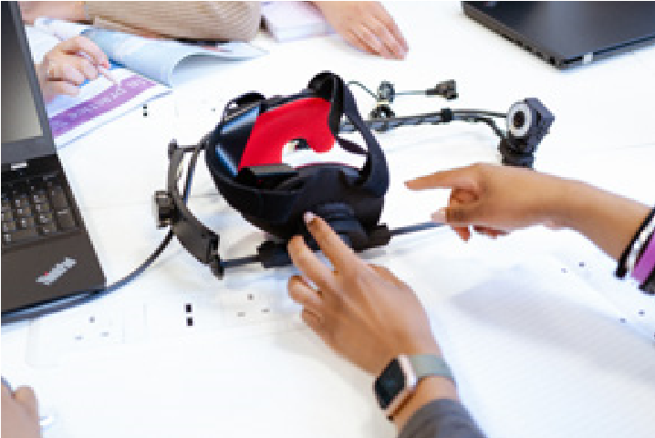


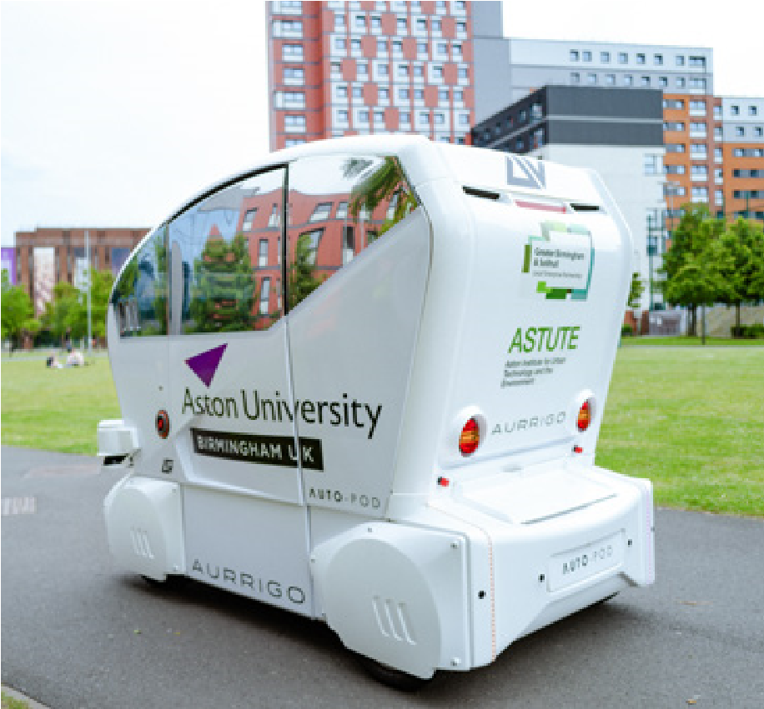



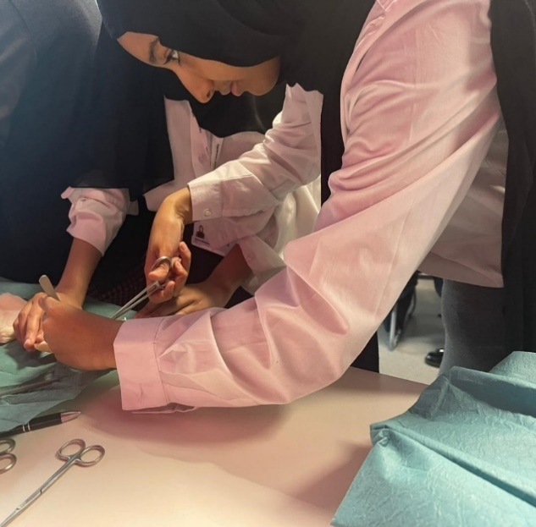



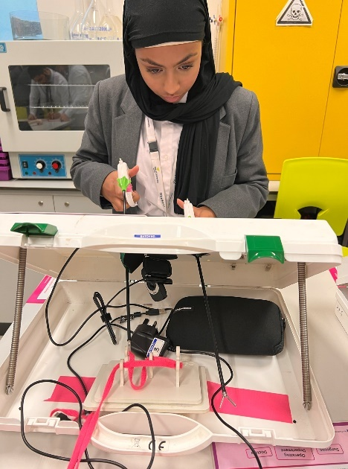
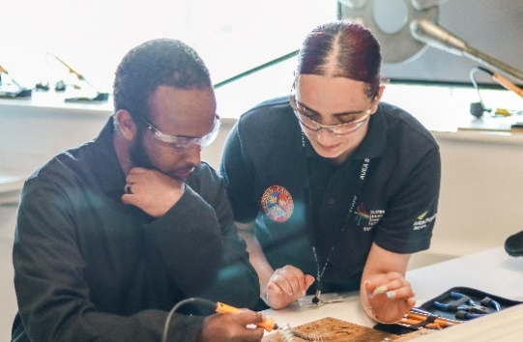


Job Description and Personal Specification
Director of Personal Development and Enrichment

Role: Director of Personal Development & Enrichment
Line Manager: Principal
Main Purpose of the Role

At Aston University Engineering Academy (AUEA), personal development and enrichment is not an add‑on — it is foundational to who we are and who our students become and the impact they have within their community, nationally and internationally.

We are seeking an exceptional and visionary leader to become our Director of Personal Development & Enrichment, a role that sits at the heart of our commitment to ensuring every young person is confident, resilient, socially responsible and aspirational for their future.

This is a rare opportunity to shape a whole‑school culture where personal growth, character, wellbeing and ambition are lived values — empowering students not only to succeed academically, but to thrive in life beyond AUEA.

As a senior leader, you will champion inclusive, high‑quality personal development provision, inspire staff and students alike, and drive a shared moral purpose that places pupils’ futures at the centre of everything we do. You will join a highly functional and successful team who strongly believe in developing the whole person. The role is open to teaching and none teaching applicants (noting delivery to learners will be required in the role, but training would be provided)

Contents

Key Duties and Responsibilities 2
1. Strategic Leadership of Personal Development 2
2. Statutory Provision and Curriculum Oversight 2
3. Careers Education and Employer Engagement 3
4. Education Visits 3
5. Extracurricular, Super-Curricular and Enrichment 3
6. Inclusion, Equality and Access 3
7. Quality Assurance, Impact and Ofsted Readiness 4
8. Line Management and Professional Development 4
9. Safeguarding and Ethos 4
10. In addition 4
11. Director of Personal Development – Personal Specification 5

Key Duties and Responsibilities

1. Strategic Leadership of Personal Development
- Provide clear strategic leadership for Personal Development & Enrichment across the academy, aligned with AUEA’s vision, values and ethos.
- Develop and communicate a coherent Personal Development & Enrichment strategy with clear intent, implementation and impact.
- Advise SLT on all matters relating to Personal Development & Enrichment, statutory compliance and inspection readiness.
- Work with departments to ensure Personal Development & Enrichment is embedded across the curriculum, extracurricular and super-curricular offer.
- Lead self-evaluation and improvement planning for Personal Development & Enrichment, produce report for governors and contribute to whole-school SEF and SIP.
- Ensure the academy meets and Ofsted expectations for Personal Development at Exceptional.
- Monitor and evaluate the impact or personal development & Enrichment initiatives using data, student voice, and quality assurance processes.
- Lead CPD for staff on student personal development & Enrichment.
- Manage budgets related to enrichment, careers and personal development & Enrichment.
- Lead and teach on the delivery of high quality PSHE/RSE including the planning and delivery of deep learning days.

2. Statutory Provision and Curriculum Oversight
- Ensure full statutory compliance with DfE guidance and high-quality provision for:
  - PSHE Education
  - Relationships and Sex Education (RSE)
  - Careers Education and Guidance
  - Education Visits
- Work with staff to ensure contextualisation of learning is appropriate, inclusive and meets the needs of SEND and detailed in Big Picture Plans.
- Oversee PSHE/RSE curriculum design, sequencing and delivery to ensure content is age appropriate, inclusive and ambitious.
- Ensure provision reflects current statutory guidance and best practice.
- Monitor delivery and impact through lesson visits, work scrutiny, student voice and outcomes.
- Ensure Fundamental British Values and equality objectives are embedded across the curriculum.

3. Careers Education and Employer Engagement
- Line manages the Careers Leader, holding them to account for high standards of provision.
- Ensure AUEA meets Gatsby Benchmarks and statutory careers guidance requirements.
- Oversee effective careers guidance, employer engagement, work-related learning and progression outcomes.
- Ensure careers education supports informed decision-making and successful next steps for all students both Pre and Post 16.
- Oversee effective careers guidance, employer engagement, work-related learning and progression outcomes.

4. Education Visits
- Act as Educational Visits Coordinator working with Principal to sign off Education visits as part of EVC legal framework and risk (training provided)
- Line manages the Education Visits administrator, holding them to account for high standards of provision.
- Ensure AUEA meets EVC requirements and all trips/visits are captured in Gatsby Benchmarks.

5. Extracurricular, Super-Curricular and Enrichment
- Provide leadership and management of:
  - A rich and inclusive enrichment programme
  - Clubs, projects, CCF, DofE, voluntary and leadership opportunities
  - Extracurricular and super-curricular offer
- Ensure opportunities are high quality, purposeful and inclusive, supporting students’ character development, aspirations and cultural capital.
- Ensure sixth form students receive tailored guidance for university, apprenticeships and employment.
- Monitor participation and remove barriers to engagement, especially for disadvantaged and vulnerable students.
- Promote student wellbeing, resilience and mental health awareness. Ensuring safeguarding themes are embedded in the curriculum.

6. Inclusion, Equality and Access
- Work closely with:
  - PD Tutors
  - Pastoral Team
  - SEND Team
- Ensure Personal Development & Enrichment provision is inclusive, equitable and accessible to all students.
- Monitor the experience and outcomes of key groups including SEND, disadvantaged students and those with additional needs.
- Promote equality, diversity and respect through curriculum content and enrichment opportunities.

7. Quality Assurance, Impact and Ofsted Readiness
- Ensure robust systems are in place to demonstrate clear impact of trips & visits on Personal Development and/or academic progress.
- Use data, student voice and destination outcomes to evaluate trip/visit effectiveness.
- Prepare evidence for SLT and Local Governing Board
- Link education visits to careers education

8. Line Management and Professional Development
- Line manages the Careers Leader and Education Visits Administrator.
- Hold line managed staff to account through high-quality performance management.
- Support professional development of staff contributing to Personal Development delivery.
- Build a strong, collaborative Personal Development team.

9. Safeguarding and Ethos
- Promote a strong culture of safeguarding and student welfare within all aspects of Personal Development.
- Work closely with DSL and Pastoral Leaders to support students’ wellbeing.
- Act as a role model for AUEA values, professionalism and leadership behaviours.

10. In addition
- Willingness to work as part of team across the academy
- Carryout day to day duties
- Any addition requirements as directed by the Principal or Executive Principal

Director of Personal Development – Personal Specification

Category | Criteria | Essential / Desirable | Evidence
Qualifications, Training and Professional Learning | Evidence of substantial professional experience in education, youth development or a closely related field. | Essential | Application
Qualifications, Training and Professional Learning | Commitment to ongoing professional development and aligning practice with statutory guidance and best practice. | Essential | Application / Interview
Qualifications, Training and Professional Learning | Qualified Teacher Status (QTS). | Desirable | Application
Qualifications, Training and Professional Learning | Leadership or management training at middle or senior leadership level. | Desirable | Application
Qualifications, Training and Professional Learning | Relevant training in PSHE, RSE, careers education, safeguarding or inclusion. | Desirable | Application
Leadership Experience | Proven experience of leading or coordinating Personal Development, pastoral provision, enrichment, careers or related areas. | Desirable | Application / Interview
Leadership Experience | Experience of influencing whole-organisation practice and contributing to strategic decision making. | Desirable | Application / Interview
Leadership Experience | Experience of line managing staff and holding others to account for quality and impact. | Desirable | Application / Interview
Leadership Experience | Experience working closely or part of a senior leadership team. | Desirable | Application
Leadership Experience | Experience of preparation for, or participation in, Ofsted inspections. | Desirable | Application / Interview
Knowledge and Understanding | Secure understanding of the Ofsted Inspection Framework, particularly the Personal Development judgement. | Essential | Interview
Knowledge and Understanding | Strong knowledge of statutory requirements for PSHE Education, RSE and Careers Education and Guidance. | Essential | Interview
Knowledge and Understanding | Understanding of inclusion, equality of access and meeting the needs of diverse learners. | Essential | Interview
Knowledge and Understanding | Detailed knowledge of Gatsby Benchmarks and careers quality frameworks. | Desirable | Interview
Knowledge and Understanding | Understanding of post-16 progression pathways and destination outcomes. | Desirable | Interview

Category | Criteria | Essential / Desirable | Evidence
Skills and Professional Attributes | Ability to articulate clear intent, implementation and measurable impact. | Essential | Interview
Skills and Professional Attributes | Highly effective leadership, communication and organisational skills. | Essential | Interview
Skills and Professional Attributes | Ability to evaluate provision using data, pupil voice and qualitative evidence. | Essential | Interview
Skills and Professional Attributes | Interpersonal skills to advise, challenge and support senior leaders. | Essential | Interview
Skills and Professional Attributes | Ability to build collaborative relationships with pastoral teams, SEND, tutors and external partners. | Essential | Interview
Skills and Professional Attributes | Experience of quality assurance processes such as observations, reviews and audits. | Desirable | Application / Interview
Skills and Professional Attributes | Experience of developing staff practice through coaching or training. | Desirable | Application / Interview
Personal Qualities and Values | Strategic, reflective and improvement-focused mindset. | Essential | Interview
Personal Qualities and Values | Commitment to students’ personal growth, wellbeing, aspirations and future success. | Essential | Application / Interview
Personal Qualities and Values | Strong moral purpose rooted in inclusion, equality and opportunity for all. | Essential | Interview
Personal Qualities and Values | Credible, calm and authoritative presence in senior leadership discussions. | Essential | Interview
Personal Qualities and Values | Resilient, adaptable and solution-focused. | Essential | Interview
Personal Qualities and Values | Innovation and creativity in enrichment, leadership and super-curricular opportunities. | Desirable | Interview
Personal Qualities and Values | Ability to inspire students and staff through vision and example. | Desirable | Interview

