
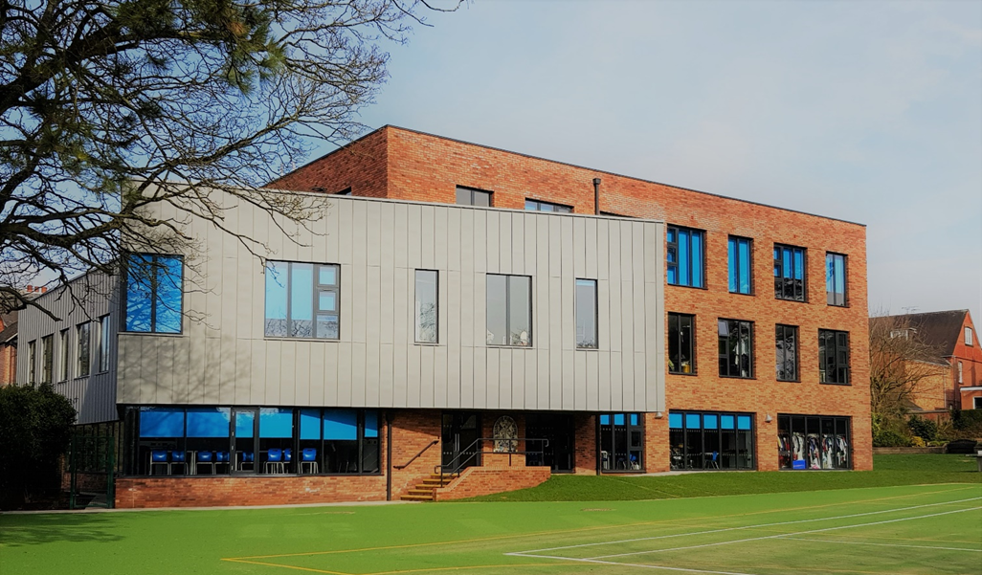

Teacher of Secondary Religious Education
Prayer and Liturgy Lead
Information booklet for prospective applicants

Dear Applicant
Thank you for your interest in joining our team as a Full-time Teacher of Religious Education and Prayer and Liturgy Coordinator (PLC) at St Dominic’s Priory School in Stone.
St Dominic’s Priory School is a small, exceptionally friendly and highly successful Catholic independent co-educational school, educating pupils from Pre-school through to age 16. While rooted in Catholic values, we warmly welcome children of all faiths and backgrounds.
At the heart of our ethos is a commitment to educating the whole person. We strive to identify and nurture the individual strengths of every child, enabling them to flourish academically and personally. Our students develop a strong sense of purpose, growing into confident, independent young people who are well prepared to embrace life’s opportunities. They combine enthusiasm and enjoyment in learning with a genuine determination to achieve, and they thrive when given responsibility.
We are proud to be recognised as one of the top-performing non-selective schools in the area. Our students have once again achieved outstanding GCSE results, with a 100% pass rate across all subjects this year. Consistently performing significantly above the national average, our results reflect our commitment to delivering an exceptional all-round education.
Our school environment continues to evolve, with a newly constructed three-storey teaching facility that has further enhanced the educational experience for both students and staff. We operate a two-form entry in the senior school, with small class sizes capped at 20 pupils. This ensures that every child is truly known, supported, and encouraged to reach their full potential.
We are seeking an inspirational and dedicated teacher of Religious Education who is passionate about raising attainment and aspirations. The successful candidate will have experience of teaching Religious Education at Key Stage 3 and GCSE level.
The Prayer and Liturgy Coordinator (PLC) will foster, lead, and coordinate the prayer and liturgical life
of the school, ensuring it is fully consistent with the mission of the Catholic Church and the requirements set out in To Love You More Dearly – The Prayer and Liturgy Directory (CES, 2023) of the school, ensuring it is fully consistent with the mission of the Catholic Church and the requirements set out in To Love You More Dearly – The Prayer and Liturgy Directory (CES, 2023).
The postholder will work with the Headteacher and Primary RE Subject Leader, parish clergy, and staff to embed prayer and liturgy at the heart of the school’s life and nurturing pupils’ personal relationship with Christ and supporting their growth as active participants in the Church’s worship, and ensuring that prayer and liturgy visibly contribute to the flourishing of pupils and staff.
In return, we offer the opportunity to work within a caring, supportive and close-knit environment, alongside excellent opportunities for professional development and career progression.
I very much hope you will consider applying for this role. I would be delighted to speak with you further and to welcome you to visit the school for a tour, so you can experience first-hand what makes our community so special.
I look forward to hearing from you.
Yours sincerely
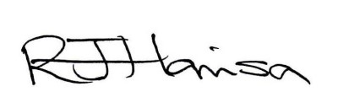
Rebecca Harrison
Headteacher

The Role:

Prayer and Liturgy Coordinator and Secondary Religious Education Teacher, Stone, Staffordshire
Dates: Start September 2026
Salary: Staffordshire Teachers’ Pay Scale based on experience
Teaching: Key Stage 3 & 4
Location: Stone
Contract type: Permanent – Full time
(Part time contract may be considered)

The application form and a covering letter of no more than two sides of A4 should be returned to:

Mrs Rebecca Harrison
Headteacher
St. Dominic’s Priory School
37 Station Road
Stone
Staffordshire
ST15 8ER
All relevant documents (application form and job description) are available to download from this site or the school website www.stdominicspriory.co.uk (found under ‘About, Job Vacancies’).
Please return all applications to Rebecca.harrison@stdominicspriory.co.uk for the attention of Mrs Harrison.
This school is committed to safeguarding and promoting the welfare of children and expects all staff and volunteers to share this commitment. As we operate in an educational environment the role is dependent on an enhanced DBS check.
Closing Date: 8th May 2026
Interview date: 11th May 2026

The job profile for Prayer and Liturgy Coordinator and Secondary Relgious Education Teacher
JOB TITLE: Teacher of Religious Education - Secondary
Prayer and Liturgy Coordinator (PLC)
DURATION / HOURS: Permanent post with effect from September 2026
PAY: Staffordshire Teachers’ Pay Scale based on experience and TLR for SLT responsibilities
ELIGIBLE TO APPLY: All teachers with suitable skills and experience
SELECTION PROCESS: Method: Please complete the application form.
Deadline: 5th May 2026

Core Purpose
As Prayer, Liturgy and Religious Education Lead, you will help shape the spiritual and academic life of our independent Catholic school. Your role is to nurture a community where prayer, worship, and high-quality religious education sit at the heart of daily life. You will guide pupils and staff in deepening their relationship with Christ, ensure our prayer and liturgical life is vibrant and authentic, and lead a strong RE curriculum that reflects the Religious Education Directory To Know You More Clearly and the Prayer and Liturgy Directory To Love You More Dearly. Working closely with the Headteacher, clergy, staff, and families, you will help ensure our Catholic identity is lived joyfully and confidently throughout the school.
Key Responsibilities
1. Strategic Leadership
- Lead the school’s vision for prayer, liturgy, and religious education in a way that reflects our Catholic mission and the character of an independent school.
- Develop and oversee whole-school policies for prayer, liturgy, and RE.
- Create and implement the annual plan for prayer and liturgy, alongside the RE improvement plan.
- Ensure the school meets diocesan expectations and maintains high standards in both RE and Catholic life.
- Work with senior leaders and governors to ensure RE is valued, well-resourced, and given parity with other core subjects.
- Use school and diocesan data to monitor progress and shape future planning.
2. Prayer
- Establish a daily rhythm of prayer that is meaningful, age-appropriate, and rooted in the liturgical year.
- Support staff and pupils in leading prayer with confidence.
- Ensure pupils learn key traditional prayers and understand their place in Catholic life.
- Provide creative and engaging prayer resources, including seasonal devotions such as the Rosary, Stations of the Cross, and Marian celebrations.
- Help weave prayer naturally into the RE curriculum and wider school life.
3. Liturgy and Formation
- Plan and coordinate liturgical celebrations, including Mass and sacramental moments, ensuring they are reverent and true to Church teaching.
- Work closely with clergy to support high-quality worship.
- Prepare pupils to take on liturgical ministries and develop their confidence in participating in worship.
- Offer formation for staff and pupils so they understand the meaning and structure of Catholic liturgy.
- Encourage pupils and staff to take ownership of worship appropriate to their stage and role.
- Attend diocesan training and share learning with colleagues.

4. Religious Education Curriculum Leadership
- Ensure the RE curriculum is faithful to the RED and sequenced for strong progression across all key stages.
- Oversee schemes of learning that are academically ambitious, creative, and accessible to all pupils.
- Ensure smooth progression from KS3 to GCSE and post-16, encouraging pupils to continue their study of RE where possible.
- Maintain compliance with exam board requirements and support excellent outcomes at GCSE and A-level.
- Provide a meaningful core RE programme for sixth-form students.
- Promote enrichment opportunities such as retreats, trips, speakers, and service projects.
5. Teaching and Learning
- Promote consistently high-quality teaching in RE by modelling lessons, sharing effective practice, and supporting staff development.
- Ensure teaching is rooted in strong subject knowledge and effective pedagogy.
- Set high expectations for pupil progress, engagement, and achievement.
- Support pupils in developing religious literacy, critical thinking, independence, and reflective skills.
- Celebrate pupils’ achievements through displays, assemblies, and wider school recognition.
6. Leading and Supporting Staff
- Lead and support the RE department, ensuring clarity of roles and a shared sense of purpose.
- Run departmental meetings and professional learning sessions.
- Deploy staff effectively to meet curriculum needs.
- Provide training for staff on teaching RE and leading prayer and liturgy.
- Encourage staff engagement with diocesan networks and professional development.
7. Chaplaincy and Community
- Build strong relationships with local clergy, parishes, and chaplaincy teams.
- Encourage pupils to take part in chaplaincy or faith leadership groups.
- Support social action, charitable work, and care for creation as expressions of faith.
- Welcome parents and carers into the prayer life of the school and help them feel part of the community.
8. Monitoring and Evaluation
- Monitor the quality of prayer, liturgy, and RE through observations, pupil voice, work scrutiny, and data analysis.
- Gather feedback from pupils, staff, parents, and clergy to inform improvement.
- Report regularly to senior leaders and governors on strengths and areas for development.
- Lead self-evaluation of Catholic life, prayer, liturgy, and RE in line with diocesan expectations.
- Use monitoring to shape training, resourcing, and future planning.
9. Personal Formation
- Show a genuine commitment to personal faith and ongoing spiritual growth.
- Model a joyful and authentic Catholic witness to pupils and staff.

Person Specification – Teacher of Music and Performing Arts
 |  | Essential | Desirable
1 | Qualifications | Qualified Teacher Status  Honours Degree in Religious Studies or similar i.e. Theology etc | Further professional study
2 | Experience | Experience of teaching Religious Education to a range of key stages and abilities  Excellent track record of attendance
3 | Knowledge/Skills | Up-to-date knowledge of examination specifications for GCSE Religious education.
4 | Personal Qualities | Practising Catholic  Resilience, determination and enthusiasm  High expectations of self and students  Ability to work as part of a team  Excellent written and oral communication skills  A desire to keep skills and knowledge up to date  A willingness to contribute to the extra-curricular life of the school | A desire for further professional development and promotion

