


Mealtime Assistant
Permanent Contract
Candidate Information

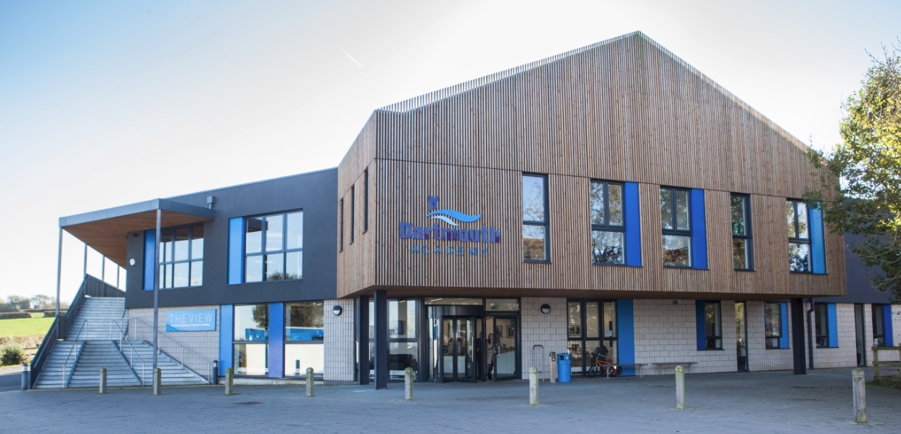















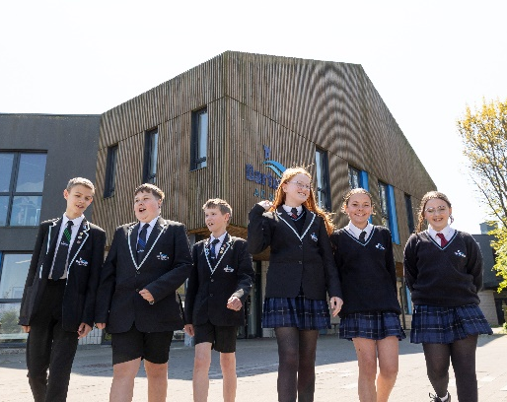
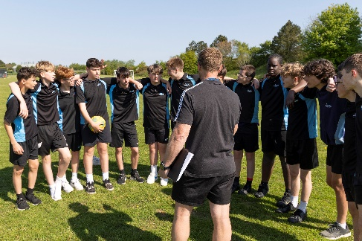


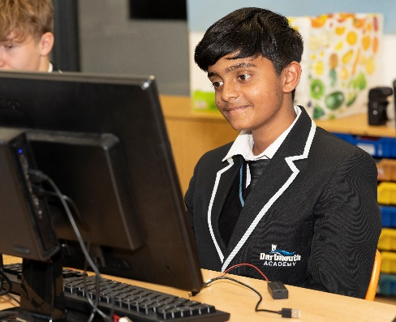
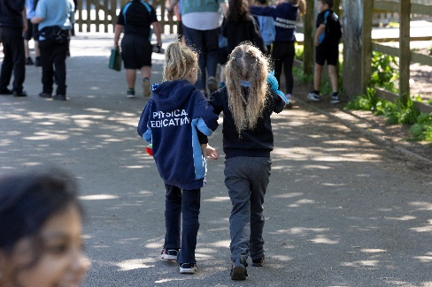
Welcome from Education South West

Dear Candidate,

Thank you for your interest in Education South West - we are always on the lookout for exceptional talent to join us and contribute to our team of creative education professionals.

At Education South West we believe that education makes children’s lives better, it is as simple as that; it enables them to lead great lives in every sense of the word. We believe that every child has the right to achieve all that they are capable of and more, regardless of their background or raw ability.

Across all of our schools our staff aim to provide an educational experience which is outstanding; our schools all believe strongly in the power of and broad and balanced curriculum. Sport, art, technology drama and music play an important role in all of our schools.

We encourage innovation, creativity and individuality. By sharing this individuality and creativity we firmly believe that schools and communities become stronger through unity and collaboration.

We are caring and compassionate. Every individual in our schools matters and we believe strongly that children and staff should enjoy their time at school, and work. A positive can-do attitude to their work and study is a must. The happier and more stimulated a person is the more motivated they are to improve.

We believe in developing a positive attitude to learning and to life, in having clear goals and in providing a supportive environment to help the realisation of these.

We support and challenge our school leaders and the staff in our schools to be the very best they can, leading effective teams at every level, growing future leaders and working together to provide an exciting education for all.

We welcome and support aspirational and ambitious teachers and classroom support staff, dedicated to supporting children through their time at school.

We offer excellent opportunities and professional development through in-school CPD, our Research School status, through our teaching schools and through our links with the wider education community. We are ambitious for our children and our employees and always looking to support, challenge and develop talent, whatever stage you are in your career.

When recruiting staff to work with children we place great importance on:

- people who go the extra mile
- a commitment to professional development and a desire to continue learning, via research, private study and in learning from others
- a desire to ensure that everything that is done within schools is the very best it can be
- a firm commitment to the philosophy that we work in education to improve young people’s lives and improve society; we serve our communities and the wider populace
- the ability to develop positive relationships with pupils, students and parents
- good interpersonal and communication skills when liaising with stakeholders
- a good sense of humour
- a commitment to working in partnership with others and sharing selflessly best practice within and outside of ESW

Your journey with ESW starts here and I look forward to meeting you in the future.

Yours faithfully,

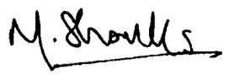
Matthew Shanks
CEO

Letter from the Principal

Mealtime Assistant - £13.28 per hour

Thank you for your interest in Dartmouth Academy and the position that we have available. I am delighted that you are considering joining our school: our aim is to seek the very best practitioners in the profession to join our team and I hope to read your application soon.

Pupils feel happy at Dartmouth Academy. They embrace the school’s mantra to ‘be your best self’. As a small, all-through school, pupils and staff value the strong relationships they have. Pupils join the school at different stages. Leaders support pupils at those different transition points. Pupils say they feel welcomed at the school.
Ofsted, April 2023

Woven throughout both our aspirational curriculum and ethos of empathy and understanding is the drive for every child to be a scholar in their learning. Staff create and teach academically-rich schema whilst understanding, and planning to overcome, the barriers a child may face. The concept of scholarship drives the role which staff play in being instrumental to every child’s development, not simply in their academic achievements but also as a person. From the moment pupils arrive into our Early Years Foundation Stage, we share with them the school mantra that fosters academic success as not a measure of ability but an indication of how hard pupils work: Be Your Best Self.

If you have a genuine desire to do the best for young people, then we would welcome your application. The school is committed to safeguarding pupils and personnel, and will conduct checks based on the information in your application. If you are selected for interview, safeguarding will feature in the interview programme.

If you wish to visit the school or have any questions about this role, please feel free to contact the school and my PA, Vicki Hart, on admin@dartmouthacademy.org.uk. Applications must be made by completion of an application form, and candidates invited to interview must supply a signed copy of their application form before their interview takes place. We would also request that interviewees bring to the interview original copies of relevant exam certificates, and where available original copies of their DfE registration and DBS disclosure.

The closing date for applications is 9am Monday 18th May 2026 with interviews to take place week beginning Monday 18th May.



Paul Girardot
Principal

THE ACADEMY

Dartmouth Academy is an all-through school and a member of Education South West which comprises 6 secondary schools and 9 primary schools within Devon. The schools with the ESW family share a common desire to give our children the education, opportunities and confidence that will enable them to lead great lives.


The Academy is in the beautiful town of Dartmouth which is situated on the mouth of the River Dart within the South Hams. It is a wonderful area to live and work. Open since September 2010, with modern, purpose-built facilities since 2014, we are one of a small but growing number of schools nationally which offer education for children from ages 3-16.

As a community of individuals we have a shared vision for creating the current and future happiness and success of every child who attends Dartmouth Academy. Regardless of our role within the school, or the point in their school career when we are working with them, our involvement will shape aspects of their future selves. We may not see the immediate impact of the vision we have for them but we each play a vital part in its creation.

THE ACADEMY’S FACILITIES
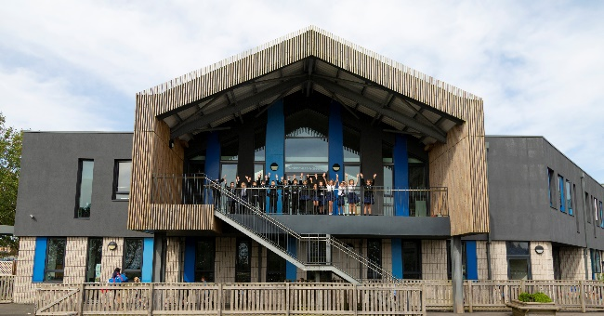
Visitors often comment on the excellent building which the school is housed in, the facilities it has and the unrivalled view of the River Dart. The Academy’s building facilitates a seamless transition for children at each crucial stage in their school journey, ensuring they feel part of the whole community.

Subjects benefit from access to great facilities to enable the curriculum, whether that is the Geography labs, the Food Technology suite, the Product Design & Engineering room, the Art rooms and Sculpture Studio, the Fitness Suite, the Forest School Area.

We would recommend a visit to the Academy so that you can see the wonderful environment which you could be teaching in.

STAFF AND PUPILS OF THE ACADEMY

As a smaller school, and especially as an all-through school, relationships between staff and pupils are excellent. New members of the team are quickly able to build strong relationships with all pupils at the Academy, whether they teach them or are simply greeting them in the corridor. This is an important part of the overall sense of community and also supports pupils’ focus and positive attitude in the classroom. Staff commitment is high and positive relationships are evidenced through the time which staff devote to helping pupils continue to develop out of classes.

We value the voice of every colleague and give staff the opportunity to participate in decision-making process through regular whole school, pastoral and developmental meetings, as well as whole school events.


DARTMOUTH ACADEMY
Job Description

Post Title: Mealtime Assistant
Responsible to: MTA Supervisor
Scale: £13.28 per hour

Job Purpose
Contacts will be with immediate superiors relating to the tasks to be undertaken and with pupils to oversee lunchtime activity. Under the direction of the supervisor, to effectively supervise pupils during the lunch period, providing a continuous presence. To ensure the safety, welfare and conduct of pupils in accordance with Academy policy.
Midday Assistants have a shared role within the Academy in helping to raise the social achievements of pupils. They are responsible for ensuring that lunchtimes are an enjoyable and safe experience for all the pupils.
Main Responsibilities:
Supervision and control of students in the dining hall:
- To be responsible for supervising a group of pupils in the dining hall of the Academy during the lunch period, providing a point of reference to pupils whenever the need arises, responding to issues in a calm and reasoning manner.
- To assist with organising the dining area appropriately. Organising the entrance of pupils into the dining hall and from the dining hall to playground.
- To direct pupils to the queue, resolving any seating disputes, separating pupils where necessary.
- To encourage good eating practices, ensuring safety with cutlery and courtesy towards staff. To encourage pupils to eat their midday meal and assist with cutting up food, pouring liquids, etc where necessary, paying particular attention to those with special needs or disabilities.
- To be aware of pupils on special or restricted diets for medical reasons from information provided.
To ensure all areas are left clean and tidy in accordance with hygiene, health and safety procedures, cleaning up food spillages. To ensure pupils tidy/clear up in a satisfactory manner, leaving tables clean and clear for the next occupants.
Supervision and control of students in the playground and around the school premises:
- To direct and supervise pupils in the playground, discouraging any dangerous activities, ensuring safety and well-being, and providing emotional support where necessary.
- To prevent instances of bullying in the playground, being aware of changes in friendships, encouraging socialising, play etc.
- To ensure that pupils keep out of areas that are out of bounds during the lunch break and don’t leave the Academy premises without permission/authorisation.
- To be aware of security procedures with regard to entrance and exits and to approach visitors and direct them to the appropriate contact person. To be observant of any loiterers and report to the MTA Supervisor or other appropriate staff.

Child Protection
To be aware of responsibilities under child protection legislation and report any concerns to a senior supervisor or the senior designated person.

- To promote equality, diversity and inclusion and demonstrate this within the role.

- To be jointly responsible for promoting and safeguarding the welfare of students (unless role is more defined)

Personal Qualities/Skills:
- A logical, methodical, and organised work ethic.
- An awareness of the importance of complete confidentiality.
- Ability to stay calm in a crisis.
- Ability to recognise problems and deal with difficulties quickly, quietly and effectively.
- Initiative and energy to work to a high standard under pressure.
- Flexibility, self-confidence and enthusiasm.


How to apply

Application deadline
Completed applications must be received by 9am Friday 14th August 2026, Interviews to take place week beginning 17th August 2026

Please submit your application via the mynewterm website, link available on our website.

Completing your application
Candidates are asked to complete all the standard information required on the application form, and to submit a supporting statement outlining your suitability for the role.

The Governors are committed to safeguarding and promoting the welfare of children and applicants must be willing to undergo child protection screening appropriate to the post, including checks with past employers and an enhanced disclosure via the Disclosure and Barring Service.

It is the Governors’ Policy to ask to see original certificates for all qualifications of A Level or equivalent, and above, at interview.

Discussion and visits
Informal discussions with a member of the team are welcomed, as well as visits to the Academy. Please arrange a suitable time with Vicki Hart via admin@dartmouthacademy.org.uk.

References
Candidates are advised that references will be taken up immediately after shortlisting. Candidates are asked to ensure that their referees are informed of the need to respond within the timescale set. In all cases, at least one professional reference is required.

The post will be offered subject to satisfactory completion of pre-employment checks.

