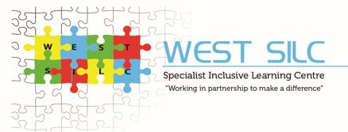

WEST SILC

SPECIALIST ENGLISH TEACHER (post 16)

RECRUITMENT PACK

Michelle Wilman
Principal

Telephone: 0113 3862450
Email: info@westsilc.org
Website: www.westsilc.co.uk
Address: 4 Town Street, Stanningley, Leeds, LS28 6HL


The Powerhouse: Life Changing

Welcome to Our School

We are an all-age, 2-19, generic special school dedicated to nurturing learners with moderate, severe, profound and multiple learning difficulties, autism, communication challenges, sensory processing differences, and SEMH needs on their learning journey. Our provision is based on specialist sites and mainstream partnerships in the West of Leeds.
Each cohort of learners is primarily based within one specialist pathway, where they access a unique, expertly tailored curriculum built around their individual needs, interests and aspirations. As learners grow and progress, they can move flexibly between pathways - ensuring their journey always matches their evolving strengths and goals.

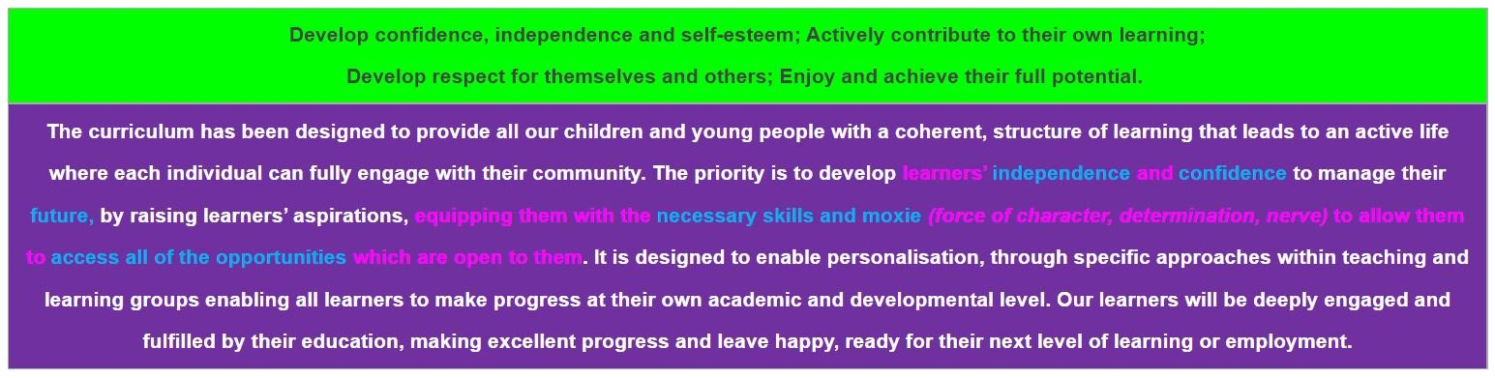
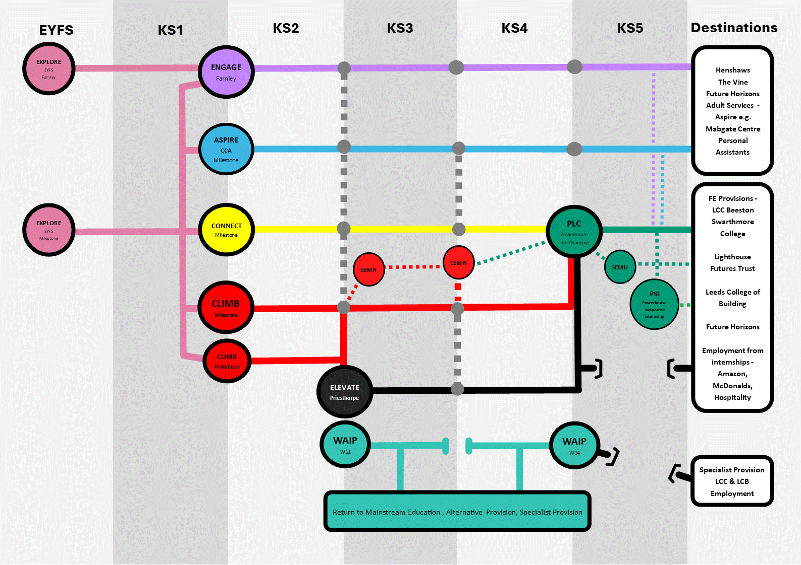
Our school is a place where every learner is seen, heard, and valued – and where every staff member is part of something truly meaningful.

Step into The Powerhouse - West SILC’s vibrant, future-focused post-16 college department - where education meets transformation.

This isn’t just a job. It’s a mission. A chance to guide, inspire, and empower young adults with learning difficulties as they transition into meaningful, independent lives.
We are looking for an inspiring, creative and passionate English Specialist Teacher to join our Post-16 Powerhouse department in Farsley, where we are transforming what is possible for young adults with special educational needs.

Why Powerhouse?
Because Lives Change Here.

Our Powerhouse Life-Changing Pathway is built on innovation, inclusivity, and ambition. It offers dynamic, immersive learning environments focused on preparing our young people for adulthood. Designed for learners aged 16 and above, our bespoke curriculum is grounded in real-world learning and prepares young people not only to live independently but also to thrive in employment—wherever their journey leads.

Our learners follow our innovative Powerhouse Life-Changing Curriculum, designed around two key strands:
🟡 Learning to Live – developing communication, independence, personal safety, community participation and life skills.
🟡 Learning to Earn – preparing learners for employment through vocational learning, enterprise projects, work placements and supported internships.

Why teach English at West SILC?
✅ Deliver English in meaningful, real-world contexts that make a genuine difference to learners' lives
✅ Teach Functional Skills English from Entry Level 1 to Level 2, alongside personalised communication programmes and English elements of Personal Progress qualifications
✅ Develop literacy through practical activities such as job applications, interviews, travel training, community learning, enterprise projects and independent living skills
✅ Support learners to become confident communicators through AAC, symbols, signing, assistive technology and personalised communication systems
✅ Work within state-of-the-art simulated learning environments including The Hub and The Foundry, where literacy is brought to life through authentic real world experiences
✅ Join a passionate, innovative and supportive team dedicated to preparing young people for adulthood

What we’re looking for:
✔ A qualified teacher (QTS/QTLS) who believes in educating for life, not just lessons
✔ A passionate English specialist who believes literacy can transform lives
✔ Experience teaching English, Functional Skills English, GCSE English or literacy programmes
✔ A creative practitioner who can make English engaging, relevant and accessible for learners with SEND
✔ Experience of adapting learning for learners with MLD, SLD, autism, SEMH and communication needs
✔ Someone who understands that communication, self-advocacy and literacy are essential foundations for independence and employment
✔ A team player who builds strong relationships with learners, families, employers and professionals

What Makes Us Different?
At the heart of everything we do is a deep belief in:
🟡 Empowerment – Supporting learners to own their decisions and shape their future.
🟡 Independence – Equipping individuals to stand tall and live with confidence.
🟡 Dignity and Respect – Celebrating every learner’s unique strengths, potential and dreams.
🟡 Holistic Growth – We nurture the whole person—cognitive, social, emotional, and vocational.
🟡 Community Connection – Learners actively engage in work placements, trips, enterprise projects, and real-life travel training.

Strand 1: Learning to Live
Learners gain essential life skills that promote autonomy and wellbeing, including:
- Personal Care, Health & Nutrition
- Independent Living: Budgeting, travel, cooking, and home management
- Social & Communication: Advocacy, relationship safety, and digital citizenship
- Money Matters: Real-life budgeting, shopping, and financial planning
- Community Engagement: Using public services, our travel training bus, safe travel, and contributing to society and our local community.

All of this happens with our simulated learning environments: The Hub, our fully equipped Life Skills Suite, Get Cooking our bake off style Kitchen and our IKEA home management learning area.
- A real-world Supermarket
- A fully functional Post Office, Hotel Room, Kitchen, and Travel Zone
- A Bake-off style specialist kitchen
- IKEA home management learning area

Strand 2: Learning to Earn
This is where we prepare learners for the world of work with:
- Work Readiness: Timekeeping, teamwork, and workplace communication
- Vocational Training across industries
- Enterprise & Entrepreneurship opportunities
- Work Placements & Supported Internships (including with Amazon)
- Job Coaching: CV writing, interview prep, and personal career planning

This strand lives in The Foundry, our dynamic Employment Suite, featuring:
- A Warehouse built by Amazon
- Barista & Bartending Training
- Nandos Kitchen and restaurant
- Office and admin learning area
- Job Centre built by the DWP
Every zone replicates a real workplace, giving learners authentic, hands-on experience to build confidence, skills, and ambition.
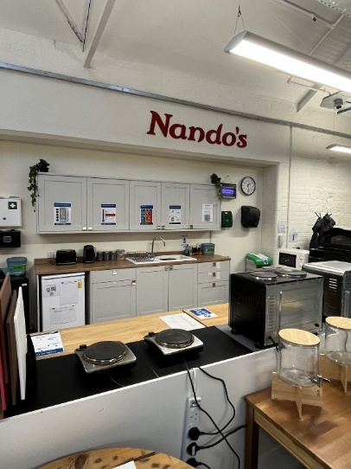
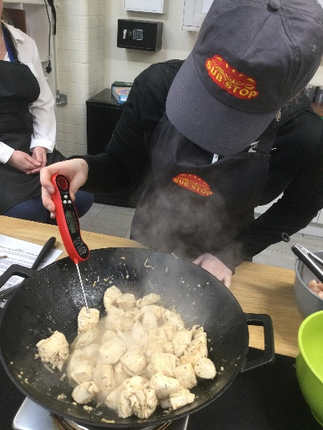
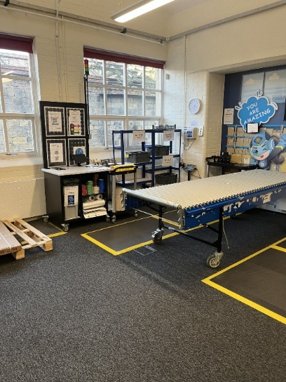
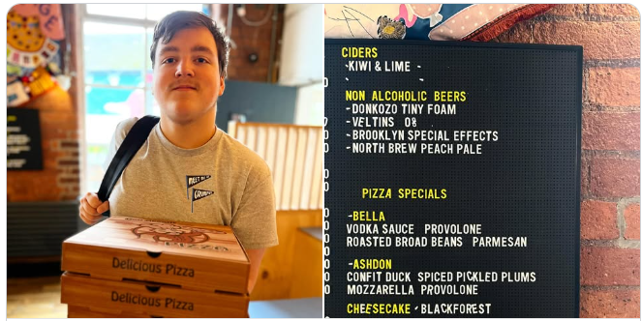
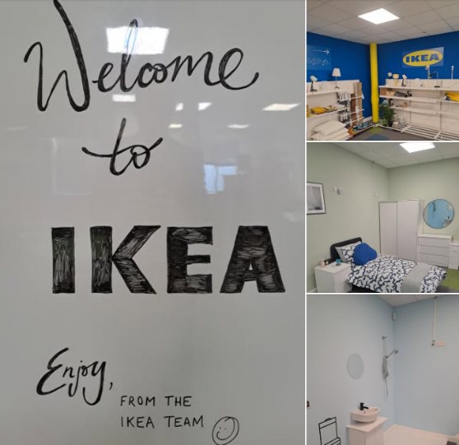
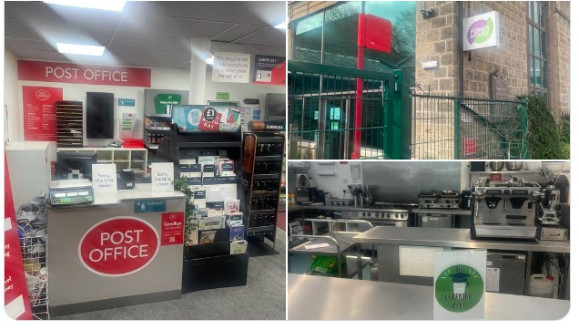

How We Teach:
Teaching at Powerhouse is all about connection, creativity, and care:
✅ Bespoke Learning Plans – Tailored to each learner’s needs and aspirations
✅ Hands-on, Experiential Learning – In real and simulated environments
✅ Multi-Sensory Approaches – Inclusive and engaging for all
✅ Strong Partnerships – With families, employers, local businesses and our community
✅ Flexible Pathways – Adapting to each learner’s evolving goals

Our Impact – Where Learners Soar
We don’t just measure success by qualifications. We measure it in:
✨ Confident communicators who can self-advocate and build lasting relationships
✨ Independent young adults who can manage their health, home and finances
✨ Positive community engagement, self-regulation, and personal pride
✨ Progression to meaningful destinations – employment, further education, supported living, and more
With 95% of our learners successfully transitioning to their chosen destination and our NEET rate well below national average, Powerhouse is delivering real results.

Key Accreditations & Pathways
Learners work towards:
🎓 Functional Skills in Maths and English (Entry 1 to Level 2)
🎓 BTECs, Entry/Pre-Entry Qualifications
🎓 Duke of Edinburgh Bronze Award
🎓 Vocational accreditations (e.g. Barista, Food Hygiene, Digital Skills)
🎓 Supported Internships with major partners like Amazon and Nandos

Hear the Call?
If you're an English specialist and passionate about person-centred learning, believe in real-world outcomes, and are ready to work in a team that values bold ideas and deep care, then Powerhouse is calling.
Come be part of something bigger. Change lives. Inspire independence. Empower futures.

West SILC – Working in Partnership to Make a Difference
We aim for all our students, irrespective of social class, age, gender, ability, religion, race or creed to:
    - Develop confidence, independence and self-esteem.
    - Actively contribute to their own learning.
    - Develop respect for themselves and others.
    - Enjoy and achieve their full potential.

Job Description – English Specialist Teacher
Job Title: Class Teacher
Salary: M1 – UPR3, Minimum SEN Allowance
Contract Type: Permanent
Reporting to: Pathway Leader / SLT
Location: West SILC
Core Purpose:
To deliver outstanding, engaging, and meaningful teaching to learners, ensuring their academic, personal, social and emotional development in line with their EHCPs.
Key Responsibilities:
- Deliver a person centered, aspirational curriculum for post 16 learners, adapted creatively to the needs, future interests and abilities of learners on your pathway – including contextualised, immersive, therapeutic and visual approaches.
- Facilitate learning that empowers and engages, enabling learners to make meaningful progress across both academic and personal outcomes, effectively equipping them with all the skills for the next stage in their journey.
- Plan and deliver high-quality, personalised sessions across both Learning to Live and Learning to Earn strands ensuring sessions are purposeful, inclusive and rooted in each learner’s EHCP, aspirations, strengths and communication style.
- Build positive, trusting relationships that promote learner wellbeing, emotional regulation and independence – using tools like Zones of Regulation and structured visual supports.
- Inspire curiosity, motivation and joy through consistent routines, multi-sensory experiences, and meaningful enrichment, both inside and outside the classroom.
- Track and celebrate progress using Evidence for Learning, documenting every small step on our Learning Journeys and EHCP small steps.
- Work collaboratively with support staff, therapists and families, building strong partnerships to support holistic learner development.
- Champion the values and aspirations of the Pathway and West SILC, contributing to a culture of inclusion, respect and high expectations.
- Take the lead on an area of curriculum, developing engaging plans with clear goals and success criteria that support independence, life skills, and preparation for adulthood.
- Support the wider school vision by contributing to whole-school improvement, planning, and the development of inclusive policies and practices.
- Reflect on your practice and grow professionally, using feedback, performance management and CPD to continually refine and improve your impact.
- Support learners across the SILC, being flexible to teach on any site as needed, and always committed to making a difference wherever you’re based.

What this means in more detail:

Planning, Teaching and Class Management
You will:
- Plan engaging, progressive lessons that are tailored to each learner’s strengths, needs and next steps – always with high expectations and meaningful outcomes in mind.
- Set clear, ambitious teaching objectives, and choose exciting, relevant ways to teach and assess them.
- Use time effectively and plan tasks that challenge, motivate and support each learner to succeed.
- Stay responsive to learners’ profiles – including communication styles, EHCP targets and sensory needs – and adapt your teaching accordingly.
Your teaching will:
- Blend structure with creativity, using practical, contextualised, immersive and therapeutic approaches that bring key ideas to life.
- Embrace a wide variety of resources – including ICT, assistive tech, and visual tools – to maximise accessibility and interest.
- Encourage participation, independence and joy in learning.
- Help every learner move closer to their personal potential, no matter their starting point.
In your classroom:
- You’ll create a calm, consistent and respectful learning environment.
- You’ll support learners to regulate their emotions and make positive behaviour choices.
- You’ll celebrate progress – not just in levels, but in confidence, engagement and relationships.
- You’ll ensure all learners are seen, supported and safe, and that their achievements compare positively with those in similar settings.

Monitoring, Assessment and Reporting
You will:
- Use assessment to drive learning – identifying what’s working, what’s next, and how to get there.
- Mark, monitor and reflect on work to inform planning and celebrate success.
- Set personalised targets and track progress through Evidence for Learning and our Strides assessment.
- Keep clear, purposeful records that highlight growth, inform interventions and shape next steps.
- Share progress meaningfully with learners, families, and the wider team – building trust and collaboration through transparency and care.

Pastoral Responsibilities
You will:
- Be a form tutor, providing structured pastoral support and a consistent point of contact to help learners feel secure, understood and ready to engage.
- Promote attendance, engagement, and participation in all areas of school life.
- Be responsible for reviewing and developing each learner’s EHCPs, behaviour plans, risk assessments and personal profiles in your class.
- Be proactive in spotting and supporting learners’ challenges – working with colleagues and families to find solutions.
- Build positive, respectful relationships with families, carers and external professionals – always putting the learner’s wellbeing first.

Curriculum Leadership (Area to be Agreed)
As a curriculum lead, you will:
- Coordinate planning, resources and activities within your subject or focus area.
- Support colleagues in delivering exciting, relevant and inclusive learning experiences.
- Review and evolve the curriculum collaboratively, keeping learners’ needs and strengths at the heart of your decisions.
- Stay current with national and sector developments in your area, bringing fresh ideas to the team.

Professional Responsibilities
You will:
- Understand and fulfil your professional and legal duties – including those related to KCSIE, safeguarding and child protection.
- Model the school’s values in everything you do – from your appearance and conduct to your relationships with learners and staff.
- Engage fully with the life of the school – contributing to meetings, reviews, school events and working parties as needed.
- Stay committed to your own growth, seeking out CPD and using what you learn to enhance your impact.
- Positively contribute to school priorities – including wellbeing, equity and Every Child Matters agenda.
- Build positive relationships with families and governors, sharing your passion for what’s possible for our learners.
- Take on additional responsibilities in line with the evolving needs of the school – always with the goal of making a real difference.

General Duties:
- Safeguard and promote the welfare of all learners.
- Contribute to whole-school improvement, staff training, and the positive ethos of the Post 16 department.
- Fulfil professional duties outlined in the Teachers’ Standards.

Person Specification – Class Teacher (Post 16 Powerhouse: Life Changing Pathway)
NB. Essential criteria are the qualities that candidates must have to do the job. Desirable criteria are the extra qualities that will enhance a candidate’s job performance and aid short listing. Ensure that your written application and your performance through the selection process demonstrates these.
Criteria | Essential | Desirable
Qualifications | - Qualified Teacher Status | - Additional qualifications in SEND, autism, or SEMH education  - Evidence of ongoing professional development in SEND or vocational learning / related fields
Experience | - Good or outstanding English teaching experience in any setting (mainstream/SEND/PRU/AP/FE)  - Ability to deliver English through engaging, life and work skills based, personalised sessions  - Able to track progress through formative and summative methods; assessing progress through small steps  - Strong understanding and experience of Preparing for Adulthood outcomes and developing in terms of inclusive, adaptive teaching approaches to SEND learners  - Creative approach to teaching English including through life skills and vocational subjects  - Experience of supporting learners to develop employability communication skills and self-advocacy.  - Confidence in supporting emotional regulation and learner wellbeing  - Able to create appropriate EHCP outcomes and breaking down into smaller steps  - Successful strategies for supporting young people with social, emotional and mental health needs  - An understanding of the needs of parent/carers of young adults with SEND. | - Able to adapt teaching to outcomes from – Entry Level to Level 2 (functional skills)  - Qualifications experience – delivering English  - Functional Skills (Entry 1 to Level 2)  - GCSE English experience  - BTECs, Entry/Pre-Entry Qualifications  - Experience teaching learners with moderate to severe learning difficulties and additional needs  - Knowledge of AAC and communication development  - Experience of teaching literacy through Preparing for Adulthood outcomes  - Delivering speech and language programmes, use of visuals, task plans, etc.  - Experience using Evidence for Learning assessment (or similar)  - Training in Zones of Regulation or similar approaches  - Knowledge of therapeutic interventions  - Experience in holding annual reviews and associated paperwork  - An understanding of the needs of parent/carers whose children are at risk of disaffection/exclusion or developing mental health problems or and supporting them to allow their child to become independent.
Personal Qualities | - Passion for meeting the needs of neurodiverse learners and building positive relationships  - Strong team working and communication with professionals and families  - Reflective, creative, nurturing, and inclusive in approach  - Resilience and determination to succeed  - Good communication skills, able to establish credibility, trust and work collaboratively with pupils, school staff, other professionals and community groups  - Tactful, patient and sensitive  - Innovative and resourceful | - Understanding of trauma-informed and attachment-aware approaches  - Experience leading a class team (e.g., HLTAs, support staff)  - Emotional self-awareness
Safeguarding & Equality | - Commitment to safeguarding, equality, and promoting a safe learning environment  - Enhanced DBS checks | - Experience contributing to safeguarding planning and behaviour support strategies, individual pupil risk assessments

