

Application Pack for Central Team Administrative Assistant

Dear Applicant
Thank you for your interest in the position of Central Team Administrative Assistant at Pioneer Learning Trust. I am thrilled that this exciting opportunity has arisen to join our Multi Academy Trust to strengthen and enhance our successful Pioneer School Improvement Team.
Established in 2019, Pioneer Learning Trust is a group of seven academies in Luton and Bedford. Southfield Primary Academy is host to an Attendance and Behaviour Hub, engaging with schools in a range of contexts through the DfE’s RISE Programme.
Our vision is to relentlessly pursue excellence and equity across our family of schools, where values-based leadership places children at the heart of everything; using the expertise of our extensive staff team, including Lead Practitioners and Specialist Leaders, to enable all to succeed.
We are a strongly collaborative, values-based Trust with extremely strong partnership links with key partners. Pioneer is a delivery arm of the Chiltern Teaching School Hub for CPD such as the Early Career Teacher Entitlement. As a Lead School for Initial Teacher Training, we also have close links to Chiltern Training Group and have extremely strong teacher recruitment as a result.
We are looking to recruit a dynamic and experienced administrative assistant to support the smooth running of our central services, including HR and Payroll, Recruitment and Governance.
This new role is an exciting opportunity for a professional who has the aspiration, integrity and ability to set high personal and professional standards to support our central team in their work across all schools in our growing Trust.
We are looking for a professional who deeply shares our values and is able to work collaboratively with our leaders and school teams in ensuring that our central services are of the highest possible standard.
This is an exciting and very rewarding role and we look forward to receiving your application.

Yours faithfully


Cori Bateman
Chief Executive Officer







- Welcome Letter
- Copy of the Advertisement
- Pioneer Learning Trust Vision and Values
- Job Description
- Person Specification
- How to Apply



About the Role

Following a period of growth, the Trust is expanding our Central Team to ensure that schools are effectively supported by the Executive Team, particularly in the areas of HR and Recruitment but also in a range of other administrative aspects. Additionally, our Executive Team and Trust Board would like to utilise the skills of the Central Team Administrative Assistant to support their essential functions with a full clerking service and general administrative support.

You will be a highly professional individual capable of working in a fast-paced work environment, adapting to meet the varying needs of the organisation. A successful candidate will have the ability to engage professionally with a range of different personnel across our 500+ staff team, coupled with the flexibility and efficiency required to fulfil the full range of administrative elements of the role.

Job Purpose
The Central Team Administrative Assistant role provides a comprehensive administrative service to the Trust’s Central Strategic Leadership Team. Working closely with the Executive Team and HR Services Manager, the post holder is responsible for a wide range of administrative tasks including HR and payroll administration, recruitment coordination, governance support for the Board of Trustees and general admin support to the Executive Team.

This is a multi-faceted role requiring:

- High quality administrative skills
- A flexible approach balanced with the ability to manage the expectations of others
- Rigour and clarity of written communication
- Excellent time management skills
- The ability to prioritise and complete tasks to a high standard
- Excellent face to face communication skills and the ability to relate to a range of different people
- Process driven practice and the ability to recognise and challenge poor practice

Pioneer Learning Trust is committed to safeguarding the welfare of its students and the successful applicant will be subject to an enhanced Disclosure and Barring Service certificate and checks of the relevant barred list/prohibition lists.

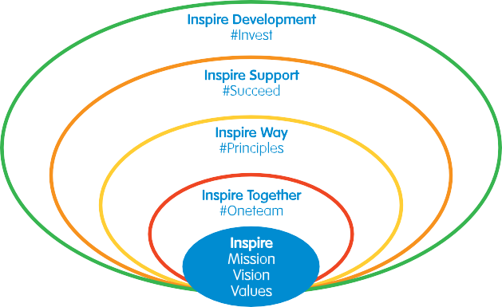

Transforming Lives, Building Futures

Our Vision

Pursuing Excellence and Equity
We are a primary focused Trust specialising in curriculum, pedagogy and practice. Our vision is to provide our pupils with an outstanding quality of education through continuous review and improvement in order to achieve our mission of all pupils having an equal opportunity to achieve a successful future in education and work.

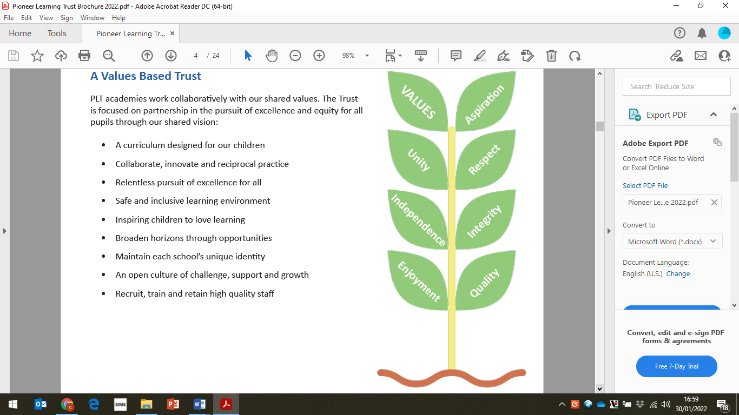
A Values-Based Trust
PLT academies work collaboratively with our shared values. The Trust is focused on partnership in the pursuit of excellence and equity for all pupils through our shared vision:

- A curriculum designed for our children
- Collaborate, innovate and reciprocal practice
- Relentless pursuit of excellence for all
- Safe and inclusive learning environment
- Inspiring children to love learning
- Broaden horizons through opportunities
- Maintain each school’s unique identity
- An open culture of challenge, support and growth
- Recruit, train and retain high quality staff

The Pioneer Promise – Opportunities for our Pupils
In the realisation of our vision and in pursuit of excellence and equity, our schools each commit to The Pioneer Promise. We are absolutely passionate about our pupils developing a love of reading, a passion for maths and a thirst for knowledge of the world around them, but we also want our children’s school days to be filled with memories of their friendships and experiences. Our promise is that we will fill our children’s school years with opportunities to be inspired and challenged, to experience excitement and adventure, to broaden their horizons, and to learn about people, community and the wider world beyond their classroom.





Respect
Experience other cultures in working with a range of people
Unity
Engage with the community to make
a positive contribution
Integrity
Contribute to sustainability goals and become global citizens
Aspiration Take part in employment based skills activities




Independence
Sleep away from home
Quality
Perform for an audience or represent their school at events
Enjoyment
Participate in a range of outdoor and adventurous activities

Job Description

Job title: Central Team Administrative Assistant
Required: as soon as possible
Location: Trust Wide
Salary Range: L5 (£27,368 - £30,340)
Hours : 37 hours per week, 41 weeks per year
(term time plus INSET days plus 2 weeks to be worked flexibly)

Job Purpose
The Central Team Administrative Assistant role provides a comprehensive administrative service to the Trust’s Central Strategic Leadership Team. Working closely with the Executive Team and HR Manager, the post holder is responsible for a wide range of administrative tasks including HR and payroll administration, recruitment coordination, governance support for the Board of Trustees and general admin support to the Executive Team.

This is a multi-faceted role requiring:

- High quality administrative skills
- A flexible approach balanced with the ability to manage the expectations of others
- Rigour and clarity of written communication
- Excellent time management skills
- The ability to prioritise and complete tasks to a high standard
- Excellent face to face communication skills and the ability to relate to a range of different people
- Process driven practice and the ability to recognise and challenge poor practice

Ethics and Professional Conduct
As a member of the Central Team in our Trust, the Central Team Administrative Assistant is expected to demonstrate consistently high standards of principled and professional conduct. They should always uphold and demonstrate The Principles of Public Life (The Nolan Principles).

The Central Team Administrative Assistant is responsible for upholding public trust in our Schools and the
Trust as a whole and should maintain high standards of ethics and behaviour.
The Central Team Administrative Assistant should serve in the best interests of the Trust's
pupils, conducting themselves in a manner compatible with their influential position in society.

Key accountabilities:
1. HR Administrative Support
Working under the direction of the HR Services Manager:
- Support the administration of payroll related matters including: staff timesheets, leave of absence, sickness absence, contract variations and other aspects affecting pay
- Support in the monitoring and recording of sickness absence and other leave types impacting payroll (e.g., maternity, paternity, or leave of absence).
- Support the HR Service Manager with accurate monthly payroll administration and responding to staff pay queries.
- Assist in the implementation and distribution of HR policies and procedures across the Trust.
- Liaising with the HR Services Manager and the Trust’s external HR Advisors in relation to incoming queries from schools.
- Undertake note-taking for HR-related meetings and panel hearings, including attendance reviews, disciplinary, or grievance cases.
- Keep up to date with changes to legislation and support updates to policy and practice across schools.
- Support in the monitoring of compliance and application of policy.
- Support in the maintenance of HR Personnel files for all employees across the Trust.
- Support in the roll out and tracking of Trust level compliance training for all staff across the Trust.
- Support in the standardisation and audit of the single central record across the Trust

- Centralised Recruitment Administration
Working under the direction of the HR Services Manager and the Executive Team
- Liaise with headteachers and school-based HR Admin staff to understand the recruitment needs of the organisation, ensuring that all information related to the position is gathered prior to any recruitment process beginning.
- Ensure that all recruitment processes comply with the Trust’s Safer Recruitment Policy, including the management of referencing in accordance with the Trust’s Referencing Policy.
- Coordinate the administrative elements of the recruitment process, including generating and placing advertisements across various platforms and social media.
- Perform initial screening of applications to ensure minimum requirements are met and engage with applicants to resolve gaps in employment history.
- Provide schools with clear guidance of requirements on recruitment days, particularly in regard to candidate ID and documentation required on the day.
- Act as a point of contact for candidate communications, including supporting schools with interview schedules, communicating interview information to candidates and co-ordinating feedback for candidates following the interview process
- Conduct all pre-appointment checks in strict compliance with Safer Recruitment procedures, securing all information required for the Single Central Record.
- Set up and maintain standard personnel files for new starters.

- Governance Administration for the Trust Board and Company Secretary
Working under the direction of the CEO and Company Secretary (CFOO):
- Support the Company Secretary with any administrative aspects such as updating any changes required on Companies House, Governorhub, the Trust and schools’ websites.
- Undertake administrative work related to Trust governance, such as communications to Trustees, note taking at meetings, managing documentation, etc.
- Convene and provide a clerking service for all Trust Board meetings and the AGM, for example manage development of agendas and maintain documentation via platforms such as GovernorHub.
- Liaise with school personnel to ensure statutory duties are met, such as keeping Companies House, GovernorHub and 'Get Information About Schools' (GIAS) updated.
- Publish approved Trust policies and statutory information on school and Trust websites in coordination with IT services.
- Provide an ad-hoc clerking service to schools’ local governing bodies to cover absence or gaps in service.

- Administrative Support for the Executive Team
Working under the direction of the HR Services Manager and the Executive Team
- Provide general administrative support to the Executive Team.
- Support in the production of documentation, reports, and correspondence as required.
- Undertake accurate note-taking on an ad-hoc basis at various leadership and strategy meetings.
- Provide effective clerking support for Finance and Education committees, including agenda preparation and minute distribution.
- Manage ad-hoc administrative projects as directed by the Executive Team.
- Any other tasks or responsibilities commensurate to the role.

Job Title: Central Team Administrative Assistant | Essential (E)  Desirable (D) | Application Form (AF) Interview (I)  Reference (R)
Requirements | Essential (E)  Desirable (D) | Application Form (AF) Interview (I)  Reference (R)
Qualifications
Good general education, including GCSE Grade C/5 or above in English and Maths (or equivalent) | E | AF
Qualifications in administration, personnel management, or recruitment | D | AF
Qualified to CIPD Level 3 or willingness to work towards this qualification | E | AF
Experience
Significant experience in a general administrative or executive support role | E | AF/I/R
Experience in taking accurate minutes and servicing formal meetings | E | AF/I/R
Experience in HR, payroll, or recruitment administration | E | AF/I/R
Experience in an educational environment or Multi-Academy Trust (MAT) | D | AF/I/R
Experience with school governance administration | D | AF/I/R
Knowledge and understanding
Secure understanding of the requirement to maintain absolute confidentiality and exercise discretion at all times | E | AF/I/R
Secure understanding of the importance of inclusion, diversity and access | E | AF/I
Some knowledge of child protection and safeguarding procedures | E | AF/I
Secure understanding of the impact of change on organisation and individuals | E | AF/I
Some knowledge of legal issues relating to including equal opportunities, race relations, disability, human rights and employment legislation | D | AF/I
Skills
Excellent organisational skills with the ability to manage competing priorities and strict deadlines | E | AF/I/R
Strong listener with the ability to communicate clearly and concisely (verbal and written) | E | AF/I/R
Demonstrable people skills – able to receive and give accurate information to a wide range of people inside and outside of the organisation | E | AF/I/R/T
High level of IT literacy, including Office 365 and/or Google suite, Information Management Information Systems and the safe use of Artificial Intelligence (AI) in the workplace | D | AF/I/R
Able to work efficiently with IT systems to streamline processes and manage demands in a busy work environment | E | AF/I/T
Able to innovate and make suggestions of improvement to systems and processes | D | AF/I/T
Excellent agenda writing and accurate minuting skills | E | AF/I//RT
Able to seek and apply knowledge to the task of writing policies and documents | E | AF/I/R
Able to interpret and make use of high volumes of information with accuracy and precision | E | AF/I/R
Able to work on own initiative within the organisation’s policy and procedure | E | AF/I/R
Other (including special requirements)
Understanding and commitment to the safeguarding of children | E | AF/I
Full driving license and access to own vehicle for movement between school sites | E | AF
Awareness of Safer Recruitment requirements | D | I
Commitment to Health and Safety | E | I

Person Specification

How to apply

For further information and to apply for this position, please visit our website at www.pioneerlearningtrust.com

Closing date: Monday 18th May 2026 at noon

Interviews: to be confirmed

If you would like a conversation with the CEO Cori Bateman about this post then please contact her via email at cbateman@pioneerlearningtrust.co.uk

Pioneer Learning Trust is committed to safeguarding the welfare of its students and the successful applicant will be subject to an enhanced Disclosure and Barring Service certificate and checks of the relevant barred list/prohibition lists.

